What is the Alaska Developmental Profile?
Many families take pictures of their child’s first day of school to commemorate their entrance into formal schooling. The Alaska developmental profile is similar as it is a way for teachers to document where children are when they enter school for the first time. This gives teachers and school information on what skills and behaviors children have at the beginning of the school year to help them adjust their instruction to the child’s level.

How is the Alaska Developmental Profile different from other statewide assessments?
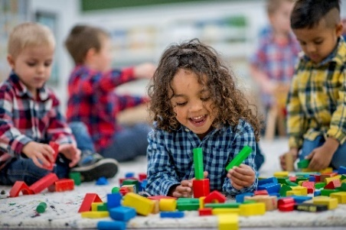
When people hear the word “assessment”, it often conjures up images of students sitting down and being tested on what they know and don’t know. The Alaska Developmental Profile is observation-based, meaning that teachers observe children during their regular instruction. Under statute, the Alaska Developmental Profile is required to consider background information and teachers are encouraged to talk with families or previous providers to help determine each child’s entering skill level.

What skills does the Alaska Developmental Profile look for?
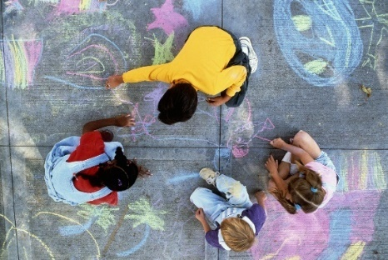
The ADP has 13 different goals that children entering kindergarten should be consistently demonstrating. These goals are based upon Alaska’s Early Learning Guidelines for children from birth to school entry.
The follow table breaks down the goals and indicators for each goal:
ADP Goal | Indicator
Goal 1: Demonstrates strength and coordination of large muscles | Running with an even gait and few falls, maintaining balance while bending, twisting, or stretching, kicking a ball at a given point with accuracy, able to alternate weight & feet while skipping or using stairs.
Goal 2: Demonstrates strength and coordination with small muscles | Cutting, drawing, able to manipulate clothing fasteners, and putting together or pulling apart manipulative such as blocks or beads.
Goal 3: Participates positively in group activities | Following simple rules, participating in group activities, or inventing activities that include more than one child.
Goal 4: Regulates their feelings and impulses | Expressing themselves in safe & appropriate ways, seeking peaceful resolutions to conflict, modifying behavior for different environments, or listening to instructions before starting an activity.
Goal 5: Shows curiosity and interest in learning new things and having new experiences | Engaging in discussion about new occurrences, looking for new information, or using familiar materials in a new way.
Goal 6: Sustains attention to tasks and persists when facing challenges | Demonstrations of this could include remaining engage while peers or adults are the focus of attention like in Storytime, working on a task over a period of time such as leaving or returning to it, being able to shift attention back to an activity after being distracted, or accepting age-appropriate challenges and persisting through frustration.
Goal 7: Demonstrates knowledge of numbers and counting | This could include counting to 10 from memory, understands that in counting a set of items, each item must be counted one and none should be left out, and using basic numbers and counting in play.
Goal 8: Sorts, classifies, and organizes objects | Sorting, classifying, and organizing objects. Demonstrations of this could include sorting objects into categories, creating or duplicating patterns, or being able to describe whey objects are arranged and sorted the way they are.
Goal 9: Uses receptive communication skills | Listening to other in a group, responding to requests, and understanding prepositions in commands
Goal 10: Uses expressive communication skills | Asking others for help, defining words, using words correctly to indicate understanding, naming several non-present objects or expressing ideas in more than one way.
Goal 11: Demonstrates phonological awareness | Participating in or creating song, rhymes, and games, identifying initial sounds.
Goal 12: Demonstrates awareness of print concepts | Demonstrating how to follow text left to right, recognizing the different between letters, words, and numerals. Pointing to the title or the book, reading own first name, or environmental print
Goal 13: Demonstrates knowledge of letters and symbols (alphabet knowledge) | Recognizing or printing several upper- and lower-case letters, writing or recognizing the letters in their name.

How frequently does a child have to do something to be considered consistently demonstrating a skill?

A child is not expected to show each skill and ability all the time to be considered consistently demonstrating. The following table shows the rating scale of when a student is consistently demonstrating, progressing, or not consistently demonstrating.
Rating | Category | Definition
2 | Consistently Demonstrates | Student demonstrates the indicated skills or behaviors on a consistent basis (80% or more of the time).  Give this rating if the student is generally able to demonstrate these skills most of the time. Students are not required to successfully demonstrate each skill and behavior all of the time to receive this rating.
1 | Progressing | Student demonstrates the indicated skills or behaviors on an inconsistent basis.  Give this rating if the student demonstrates the indicated skills or behaviors on an inconsistent basis OR if they are unable to consistently demonstrate most of the indicated skills and behaviors (i.e., for students who demonstrate only some of the indicated skills or behaviors consistently).
0 | Does Not  Demonstrate | Student does not demonstrate the indicated skills or behaviors (20% or less of the time).  Give this rating if the student is generally unable to successfully demonstrate these skills most of the time.

What does it mean if my child is “Progressing” or “Not consistently demonstrating” on a goal?
If your child is “not consistently demonstrating” or “progressing” on a goal, it just means that they were not able to show that skill at the beginning of the school year. You should talk with your child’s teacher about areas of strength and need and to support your child’s progress at home and school.

What can I do to support my child?
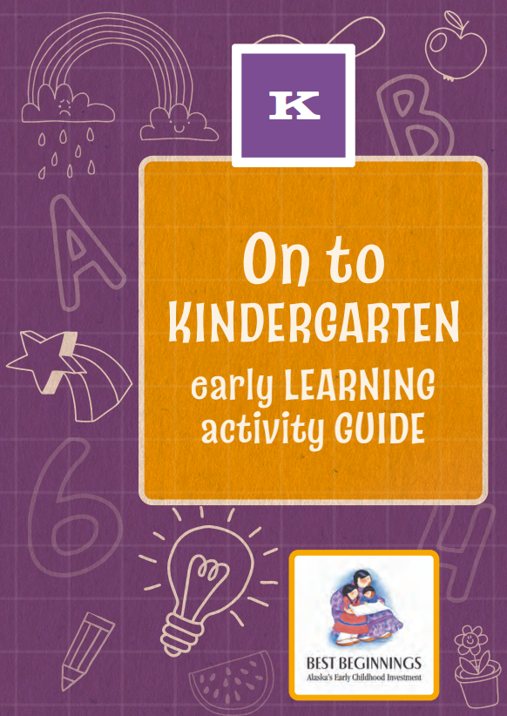
In 2020, Alaska updated its “Early Learning Guidelines”. This is a document that is available online or in a printed format, which details the widely held expectations for children ages birth to 60 months. A activity guide was also created to showcase different ways that families can support skill development. Examples include reading books together, asking your child to retell a story, or finding patterns in nature.

ADP Program Manager Contact Information:
Supanika Ordonez
Supanika.ordonez@alaska.gov
907-465-8707

