 | Eggs & Child Nutrition Programs | 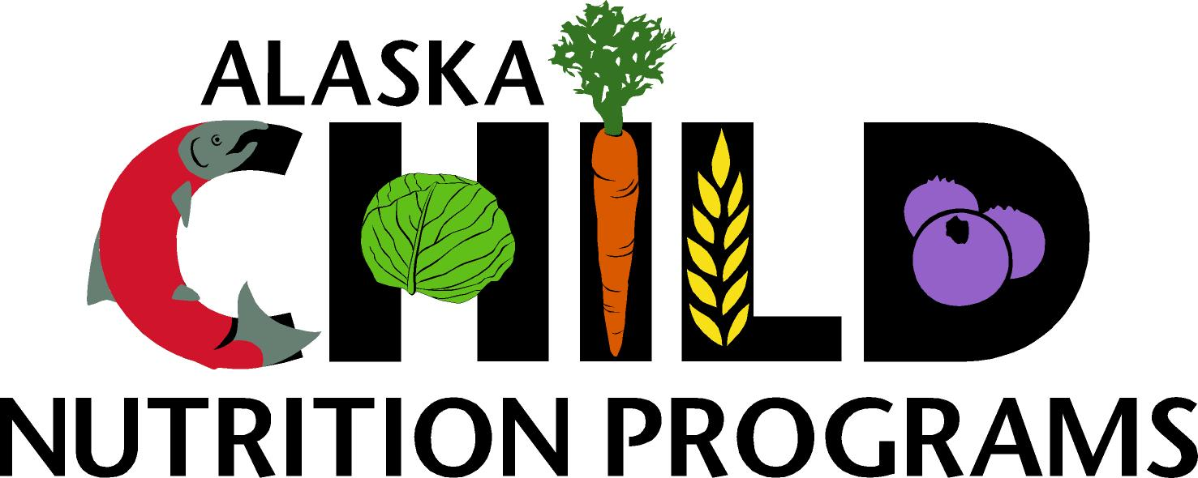

Child Nutrition Programs serving meals to high-risk populations including pre-school children or older adults must serve pasteurized eggs or egg products as substitute for raw eggs in the preparation of foods such as Caesar salad, hollandaise or Béarnaise sauce, mayonnaise, meringue, eggnog, ice cream, and egg-fortified beverages, and in recipes using more than one egg is broken and the eggs are combined such as hot-held items like scrambled eggs, omelets, and French toast.
This rule does not apply for:
- Raw eggs that are combined immediately before cooking for one consumer's serving at a single meal, cooked to proper temperature and served immediately, such as an omelet, soufflé, or scrambled eggs
- Raw eggs that are combined as an ingredient immediately before baking and the eggs are thoroughly cooked to a ready-to-eat form, such as a cake, muffin, or bread
- Hard boiled eggs

Pasteurized eggs can be purchased in the shell, in liquid form, or powdered.
For more information on eggs and food service, please see Alaska Administrative Code 18AAC 31.215

Child Nutrition Programs

Teaching and Learning Support
801 West 10th Street, Suite 200
P.O. Box 110500
Juneau, Alaska 99811-0500
Phone: 907.465.8712
Fax: 907.465.8910

