Recruiter Handbook
2019-2020
Alaska Department of Education & Early Development
Table of Contents
Program & Policies Overview 3
The Alaska Migrant Education Program (MEP) 3
History 3
Purpose 3
Goal 3
Legal/Authoritative Reference 4
Organization 4
Family Educational Rights and Privacy Act (FERPA) 5
Online Safety and Security 7
The Migrant Education Program Recruiter 9
Importance of Identification & Recruitment (ID&R) 9
Roles of the District Recruiter 9
Characteristics of a Successful Recruiter 10
Interviewing Families of Migratory Children 13
The Recruiter as Interviewer 13
Preparing for an Interview 13
Interviewing the Families 14
Eligibility Requirements 21
MEP Eligibility Transition from NCLB to ESSA 21
Start of Eligibility 21
Length of Eligibility 21
The Four Migrant Eligibility Requirements 22
Eligibility Determination Process 34
Determining Eligibility 35
Prospective Re-Interviewing 35
Certificate of Eligibility (COE) 37
About the COE 37
Economic Necessity and the COE 38
Changes to the Alaska COE 38
2019-2020 COE 39
Certificate of Eligibility (COE) Guide 40
Important Reminders About COEs 70
Annual Recertification of No New Moves (ARC) 71
About the ARC 71
When to Use an ARC Form 71
Changes to the Alaska ARC 71
2019-2020 ARC 72
Annual Recertification of No New Moves (ARCs) Guide 73
Alaska Migrant Web System 77
About the Web System 77
Updates to the Web System 77
Overview of Recruiting Using the Web System 78
Accessing the Web System 79
Navigating the Web System 83
Creating a COE in the Web System 88
Important Information Regarding COEs in the Web System 90
Creating an ARC in the Web System 100
Important Information Regarding ARCs in the Web System 102
Glossary 105
Acronyms/Abbreviations 105
Definitions 106
Appendix 115
Eligibility Checklist 115
COE Review Checklist 116
Eligibility Flowchart 117
Interview Framework 119
Sample Interview Script 121
When to Fill Out a COE 123
When to Fill Out an ARC 124
Guide to Economic Necessity and Personal Subsistence 125
Key Charts 126
State Abbreviations Key 127
US Districts & Territories Key 127
School District Boundaries 128
Commercial Fishing Terms 129
Subsistence Fishing Terms 129
Agriculture/Logging Terms 130
Agriculture/Crop Terms 130
Agriculture/Livestock Terms 130
COE Comments Menu 131
School Name/Enroll Date/Grade Flowchart 133
Alaska School District Map 134
Calendars 135
Migrant Education Office (MEO) Contact Information 136

Program & Policies Overview

The Alaska Migrant Education Program (MEP)
The U.S. Department of Education provides formula grants to states to establish or improve education programs for migratory children and youth. In turn, the Alaska Migrant Education Program provides grants to school districts to improve educational opportunities for migratory children to help them succeed in the regular school program, meet the challenging State academic standards that all children are expected to meet, and graduate from high school.

History
The Migrant Education Program is authorized by Title I, Part C of the Elementary and Secondary Education Act of 1965. Congress established the national Migrant Education Program in 1966 to provide funds to establish or improve educational programs designed to meet the unique needs of migratory children and youth. Congressional support has increased steadily since then.
The State of Alaska became involved with the Migrant Education Program in 1980 when the federal definition of qualifying migratory activity was expanded to include both logging and fishing. Currently, 41 of Alaska’s school districts operate a Migrant Education Program.
Today, the Migrant Education Program identifies roughly 250,000 children across the country with approximately 13,000 migratory children in Alaska. With these funds, states and local schools provide a broad range of instructional and support services to supplement regular classroom instruction and to help migratory children overcome barriers arising from lifestyle, mobility, and educational interruption.

Purpose
The purpose of the Migrant Education Program is to:
- Assist states in supporting high-quality and comprehensive educational programs and services during the school year and, as applicable, during the summer or intersession periods, that address the unique educational needs of migratory children.
- Assure that migratory children who move among the States are not penalized in any manner by disparities among the States in curriculum, graduation requirements, and challenging State academic standards.
- Ensure that migratory children receive full and appropriate opportunities to meet the same challenging State academic standards that all children are expected to meet.
- Help migratory children overcome educational disruption, cultural and language barriers, social isolation, various health-related problems, and other factors that inhibit the ability of such children to succeed in school.
- Help migratory children benefit from State and local systemic reforms.

Goal
The primary goal of the Migrant Education Program is to ensure that all migratory children and youth reach challenging academic standards and graduate with a high school diploma that prepares them for responsible citizenship, further learning, and productive employment.

Legal/Authoritative Reference
The Migrant Education Program is authorized by the following legal and authoritative references:
- Statute – Elementary and Secondary Education Act (ESEA), Title I , Part C, §1301-1309, as amended by the Every Student Succeeds Act (ESSA)
- Code of Federal Regulations – 34 CFR §§ 200.81-200.89
- Guidance – MEP Policy Non-Regulatory Guidance

Organization
The Migrant Education Program (MEP) is organized at several different levels of government and operation:
- U.S. Department of Education - Office of Migrant Education (OME)
- Alaska Department of Education & Early Development - Migrant Education Office (MEO)
- School Districts - Local Migrant Education Program

Role of the Federal MEP Staff
At the federal level, the Office of Migrant Education (www2.ed.gov/programs/mep) administers the MEP nationally and provides guidance and support to states that receive grants. The OME has several responsibilities, including providing national leadership, conducting special initiatives, helping U.S. Department of Education (ED) to calculate state MEP allocations, monitoring state programs for compliance with federal requirements, collecting and analyzing student performance data, developing regulations and guidance, and providing technical assistance on how to implement the MEP. A federal program officer (i.e., contact person) is assigned to each state to assist and monitor its implementation of the MEP.

Role of State MEP Staff
OME awards MEP formula grants to the Alaska Department of Education & Early Development – Migrant Education Office (education.alaska.gov/ESEA/TitleI-C). The MEO is then responsible for the operation and administration of the state migrant education program. The MEO sub-grants the funds to districts to administer and operate local migrant education programs. MEO staff are responsible for overseeing all aspects of the administration of the program, including the state’s Identification & Recruitment (ID&R) system. The focus of the MEO is to provide overall leadership and direction for the state as a whole, and to ensure that local programs comply with all applicable laws and other requirements. The state is responsible for finding and enrolling migratory children from across the state, for determining their unique needs, and for developing a service delivery plan that uses resources in an equitable and effective manner. The MEO also provides statewide leadership and guidance to recruiters. When a recruiter asks a question that cannot be answered at the local level, the district should raise the question at the state level for a response.

Role of District MEP Staff
At the district level, the emphasis is on finding and serving individual migratory children. The recruiter, perhaps with assistance from other local staff, finds potentially eligible migratory children, determines whether they may be eligible for the MEP, and helps connect them with appropriate services. Once the child is identified and the child’s needs are assessed, migrant educators and others at the district level may provide extra services that are beyond those offered by the local school. For example, MEP teachers and tutors may provide in-home tutoring, after school coursework, or summer programs. Migratory children may also be eligible to receive services through other programs serving migratory students.
Local school districts that receive a sub-grant from the State Education Agency (SEA) to serve migratory children are responsible to the state MEP. When a recruiter or anyone else at the local level has a question or needs support, the recruiter should turn to an immediate supervisor for assistance. The supervisor may be an ID&R staff member or a local program coordinator who has broader duties. Local projects are often asked to gather local data for the state for evaluation purposes and also to inform state decision makers.

Family Educational Rights and Privacy Act (FERPA)
Family Educational Rights and Privacy Act (FERPA) (20 U.S.C. § 1232g; 34 CFR Part 99) is a Federal law that protects the privacy of student education records. The law applies to all schools that receive funds under an applicable program of the U.S. Department of Education.
FERPA gives parents certain rights with respect to their children's education records. These rights transfer to the student when he or she reaches the age of 18 or attends a school beyond the high school level.
Parents or eligible students (eligible students are children who have reached the age of 18 or have otherwise had FERPA rights transferred to them) have the right to inspect and review the student's education records maintained by the school. Schools are not required to provide copies of records unless, for reasons such as great distance, it is impossible for parents or eligible students to review the records. Schools may charge a fee for copies.
Parents or eligible students have the right to request that a school correct records which they believe to be inaccurate or misleading. If the school decides not to amend the record, the parent or eligible student then has the right to a formal hearing. After the hearing, if the school still decides not to amend the record, the parent or eligible student has the right to place a statement within the record setting forth his or her view about the contested information.
Generally, schools must have written permission from the parent or eligible student in order to release any information from a student's education record. However, FERPA allows schools to disclose those records, without consent, to the following parties or under the following conditions (34 CFR § 99.31):
- school officials with legitimate educational interest,
- other schools to which a student is transferring,
- specified officials for audit or evaluation purposes,
- appropriate parties in connection with financial aid to a student,
- organizations conducting certain studies for, or on behalf of, the school,
- accrediting organizations,
- to comply with a judicial order or lawfully issued subpoena,
- appropriate officials in cases of health and safety emergencies, and
- state and local authorities, within a juvenile justice system, pursuant to specific State law.
Schools may disclose, without consent, directory information such as a student's name, address, telephone number, date and place of birth, honors and awards, and dates of attendance. However, schools must tell parents and eligible students about directory information and allow parents and eligible students a reasonable amount of time to request that the school not disclose directory information about them. Schools must notify parents and eligible students annually of their rights under FERPA. The actual means of notification (special letter, inclusion in a PTA bulletin, student handbook, or newspaper article) is left to the discretion of each school.
Family Policy Compliance Office
1-800-USA-LEARN
U.S. Department of Education
400 Maryland Avenue, SW
Washington, D.C. 20202-8520
(ed.gov/policy/gen/guid/fpco/ferpa)

FERPA Overview
The Family Educational Rights and Privacy Act (FERPA) of 1974 is a Federal law which:
- Protects the privacy of student education records (including the hard copy Certificate of Eligibility (COE), as well as any electronic versions of the COE).
- Applies to all schools and educational agencies that receive funds under an applicable program of the U.S. Department of Education.
- Gives parents certain rights with respect to their children’s education records. These rights transfer to students when they turn 18 or attend a school beyond high school.
- Requires that educational agencies and institutions adopt a policy regarding how they meet the requirements of FERPA and how they notify parents and eligible students annually of their rights.

Parent Information
- Parents or eligible students have the right to access and inspect the student’s educational records.
- Parents or eligible students have the right to request that education records be corrected if they are found to be inaccurate or misleading.
- Generally, schools and districts must have written permission from the parent or eligible student before releasing any information from a student’s education record (including the COE).

Recruiter Information
When closing your interview with families, the following conditions and FERPA rights must be explained to parents:
- Before the interviewee signs the COE, have them review the COE for accuracy.
- Tell the parent: “The information that you have provided to us is confidential. By signing the COE, you give us permission to enroll your child into the Migrant Education Program (if they are approved). FERPA gives you the right to access and update your children’s records upon request.”
- Obtain a signature from the parent.
- Explain that the COE will be reviewed and after a determination of eligibility is made, the parent will be contacted and will be given a copy of the approved COE.
- Tell the parent: “If approved into the program, your children may be eligible to receive services such as: enrollment in the free lunch program, educational tutoring, and educational books.”
- Tell the parent: “You might receive a call from the Migrant Education Office (MEO) to verify the information on the COE.”
- Thank parents for their time and inform them that somebody will follow up with them once an official eligibility determination has been made.

FERPA Best Practices

Personally Identifiable Information (PII)
- Personally Identifiable Information includes but is not limited to: student name, date/place of birth, parent’s names, addresses, student ID, etc.
- Personally Identifiable Information is protected under FERPA. Any notes with personally identifiable information should be shredded once the interview has concluded.
- Personally Identifiable Information may not be disclosed without written consent.

Paper Security
- Be sure to shred any extra copies of the COE, or any COEs that had mistakes.
- If you keep notes of your interview, be sure to properly store/destroy them if they contain personally identifiable information (student’s name, parent’s names, address, student ID, date/place of birth, etc.).

Electronic Security
- Electronic COEs must be completed using official district computers (not personal computers) and copies must be securely deleted (not stored on the computer).
  - Laptop computers are required to have encryption to protect student data.
- If transmitting COEs to a parent's personal email account, consider obtaining parent permission (even verbal permission) prior to emailing. The district may consider password protecting the COE before emailing it to parents.
- Always use official district email accounts to send student data (COEs).
- When you receive reports containing personally identifiable student information, consider saving the report to a secure location and deleting the email. When you send reports, consider deleting the sent email.
- Consider password protecting documents containing personally identifiable student information before you save or send them.

COE Requests
If another district requests a copy of a COE:
- Ask if that child has moved to their district and is enrolling in their district.
- Ask if the parent signed a written release.
- Check if your district has a written release on file.
- Call the MEO and inform us of the child’s move and we can coordinate with the receiving district.

Online Safety and Security
To protect the information of Alaska’s migratory children, it is important to keep cyber security in mind. Recruiters, records managers, and other MEP staff must ensure that child data is secure by utilizing best practices in regards to password and email security. MEP staff should be careful when accessing or sharing confidential child data. Only those with a business need to know should receive MEP data or access to MIS2000, the Alaska Migrant Web System, or district MEP data systems.
Some of the most common threats to data security are email phishing and weak passwords. It is important that MEP staff recognize such threats and protect their accounts with strong passwords. Passwords, usernames, and other credentials should never be shared. MEP child information must only be accessed from official district computers. Computers must be encrypted to ensure the protection of data. District staff accessing MEP data from the Alaska Migrant Web System, must have official district email addresses. Furthermore, MEP staff should only email MEP data securely, complying with district policies, with those with a business need to know.
District MEP staff must adhere to all district cyber security policies in order to protect migrant data. Computers should be locked when unattended. Digital information should be stored in an encrypted format where technically possible. Any information printed from the Alaska Migrant Web System, MIS2000, and other services should be kept securely (locked up) when not in use. Any security breaches must be reported to the state MEO immediately.

Password Security
It is important that users have strong passwords, and utilize best practices when accessing secure data systems. Passwords for secure systems should meet district policy requirements. Passwords should:
- contain a minimum of eight characters,
- have a mixture of upper case and lower case letters, numbers, and special characters (#, @, !, etc.), and
- be changed periodically.
It is equally important to know that passwords should not be:
- shared among users,
- remembered using an internet browser’s “remember password” feature, or
- written down or kept in an area where they are easily discoverable.

Email Security
District staff must utilize caution when responding to email requests and/or sending migrant program data. District staff should follow district policy when emailing MEP data and should use official district emails only. Below is a list of best practices:
- Do not open unexpected attachments.
- Do not click on suspicious links within emails.
- Install and update anti-virus software on all devices.
- Learn how to recognize phishing.
- Only give email addresses to websites and services that are trustworthy.
MEP staff should only email child data securely to individuals with a business need to know. MEP staff must follow district policies and procedures to ensure that data is protected.

Recognizing Phishing
One common threat to data security is email phishing. Phishing is an attempt to obtain sensitive information such as usernames, passwords, and other personal information, often for malicious reasons. The individual phishing will disguise themselves as a reputable entity in electronic communication in order to gain the user’s trust and obtain access to sensitive materials. Users should be wary of emails soliciting identification and/or password information from them. Please be aware that the Alaska Migrant Web System and state MEP staff will never email users to ask for their account credentials.
Users must learn how to recognize phishing emails. Some common hallmarks of phishing include but are not limited to:
- Messages that contain threats to shutdown accounts or devices.
- Requests for personal information (passwords, etc.).
- Language pushing the user to act fast, such as “urgent”.
- Forged email addresses (ones that look similar to official, but are not quite right).
- Poor writing and bad grammar emails.
For more information on data security, contact the district’s IT department or the State Migrant Education Office.

The Migrant Education Program Recruiter

Importance of Identification & Recruitment (ID&R)
Identification means actively looking for and finding migratory children and youth. Recruitment means making contact with the family or youth and obtaining the necessary information to document the student’s eligibility and enroll them into the MEP.
The identification & recruitment (ID&R) of migratory children is essential because the district must create a record of eligibility for each migratory child before he or she can receive any of the MEP’s educational or supportive services. The longer it takes a district to find a migratory child, the more time passes before the child receives the extra services he or she may need to succeed. Furthermore, the children who are most in need of MEP services are often the most difficult to find. Migratory children who are not identified may experience problems such as delays in placement or incorrect school assignment; failure to count partial credits or inappropriate course sequence for graduation from the student’s home-based school; and obstacles to receiving necessary supplemental services. Even if an individual migratory child does not receive direct services, it is important to identify all migratory children so their needs can be assessed and monitored to plan future services if a need does arise.

Roles of the District Recruiter
This handbook is written to assist district migrant staff by providing information and guidance about Alaska’s Migrant Education Program (MEP). District recruiters participate in the effort to identify and recruit families of eligible migratory children. Recruiters work closely with district records managers during fall recruitment and throughout the year to collaborate on identification tasks and eligibility reviews. The roles and responsibilities of the district recruiter are listed below:

Training
- Attend annual migrant education fall training.
- Review all training materials to better understand the necessary information needed to make eligibility determinations for the MEP.

Identifying and Recruiting
- Become familiar with locations where migratory families and youth live and work.
- Be able to explain the migrant education program to parents/guardians.
- Use district resources to develop a list of potential families of migratory children to interview.
- Interview potential families.
- Follow ethical standards and confidentiality laws.
- Implement state quality control procedures.

Interviewing and Filling out the Certificate of Eligibility (COE)
- Interview all current eligible migratory children to verify eligibility and update information.
- Interview families of potential migratory children.
- Keep accurate records of all contacts made.
- Complete a COE on all families that appear to meet eligibility requirements.

Interviewing and Filling out the Annual Recertification of No New Moves (ARC)
- Interview all current eligible migratory children to verify eligibility and update information.
- Keep accurate records of all contacts made.
- Complete an ARC on all families that did not make a new move but still have eligibility.

Obtaining Signatures on the COE
- The interviewee must sign the COE first.
- The recruiter signs the COE after the interviewee.
- Submit the completed COE to the district records manager for review and to obtain the designated SEA signature.

Obtaining Signatures on the ARC
- The recruiter signs the ARC after interviewing the family.
- Submit the completed ARC to the district records manager for review and to obtain the designated SEA signature.

Follow Up
- COE is reviewed by the MEO staff and eligibility status is determined; however, if the MEO has additional questions before an eligibility determination can be made, the records manager is notified. The records manager in turn contacts the recruiter for more information.
- Recruiters stay in contact with the records manager until all potential families of migratory children have been contacted, interviewed, and all eligibility decisions have been made.

Characteristics of a Successful Recruiter
As a general rule, it takes about three years for a recruiter to fully learn the job. The specific skills required to be a great recruiter are developed over time. If the recruiter does not initially possess these skills, the records manager can help the recruiter cultivate them.
When ID&R coordinators and MEP administrators are asked about “a great recruiter” or “their best recruiter,” certain characteristics emerge. A great recruiter is able to:

- Make correct initial eligibility decisions.
- Document child eligibility accurately and clearly.
- Manage time wisely.
- Work independently.
- Remain flexible and adapt to a constantly changing environment.
- Relate well to others and gain their trust.
- Use effective interviewing (i.e., questioning) skills.
- Maintain appropriate relationship boundaries.
- Follow confidentiality laws.
- Demonstrate personal integrity.
- Speak the native language of local families of migratory children and exhibit cultural sensitivity.

Few recruiters come to the job with all of the skills that make a great recruiter. Effort, enthusiasm, and a willingness to learn are necessary. Although it may take a number of years to be considered great, it is within the grasp of every recruiter to achieve excellence.

Lessons Learned
Each recruiter has stories about things that went wrong or that could have been done differently in carrying out his or her roles and responsibilities. These lessons learned may help the new recruiter avoid pitfalls that experienced recruiters have faced.

Know About the Local MEP
The recruiter must know more than just recruitment. The recruiter is often the face of the MEP to families, out of school youth, schools, and the local community. A migratory family will often ask the recruiter questions about MEP services that the school and other programs offer such as: does the MEP offer a pre-school program, is there a summer school, are dropouts eligible for the MEP, and what programs are available to help my son/daughter graduate? The recruiter should learn about the MEP and other school and community programs that migratory children and families are eligible for.

Develop a Recruitment Network
A recruitment network is a system of contacts including individuals, agencies, and other institutions that provide information on how to identify and locate potentially eligible children. Establishing a recruitment network and developing a strong working relationship with each member of that network is an important way of finding migratory children who may be eligible for MEP services. Key sources of information include employers, schools, community-based agencies, commercial establishments, and others.

Determine Work Priorities
The recruiter often has many roles. If the recruiter is expected to recruit and do other work duties, the recruiter should determine the work the supervisor considers the highest priority and allocate time accordingly.

Give the MEP Its Due
If a recruiter is paid by more than one funding source, the recruiter should ask an immediate supervisor how much of his or her time is paid from MEP funds and how many hours per week should be spent on ID&R activities. The recruiter should then devote that amount of time to MEP work. Similarly, a recruiter who works full-time for the MEP should guard his or her time to make sure all work activities benefit the MEP.

Ask Questions
There are many people who work in the MEP who are willing to help the recruiter do the job correctly. If the recruiter has a question or does not understand how something should be done, the recruiter should ask someone who is knowledgeable and write down the answer. In this way, the recruiter will become increasingly knowledgeable over time.

Make Ethical Decisions
The recruiter will meet families and youth who have great needs. The recruiter may believe that those children need and deserve help, even if they do not qualify for the MEP. On the other hand, the recruiter may meet families whose children clearly qualify for the MEP, but may not find them as deserving. Because of these feelings, the recruiter may experience internal conflict about making accurate eligibility decisions. Each recruiter brings a set of personal beliefs and biases to the job; the recruiter will need to put these personal feelings aside in order to make objective decisions based on the MEP eligibility criteria.

Be Aware of Federal, State, and Local Requirements
States and districts may have their own requirements for the recruiter that go beyond the federal requirements. State and district-specific requirements may include responsibility for knowing and understanding privacy laws and reporting suspected cases of child abuse or child abduction. Recruiters also need to become familiar with the Family Educational Rights and Privacy Act (FERPA) – the federal law that protects the privacy of student education records from unauthorized release. While these areas should be part of every recruiter’s training, if the recruiter is not aware of FERPA or the applicable state privacy, child abuse, or other relevant laws, the recruiter should ask a supervisor.

Remember That a Recruiter Is Not Alone
Being a recruiter can sometimes seem like a lonely job. However, ID&R is a team effort. It is important for the recruiter to understand that identifying, recruiting, and determining initial eligibility of migratory children is the mutual responsibility of the recruiter and the ID&R team. When the recruiter has questions or needs help, there are other people who work in the MEP at the local and state levels who can assist.
Page intentionally left blank

Interviewing Families of Migratory Children

The Recruiter as Interviewer
Recruiting requires a great deal of knowledge, skill, and sensitivity. In particular, the recruiter needs to thoroughly understand the MEP child eligibility requirements and be able to ask probing, yet, not leading, questions to make informed decisions about whether a child or youth may qualify to receive MEP services. Furthermore, the recruiter needs to solicit this information without offending the migratory family or youth. This section addresses how the recruiter prepares to interview families of migratory children and youth, as well as how the recruiter should conduct the interview.
The recruiter must strike a balance between having a relaxed conversation and gathering the very specific information needed to determine child eligibility. Conducting a thorough interview and accurately documenting the information collected is key to determining a child’s eligibility for the MEP. This section will walk the recruiter through the process immediately before visiting prospective families or youth all the way through what to do after completing the interview. It is important to note that recruiters cannot act as an interviewer for their own family. Another member of the MEP staff must interview such families.

Preparing for an Interview

Supplemental Interview Forms
To determine whether a child or youth is eligible for the MEP, the recruiter needs to interview the migratory worker or another responsible adult to obtain information regarding eligibility. Supplemental interview forms may be used to guide the recruiter through a series of questions to create a structured, yet comfortable, conversation to draw out the information needed to make a preliminary eligibility determination. It is the recruiter, not the migratory worker, with the help of other MEP staff, who makes the preliminary eligibility determination of whether a child qualifies for the MEP. In Alaska, the Migrant Education Office (MEO) makes the final eligibility decision.
While a supplemental interview form is a useful tool in determining child eligibility, it is not all-inclusive. There are situations where the recruiter may need to ask additional questions to address a particular interview situation. However, supplemental forms provide two purposes: a starting point for new recruiters to understand the basic questions to determine child eligibility, and a supporting record of the underlying information the national COE is designed to collect. The new recruiter may find a script more useful than a veteran recruiter. However, the veteran recruiter should consider making a script part of the standard interview process to ensure that he or she is asking all of the key questions through the process of the interview.
The Interview Framework (page 119) is formatted to guide the new recruiter through an eligibility interview. It is organized into seven sections that reflect the interview process:
- Lay the Groundwork for the Interview
- Transition to the Interview
- Gather Information on Child Eligibility
- Complete COE
- Transition to the Confirmation Process
- Confirm Responses
- Close the Interview

Asking Screening Questions
After the new recruiter has conducted several interviews and has gained experience with the structure and questions, he or she might want to select a few questions that can be used to screen families and youth. This practice helps by quickly screening whether anyone in the household meets the primary eligibility criteria, thereby warranting a full interview. Although the most reliable way to determine which children or youth are eligible for the program is to conduct a full interview with every prospect, because of time constraints, the recruiter may decide to focus on those children and youth who are most likely to be eligible.
If the recruiter uses screening questions, he or she should not make a preliminary eligibility determination without asking all of eligibility questions. The type of friendly conversation that often occurs during an initial screening will not give the recruiter enough information on each of the basic child eligibility factors to make a reliable child eligibility determination. During the full interview, the recruiter will need to ask enough follow up questions to gather all needed information. Asking screening questions may help the recruiter use time wisely by only conducting interviews when it is likely that a child or youth will be eligible for the MEP. However, screening questions cannot replace a full interview.

Changing the Order of Questions Asked
Another adaptation or modification that a recruiter might consider is changing the order of the questions to start with the questions that would be most likely to disqualify a particular child or youth first. For example, if the recruiter is interviewing a mother who has three young children with her, the recruiter might find it more productive to begin the interview by asking whether the family has moved within the last 36 months rather than by asking the ages of the children. If the family has not moved, there is no reason to proceed further with the interview. Also, the recruiter may want to change the phrasing of questions to use language that local families might be more familiar with or may want to translate the questions into the family’s native language. Although recruiters have the flexibility to modify the order of questions, recruiters must examine the basic eligibility factors to determine whether a child is eligible for the MEP.

Interviewing the Families

Before the Visit
The following list provides general steps the recruiter may wish to follow prior to visiting a family:
- Pre-screen families or youth prior to the visit, if possible.
- Develop a schedule of whom to visit each day.
- Determine whether an interpreter is needed and, if so, make suitable arrangements.
- Bring a copy of the family’s previous Certificate of Eligibility (COE), if available.
- Dress neatly, but not too formally, so that the family feels comfortable.
- Give a colleague a copy of the day’s schedule, complete with locations, approximate times, and when the recruiter expects to return to the office or home. Notify the office or a co-worker if plans change.
- Print a copy of the Sample Interview Script and the child eligibility factors.
- Bring any materials the recruiter will need to complete the COE.
- Take time to get organized before conducting each interview.

During the Interview

Introductions
The recruiter should begin by introducing himself or herself and explaining what the migrant education program is and the reason for the visit. It is not necessary to go into great detail about MEP services, but the recruiter should provide enough information to put the interviewee at ease so the recruiter can gather accurate information. A parent or youth may feel less apprehensive and may be more forthcoming if he or she understands the reason for the interview. The recruiter may also want to point out that he or she is not selling anything; the MEP is free for eligible children and the information they provide is confidential.

Common Ground
The recruiter will need to think about how to build a rapport with families of migratory children. Making friendly conversation may make parents feel more comfortable.
Conversational Tone
This will help put the interviewee at ease and will make the recruiter more likely to obtain accurate information. Administrators often try to hire recruiters who are friendly, non-threatening, and if possible, from similar cultural backgrounds so families and youth feel comfortable talking with them. Being too “business-like” or asking probing questions too quickly can make a family or youth feel uneasy and unwilling to share information. Having an understanding of possible cross cultural differences will help to set the proper tone of the interview.

Note Taking
The recruiter should always take notes during the interview rather than relying on memory. These notes, which can be filed with the completed COE or on a supplemental interview form, become important when an eligibility determination is questioned or when a third party requests additional information on how the decision was made (e.g., as in the case of a quality control re-interview, or in an appeal by a parent).

Active Listening
The recruiter can only get the information that is needed when the interviewee is talking. Therefore, the recruiter should be sure not to dominate the conversation. The recruiter should use active listening skills, including techniques like the following:
- Focus on the speaker.
- Sit near the speaker.
- Lean forward in an engaged pose.
- Restate the speaker’s key points.
- Summarize the conversation.
- Ask relevant questions.
- Show interest through facial expressions and gestures like nodding.
- Let the speaker rest after talking.

Repeat/Reword Questions
The recruiter should feel comfortable asking a question a second time or approaching it from a different angle. Rewording a question may help the interviewee understand what information the recruiter is seeking.

Answer Questions/Follow Up
If the family or youth asks a question that the recruiter cannot answer, the recruiter should not be afraid to say, “I do not know the answer to that, but I’ll be glad to find out for you.” It is much better for the recruiter to admit not knowing something than to give the wrong answer. Writing down any questions or concerns the family or youth might have and following up with them later will help build the recruiter’s credibility within the migrant community.

Additional Information or Documentation
There are scenarios in which the recruiter is advised to ask more questions or to get additional documentation.
The facts are unclear – An interviewee may give conflicting or unclear answers because of fear or stress, an inability to recall specific information, language issues, or other unintentional reasons. Another example is where language issues prevent the recruiter from getting clear responses to eligibility questions (e.g., the person being interviewed speaks a language that is not typically spoken in that area and the district is unable to find a good translator). The child should not be enrolled until the MEP has enough information to determine if he or she is eligible.
The recruiter suspects that the family has not been truthful – In some cases, families may say whatever they need to say to get their child a desired MEP service (e.g., extra tutoring).
If there is a question regarding economic necessity – If a move was of an extremely short duration of time it may be questionable whether the family moved due to economic necessity. The MEP considers economic necessity to mean the worker moved either because he or she could not afford to stay in the current location or went to a new location in order to earn a living.
It is not clear that the employment the worker is engaged in or actively sought is qualifying work – If the worker moved to find work that the state has not qualified previously, it may not be clear whether the work meets the definition of being agricultural/fishing or of being temporary/seasonal employment. In this case, the recruiter would need to collect enough information to allow the state to determine if the work qualifies for the purposes of the MEP.
The worker did not engage in qualifying work soon after the move, information (1) on the ways in which the worker actively sought such employment and (2) the recent history of the worker’s moves for qualifying work is not evident – For workers who did not engage in qualifying work soon after the move, the recruiter needs information on both (1) and (2). The recruiter should ask the worker about where he or she applied for work and how many potential employers he or she contacted within 60 days after the move.
The family made a short duration move – If a move was of an extremely short duration of time, for example a few days or less than one week, it may be questionable whether the move was a change in residence. In cases where change of residence may be questioned, the recruiter should clearly document on the COE why he or she believes that a move of such short duration would be considered a qualifying move.

Confirm Information and Form Signing
The recruiter should review the COE with the person who was interviewed to make sure that everything recorded on the form is accurate. The interviewee may make corrections or remember additional details; the recruiter should take the time to get it right. The recruiter should summarize the information gathered from the interview and repeat it back to allow the interviewee to make corrections if necessary. Once any needed corrections have been made to the COE, the recruiter can then ask the interviewee to sign the form to verify that he or she provided the information and that it is true to the best of his or her knowledge.
It is important to remember that the recruiter cannot interview members of their immediate family for the MEP or sign the COE for members of their immediate family as the interviewer. Another MEP staff member will need to complete the interview, form, and sign as the interviewer for members of the recruiter’s immediate family.

After the Visit
After the recruiter has completed the interview portion of the visit, he or she should do the following:
- Check the COE to make sure it is complete, clear, signed, and correct.
- If needed, consult with the translator to verify the information on the COE and observations regarding the interview.
- Make a note of any observations about the family or youth that may assist in making the final eligibility determination.
- Follow up on any promises made to the family during the interview.
- Avoid sharing private information about the family that came out of the visit. Respecting confidences is a way of gaining the respect and trust of the family. Much of this information is also protected by privacy laws.

Difficulties While Interviewing
The recruiter may encounter any number of difficulties during an interview. While it is impossible to anticipate every possible issue a recruiter might encounter, some of the most common difficulties are discussed below.

Resistance
A migratory family or youth may refuse to be interviewed or may not want to disclose information about their employment, particularly if the family or youth is not familiar with the program. It is important that the recruiter assure the interviewee that the COE will only be used to document the child’s eligibility for the MEP. By explaining the MEP’s basic purpose, the recruiter may be able to persuade the family to allow the recruiter to interview them. Another strategy is to give the family time to think about the request and come back later.
To overcome resistance, it might be helpful for the recruiter to make the following points:
- The State is required to look for all children who are eligible for MEP services.
- The MEP is a supplemental educational program that helps migratory children who are struggling to keep up in school due to factors such as a lack of educational continuity, lost instructional time, difficulty adjusting to a new school, lack of educational support in the home, health issues, and access to services.
- Even if a child does not need help at this time, the family should know about the MEP for future reference.

Leading Questions
Because the interview is critical to determining the child or youth’s eligibility for the MEP, the recruiter should avoid asking questions that lead families to give vague or untruthful answers. Leading questions can often be answered by “yes” or “no” responses and prompt the interviewee to give a particular answer. On the other hand, open-ended questions prompt the interviewee to provide more information than simply “yes” or “no.”
DO Ask Open-Ended Questions | DO NOT Ask Leading Questions
Why did you move here? | You moved here to work in fishing, right?
What kind of work were you looking for?  How did you know this type of work was available? | Did you move to engage in any type of fishing work?
Has anyone in your family moved recently?  When did they move? | You have moved recently, have you not? Say, within the past three years?
How long has your family been living in [name of current home town]?  Did you ever travel anywhere else? | You know we have a great summer program for children who have moved. I will bet your kids have moved in the last few years, have they not?

Chronological Confusion
Experienced recruiters often report that it is easier to get a worker to tell what was done than when it was done. For example, a worker may recall having drift net for salmon, but may have trouble remembering the exact start date. Many people have trouble remembering specific dates; this can be even more difficult for families of migratory children who move frequently. It is critical that the recruiter get the most accurate date possible since the child or youth must have moved within the preceding 36 months to be eligible for the MEP.
To help the worker place the event in time, the recruiter may wish to:
- Review a calendar with the worker and ask the worker to point to the date of the move.
- Help the worker recall important news, school, or family events and try to determine if the move happened before or after that event.
- Ask the worker to recall the ages or grade levels of the children at the time of the move.
- Check with other family members.

Contradictions
During an interview, a family may give answers that appear to be contradictory or inconsistent with what the recruiter has observed. If a situation is unclear or if the recruiter is not satisfied with the answers that the interviewee provided, the recruiter should tell the interviewee that he or she has to consult with a supervisor and that he or she will inform the family of the supervisor’s decision. A family or interviewee may feel pressure to give false or exaggerated information for a variety of reasons: to qualify for services, to please a friendly recruiter, to appease another family member, or to compensate for not knowing or remembering the answers to certain questions. The recruiter should be aware of these motivations and clarify any information that does not appear to be accurate.

Premature Determinations
The recruiter should avoid telling the interviewee whether the child or youth is eligible for the MEP during the initial visit. There may be circumstances or issues that the recruiter did not consider during the interview that may later affect the eligibility determination. The recruiter should inform the family that others need to review the national COE before a final eligibility determination is made, and that someone from the MEP will notify the family of the outcome.
Similarly, the recruiter should avoid telling the interviewee that the child or youth will receive MEP services. The MEP is not required to serve every eligible migratory child. In some areas, an eligible child may not be served because there are other eligible children who have greater needs. Funds are limited and local programs are often forced to make tough decisions. Families often ask what kind of services their children will receive, and the recruiter may be tempted to list all the services the local program provides. However, the recruiter should keep in mind that not all eligible children will receive all services. Therefore, while most programs assess migratory children and do their best to deliver the most appropriate services, there is no guarantee that every child will be served.

Assumptions and Judgments
The recruiter is susceptible to making assumptions and judgments about people they encounters that may make interviewing difficult.
Assumption | Fact
Every child in a family qualifies for the MEP. | There are times when one or more children in a family may not be eligible for the MEP. For example, a child may have been born after the family made the qualifying move or an older child may already have completed high school.
If the children did not move with the worker, they do not qualify for the MEP. | In some cases, a worker may move alone, leaving the children with a spouse or grandparent. In these cases, the children are not eligible for the MEP because they did not move. However, it is possible that some or all of the children made a subsequent qualifying move with the worker.
All workers at a particular job-site (fish camp) qualify. | Some sites have both permanent and temporary or seasonal jobs. The recruiter should make sure that the job the worker sought is temporary or seasonal.
All migratory families or workers are Alaska Native. | Migratory workers have been identified in many different ethnic groups.
If the worker’s most recent qualifying move was not to find qualifying work, his children do not qualify. | If a child makes a qualifying move with or to join a parent/guardian who is a migratory worker, regardless of whether this particular move was to find qualifying work, the child could still be eligible for the MEP if the child’s move was within the 36 months preceding the date of the interview, and the parent still retains his/her status as a migratory worker.

The recruiter may unconsciously make judgments about individual families or youth that affect the outcome of the interview. For example, over time the recruiter may become aware that some families are more or less respected by other members of the local migratory community. The recruiter should be careful not to base eligibility decisions on assumptions or judgments formed by others, but rather look objectively at the facts. Even if the recruiter is uncomfortable with a particular family or youth’s lifestyle or behavior, the recruiter cannot factor these feelings into the eligibility decision. The recruiter’s role is not to judge a family or youth, but rather to make objective eligibility determinations for the MEP.

Page intentionally left blank

Eligibility Requirements
Alaska’s migratory children are identified and recruited by trained migrant education staff in each school district. It is the primary role of the recruiter to determine potential eligibility.
In Alaska the term migratory child means a child or youth who is entitled to free public education or is not yet at grade level at which free public education is offered, made a qualifying move due to economic necessity across school district boundaries (or 20 or more miles to a temporary residence in a school district of more than 15,000 square miles) in the preceding 36 months:
- as a migratory agricultural worker or a migratory fisher; or
- with, or to join, a parent/guardian or spouse who is a migratory agricultural worker or a migratory fisher.

MEP Eligibility Transition from NCLB to ESSA
A migratory child whom the MEO determined to be eligible for the MEP prior to July 1, 2017, based on use of the prior version of the national COE (i.e., the version prepared under the ESEA, as amended by NCLB) remains eligible to receive MEP services for 36 months from his or her most recent qualifying arrival date (QAD), until he or she ages out of the program, or until he or she graduates from high school—whichever occurs first.

Start of Eligibility
A child may be identified as a migratory child when the child and the migratory agricultural worker or migratory fisher (if the child is not the worker) complete the qualifying moves. This is often referred to as the qualifying arrival date, or QAD, for purposes of the COE.
However, a child is only eligible to be counted and served as an eligible migratory child after the state Migrant Education Office (MEO) has determined that
- the child meets all MEP eligibility criteria (see definition of “migratory child”), including that the worker (if the child is not the worker) meets the definition of a “migratory agricultural worker” or “migratory fisher,” and
- all information has been properly recorded on a COE.

Length of Eligibility
A child is eligible to receive services for up to three years (36 months) from their most recent qualifying arrival date (QAD). However, annual verification and recertification of eligibility in the MEP is a requirement of the State of Alaska.
If the child continues to qualify for the program and does not graduate, services may be provided to this child from birth up to age 20. If a child has an active IEP on file, they are eligible for services until the age of 22.

The Four Migrant Eligibility Requirements
A child is eligible for the Alaska Migrant Education Program if all of the following conditions are met:
- The child, is eligible for free public education, and
- made a qualifying move(s) due to economic necessity across school district boundaries
- as, with or to join a parent/guardian or spouse
- who is a migratory agricultural worker or migratory fisher.

Child

Child Overview
The child is:
- Under the age of 20 (22 with an active IEP), and
(must include either b or c)
- entitled to a free public education (through grade 12) under state law, or
- not yet at a grade level for which the district provides a free public education

The child is under 20 years of age, and
To be eligible for the MEP the child needs to be under 20 years of age, or under 22 years of age with an active Individualized Education Program (IEP) on file.
A child who is eligible for special education (active IEP) is entitled to a free public education until the age of 22. An active IEP is a written document required for each child who is eligible to receive special education services. Determining if a student has an active IEP on file is the responsibility of the records manager.
There is no minimum age requirement for the migrant education program. Children from birth up to age 20 (22 with an active IEP) are potentially eligible for the program.
Must include either b or c:

The child is entitled to a free public education (through grade 12) under state law, or
The child has not graduated from high school. In the State of Alaska, a child is not considered to have a graduated from high school if they have received a Certificate of Achievement or GED, but not a high school diploma.
For the purposes of the MEP, out of school youth means children up to age 20 who are entitled to a free public education in the State and who meet the definition of a migratory child, but who are not currently enrolled in a K-12 institution. This term could include students who have dropped out of school or youth who are working on a high school equivalency diploma (GED) outside of a K-12 institution.

The child is not yet a grade level at which the district provides a free public education
The child is too young to be enrolled in school. Children can be eligible for the program from birth, so long as they meet all eligibility criteria.

Qualifying Move

Qualifying Move Overview
The child made a qualifying move within the previous 36 months:
- Due to economic necessity, and
- From one residence to another residence, and
- From one school district to another school district, except
  - In districts greater than 15,000 square miles a qualifying move must cross district boundaries or be at least 20 miles, one way to a temporary residence, and
- The length of the qualifying move must be at least 1 night/2 days with a total of 7 nights/8 days within a one year period.

A move due to economic necessity, and
The child and the worker (if the child is not the worker) moved because they could not afford to stay in the current location.
In order to establish MEP eligibility, all qualifying moves must occur due to an economic necessity. The MEP is premised on the Federal government’s understanding that migratory children have unique needs because of their mobility, and generally are in low-income families. Economic necessity is integral to a move that makes a child a “migratory” child.
A person who leaves from the place where he or she lives to, for example visit family or friends, attend a wedding or other event, take a vacation, have an educational or recreational experience, or take care of a legal matter would not have “changed residence due to economic necessity” because the person did not go the new place because of financial need. Similarly, this person would not have “changed residence due to economic necessity” upon returning home from one of these visits.
There is no income test for eligibility under MEP regulations and the recruiter may not ask the amount of income derived from employment. Neither the worker, nor his/her family, is expected to maintain, nor is the state expected to review written documentation on income or work history as a condition of determining the eligibility of children for the MEP.
Parents and/or migratory agricultural workers and migratory fishers certify the truth of economic necessity by signing the COE as the interviewee. Similarly, recruiters attest that they verified the moves documented on the COE were due to economic necessity by signing the COE as the interviewer.
Refer to page 125 for the Guide to Economic Necessity and Personal Subsistence.

From one residence to another residence; and
A residence is a place where one lives and not just visits. In certain circumstances, boats, vehicles, tents, trailers, etc., may serve as a residence.

From one school district to another school district, except—
  - In the case of a school district of more than 15,000 square miles, wherein a qualifying move is a distance of 20 miles or more, one way to a temporary residence.
- Under ESSA, this exception has been expanded. The 20+ mile rule applies to all qualifying moves made within a district greater than 15,000 square miles, instead of those qualifying moves for fishing work only.
Further documentation for qualifying moves in districts with more than 15,000 square miles must be done during the interview process. A map is required to document moves of 20 miles or more. The map must have a legend/scale for determining distance and must be attached to the original COE and be kept on file at the district office.

School District Boundaries
Districts with an area less than 15,000 square miles – In all school districts which have an area less than 15,000 square miles, qualifying moves must cross school district boundaries.

Anchorage School District
Annette Island School District
Bristol Bay School District
Cordova School District
Craig School District
Delta-Greely School District
Denali School District
Dillingham School District
Fairbanks School District
Galena School District
Haines School District
Hoonah School District
Hydaburg School District
Juneau School District
Kake School District
Kashunamiut School District
Ketchikan School District
Klawock School District
Kuspuk School District
Mt. Edgecumbe School District
Nenana School District
Nome School District
Pelican School District
Petersburg School District
Pribilof School District
Saint Mary’s School District
Sitka School District
Skagway School District
Tanana School District
Unalaska School District
Valdez School District
Wrangell School District
Yupiit School District

Districts with an area more than 15,000 square miles – In all school districts which have an area more than 15,000 square miles, qualifying moves must cross school district boundaries or be a distance of 20 miles or more, one way to a temporary residence.

Alaska Gateway School District
Aleutian Region School District
Aleutians East School District
Bering Strait School District
Chatham School District
Chugach School District
Copper River School District
Iditarod School District
Kenai School District
Kodiak School District
Lake & Peninsula School District
Lower Kuskokwim School District
Lower Yukon School District
Mat-Su School District
North Slope School District
Northwest Arctic School District
Southeast Island School District
Southwest Region School District
Yakutat School District
Yukon Flats School District
Yukon-Koyukuk School District
Further documentation for qualifying moves in districts with an area more than 15,000 square miles must be done during the interview process. A map is required to document moves of 20 miles or more. The map must have a legend/scale for determining distance and must be attached to the original COE and be kept on file at the district office. Districts must adopt necessary procedures to ensure the validity of the qualifying move. On the COE, the specific geographic location of the most recent qualifying move must be listed to determine eligibility.

The length of the Qualifying Move(s)
The length of the qualifying move(s) must be at least one night/two days, with a total of at least seven nights/eight days within a one year period. Same day moves do not qualify. Qualifying migratory moves always include overnight stays. Any activity that involves only day trips does not qualify for the migrant program.
A migratory worker and a migratory child must stay in a new place long enough to show that the worker and child “moved,” i.e., changed residence due to economic necessity. Recruiters should carefully examine and evaluate relevant factors, such as whether the move to work was a one-time act or a series of short moves to work in order to augment the family’s income.

Other Important Move Factors
Both the child and the worker must make qualifying move(s), in order for the child to be eligible for the MEP.
With respect to moves of short duration (less than a week), an independent reviewer might question whether the move was really due to an economic necessity. It is important to have sufficient documentation that such moves meet the definition of qualifying moves.
The MEP was established to benefit families who perform qualifying work in the United States. Therefore, moves to another country are not considered to be qualifying moves. However, if an individual’s move to another country is a “change of residence,” the individual’s move back to a school district in the U.S. might be a qualifying move.

As, With or to Join

Move Type Overview – As, With or to Join
A migratory child must have made a qualifying move within the preceding 36 months as a migratory agricultural worker or a migratory fisher, or did so with, or to join a parent/guardian or spouse who is a migratory agricultural worker or a migratory fisher.
The child made a qualifying move within the preceding 36 months:
- as the migratory agricultural worker or migratory fisher, or
- with a parent/guardian or spouse, or
- to join a parent/guardian or spouse
- As – The migratory child is at least fourteen years of age, and is the migratory agricultural worker or migratory fisher.
- With – The child and the migratory agricultural worker or migratory fisher make the qualifying move at the same time.
- To Join – The child made the qualifying move independently from the migratory agricultural worker or migratory fisher. The child’s qualifying move may either precede or follow the migratory agricultural worker’s or migratory fisher’s qualifying move.
For example, the child may move before the migratory agricultural worker or migratory fisher in order to start the school year on time, or the migratory agricultural worker or migratory fisher may move before the child in order to set up fish camp. In either case, the fact that the child and his or her parent/guardian or spouse do not move at the same time does not nullify the child’s eligibility for the MEP. However, all qualifying moves, must be made due to economic necessity.
An explanation is required in the Comments section of the COE if the child preceded the migratory agricultural worker or migratory fisher, or joined the migratory agricultural worker or migratory fisher at a later date.
Parent/Guardian – The legal guardian or other person standing in loco parentis (such as a grandparent, stepparent, aunt or uncle, older sibling with whom the child lives, or a person who is legally responsible for the welfare of the child).
A guardian is considered to be any person who stands in the place of the child’s parent (“in loco parentis”), whether by voluntarily accepting responsibility for the child’s welfare or by a court order. A legal document establishing the guardianship is not necessary. A sibling may act as a guardian for the child. However, siblings must be at least 14 years of age to do so.
Spouse – The husband or wife of the migratory child.

Qualifying Arrival Date (QAD) Depends on Move Type
The Qualifying Arrival Date (QAD) is the day the child and the migratory agricultural worker or migratory fisher (if the child is not the worker) complete the qualifying moves to be together. For example,
- If the child moved as the worker, the QAD is the date the child arrived.
- If the child moved with the worker, the QAD is the date the child and the worker arrived.
- If the child’s move preceded the migratory worker’s move, the QAD is the date that the migratory worker arrived.
- If the child’s move followed the migratory worker’s move, the QAD is the date the child arrived.

Additional Information
If the child is not the migratory agricultural worker or migratory fisher, the child must move with, or to join a parent/guardian or spouse who is a migratory agricultural worker or migratory fisher.

Migratory Agricultural Worker or Migratory Fisher

Migratory Worker Overview
A migratory child must make a qualifying move as, with or to join a migratory agricultural worker or migratory fisher.
The child made a qualifying move within the preceding 36 months as, with or to join a parent/guardian or spouse who is a migratory agricultural worker or migratory fisher.
Definition of migratory agricultural worker or migratory fisher:
- The migratory agricultural worker or migratory fisher made a qualifying move in the preceding 36 months, and
(must include either b or c)
- after doing so engaged in new temporary or seasonal employment or personal subsistence in agriculture or fishing soon after the move, or
- If the individual did not engage in such new employment soon after the move,
  - The individual actively sought such new employment, and
  - The individual has a recent history of moves for temporary or seasonal employment in agriculture or fishing

Migratory Agricultural Worker
The term migratory agricultural worker means an individual who made a qualifying move in the preceding 36 months and, after doing so, engaged in new temporary or seasonal employment or personal subsistence in agriculture, which may be dairy work or the initial processing of raw agricultural products.
If an individual did not engage in such new employment soon after the move, the individual may be considered a migratory agricultural worker if he or she meets both of the following criteria:
- The individual actively sought such new employment; and
- The individual has a recent history of moves for temporary or seasonal agricultural employment.

Migratory Fisher
The term migratory fisher means an individual who made a qualifying move in the preceding 36 months and, after doing so, engaged in new temporary or seasonal employment or personal subsistence in fishing.
If the individual did not engage in such new employment soon after the move, the individual may be considered a migratory fisher if he or she meets both of the following criteria:
- The individual actively sought such new employment; and
- The individual has a recent history of moves for temporary or seasonal fishing employment.

Removal of Purpose of Worker’s Move
As amended, ESEA no longer requires that a worker needs to move “in order to obtain” qualifying work. The new statutory definitions enable individuals to be considered migratory agricultural workers and migratory fishers without the need for recruiters or States to determine the intent or purpose(s) of the worker’s move.

Individuals Engaged in Qualifying Work Soon After the Move
As amended, ESEA establishes that whether an individual may be considered a migratory agricultural worker or migratory fisher depends on whether the individual engaged in new qualifying work soon after the move.
Engaged In – To do or take part in new temporary or seasonal employment or personal subsistence in agricultural or fishing work. To be considered a migratory worker, an individual must be physically engaged in qualifying work for at least 7 nights/8 days within a one-year period.
Soon After the Move – Within 60 days after the qualifying move.
The 60-day window allows for extenuating circumstances which would delay an individual’s engagement in new qualifying work immediately after a qualifying move (e.g., local conditions in agricultural or fishing operations, illness or other personal circumstances), while still proving a reasonable temporal (chronological) connection between the move and the worker’s engagement in qualifying work. A worker who takes a non-qualifying job for a limited period of time after a move may still be considered a migratory agricultural worker or migratory fisher based on that move, so long as the worker either engages in new qualifying work that is still “soon after the move” or meets the alternative requirements listed below.

Individuals Who Do Not Engage in New Qualifying Work Soon After the Move
An individual who, for whatever reason, does not engage in new qualifying work soon after the move may only be considered a migratory worker if that individual has both actively sought new qualifying work and has a recent history of moves for qualifying work.
Actively Sought – May occur before or after the qualifying move (e.g., the individual, or someone on his or her behalf, may have: applied for qualifying work at a particular agricultural or fishing job site, applied at a center that coordinates available temporary or seasonal employment, applied for such employment before moving, or have moved reasonably believing, based on newspaper ads or word of mouth, that such work would be available after the move.) The process of actively seeking new qualifying work should happen within 60 days of the move.
Recruiters may rely on the worker’s statement regarding his or her attempts to obtain new qualifying work. Recruiters must note in the Comment Section of the COE when and how the individual actively sought qualifying work. The information, which would include the worker’s statement together with any additional information the recruiter chooses to add based on his or her knowledge of the area and type of work available, should provide sufficient information to the COE reviewers and third parties to assess the reasonableness.
Recent History of Moves – A recent history of moves (at least 2) that resulted in temporary or seasonal agricultural or fishing employment (i.e., qualifying work) within the preceding 36 months of the recruiter’s interview.
Recruiters may rely on the worker’s statement regarding his or her history of moves for qualifying work. The recruiter should ask whether the worker has ever moved before and request information on the dates of the moves, and whether the worker, or his or her parent/guardian or spouse, engaged in qualifying work after these moves. The recruiter must note this information in the Comments Section of the COE. The information, which would include the worker’s statement together with any additional information the recruiter chooses to add, should provide sufficient information to allow COE reviewers and third parties to assess the reasonableness.
Given the plural form of the word “moves” an individual must have made at least two moves for qualifying work within the preceding 36 months of the recruiter’s interview.
The statute uses the phrase “recent history of moves,” but does not state that these moves must be “qualifying moves” (i.e., moves from one school district to another or 20 miles or move in districts of at least 15,000 square miles). Therefore, an individual’s recent history of moves for qualifying work does not have to meet the distance requirements. However, any such historic moves must meet the regulatory definition of “move” which requires a change from one residence to another residence that occurs due to economic necessity.

Qualifying Work & Employment
The term qualifying work means temporary or seasonal employment or personal subsistence in agriculture or fishing.

Temporary and Seasonal Employment
- Temporary Employment – Work conducted for a limited time frame (usually only a few months, but no longer than 12 months) as stated by the employer or the worker, or as otherwise determined by the Migrant Education Office (MEO) on a reasonable basis.
Regulations identify three ways to determine that employment is temporary:
  - Employer Statement – The employer states that the worker was hired for a limited time frame, not to exceed 12 months;
  - Worker Statement – The worker states that he or she does not intend to remain in that employment indefinitely (i.e. the worker’s employment will not last longer than 12 months);
  - State Determination – The state has determined on some other reasonable basis that employment will not last longer than 12 months.
- Seasonal Employment – Employment that occurs only during a certain period of the year because of the cycles of nature and that, by its nature, may not be continuous or carried on throughout the year.
  - The phrase cycle of nature is used to describe the basis of why certain types of employment in agricultural or fishing work only occur during certain, limited periods in the year. The length of seasonal employment is based on the distinct period of time associated with the cultivation or harvesting cycles of agricultural or fishing work, and is not employment that is continuous or carried on throughout the year.
  - Seasonal employment may not last longer than 12 months.

Personal Subsistence
The worker and the worker’s family, as a matter of economic necessity, consume, as a substantial portion of their food intake, the crops, dairy products, or livestock they produce or fish they catch.

Agricultural/Logging
- Agricultural Work – The production or initial processing of raw agricultural products, such as crops, poultry, or livestock; dairy work; as well as the cultivation or harvesting of trees that is performed for wages or personal subsistence. For a detailed list of Agriculture/Logging/Crop Terms, refer to page 130.
  - All agricultural activities require special comments in the Comments Section (pages 64).
  - For the purposes of the MEP, cultivation or harvesting of trees for personal subsistence is not considered qualifying work.
- Agricultural Production – Work on farms, ranches, dairies, orchards, nurseries, and greenhouses engaged in the growing and harvesting of crops, plants, or vines, and the keeping, grazing, or feeding of livestock or livestock products for sale. The term also includes the production of bulbs, flower seeds, vegetable seeds, and specialty operations such as sod farms, mushrooms cellars, and cranberry bogs.
  - Crop – A plant that is harvested for use by people or by livestock.
    - OME considers a crop to be a plant that is harvested for use by people or by livestock. Therefore, the gathering of wild plants such as roots and tubers for personal subsistence may be considered qualifying work.
    - The agricultural production of crops involves work such as preparing land or greenhouse beds, planting, seeding, watering, fertilizing, staking, pruning, thinning, weeding, transplanting, applying pesticides, harvesting, picking, and gathering.
  - Livestock – Any animal produced or kept primarily for breeding or slaughter purposes, including, but not limited to, beef cattle, hogs, sheep, goats, and horses. For the purposes of the MEP, livestock does not include animals that are raised for sport, recreation, research, service, or pets. Animals hunted or captured in the wild are not considered livestock.
    - The agricultural production of livestock involves raising and taking care of animals described in the definition of livestock. This includes herding, handling, feeding, watering, caring for, branding, tagging, and assisting in the raising of livestock.
- Initial Processing – Work that is beyond the production stage of agricultural work and precedes the transformation of the raw product into something more refined. It means working with the raw product.
- Examples of initial processing work in the poultry and livestock industries include, but are not limited to: stunning, slaughtering; skinning; eviscerating; splitting carcasses; hanging; cutting; trimming; deboning; and enclosing the raw product in a container.
- Examples of initial processing work in the crop industries include, but are not limited to: cleaning; weighing; cutting; grading; peeling; sorting; freezing; and enclosing the raw products in a container.
- A product is no longer considered to be in the stage of initial processing once transformation of the raw product into something more refined begins.
- Cultivation of Trees – Work that promotes the growth of trees.
  - Examples of work that can be considered the cultivation of trees include, but are not limited to: soil preparation, plowing or fertilizing land, sorting seedlings, planting seedlings, staking, watering, removing diseased or undesirable trees, applying insecticides, shearing tops and limbs, and tending, pruning, or trimming trees.
- Harvesting of Trees – The act of gathering or taking of the trees.
- Some examples of harvesting are: topping, felling, and skidding. This does not include harvesting for personal use.
- Clearing trees in preparation for construction, trimming trees around power lines, and cutting logs for firewood are not considered part of the cultivation or harvesting of trees.
- The transporting of trees is not agricultural work for purposes of the MEP because it occurs after the cultivation of harvesting trees.
- The initial processing of trees is considered agricultural work for the purposes of the MEP because trees are a raw agricultural product.

Fishing
- Fishing Work – The catching or initial processing of fish, or shellfish or the raising or harvesting of fish or shellfish at fish farms. It consists of work performed for wages or personal subsistence. For a detailed list of Commercial/Subsistence Fishing Terms refer to page 129.
- Catching fish for sport or recreational purposes is not qualifying work for the migrant program.
- Qualifying activities are performed by fishers, or by the operator of a commercial fishing vessel, and/or any assistant on board. The migratory fisher must be an integral part of the fishing activity.
- Fish Farm – A tract of water, such as a pond, a floating net pen, a tank, or a raceway reserved for the raising or harvesting of fish or shellfish. Large fish farms sometimes cultivate fish in the sea, relatively close to shore. The fish are artificially cultivated, rather than caught, as they would be in “fishing.” Fish species raised on fish farms may include: catfish, tilapia, salmon, cod, carp, eels, oysters, and clams.
- Examples of qualifying work on a fish farm include: raising, feeding, grading, collecting, and sorting of fish, removing dead or dying fish from tanks or pens, and constructing nets and cages.
- Initial Processing – Work that is beyond the production stage of fishing work and precedes the transformation of the raw product into something more refined. It means working with the raw product.
- Examples of initial processing work in the fishing industry include, but are not limited to: scaling, cutting, freezing, dressing and enclosing the raw product in a container.
- A product is no longer to be in the stage of initial processing once transformation of the raw product into something more refined begins.

Eligibility Determination Process

Determining Eligibility
Determining eligibility for the Migrant Education Program (MEP) is not a simple task. Interpreting migrant education rules is difficult when considering a family’s unique situation. For this reason, the recruiter should take special care to collect complete and accurate information during the interview.
In making the initial eligibility determination, the recruiter should always keep in mind the intent of the program. The intent of the MEP is to meet the needs of the children whose education or living situations are somehow disrupted because of moves they make, due to economic necessity, with family members that have performed seasonal or temporary fishing work, logging or agriculture work. In making an eligibility determination, the decision must be based on facts and evidence, not simply on gut feelings, because that may result in an inaccurate determination.
- A trained recruiter interviews the family and fills out the COE for preliminary eligibility.
- The COE is reviewed by the records manager, the designated SEA reviewer, and the MEO. The district staff goes back to the family for any needed, missing, or additional information.
- By signing the COE, each district staff member certifies that the COE is complete, filled out correctly, and that the information meets MEP eligibility requirements.
- The records manager ensures that COE data is entered into MIS2000 accurately before submitting it to the MEO.
- A final eligibility determination is made by the MEO staff. Recruiters and records managers do not determine final eligibility.
- If there are questions or doubts regarding eligibility or other unusual factors at the district level, the district office should contact the MEO.
- Children are not eligible for services in the Migrant Education Program until the COE is approved by the MEO.
- The district contacts the family with final eligibility and sends them a copy of the paper COE.

Prospective Re-Interviewing
The United States Department of Education’s Office of Migrant Education requires each state to conduct an annual review of the program’s eligibility determinations. Re-interviewing may alert the MEO to misunderstandings of the eligibility requirements at the district level. It may also help to find clerical or computer errors. The prospective re-interviews are conducted by trained and qualified personnel who are independent of the original interviews. The prospective re-interviews may be conducted either in-person or by telephone.
Interviewees are selected from a random student list generated by MIS2000. Interviews are conducted using a standard eligibility interview form. Following the interview, the answers from the form are compared to the COE. If the information contradicts the information on the COE or indicates that the family is not eligible for the MEP, the MEO will bring the COE and issues raised during the re-interview to the attention of the records manager. The records manager will then have the opportunity to provide additional information such as notes from the recruiter, further information regarding the family’s migratory moves, and other pertinent information. The MEO will work with district staff until all questions and data integrity issues are resolved.
- An interviewee signature on a COE certifies that a parent is willing to talk to the MEO, should they be contacted.

Page intentionally left blank

Certificate of Eligibility (COE)

About the COE
Alaska’s migratory children are identified and recruited by trained migrant education staff at each school district. If a district believes a family meets the eligibility requirements for the MEP, the recruiter completes a COE. The COE is the official form for documenting and certifying the eligibility of every migratory child each year. A sample COE can be found on page 39.
The COE is used for children who are new to the migrant program or have been in the program, but have made a new qualifying move since the last parent interview. A new move COE begins a child’s eligibility for three years. A new student COE establishes a child’s eligibility in the recruiter’s district. Detailed instructions for completing a COE are found starting on page 40.

The Certificate of Eligibility (COE) Form – Hard Copy
- The COE prints on 8.5 x 11 paper. It is a one page form. Districts are responsible for printing their own forms.
- A hard copy of the fully signed COE must be kept in the migratory child(ren)’s file for 10 years.
- A hard copy of the fully signed COE must be offered to the family for its records.

The Certificate of Eligibility (COE) Form – Electronic/PDF Version
- The COE is available in an electronic/PDF version. A copy of the electronic COE can be found on the USB drive received at fall training or on DEED’s Forms Page (education.alaska.gov/forms). Completed electronic COEs should not be saved on personal computers due to potential problems in securing child data. Electronic COEs should be printed and then deleted.
- The electronic COE must be printed in order to obtain required signatures.
- A hard copy of the fully signed COE must be kept in the migratory child(ren)’s file for 10 years.
- A hard copy of the fully signed COE must be offered to the family for its records.

The Certificate of Eligibility (COE) Form – Web Based
- Districts have the flexibility to create COEs through the Alaska Migrant Web System (ak.msedd.com).
- The COE in the web system looks similar to the one page COE form. All sections of the COE are filled out online, and then printed to obtain signatures. After signatures are obtained, the recruiter submits the COE directly to the records manager’s MIS2000 desktop through the submission process.
- Prior to submission to MIS2000, all COEs created in the Alaska Migrant Web System, must be printed in order to obtain required signatures.
- A hard copy of the fully signed COE must be kept in the migratory child(ren)’s file for 10 years.
- A hard copy of the fully signed COE must be offered to the family for its records.
One copy of the approved COE must be kept in the migrant program files for 10 years. The second copy must be offered to the family for its records.

Economic Necessity and the COE
The Migrant Education Program is predicated on the fact that the moves a child and the migratory worker make, are made due to economic necessity. This is considered to mean that – the child and the worker (if the child is not the worker) move because they could not afford to stay in the current location. The statutory requirement that a qualifying move be made due to economic necessity clarifies that under ESEA, economic necessity is integral to a move that makes a child a migratory child. As such, it is the recruiter’s responsibility to verify that the moves listed in the Qualifying Moves & Work, Additional Qualifying Moves, and Comments Sections were made due to economic necessity.
In order to verify that the moves listed on the COE were made due to economic necessity the recruiter should ask questions of the family. Refer to the Guide to Economic Necessity and Personal Subsistence on page 125 of the Appendix for a list of possible questions. By signing the COE, the interviewee and the recruiter are attesting that the child(ren) and the migratory worker made moves due to economic necessity. The recruiter is not required to document the economic necessity of the moves in the Comments Section of the COE. However, consistent with federal guidance it is recommended that recruiters provide a comment on the COE if there appears to be any reason that an independent reviewer would question whether the child or worker moved due to economic necessity.

Changes to the Alaska COE
Other than the school year being updated to 2019-2020, no changes have been made to the Alaska COE.

2019-2020 COE
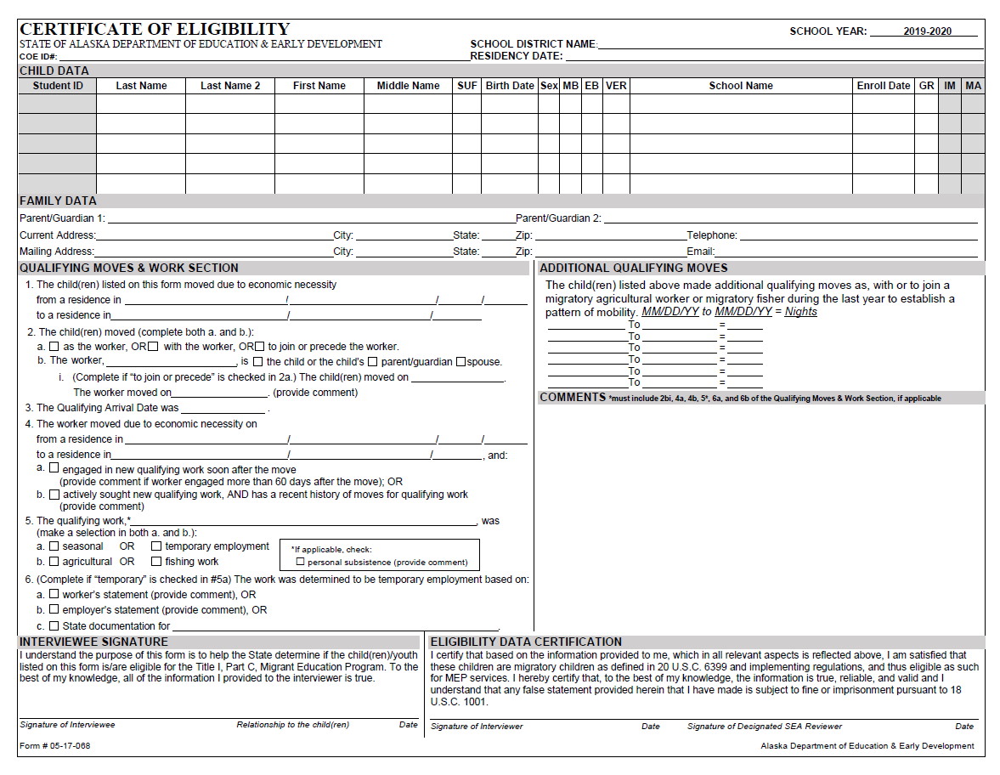

Certificate of Eligibility (COE) Guide
The following pages provide a step by step guide on how to fill out each of the required sections of a COE. Guidance provided is this handbook is aligned to the U.S. Department of Education’s National COE Instructions.
All attempts should be made to complete all data elements and sections of the COE. In cases where a response may not be required or does not apply, the recruiter must write a dash (-) or “N/A” in the appropriate blank unless instructed not to when completing a hard copy or electronic (PDF) COE. Do not write a dash (-) or “N/A” when inputting COEs into the Alaska Migrant Web System (ak.msedd.com) and MIS2000.
Use the following procedures when:
- a child is new to the MEP, or
- a child is already in the MEP and has made a new qualifying move since the last parent interview, or
- a child is already in the MEP and has moved into the recruiter’s district from another district or state.
Refer to page 123 for a flowchart regarding when to fill out a COE.

Top of COE

School District Name
Print the name of the school district (no abbreviations). Refer to page 128 for a list of school districts.

School Year
The current school year is preprinted on the upper right corner of the COE.

COE ID #
This number will be auto-generated for COEs created through the web system. For COEs not created in the web system, records managers will fill this space with the computer generated number from MIS2000. Do not record a dash in this field.

Residency Date
This is the date the family establishes or reestablishes residency in the recruiter’s district. Record the date, using two-digit numbers that refer to the month and day, and the last two digits of the year, (MM/DD/YY) that the child(ren) moved to (i.e., arrived in) the recruiter’s school district.
- If the child(ren) is eligible for the MEP based on a qualifying move prior to the move into the recruiter’s school district (i.e. the move into the recruiter’s district is not a qualifying move), the residency date will be later than the qualifying arrival date (QAD).
- If the child(ren) and the worker, make a permanent move together (at the same time) into the recruiter’s district, and that move is a qualifying move, then the Residency Date and the QAD will be the same.
- If the child(ren) moved prior to the worker’s move, the residency date would precede the QAD.
  - Note, although it is possible to record a residency date that precedes the QAD, a COE cannot be filled out and a child cannot be enrolled in the MEP until after the child and worker each make a qualifying move.

Child Data Section
Child data includes the name, birth date, sex, school enrollment information, and health information for each child listed on the COE. A recruiter should include all children with the same family and eligibility data on the same COE. If any of the family data or eligibility data is different (including different QAD, Residency Date, or Additional Qualifying Moves) the children should be documented on separate COEs.
Reminders:
- List all eligible children in the family who made the qualifying move from youngest to oldest with the youngest child at the top of the list.
- Include children whose ages were from birth up to age 20 at the time of the qualifying move (up to age 22 with an active IEP on file with the district).
- For COEs not created in the web system, if there are more than five children who made the qualifying move (and have all of the same family and eligibility data), list the additional children on a second COE. All sections of the second COE must be completed. Obtain all signatures on both copies of the COE and staple them together. All children will be listed under one COE ID# in MIS2000.
- Only children who have made the same move with the same worker should be listed on one COE. If some of the children in the family made qualifying moves to other locations or on different dates or with different workers, they should be listed on a separate COE.

Student ID
If a child is enrolled in a public school, the records manager can obtain the child’s Alaska Student ID (AKSID) from the district registrar. For children who have never been in an Alaska public school, MIS2000 will generate a place holder number. If a child’s Alaska Student ID is not known, leave this space blank. Do not enter any other number in this space, including school or district identification numbers. Do not record a dash in this field.

Last Name 1
Record the legal last name of each eligible child in the family. If the child has a multiple or hyphenated last name (e.g., Ramírez-García), record the first part of the name (i.e., Ramírez).

Last Name 2
If the child has a multiple or hyphenated last name (e.g., Ramírez-García), record the second part of the name (i.e., García). If the child has more than two last names, record the entire name in the correct order in the Comments Section.

First Name
Record the legal first name of each eligible child in the family. This is the name given to the child at birth, baptism, during another naming ceremony, or through a legal name change. Do not record nicknames or shortened names (e.g., Ale or Alex for Alejandra).

Middle Name
Record the legal middle name of each eligible child in the family. This is the secondary name given to the child at birth, baptism, or during another naming ceremony, or through a legal name change. Do not record nicknames or shortened names (e.g., Ale or Alex for Alejandra). It is now possible to fit multiple middle names in the Middle Name Field in the web system, but if there is insufficient space, only list the child’s first middle name only in the Middle Name field and include all middle names in the Comments section.

Suffix (SUF)
Where applicable, record the child’s generation in the family (e.g., Jr., Sr., III, 3rd).

Birth Date
Record the month, day and year the child was born. Use the two-digit number that refers to the month and day, and the last two digits of the year. For example, September 20, 2003, would be written as 09/20/03.

Sex
Record the child’s gender (sex).
Code | Gender (Sex)
M | Male
F | Female

Multiple Birth Flag (MB)
Record “Y” if the child is a twin, triplet, or other multiple births. Write “N” if the child is not a twin, triplet, etc.
Code | Multiple Birth (MB) Type
Y (Yes) | Twin, Triplet, or Other Multiple Birth
N (No) | Single Birth

Ethnic Breakdown (EB)
Ask the parent/guardian for the child’s ethnic background and enter only one EB code. Do not make assumptions. The district can choose to use previously verified PowerSchool records to get this information. However, the parents should always confirm it is correct.
Code | Race/Ethnic Breakdown (EB)
1 | White
2 | Black or African American
3 | Hispanic/Latino
4 | Asian
5 | American Indian
6 | Alaska Native
7 | Two or More Races
8 | Native Hawaiian or Other Pacific Islander

Birth Date Verification Code (VER)
Record the four digit code that corresponds to the evidence used to confirm each child’s birth date. If written evidence is not available, the interviewer may rely on the interviewee’s verbal statement. In such cases, the interviewer should record 1007 – the number that corresponds to parent’s affidavit. When creating the COE in the web system there a dropdown box listing the various VER types.
Code | Birth Date Verification (VER) Type
1003 | Baptismal or Church Certificate
1004 | Birth Certificate
1005 | Entry in Family Bible
1006 | Hospital Certificate
1007 | Parent’s Affidavit
1008 | Passport
1009 | Physician’s Certificate
1010 | Previously Verified School Records
1011 | State Issued ID
1012 | Driver’s License
1013 | Immigration Document
2382 | Life Insurance Policy
9999 | Other

School Name
Print the name of the school where the child is enrolled (no abbreviations). This field cannot be left blank. All children will have information recorded in this field. Migratory children can be:
- enrolled in a public school in the recruiter’s district,
- enrolled in a non-public school in a recruiter’s district,
- not enrolled in school,
- enrolled in a public school in another district, or
- enrolled in a non-public school in another district.
Refer to the School Name/Enroll Date/Grade Flowchart on page 133 for more detailed information on how to accurately complete this field.

Enroll Date
The first day of school the child attends after the most recent qualifying move. All children will have an enroll date with two exceptions:
- children who are too young to be enrolled in school (i.e. babies)
- children who have dropped out of school (i.e. out of school youth)
For more information on how to accurately complete this field, refer to the School Name/Enroll Date/Grade Flowchart on page 133.
The enroll date must be the same as, or after, the residency date. See the example below for how to record the information when a qualifying move interrupts the school year.
Example: A child started school at the beginning of the school year (08/20/19), but left due to a migrant move in September (09/09/19). When this mid-year migratory move is documented on the COE, the enroll date should be the date the child returned to school after the migratory move (09/16/19).

Grade (GR)
Enter the child’s current grade at the time the COE is completed. A grade must be listed for every child who is enrolled in a school program whether it is home school, private school, or in a school operated by the district. Children attending preschool programs will have PS reported for their grade. Children not yet attending any school are listed as grade 00. Children who were in school at some point, but are no longer attending are listed as grade OY.
Code | Grade (GR)
00 | Not Yet in School
PS | Preschool
K | Kindergarten
1 | First Grade
2 | Second Grade
3 | Third Grade
4 | Fourth Grade
5 | Fifth Grade
6 | Sixth Grade
7 | Seventh Grade
8 | Eighth Grade
9 | Ninth Grade
10 | Tenth Grade
11 | Eleventh Grade
12 | Twelfth Grade
OY | Out of School Youth

School Name/Enroll Date/Grade Scenarios
Below are examples of different scenarios showing how to fill out the School Name, Enroll Date, and Grade on the COE/ARC. A School Name/Enroll Date/Grade Flowchart of this information is available on page 133.

For Children Attending School in the Recruiter’s District
- Enrolled in a Public School in the Recruiter’s District
This scenario pertains to children from preschool to grade 12 enrolled in any public school operated by the recruiter’s district. This includes the recruiter’s district operated public schools, preschools, charter schools, and homeschools. This scenario does not include head start programs.
Example: You are a recruiter for Mat-Su School District. The child you are recruiting lives in Mat-Su School District and is enrolled at Palmer Middle School, a public school operated by the Mat-Su School District. The child is in the 7th grade and their first day of school after their most recent qualifying move for the current school year was 08/20/19.
SCHOOL NAME | ENROLL DATE | GR
PALMER MIDDLE SCHOOL | 08/20/19 | 7
Required Comment: None
- Enrolled in a Non-Public School in the Recruiter’s District
This scenario pertains to children from preschool to grade 12 enrolled in any non-public school located in the recruiter’s district. Non-public schools include head start programs, private schools, and homeschools (not operated by any public school district). The name of the school they attend must be recorded in the Comments Section.
Example: You are a recruiter for Mat-Su School District. The child you are recruiting is enrolled at Valley Christian School, a private school. The child is in the 3rd grade and their first day of school after their most recent qualifying move for the current school year was 08/21/19.
SCHOOL NAME | ENROLL DATE | GR
MAT-SU NON-PUBLIC SCHOOL | 08/21/19 | 3
Required Comment: The child is enrolled at Valley Christian School.

For Children Not Attending Any School
- Not Yet in School (Too young to enroll)
This scenario pertains to children/babies who are too young to enroll in school.
Example: You are a recruiter for Mat-Su School District. The child you are recruiting is too young to be enrolled in school, but went on the qualifying move.
SCHOOL NAME | ENROLL DATE | GR
MAT-SU SCHOOL DISTRICT | - | 00
Required Comment: None

- Not Enrolled in School (Out of School Youth)
This scenario pertains to children who were in school at some point, but are no longer attending. These children must not have a high school diploma. They can, however, possess a GED.
Example: You are a recruiter for the Mat-Su School District. The child you are recruiting has dropped out of school.
SCHOOL NAME | ENROLL DATE | GR
MAT-SU SCHOOL DISTRICT | - | OY
Required Comment: None

For Children Going to School in Another District
- Enrolled in a Public School Operated by Another District
This scenario pertains to children who are enrolled in a State of Alaska public school, including preschool and homeschools that are operated by any district other than the recruiter’s. The school district name and the name of the school the child is enrolled in must be recorded in the Comments Section.
Example: You are a recruiter for Mat-Su School District. The child you are recruiting resides in Mat-Su School District, but is enrolled at Mt. Edgecumbe High School, a public high school operated by Mt. Edgecumbe School District. The child is in the 10th grade and their first day of school after their most recent qualifying move for the current school year was 08/17/19.
SCHOOL NAME | ENROLL DATE | GR
ANOTHER DISTRICT: PUBLIC | 08/17/19 | 10
Required Comment: The child is enrolled in Mt. Edgecumbe School District and is attending Mt. Edgecumbe High School.
- Enrolled in a Non-Public School Located in Another District
This scenario pertains to children from preschool to grade 12 enrolled in any non-public school located in a district other than the recruiter’s. Non-public schools include, private schools, homeschools, headstarts, and preschools not operated by any public school district. The school the child is enrolled in must be recorded in the Comments Section.
Example: You are a recruiter for Mat-Su School District. The child you are recruiting is enrolled in CCS Learning, a preschool not operated by any school district. The child’s first day of preschool after their most recent qualifying move for the current school year was 08/19/19.
SCHOOL NAME | ENROLL DATE | GR
ANOTHER DISTRICT: NON-PUBLIC | 08/19/19 | PS
Required Comment: The child is enrolled in CCS Learning.

Immunization Records Flag (IM)
Record whether or not the district has immunization records on file (not necessarily in the migrant files) for each child listed on the COE.
The migrant program is not required to obtain copies of the child’s immunization records. This field does not indicate whether a child is immunized or which immunizations a child has received. This field only indicates that the district has the child’s immunization records on file.
Code | Definition
Y | Yes, the district has immunization records on file for the child.
N | No, the district does not have immunization records on file for the child.

It is anticipated that the district will not have immunization records on file for every migratory child enrolled in the district MEP, as children can potentially be enrolled from birth up to age 20. A response indicating the district does not have immunizations records on file is expected in many cases.
The IM Field’s purpose is to indicate whether Immunizations Records are available for the migratory child to help facilitate the child’s enrollment if they transfer to a new school, district, or state. Recruiters should not ask parents for immunizations information. This information will come from the district, and is the responsibility of the records manager to obtain. The records manager could potentially find this information in a student information system, such as PowerSchool, or in the child’s cumulative file.

Medical Alert Indicator (MA)
Record if the migratory child has a health condition or problem.
Code | Definition
C | The child has a chronic (long term) health problem. Chronic health problems last a long time, potentially for a lifetime, and often develop slowly over time.
A | The child has an acute (short term) health problem. Acute health problems are usually brief in duration and usually occur suddenly, or without warning.
N | None, the child does not have a health problem.

The MA field’s purpose is to ensure that migratory children receive appropriate health support. This information will come from the district, and is the responsibility of the records manager to obtain. The records manager could potentially find this information in a student information system such as PowerSchool, or in the child’s cumulative file.
Recruiters should not ask families if their child(ren) has a health condition. However, if the recruiter observes a health problem or the parent mentions a health problem for the child, the recruiter can record this information in their notes to discuss with the records manager. Specific medical conditions do not need to be recorded on the COE, nor is it necessary for the district MEP to keep specific documentation regarding any such conditions on file outside of the information required in the Medical Alert field.

Family Data Section
In this section of the COE, the recruiter will record the contact information for the child(ren) and name of the child(ren)’s parent(s)/guardian(s).

Parent/Guardian 1
Record the name of the individual (if any) currently responsible for the child(ren). Record this individual’s legal last name (or names) and legal first name, in that order.
- If the parent/guardian has two last names or a hyphenated last name, record the individual’s last name(s) as it legally exists.
- The term “parent/guardian” on this form and in other sections of these instructions includes a legal guardian or other person who is standing in the place of the parent (in loco parentis), such as a grandparent or stepparent with whom the child lives.
- If the child(ren)’s legal parent/guardian is different from the current parent/guardian, we recommend providing the name of the child(ren)’s legal parent/guardian in the Comments section.
- If there is no parent/guardian information disclosed, or if the child is responsible for his or her own welfare (e.g., emancipated youth), write a dash (-) or “N/A.”
- For children who move as the worker, parent/guardian information will be the person(s) currently responsible for the child.

Parent/Guardian 2
Record the name of the second individual (if any) currently responsible for the child(ren). Record this individual’s legal last name (or names) and legal first name in that order.
- If the parent/guardian has two last names or a hyphenated last name, record the individual’s last name(s) as it legally exists.
- The term “parent/guardian” on this form and in other sections of these instructions includes a legal guardian or other person who is standing in the place of the parent (in loco parentis), such as a grandparent or stepparent with whom the child lives.
- If the child(ren)’s legal parent/guardian is different from the current parent/guardian, we recommend providing the name of the child(ren)’s legal parent/guardian in the Comments section.
- If there is no parent/guardian information disclosed, or if the child is responsible for his or her own welfare (e.g., emancipated youth), write a dash (-) or “N/A.”
- For children who move as the worker, parent/guardian information will be the person(s) currently responsible for the child.

Current Address
Record the physical address, including the complete name of the street or road where the child(ren) currently resides.
- In cases where a formal physical address is not available, include as much other identifying information as possible (e.g., trailer number, rural route, migrant camp, or landmark).
- P.O. Box addresses are not considered physical addresses.

City
Record the name of the city or town where the child(ren) currently resides.

State
Record the postal abbreviation used by the U.S. Postal Service for the State where the child(ren) currently resides. Refer to State Abbreviations Key on page 127 for a list of states.

Zip
Record the five or nine-digit zip code where the child(ren) currently resides. The U.S. Postal Service has an online zip code directory service (zip4.usps.com/zip4/welcome.jsp).

Telephone
Record the telephone number, including area code, of the family. If the family does not have a telephone number, record a telephone number where a message can be left (not a district number).
- When the parent/guardian signs the COE, they agree to be contacted by the MEO as part of a federal requirement to review random COEs.

Mailing Address
Record the mailing address. The mailing address can be a P.O. Box address. Include the street name or P.O. Box number, city, state, and the five or nine-digit zip code.
- If the mailing address is the same as the physical address, write “same.”

City
Record the name of the city or town where the child(ren) currently resides.

State
Record the postal abbreviation used by the U.S. Postal Service for the State where the child(ren) currently resides. Refer to State Abbreviations Key on page 127 of the Appendix for a list of states.

Zip
Record the five or nine-digit zip code where the child(ren) currently resides. The U.S. Postal Service has an online zip code directory service (zip4.usps.com/zip4/welcome.jsp).

Email Address
Record the parent/guardian’s email address. This is an optional field.

Qualifying Moves & Work Section
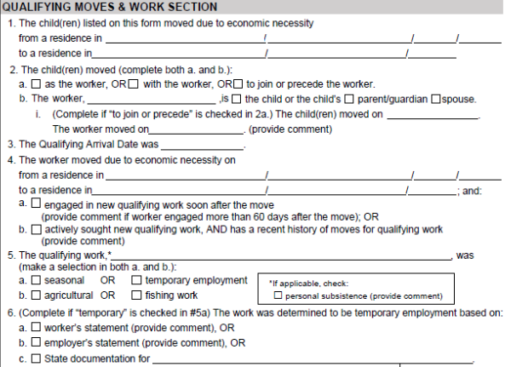
In this section, record the qualifying moves and qualifying work information, which documents the child’s eligibility for the program.
- Throughout this section, the term worker refers to the child’s parent/guardian or spouse who is a migratory agricultural worker or migratory fisher.
  - This term can also apply to a child who is at least 14 years of age, and meets the definitions of migratory agricultural worker or migratory fisher.
- The term qualifying work as used in this section refers to new temporary or seasonal employment (or personal subsistence) in agriculture or fishing.
- The qualifying moves documented in this section are the qualifying moves that meet the Migrant Education Program eligibility criteria.
  - Question 4 documents the move soon after which the worker engaged in new qualifying work (or after which he or she actively sought qualifying work), and question 1 documents the child(ren)’s move as, with, or to join the worker. Information described in question 1 and question 4 do not necessarily have to be the same.
No mistakes may be made in this section. Cross-outs, whiteout, or correction tape is not permitted.

The Child(ren) Moved Due to Economic Necessity
The Migrant Education Program is predicated on the fact that the moves a child and the migratory worker make, are made due to economic necessity. This is considered to mean that – the child and the worker (if the child is not the worker) moved because they could not afford to stay in the current location. It is the responsibility of the recruiter to verify that all moves described on the COE were made due to economic necessity.

From a Residence In
This location is the child(ren)’s last place of residency immediately prior to the qualifying move. Note that the child(ren) might have made subsequent non-qualifying moves.
- If the child and the worker moved from different previous residences, record the child’s prior residence in question 1, and record the worker’s prior residence in the Comments Section.

To a Residence In
This location is where the child(ren) resided immediately following the qualifying move as the worker, with, or to join, the worker. A qualifying move can never be made to a country outside of the United States. As mentioned previously, the child(ren) might have made subsequent non-qualifying moves.
In school districts which have an area more than 15,000 square miles:
- The child(ren) and migratory worker must have crossed school district boundaries, or have traveled a distance of 20 miles or more, one way, to a temporary residence.
- If the child(ren) migrated a distance of 20 miles or more, one way, to a temporary residence in a school district of more than 15,000 square miles, record the name of the school district where the child(ren) resided immediately prior to and immediately following the qualifying move, in order to identify this move as one that meets the 20 miles criterion.
  - If the child(ren) and the migratory worker live in different households, a second map will be required to document that the move for the migratory worker was at least 20 miles one way to a temporary residence within a district with an area more than 15,000 square mile district.
- Documentation of the migratory moves within a school district with an area more than 15,000 square miles must exist at the district office in the form of a map with a scale to verify the distance traveled to the temporary residence. The distance must be 20 miles or more, one way.
  - The map must have a scale for determining distance and must be attached to the COE. The interviewee will verify the route traveled on the map to ensure the validity of the migratory move.

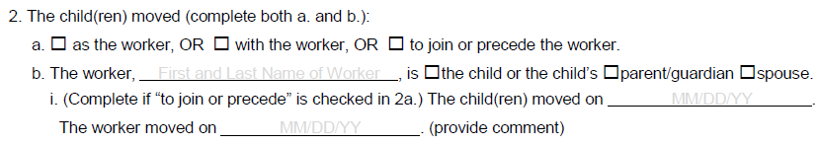

The Child(ren) Moved
This establishes how the child(ren) made the qualifying move listed in 1, whether that move was made as, with or to join a parent/guardian or spouse.

As, With, or To Join or Precede the Worker
Check one of the boxes indicating whether the child moved as the worker, with the worker, or to join or precede the worker.
- Mark the box as the worker if the child moved as the worker. A child must be at least 14 years old to be considered a worker.
- Mark the box with the worker if the child(ren) moved with (at the same time as) the worker.
- Mark the box to join or precede the worker if the child(ren) moved either before or after the date the worker moved. If this box is marked, also complete i under 2b. Note that the child(ren)’s move should occur within 12 months of the worker’s move.

The Worker
Record the first and last name (in that order) of the individual who is a migratory agricultural worker or migratory fisher (i.e., the child(ren)’s parent/guardian or spouse, or the child – if the child is at least 14 years of age, and meets the definition of migratory agricultural worker or migratory fisher).
Mark the box that indicates whether the worker is the child or the child(ren)’s relationship to the worker (i.e., parent/guardian or spouse).

To Join or Precede the Worker
If the worker moved separately from the child(ren):
- Record the date that the child(ren) moved to the school district listed in question 1.
- Record the date the worker moved to the school district listed in question 1.
- Record the reason for the different move dates, and whether the worker moved from a different location than the child(ren), in the Comments section.
- Only complete the data fields in 2bi if the box “to join or precede the worker” is checked in 2a.

Qualifying Arrival Date
Record the Qualifying Arrival Date (QAD), using two-digit numbers to refer to the month and day, and the last two digits of the year. For example, May 20, 2019, would be written as 05/20/19.
The QAD is the date that both the child and worker completed the qualifying move, due to economic necessity, to the school district listed in question 1.
- The child must have moved due to economic necessity as a worker, or with or to join a parent/guardian or spouse who is a migratory agricultural worker or migratory fisher.
- As referenced in question 2a, the child and worker will not always move together, in which case the QAD would be
  - the date the child joins the worker who has already moved, or
  - the date the worker joins the child who has already moved.
The QAD is the date that the child’s eligibility for the MEP begins. The QAD is not affected by subsequent non-qualifying moves. For more information on determining the QAD, see the chart below.
Type of Qualifying Move | Qualifying Arrival Date (QAD) – Eligibility Begins
The child moved with the worker. | The QAD is the date the child and worker both arrived.
The child moved before the worker moved. | The QAD is the date the worker arrived where the child was residing.
The child moved to join the worker after the worker moved. | The QAD is the date the child arrived to join the worker.

Qualifying Move vs. Qualifying Arrival Date

Qualifying Move
- Due to economic necessity
- One residence to another
- From one school district to another, with specific exceptions
  - For single-district States, must be from one administrative area to another
  - For districts over 15,000 square miles, must be a move of 20 miles or more one way to a temporary residence
- Must be at least 1 night/2 days with a total of 7 nights/8 days within a one year period

Qualifying Arrival Date
- Date that begins migratory child’s 36 months of eligibility
- The date that the child moves as a migratory agricultural worker or migratory fisher, or (if the child was not the migratory worker) the date that the child moves with, or to join, a parent/guardian or spouse that meets the definition of migratory agricultural worker or migratory fisher
- If the child and the worker moved together:
  - QAD = date they both arrived
- If the child moved before the worker:
  - QAD = date that the worker arrived
- If the worker moved before the child:
  - QAD = date the child arrived

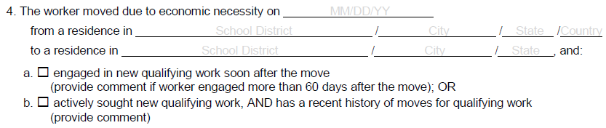

The Worker Moved Due to Economic Necessity
This is the move that establishes the individual listed in 2b as a migratory agricultural worker or migratory fisher. The information listed in the following fields can be different from the information listed in question 1.
The Migrant Education Program is predicated on the fact that the moves a child and the migratory worker make, are made due to economic necessity. This is considered to mean that – the child and the worker (if the child is not the worker) move because they could not afford to stay in the current location. It is the responsibility of the recruiter to verify that all moves described on the COE were made due to economic necessity.

Moved On
Record the date the worker moved to engage in the migratory work.

From a Residence In
This location is the migratory worker’s last place of residency immediately prior to the qualifying move where they engaged in new qualifying work soon after the move.⁵² Note that the migratory worker might have made subsequent non-qualifying moves.

To a Residence In
This location is where the migratory worker resided immediately after the qualifying move. The worker engaged in new qualifying work soon after the move in this location. A qualifying move can never be made to a country outside of the United States. As mentioned previously, the migratory worker might have made subsequent non-qualifying moves.

In school districts which have an area greater than 15,000 square miles:
- The migratory worker must have crossed school district boundaries or have traveled a distance of 20 miles or more one way to a temporary residence.
- If the worker migrated a distance of 20 miles or more one way to a temporary residence in a school district of more than 15,000 square miles, record the name of the school district where the worker resided immediately prior to and immediately following the qualifying move, in order to identify this move as one that meets the 20 miles criterion.
- Documentation of the migratory moves within a school district with an area more than 15,000 square miles must exist at the district office in the form of a map with a scale to verify the distance traveled to the temporary residence. The distance must be 20 miles or more, one way.
  - The map must have a scale for determining distance and must be attached to the COE. The interviewee will verify the route traveled on the map to ensure the validity of the move in #4.

Engaged In New Qualifying Work Soon After the Move
Mark box a. if the individual listed as the worker in question 2b moved due to economic necessity from a residence in one school district to another, and, soon after doing so, engaged in new temporary or seasonal employment (or personal subsistence) in agriculture or fishing.
- Explain in the Comments Section if the worker is determined to be a migratory agricultural worker or migratory fisher based on his or her engagement in new qualifying work more than 60 days after the qualifying move described in question 4.
  - Please note that the majority of COEs with 4a marked will not require a comment. A comment is only required for 4a if the worker engaged in new qualifying work more than 60 days after the move.

Actively Sought New Qualifying Work, AND has a Recent History of Moves for Qualifying Work
Mark box b. if the individual listed as the worker in question 2b, moved due to economic necessity from a residence in one school district to another and actively sought new qualifying work before or after the qualifying move described in question 4, and has a recent history of moves for qualifying work.
- Explain in the Comments Section how and when the worker actively sought new qualifying work. For example, the individual stated that he or she (or someone on his or her behalf) applied for qualifying work at a particular agricultural or fishing job site, or applied at a center that coordinates available qualifying work.
- Explain in the Comments Section the worker’s recent history. For example, the recruiter could write, “worker moved from Brownsville, Texas, to Decatur, Michigan, and planted tomatoes in May 2017, and moved from Decatur, Michigan to Presque Isle, ME, and picked potatoes in October 2017.”

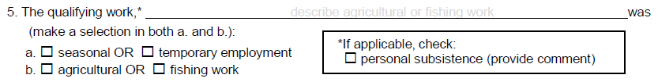

Qualifying Work
The qualifying work described here, relates to the move made for economic necessity in question 4, which establishes an individual as a migratory agricultural worker or migratory fisher.

Gear and Activity
When describing the specific agricultural and fishing work, the recruiter will use an action verb (example: beach seining) from one of the A lists and a noun (example: salmon) from one of the B lists starting on page 57.
- Only one activity and one catch/crop can be listed.
- When more than one qualifying activity occurs during the move, record the activity and catch that were engaged in for the most part during the trip in this field. All other activities and catches will be noted in the Comments Section.

Seasonal or Temporary
- Mark the box for seasonal employment if the employment occurs only during a certain period of the year because of the cycles of nature and that, by its nature, may not be continuous or carried on throughout the year.
- Mark the box for temporary employment if the employment lasts for a limited period of time, usually a few months, but not longer than 12 months. It typically includes employment where the worker states that they do not intend to remain in that employment indefinitely, the employer states that the worker was hired for a limited time frame, or the state has determined on some other reasonable basis that the employment is temporary.

Agricultural or Fishing Work
- Mark the box for agricultural work if the work involves the production or initial processing of raw agricultural products such as crops, poultry, or livestock, dairy work, as well as the cultivation or harvesting of trees. The work may be performed either for wages or personal subsistence.
- Mark the box for fishing work if the work involves the catching or initial processing of fish or shellfish or the raising or harvesting of fish or shellfish at fish farms. The work may be performed either for wages or personal subsistence.
- If more than one type of work is performed during the move listed in question 4, choose the type of work (fishing or agriculture) that the worker was engaged in for the most part. Record the other work type in the Comments section.

Personal Subsistence
- Mark the box for personal subsistence if the worker and the worker’s family, as a matter of economic necessity, consume, as a substantial portion of their food intake, the crops, dairy products, or livestock they produce or the fish they catch. A comment in the family’s own words must be provided in the Comments section to document this.

Commercial Fishing Terms
Qualifying activities are those required for the catching or initial processing of fish or shellfish for commercial sale. During the interview, use these lists of commercial fishing terms to show (A) the type of commercial fishing gear or processing activity and (B) the type of catch that describe what the migratory worker engaged in during the qualifying move described in question 4 of the Qualifying Moves & Work Section. The qualifying work description in the Qualifying Moves & Work Section (page 56) on the COE must match terms from boxes A and B.
Examples:
- Drift Net, Salmon
- Freezing, Halibut

A – Commercial Fishing Gear or Processing Activity

Beach Seining
Boxing Line Worker
Canning
Cold Storage Worker
Digging
Dinglebar
Dip Netting
Diving
Dragging
Dredging
Glazing
Drift Net
Farming
Fish Wheel
Freezing
Gillnetting
Halibut Cheeking
Hand Picking
Hand Trolling
Jigging
Laying Skates
Line Worker
Loading Dock Worker
Longlining
Packing Eggs (Roe)
Pots
Pound
Power Trolling
Preparation for Shipping
Purse Seining
Set Net
Scow
Shoveling
Smoking
Spotting
Sunken Net
Tendering
Trawling
Unload and Sort

AND

B – Type of Commercial Catch

Abalone
Arctic Cisco
Atka Mackerel
Clams
Crab
Flounder
Geoduck
Halibut
Herring
Herring Eggs
Hooligan - Smelt
Lingcod
Mussels
Octopus
Oysters
Pacific Cod
Pollock
Rockfish (Redfish)
Sablefish
Salmon
Scallops
Sea Cucumber
Sea Urchins
Shrimp
Sole
Squid
Turbot

Only one activity and one catch can be listed in the Qualifying Moves & Work Section.
When more than one qualifying activity occurs during the move, record the activity and catch that the migratory worker engaged in the most during the trip listed in question 4 of the Qualifying Moves & Work Section. All other activities and catches will be noted in the Comments Section.
When completing the COE in the web system the terms will be hyphenated with the word commercial.
Example: Drift Net-Commercial, Salmon-Commercial

Subsistence Fishing Terms
Qualifying activities are those required for the catching or initial processing of fish or shellfish for personal subsistence. During the interview, use these lists of subsistence fishing terms to show (A) the type of subsistence fishing gear or processing activity and (B) the type of catch that describes what the migratory worker engaged in during the qualifying move described in question 4 of the Qualifying Moves & Work Section. The qualifying work description in the Qualifying Moves & Work Section (page 56) on the COE must match terms from boxes A and B.
Examples:
- Set Net, Whitefish
- Smoking, Salmon

A – Subsistence Fishing Gear or Processing Activity

Beach Seining
Canning
Curing
Cutting
Digging
Dip Netting
Diving
Dragging
Drift Net
Drying
Fish Trapping
Fish Wheel
Freezing
Gillnetting
Hand Picking
Hand Trolling
Jigging
Laying Skates
Longlining
Pots
Pole
Purse Seining
Rendering
Set Line
Set Net
Spear
Smoking
Storing
Tendering
Power Trolling

AND

B – Type of Subsistence Catch

Abalone
Atka Mackerel
Arctic Char
Arctic Cisco
Arctic Grayling
Arctic Lampreys
Bering Cisco
Black Fish
Burbot
Clams
Crab
Dolly Varden
Flounder
Geoduck
Gumboot Chilton
Halibut
Herring
Herring Eggs
Hooligan
Lingcod
Longnose Sucker
Mussels
Oysters
Pacific Cod
Pike
Pollock
Rockfish (Redfish)
Salmon
Sablefish
Scallops
Sheefish
Shrimp
Smelt
Stickleback
Trout
Whitefish

Only one activity and one catch can be listed in the Qualifying Moves & Work Section.
When more than one qualifying activity occurs during the move, record the activity and catch that were the primary purpose of the trip in the Qualifying Moves & Work Section. All other activities and catches will be noted in the Comments Section.
When completing the COE in the web system the terms will be hyphenated with the word subsistence.
Example: Set Net-Subsistence, Whitefish-Subsistence

Agriculture/Logging Terms
Qualifying activities for logging are those required for the cultivation and harvesting of trees. A comment must be provided on all agricultural COEs providing a detailed description/explanation of the type of work/job duties performed, and a comment indicating if immediate or extended family members own the land the qualifying work took place on.
During the interview, use the list of logging terms to show the activity that describes the qualifying work. The qualifying work description (question 5 in the Qualifying Moves & Work Section on page 56) must match one of the activities listed below. List the name of the logging company on the COE after the activity performed.
Example: Log Chasing, Kake Tribal

Logging Activities

Boom Boat Operator
Boom Manning
Booming
Bucking
Bull Bucking
Bushing
Choke Setting
Creek Clearing
Cutting
Falling
Front End Loader
Grapple Yarder Operator
Hook Tending
Log Banding
Log Chasing
Log Loader Operating
Log Scaling
Log Towing
Planting Seedlings
Rigging Slinger
Side Rodding
Skidder Operating
Soil Preparing
Tending Seedlings
Tree Thinning
Marking
Shifting
Shovel Operator

Loggers frequently perform multiple activities during one season. List the company and activity that shows what the worker did the majority of the time.
Only one activity and one company can be listed in the Qualifying Moves & Work Section.
When more than one qualifying activity occurs during the move, record the activity and company that the migratory worker engaged in the most during the trip listed in question 4 of the Qualifying Moves & Work Section. All other activities and companies will be noted in the Comments Section.

Agriculture/Crop Terms
Qualifying activities are those required for the production, harvesting, and initial processing of agriculture products such as grains, fruits and vegetables. A comment must be provided on all agricultural COEs providing a detailed description/explanation of the type of work/job duties performed, and a comment indicating if immediate or extended family members own the land the qualifying work took place on.
During the interview, use these lists of agriculture/crops terms to show (A) the type of crop work or processing activity and (B) the type of crop that describes the qualifying work engaged in during the qualifying move described in question 4 of the Qualifying Moves & Work Section. The qualifying work description in the Qualifying Moves & Work Section (page 56) on the COE must match terms from boxes A and B.
Example: Cooking and Preserving, Corn

A – Crop Work or Processing Activity

Applying Herbicides
Applying Insecticides
Breaking/Tilling Soil
Canning and Labeling
Cooking and Preserving
Cultivating/Plowing
Cutting
Digging
Fertilizing
Freezing
Growing
Harvesting
Hoeing
Irrigating
Loading
Packaging
Picking
Planting
Preparing Land
Pruning
Thinning
Washing and Sorting
Watering
Weeding

AND

B – Type of Crop

Apples
Barley
Berries
Cherries
Corn
Hay
Mushrooms
Oranges
Pine Cone Seeds
Potatoes
Tobacco
Vegetables
Wheat

Only one activity and one crop can be listed in the Qualifying Moves & Work Section.
When more than one qualifying activity occurs during the move, record the activity and crop that the migratory worker engaged in the most during the trip listed in question 4 of the Qualifying Moves & Work Section. All other activities and crops will be noted in the Comments Section.
When completing the COE in the web system the terms will be hyphenated with the word subsistence or commercial.
Example: Picking-Subsistence, Berries-Subsistence

Agriculture/Livestock Terms
Qualifying activities are those required for the production or initial processing of livestock. A comment must be provided on all agricultural COEs providing a detailed description/explanation of the type of work/job duties performed, and a comment indicating if immediate or extended family members owns the land the qualifying work took place on.
During the interview, use these lists of agriculture/livestock terms to show (A) the type of livestock work or processing activity and (B) the type of livestock that describes the qualifying work engaged in on the qualifying move described in question 4 of the Qualifying Moves & Work Section. The qualifying work description in the Qualifying Moves & Work Section (page 56) on the COE must match terms from boxes A and B.
Example: Loading and Unloading Livestock, Reindeer

A – Livestock Work or Processing Activity

Branding/Tagging
Cleaning Animals, Stalls, Barns, etc.
Cleaning, Maintaining Area & Equip.
Feeding, Watering and Tending
Fencing/Building & Repairing Fences
Labeling
Loading and Unloading Livestock
Packaging
Slaughtering
Weighing
Preparing for Transport to Processor

AND

B – Type of Livestock

Cattle
Horses
Reindeer

Only one activity and one livestock can be listed in the Qualifying Moves & Work Section.
When more than one qualifying activity occurs during the move, record the activity and livestock that the migratory worker engaged in the most during the trip listed in question 4 of the Qualifying Moves & Work Section. All other activities and livestock will be noted in the Comments Section.

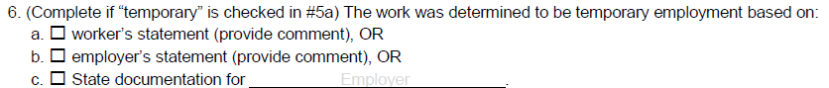

Worker’s Statement, Employer’s Statement, and State Determinations
If temporary was selected in box 5a, one of the following must be checked.

Worker’s Statement
Mark box a. if the work was determined to be temporary employment based on a statement by the worker or the worker’s family, if the worker is unavailable (provide comment). For example, the worker states that he or she only plans to remain at the job for a few months. Provide explanatory comments in Comments section.

Employer’s Statement
Mark box b. if the work was determined to be temporary employment based on a statement by the employer or documentation obtained from the employer. For example, the employer states that he or she hired the worker for a specific time period (e.g., 3 months) or until a specific task is completed and the work is not one of a series of activities that is typical of permanent employment. Provide explanatory comments in Comments section.

Verification of State Documentation
Mark box c. upon verification that the State has current documentation to support that the work described in question 5 is temporary employment for this particular employer.
- Employer – identify the employer, whether it is the name of or code for a farmer, a grower, a business, or a corporation, where the worker engaged in qualifying work.

Additional Qualifying Moves Section
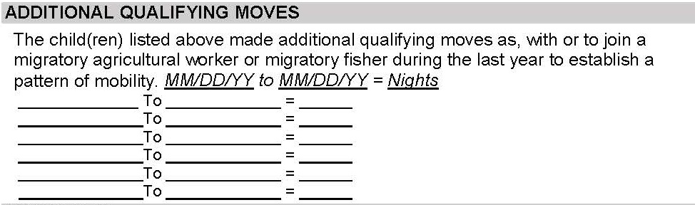
This box documents any additional qualifying moves the child(ren) made, within the previous 12 month period, as, with or to join a migratory agricultural worker or migratory fisher. The additional qualifying moves listed in this box along with the moves established in the Qualifying Moves & Work Section help to document a pattern of mobility.
Use this box only if the child(ren) made additional qualifying moves which are not listed in the Qualifying Moves & Work Section. List the dates of the other qualifying moves within the past year on the lines provided. The additional qualifying moves should be listed in descending chronological order (more recent moves at the top of the list and oldest moves at the bottom of the list).
All qualifying moves made during the previous one-year period should be listed on the form including:
- any moves that were made during the school year which interrupted the child’s education, and
- any moves made during the summer.
Moves should be listed using the two digit month, day, and year to describe the qualifying move dates. The dates are described as MM/DD/YY to MM/DD/YY. The total number of nights each additional qualifying move encompasses should be listed on the line as a whole number. If there are more additional qualifying moves in a one-year period than can fit on the lines provided, please record these additional qualifying moves in the Comments section.
Comments should be provided regarding additional qualifying moves if the additional qualifying move is at all different from the qualifying moves listed in the Qualifying Moves & Work Section. Comments should indicate differences in location, activity, catch/crop/livestock, and migratory work as applicable. Information should be included so that an independent reviewer, without prior knowledge, can understand why the eligibility determination has been made.
Please note, if the migratory worker made additional qualifying moves separately (from the child(ren) listed on the form) to engage in new qualifying work to establish them as migratory agricultural worker or migratory fisher, this information will be documented solely in the Comments section, not as a part of the Additional Qualifying Moves Section.

Comments Section
The Comments Section of the COE allows the recruiter to provide required comments, as well as any additional information or details that clarify the reasons for the recruiter’s eligibility determination. The recruiter should write clear and detailed comments so an independent party who has no prior knowledge of the eligibility determination can understand the recruiter’s reasoning for determining that the child may be eligible. Comments must be completed with the recruiter’s initials and date the interview took place. If comments are added after initial interview, those comments will need to be initialed and dated as well.
A COE comments menu is available starting on page 131.

Required Comments
The recruiter must provide comments that clearly explain items 2bi, 4a, 4b, 5*, 6a, or 6b of the Qualifying Moves & Work Section of the COE, if applicable.
2bi: The child(ren) and worker moved separately. If the child(ren) joined or preceded the worker, record the reason for the child’s later move or the worker’s later move. If the worker moved from a different school district than the child(ren), record the name of the school district in which in the worker resided immediately prior to the move.
4a: The worker engaged in new qualifying work more than 60 days after the qualifying move. Explain why worker is determined to be a migratory worker based on his or her engagement in new qualifying work more than 60 days after the qualifying move described in question 4 of the Qualifying Moves and Work Section.
4b: The worker did not engage in new qualifying work soon after the qualifying move. In this case, the recruiter must document that:
- The worker actively sought new qualifying work; and
- The worker has a recent history of moves for qualifying work
5*: The worker is a migratory agricultural worker or migratory fisher on the basis of personal subsistence, meaning that the worker and the worker’s family, as a matter of economic necessity, consume, as a substantial portion of their food intake, the crops, dairy products, or livestock they produce or the fish they catch.
6a or 6b: The employment is temporary based on the worker’s statement or the employer’s statement. In particular, record the information provided by the worker or employer regarding how long they expect the employment to last. The comment should be of sufficient length to adequately document how the recruiter came to the eligibility decision.

Additional Comments Required for Various COE Scenarios
- Additional Qualifying Moves – If the moves listed in the Qualifying Moves & Work section on the COE do not have enough nights to qualify, and additional qualifying nights were listed, a comment must be provided in the Comments section (unless all eligibility information is exactly the same). This comment should include any differences in locations of the additional qualifying moves, qualifying work, or migratory worker, as applicable. If there are more additional qualifying moves than spaces available on the COE, a comment is required detailing those additional qualifying move(s).
- Agricultural Moves – A comment must be provided on all agricultural COEs specifying whether or not immediate or extended family members own the land the qualifying work took place on.
- Child As the Worker Move – If an eligible migratory child, who is over the age of 14 makes a qualifying move as the migratory agricultural worker or migratory fisher, the move must directly support the child’s primary household and be an economic necessity for the family. Information to reflect this must be added in the Comments Section.
- Extended Move (30 Day Comment) – If the Residency Date is more than 30 days from the Qualifying Arrival Date on the COE, a comment is required to verify the actual dates the migratory worker was engaged in qualifying work. This comment ensures the migratory worker was engaged in the qualifying work for at least seven nights/eight days.
- IEP – If a child is 20 years of age or older and has an active IEP on file, a comment is required.
  - Due to confidentiality in Special Education, recruiters should not directly ask parents about IEPs. This comment may be provided by the records manager. If the parents volunteer Special Education status, it can be noted on the COE.
- Migratory Worker (Guardian)/Different Household – The migratory worker does not live in the household with the migratory child. Record the physical address and phone number of the migratory worker in the Comments Section, including the city and state. P.O. Box addresses are not considered physical addresses. Record the worker’s relationship to the child(ren) listed on the COE in the Comments Section.
  - If the qualifying work was for personal subsistence and the worker does not live with the child, the recruiter must verify and provide a statement in the Comments Section that the move and personal subsistence directly supports both the child’s primary household, and the worker’s household.
- Migratory Worker Residency Date – If the migratory agricultural worker or migratory fisher’s residency date is different than the child’s (i.e. the move listed in question 1 is different than the move listed in question 4), this date should be listed in the Comments Section. The migratory agricultural worker or migratory fisher must be engaged in qualifying work for at least seven nights/eight days in a one year period.
- Moves within Districts with and Areas Greater than 15,000 Square Miles (Map Comment) – A comment is required to document that the moves were at least 20 miles or more one way to a temporary residence when the moves are within a 15K+ district. This comment lets the reviewer know that a map with a scale is attached and the distance has been verified by the recruiter using a district map.
  - If the guardian of the migratory move lives in a different location than the child, a separate map with a scale for both the child and the guardian must be attached to original COE and a map comment for both the child and guardian must be provided.
  - If the move listed in question 4 of the Qualifying Moves & Work Section of the COE is different from the move listed in question 1, and takes places in a 15K+ district, the map should document the move from question 4. It is also possible in this scenario that a different map would be required to document the move in question 1.
  - If additional moves occur within a 15K+ district, a map with a scale is required.
- Multiple Middle Names – If a child on the COE has multiple middle names and the full name does not fit in the Child Data Section of the COE, please list the child’s full name in the Comments Section.
- Multiple Migratory Workers – When a migratory child makes multiple qualifying moves within a one-year period and the qualifying moves are made with different migratory workers, a comment is required to verify that each migratory worker has engaged in migratory work for seven nights/eight days within a one-year period.
- Not Attending Public School Operated by Recruiting District – If a child on the COE is not enrolled in a public school operated by the recruiter’s district, list the name of the school the child is attending in the Comments section.
  - If a child is attending a public school operated by another school district, also list the public school district in the Comments Section. For more information regarding school names and required comments, refer to the School Names, Enroll Dates, and Grades section starting on page 45.
  - If a child is attending a non-public school in a district other than the recruiting district, list the name of the school in the Comments section. For more information regarding school names and required comments, refer to the School Names, Enroll Dates, and Grades section starting on page 45.
- Permanent Move – If a migratory child makes a permanent move into the recruiter’s district, and that move is a qualifying move, the Residency Date and QAD will be the date they made the permanent move into the recruiter’s district. A comment is required to verify the actual dates the migratory worker engaged in the qualifying work described in questions 4 and 5. It is recommended that the recruiter provide additional comments on the COE when there are any other circumstances whereby a third party may question the eligibility determination.
  - If the permanent move into the recruiter’s district was not a qualifying move (i.e. not made due to economic necessity, or not made as, with, or to join a migratory worker), the Residency Date will be later than the QAD. A comment is required to verify the actual dates the migratory worker engaged in the qualifying work described in questions 4 and 5.
- Pole Fishing – A comment is required verifying that the pole was not used for either sport or recreation.
- Unique Situations – The Migrant Education Program is predicated on the fact that the moves a child and the migratory worker make, are made due to economic necessity. This is considered to mean that – the child and the worker (if the child is not the worker) move because they could not afford to stay in the current location. If the basis of the initial eligibility decision would not be obvious to an independent third party reviewer, the recruiter should add additional explanatory information to the Comments Section to attest to the economic necessity of the moves described on the COE.

Recommended Comments
The MEO recommends that the recruiter provide additional comments on the COE in the following circumstances and in any other circumstances in which a third party may question the eligibility determination:
- The information on the COE needs additional explanation to be clearly understood by an independent outside reviewer.
- The basis for the preliminary eligibility determination is not obvious. For example, the work is unusual enough that an independent reviewer is unlikely to understand that it is qualifying work. An explanation is needed to enable a reviewer to understand how the preliminary eligibility determination was made.
- The work could be part of a "series of activities" that, viewed together, would constitute year-round employment (e.g., mending fences on a dairy farm and bailing hay could be two parts of year-round ranching with one employer).
- The work may be viewed by an independent reviewer as either temporary or year-round employment (e.g., collecting eggs or milking cows).
- A "move" is of such brief duration that one could question whether it was a move from one residence to another residence, due to economic necessity.
- The person who provided the information on the COE form (interviewee) is not the parent/guardian of the child or the worker listed on the COE.
- The child(ren)’s legal parent/guardian(s) differ from the current parent/guardian(s) listed.
- Any children living in the household who did not go on the move.
- Any children on a separate COE/ARC due to different move dates, etc.

A Reminder Regarding Economic Necessity
Though the recruiter is not required to record an economic necessity statement for the moves listed on the COE in the Comments Section, the recruiter must verify that all of the information listed on the COE is correct and that both the child’s and the migratory worker’s moves were made due to economic necessity.
The recruiter should write clear and detailed comments so an independent party who has no prior knowledge of the eligibility determination can understand the recruiter’s reasoning for determining that the child may be eligible. When in doubt, the recruiter should add information to the COE to ensure the economic necessity of the moves is clear and that it is sufficiently documented.

Interviewee Signature Section
The interviewee signs and dates the COE on the day the interview is conducted and COE is completed. The interviewee must also write his or her relationship to the child.
The Migrant Education Program is predicated on the fact that the moves a child and the migratory worker make, are made due to economic necessity. This is considered to mean that – the child and the worker (if the child is not the worker) move because they could not afford to stay in the current location. By signing the COE the interviewee is attesting that the qualifying moves described on the COE were made due to economic necessity.

Interviewee Signature Language
I understand the purpose of this form is to help the State determine if the child(ren)/youth listed on this form is/are eligible for the Title I, Part C, Migrant Education Program. To the best of my knowledge, all of the information I provided to the interviewer is true.

Signature
This signature is required for a child to be enrolled in the MEP. It is required on all New Student/New Move COEs. Signatures do not have to be original. They can be faxed or scanned, as long as the quality of the signatures on the COE are clear. The person who signs the COE must be the source of the information contained in the document and should verify any information provided by another source.
After the parent, or the person interviewed, reviews the COE and certifies it for accuracy, he/she signs indicating all of the information is true to the best of his/her knowledge. Parents and/or migratory workers certify the truth of economic necessity by signing the COE. Without this verification, the child will not be enrolled in the MEP. Furthermore, their signature on a COE also certifies that a parent/guardian is willing to talk to the MEO, should they be contacted.

Relationship
The person who is interviewed records his/her relationship to the child(ren).

Date
The person who is interviewed records the date on which he/she signed the form.

Eligibility Data Certification Section
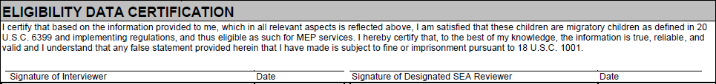
The Migrant Education Program is predicated on the fact that the moves a child and the migratory worker make, are made due to economic necessity. This is considered to mean that – the child and the worker (if the child is not the worker) move because they could not afford to stay in the current location. By signing the COE the interviewer and designated SEA reviewer are attesting that the qualifying moves described in the COE were made due to economic necessity.

Eligibility Data Certification Language
I certify that based on the information provided to me, which in all relevant aspects is reflected above, I am satisfied that these children are migratory children as defined in 20 U.S.C. 6399 and implementing regulations, and thus eligible as such for MEP services. I hereby certify that, to the best of my knowledge, the information is true, reliable, and valid and I understand that any false statement provided herein that I have made is subject to fine or imprisonment pursuant to 18 U.S.C. 1001.

Signature of Interviewer
After completing the interview and entering all necessary information on the COE, the interviewer should review the COE for completeness and accuracy. The interviewer signature is required on all COEs.
- The Interviewee should always sign and verify information on the COE before the interviewer and designated SEA reviewer sign. There will be situations where the interviewer is unable to sign the same day as the interview because the interviewee has not yet signed the COE. In this case, the interviewer should submit the COE to the parent to sign first, then it should be signed by the interviewer and dated when the COE is returned.
- By signing the COE, the interviewer does not guarantee eligibility.
- A final determination will be made by the MEO, conveyed to records managers, and then passed on to the family.
- Recruiters cannot interview, or sign for, their own family.

Signature of Designated SEA Reviewer
At least one designated SEA reviewer must check each completed COE to ensure that the written documentation is sufficient and that, based on the recorded data, the children on the form are eligible for MEP services. A designated SEA reviewer must sign and date the COE on the day it was reviewed.

Date
Record the date on which the COE was reviewed and signed.

Important Reminders About COEs

QAD/Residency Date/Enroll Date
In most cases, this is the order of the three most important dates on the COE:
- QAD – the date that the child and migratory agricultural worker complete the moves to be together. This often, but not always, happens at the location where the migratory worker is engaged in qualifying work.
- Residency Date – the date when the child comes back to, or establishes residency in, the recruiter’s district. Generally the return date of the trip.
- Enroll Date – the first day the child attends school after the qualifying move for the current school year. This is often different than the first day of school they attended for the year.
If a migratory child is making a permanent move to the recruiter’s district, the dates could potentially all be the same. For questions about the order of dates, please contact the MEO.

Enrolling Transfer Children
All potentially eligible migratory children that have transferred/permanently moved into the recruiter’s district should be interviewed. If the children are currently certified as migrant from another school district an interview and new COE will still need to be completed.
While the child(ren) need to make a qualifying move, they do not need to go on the move that qualifies the parent/guardian/spouse as a migratory agricultural worker or migratory fisher. If the permanent move to the school district was done for economic necessity and the move was conducted with a parent/guardian/spouse who is a migratory agricultural worker or migratory fisher then that move could qualify the child(ren) for MEP.

COE Corrections

Qualifying Moves & Work Section Corrections:
- No corrections may be made in this section of the COE.
- Recruiters often find it helpful to start the COE with the Qualifying Moves & Work Section, since no errors are accepted in this section. Any mistakes made require rewriting the entire form and new signatures need to be obtained. Cross-out, whiteout, and correction tape are not permitted.

Corrections on all other sections of the COE:
- Draw a single line through the incorrect information. The original text should still be readable. To distinguish corrections from the original text easily, use blue ink if the original was written in black or black ink if the original was written in blue. Do not use whiteout or correction tape.
- If additional information is added to a newly written COE by the recruiter or records manager, the correct information should be initialed and dated by the person making the change.
- The source of the correct information should be indicated in the Comments Section.

Additional Information
It may be helpful to fill out a draft of the COE, or another form designed by the district, when collecting information from the parents. Once all the information is collected and the child appears to meet the eligibility requirements, transfer the information onto an official COE. The interviewee must sign the official COE form after it is completed. When using the electronic COE, the recruiter must print the COE to obtain the signatures. If utilizing the Alaska Migrant Web System (ak.msedd.com) to complete the COE, the COE must be printed and interviewee and interviewer signatures obtained prior to submission of the COE to MIS2000.

Annual Recertification of No New Moves (ARC)

About the ARC
Alaska’s migratory children are identified and recruited by trained migrant education staff at each school district. This form is used when eligible migratory children have not made any additional qualifying moves since their last certification, but they are still currently eligible for the MEP. An Annual Recertification of No New Moves recertifies a child’s eligibility in the recruiter’s district. Detailed instructions for completing an ARC are found starting on page 73. A copy of the ARC form is available on page 72.

The Annual Recertification of No New Moves (ARC) Form – Hard Copy
- The ARC prints on an 8.5 x 11 form. It is a one page form. Districts are responsible for printing their own forms.
- A hard copy of the signed ARC must be kept in the migratory children files for 10 years.
- A copy should be offered to the family for their records.

The Annual Recertification of No New Moves (ARC) Form – Electronic/PDF Version
- The ARC is available in an electronic/PDF version. A copy of the electronic ARC can be found on the USB drive received at fall training or on DEED’s Forms Page (education.alaska.gov/forms). Completed electronic ARCs must not be saved on personal computers due to potential problems in securing child data. Electronic ARCs should be printed and then deleted.
- The electronic ARC form must be printed to obtain required signatures.
- The original signed and printed ARC form must be kept in the migratory child(ren)’s file for 10 years.
- A copy of the ARC should be offered to the family for their records.

The Annual Recertification of No New Moves (ARC) Form – Web Based
- Districts have the flexibility to create ARCs through the Alaska Migrant Web System (ak.msedd.com).
- All sections of the ARC are filled out online, and then printed to obtain signatures. After the recruiters signs the hard copy ARC, the recruiter submits the ARC directly to the records manger in the web system through the submission process.
- Prior to the records manager approval of the ARC in the web system, the records manager must have the signed hard copy of the ARC.
- A hard copy of the completely signed ARC must be kept in the migratory child(ren)’s file for 10 years.
- A copy of the ARC should be offered to the family for its records.

When to Use an ARC Form
ARC forms can only be used to recertify eligible migratory children in the recruiter’s district if all three of the following criteria are met:
- a child still has eligibility in the recruiter’s district,
- a recruiter has contacted the family to confirm a new move was not made since their last interview, and
- the child is still living in the recruiter’s district, the child is attending school in the recruiter’s district, or the child is being served by the recruiter’s district with MEP funds.
Refer to page 124 for a flowchart regarding when to fill out an ARC.

Changes to the Alaska ARC
The following minor changes have been made to the Alaska ARC:
- School year has been updated to 2019-2020
- The ARC can be completed via the web system

2019-2020 ARC
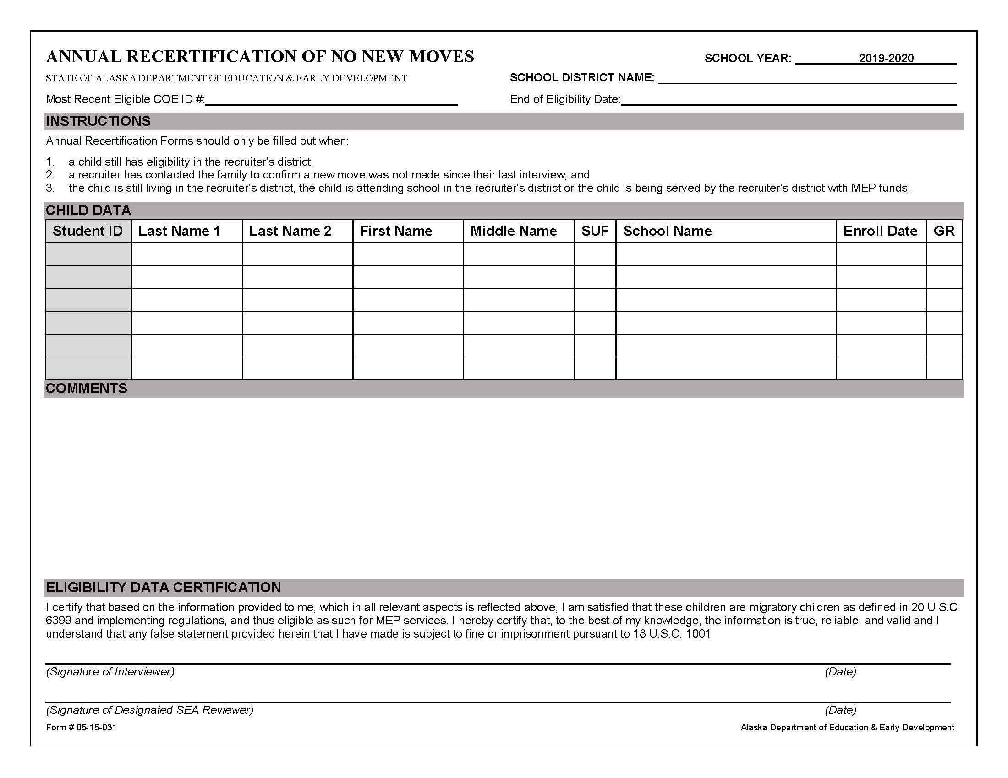

Annual Recertification of No New Moves (ARCs) Guide
The following pages provide a step by step guide on how to fill out each of the required sections of an Annual Recertification of No New Moves.

Top of ARC

School District Name
Print the name of the recruiter’s school district (no abbreviations).

School Year
The current school year is preprinted on the upper right corner of the ARC.

Most Recent Eligible COE ID
Record the COE ID number located on the top of the child(ren)’s most recent COE.

End of Eligibility Date
Record the child(ren)’s End of Eligibility (EOE) date. This date is three years (36 months) from a migratory child’s most recent Qualifying Arrival Date (QAD) listed on the child(ren)’s most recent COE. After this date a child is no longer eligible for the MEP and MEP services, unless they make another qualifying move.

Instructions Section
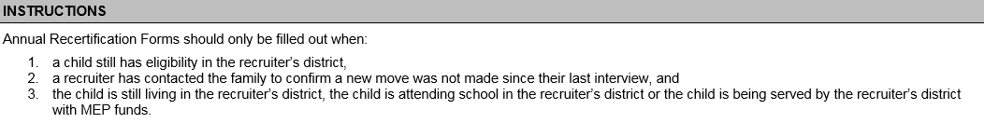
ARC forms can only be utilized to recertify a child’s migrant eligibility if all of the following criteria are met:
- a child has a has eligibility in the recruiter’s district, and
- the recruiter has contacted the family to confirm that a new move was not made since their last interview, and
- the child is still living in the recruiter’s district, the child is attending school in the recruiter’s district, or the child is being served by the recruiter’s district with MEP funds.

Enrolling Transferring Children in the MEP Who are Currently Migrant Eligible
If a child is currently certified as migrant from another school district an interview and new COE will still need to be completed in order to establish the child’s eligibility in the new district and for the district to receive funding. If the permanent move to the school district was done for economic necessity and the move was conducted with a parent/guardian/spouse who is a migratory agricultural worker or migratory fisher then that permanent move could be recorded as the child’s move on the new COE making the qualifying arrival date the date the child and migratory worker moved into the district.

Child Data Section
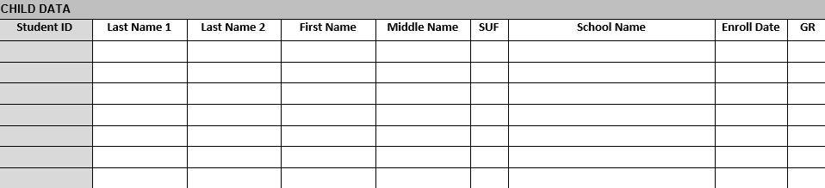
This section includes information about the child(ren) including student ID, full name, and school information.
- If any migrant eligible children in the household were listed on a separate COE due to different qualifying move information, they need to be listed on a separate ARC form.
  - Only eligible migratory children living in the same household can be listed on the same ARC form.
  - If any child(ren) in the household are not migrant eligible (this includes children who have reached the end of their eligibility) in the recruiter’s district, they cannot be listed on this form.
- Migratory children should be listed from youngest to oldest with the youngest child at the top.

Student ID
If a child is enrolled in a public school, the records manager can obtain the child’s Alaska Student ID from the district registrar. For children who have never been in an Alaska public school, MIS2000 will generate a number. If a child’s Alaska Student ID is not known, leave this space blank. Do not enter any other number in this space, including school or district identification numbers. Do not draw a line through this space.

Last Name 1
Record the legal last name of each eligible child in the family. If the child has a multiple or hyphenated last name (i.e., Ramírez-García), record the first part of the name (i.e., Ramírez).

Last Name 2
If the child has a multiple or hyphenated last name (i.e., Ramírez-García), record the second part of the name (i.e., García). If the child has more than two last names, record the entire name in the correct order in the Comments Section. If the child does not have a multiple or hyphenated name, write a dash (-) or “N/A.”

First Name
Record the legal first name of each eligible child in the family. This is the name given to the child at birth, baptism, during another naming ceremony, or through a legal name change. Do not record nicknames or shortened names (i.e., Ale or Alex for Alejandra).

Middle Name
Record the legal middle name of each eligible child in the family. This is the secondary name given to the child at birth, baptism, during another naming ceremony, or through a legal name change. Do not record nicknames or shortened names (i.e., Ale or Alex for Alejandra). If a child has multiple middle names, list the first middle name only in the Middle Name Field and make a comment. If the child does not have a middle name, write a dash (-) or “N/A” and make a comment in the Comments Section. If the child has an initial for their middle name, record the initial in the Middle Name field and make a comment in the Comments Section.

Suffix (SUF)
Where applicable, record the child’s generation in the family (e.g., Jr., Sr., III, 3rd). Otherwise, write a dash (-) or “N/A.”

School Name
Print the name of the school where the child is enrolled (no abbreviations). This field cannot be left blank. All children will have information recorded in this field. Migratory children can be:
- enrolled in a public school in the recruiter’s district
- enrolled in a non-public school in a recruiter’s district,
- not in school,
- enrolled in a public school in another district, or
- enrolled in a non-public school in another district.
Refer to the School Name/Enroll Date/Grade Flowchart on page 133 for more detailed information.

Enroll Date
The first day of school the child attends after the most recent qualifying move for the current school year. All children will have an enroll date with two exceptions:
- children who are too young to be enrolled in school (i.e. babies)
- children who have dropped out of school (i.e. out of school youth)
For more information, refer to the School Name/Enroll Date/Grade Flowchart on page 133.

Grade (GR)
Enter the child’s current grade at the time the COE is completed. A grade must be listed for every child who is enrolled in a school program whether it is home school, private school, or in a school operated by the district. Children attending preschool programs will have PS reported for their grade. Children not yet attending any school are listed as grade 00. Children who were in school at some point, but are no longer attending are listed as grade OY.
For grade codes, refer to the Key Charts on page 126.

Comments Section
Provide any additional or updated information in the Comments Section. Examples could include updated addresses or phone numbers, new children to the household, any other pertinent information. Comments must be initialed and dated by the recruiter.

Eligibility Data Certification Section
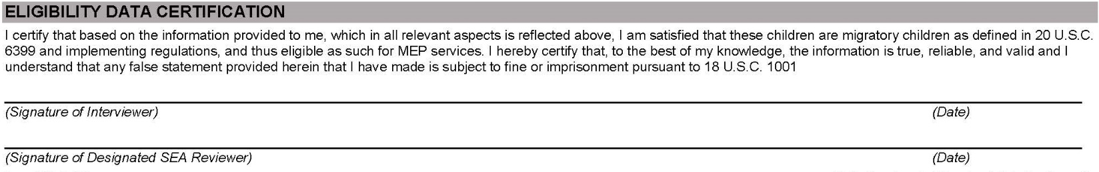

Eligibility Data Certification Language
I certify that based on the information provided to me, which in all relevant aspects is reflected above, I am satisfied that these children are migratory children as defined in 20 U.S.C. 6399 and implementing regulations, and thus eligible as such for MEP services. I hereby certify that, to the best of my knowledge, the information is true, reliable, and valid and I understand that any false statement provided herein that I have made is subject to fine or imprisonment pursuant to 18 U.S.C. 1001.

Signature of Interviewer
After completing the interview and entering all necessary information on the ARC, the interviewer should review the ARC for completeness and accuracy. The signature of the interviewer is required on all ARCs.

Date
Record the date on which the ARC was completed and signed by the interviewer.

Signature of Designated SEA Reviewer
At least one designated SEA reviewer must check each completed ARC to ensure that the written documentation is sufficient and accurate. A designated SEA reviewer must sign and date the ARC on the day it was reviewed.

Date
Record the date on which the ARC was reviewed and signed by the SEA Reviewer.

ARC Corrections
- Draw a single line through the incorrect information. The original text should still be readable. Use an ink other than the initial pen color to make it easy to distinguish from the original text. Do not use whiteout or correction tape.
- If additional information is added to a newly written ARC by the recruiter or records manager, the correct information should be initialed and dated by the person making the change.
- The source of the correct information should be indicated in the Comments Section.

Additional Information
It may be helpful to fill out a draft of the ARC, or another form designed by the district, when collecting information from the parents. Once all the information is collected and the child appears to meet the criteria to certify them on an ARC, transfer the information onto an official ARC. When using the electronic ARC, the recruiter must print the ARC to obtain the required signatures.

Alaska Migrant Web System
This section is applicable only to recruiters using the Alaska Migrant Web System for COE completion.
Please note that all data and pictures of data shown throughout this handbook are fictitious. This is done in order to protect child privacy, and give the user an accurate look at systems and requirements.

About the Web System
The Alaska Migrant Web System (ak.msedd.com) is a secure website utilized in several ways to help streamline Alaska’s Migrant Education Program. Listed below are some of the applications of the Alaska Migrant Web System:
- A secure transmission portal of migratory child data between recruiters, records manages, and the Migrant Education Office (MEO).
- A recruiting tool for recruiters and records manager to use to complete a Certificate of Eligibility (COE) or Annual Recertification of No New Moves (ARC) and submit to the district migrant database, MIS2000.
- A generator of migratory child snap reports.
The recommended browser for the Alaska Migrant Web System is Internet Explorer/Windows Edge.

Updates to the Web System

Auto Fill Question 4 in the Qualifying Moves & Work Section
Recruiters now have the flexibility to auto fill information from question 1 in the Qualifying Moves and Work Section to question 4. This process is outlined on page 93.

Printing COEs
Previously, when a COE had lengthy comments they would be cut off when the PDF was generated for printing. Now, when the comments are a length in which they do not fit into box for printing purposes, a second page will be generated to print all comments. Both pages must be kept on file for the required 10 years.

ARCs in the Web System
Recruiters now have the flexibility to create the Annual Recertification of No New Moves (ARC) in the web system. ARCs created in this way, will be approved by records managers in the web system. Once approved by records managers this information will be auto populated into the MIS2000 desktop database as approved and eligible school history lines. Refer to the detail instructions of process starting on page 100.

Web System Aligned to State of Alaska Security Standards
The web system has been aligned to State of Alaska security standards. This includes:
- A Privacy Notice that users must accept upon log in, in order to access the web system. Refer to page 82 for more information.
- Passwords must be changed every 90 days.
- Passwords must meet State of Alaska security requirements, which are:
  - be at least eight characters long, and
  - be sufficiently complex. This means the password contains a mixture of uppercase and lower case letters, numbers, and symbols.

Overview of Recruiting Using the Web System
Districts that use the Alaska Migrant Web System (ak.msedd.com) for recruiting will have the flexibility to complete a Certificate of Eligibility (COE) or Annual Recertification of No New Moves (ARC) online. This is in lieu of handwriting onto a hard copy of the COE/ARC or typing into a PDF version of the COE/ARC.
COE Process
- Recruiter completes interview with the family to determine potential eligibility.
- Recruiter enters all required COE data in the web system.
  - Records managers have the flexibility of checking COEs in the web system before the recruiter prints them for interviewee and interviewer signatures.
- Recruiter prints the COE from the web system and obtains the interviewee and interviewer signatures.
- Recruiter types the interviewee and interviewer signature information into the COE on the web system.
- Recruiter submits electronic COE data in the web system and sends the signed hard copy COE to records manager.
- Records manager receives electronic COE data in MIS2000 from the web system.
  - Records manager no longer has to manually type the COE into MIS2000 themselves. It is populated from the web system.
- Records manager obtains the SEA Reviewer signature on the hard copy COE.
- Records manager reviews COE and either:
  - Rejects the COE back to the recruiter to update/fix the COE in web system,
  - Updates/Fixes the COE in MIS2000 themselves, or
  - Pushes the COE forward for the MEO to review for final approval.
Please note that not all COEs must be completed in the Alaska Migrant Web System. Hard copy and fillable PDF versions of the COE will still be available.

ARC Process
- Recruiter completes interview with family and determines that no new qualifying moves have been made, but that child(ren) is still within the three years of eligibility for the program.
- Recruiter enters all required ARC data in the web system.
- Recruiter prints the ARC from the web system and obtains the interviewer signature.
- Recruiter submits electronic ARC data in the web system and sends the signed hard copy ARC to records manager.
- Records manager receives electronic ARC data in the web system.
  - Records manager no longer has to manually type the ARC data into MIS2000. Once the ARC has been approved by the records manager, it is populated from the web system.
- Records manager obtains the SEA Reviewer signature on the hard copy ARC.
- Records manager reviews ARC and either:
  - Rejects the ARC back to the recruiter to update/fix the ARC in the web system, or
    - The records manager also has the ability to update/fix the ARC in the web system themselves (and updates the hard copy).
  - Approves the ARC in the web system.
    - Once the records manager approves the ARC, data is populated into the MIS2000 desktop on completed approved (active and eligible) new school history lines. The records manager no longer needs the MEO to validate ARCs, if they pass all submission checks.
Please note that not all ARCs must be completed in the Alaska Migrant Web System. Hard copy and fillable PDF versions of the ARC will still be available.

Accessing the Web System

Authorized Users
The Alaska Migrant Web System is for the use of the Alaska Department of Education & Early Development Migrant Education Program, and may be accessed and used only for official Migrant Education Program business, and by authorized personnel using district issued computers.
Recruiters, records managers, and other authorized users of the system must annually sign a user access agreement form prior to access being granted access to the Alaska Migrant Web System.
Terms of the agreement include:
- To safeguard the security of any password provided to you by system administrators.
- To follow FERPA guidelines and not distribute or share any student information or migrant records.
- To not share the system access you have been given.
- To not perform actions on Alaska Department of Education & Early Development Information Technology resources which are inconsistent with the spirit of this agreement, violate any State or Federal law or result in system instability.
- To not download and save reports from the web system to a personal computer.

Termination of Access
User access to the Alaska Migrant Web System will be terminated when staff no longer have a business need for the access, such as recruiting being complete for the school year, employees changing jobs, employees resigning, etc. It is the responsibility of the records manager/migrant coordinator to immediately notify the MEO when authorized personnel have been terminated or no longer have a business need for access to the system.
The duration of access to the web system for recruiters is determined by the migrant coordinator/records manager and is marked on the Migrant Web System Recruiter Access Form. Access will be granted for either of the terms described below:
- July 1st to December 31st, or
- July 1st to June 30th.
Once the term is completed, users are disabled in the web system until a new access form has been completed.

Setting Up User Accounts
The Alaska Migrant Web System is located at ak.msedd.com. After the signed User Access Agreement form is received by the MEO, a profile will be built in the system for each user. In order to use the Alaska Migrant Web System, users are required to possess a district issued email.
Username – The username for each migrant staff member will be their district issued email.
Password – Users create their own passwords for the Alaska Migrant Web System.
- Please note that passwords must be in compliance with State of Alaska security standards outlined on page 7.

Setting Passwords
Steps to setting up a password for the Alaska Migrant Web System:
- After the MEO receives the user access agreement and builds a user profile, an activation email from the web system (support@msedd.com) will be auto generated and sent to the user at their district email address.
- The email will prompt the user to activate their account by clicking on the included hyperlink, or copying and pasting the customized web address into their internet browser.
- Both the hyperlink and web address included in the email will lead the user to this page, where the user can create a password for the system. Their first and last name will be populated into the First Name and Last Name boxes shown below.
- The user will need to type a password into the field labeled Enter your password.
  - Passwords must be strong. For more information on strong passwords, review the Online Safety section starting on page 7.
- The user will be required to confirm their password by typing their password in the box labeled And again to confirm.
- Click the Save button.

Resetting Passwords
In the event that district staff need to reset their passwords to the Alaska Migrant Web System, please follow the steps outlined below:
- In an internet browser, go to the Alaska Migrant Web System (ak.msedd.com).
- Click on the Forgot your password? hyperlink.
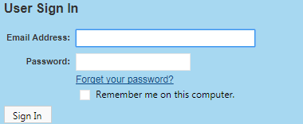
- Enter the district email address where prompted and click on the Request Password Reset button.
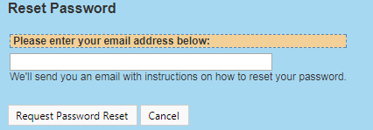
- The user will receive an email prompting them to click on the password reset link or to copy and paste the individualized link to an internet browser.
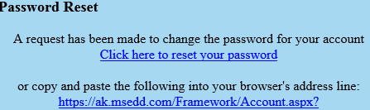
- The user will be prompted to create and validate their new password. Enter new password in the top line labeled Enter your new password. Confirm new password in the second line labeled And again to confirm. Click on the save button.
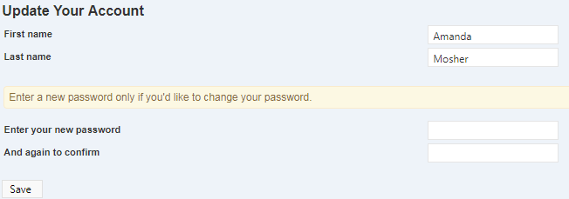

Signing In
Steps to signing in to the Alaska Migrant Web System:
- In an internet browser, go to the Alaska Migrant Web System (ak.msedd.com).
- Enter the user’s district email address in the first field, marked Email Address.
- Enter the user’s password in the second field marked Password.
- Click on the Sign In button.

Privacy Notice
You must READ and ACCEPT the information below to login into the Alaska Migrant Web System.
You are accessing a State of Alaska (SOA) information system, which includes any SOA device attached to the system (e.g., a state-owned thumb drive), the system does not include any non-SOA device (e.g., a personal cell phone or computer) used to access the system. The system exists for SOA-authorized use only. By using it, you consent to the following conditions:
- The SOA routinely intercepts and monitors communications and data stored on this information system and on any attached non-SOA device for purposes including, but not limited to, penetration testing, maintaining network operations and defense, monitoring for personnel misconduct, conducting law enforcement activities, and undertaking counterintelligence investigations. (The SOA does not intercept or monitor communications or data on personal devices used to access the SOA information system: i.e., as long as such devices are not attached to the system).
- At any time, the SOA may inspect and seize data stored on this information system and on any attached non-SOA device.
- Communications using and data stored on this information system and any attached non-SOA device are not private, such communications and data may be disclosed or used for any SOA-authorized purpose.
- This information system includes security measures (e.g., authentication and access controls) to protect SOA interests. These measures are not for your personal benefit.
- Unauthorized use of this information system is prohibited and may subject the user to disciplinary action (including dismissal) and to criminal and civil penalties.
This Notice applies only to your consent to monitoring when using this information system. It does not affect any other consent by you or any obligations you owe the SOA. For example, it does not affect your obligation to provide the SOA all state records that you have stored on any non-SOA device or non-SOA system, and if you receive an allowance for an employee-owned device, it does not affect your agreement that all records related to the device may be reviewed by the SOA or a court to locate any records related to SOA business. v.3

Navigating the Web System

Home Tab
The user will always be brought to the Home tab upon successfully logging in to the web system.
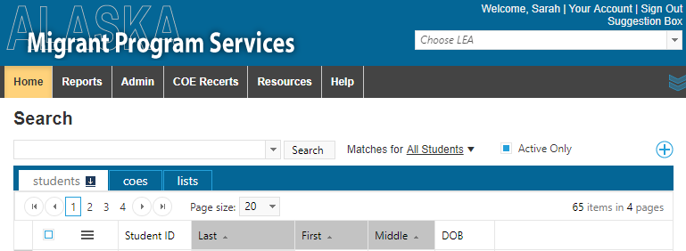
The Home tab consists of the Students and COEs subtabs.

Students Subtab
Using the Students subtab the user can search for the individual records of children and youth who are currently (or have been) migrant eligible. Users will only have access to student information through the Alaska Migrant Web System, if the student has previously been certified as migrant eligible in their district.

Searching for Students
Users can search for the records of individual migratory children from their district in the Alaska Migrant Web System using the search bar provided.

Basic Search
To search for a specific child, type their name or part of their name, in the search bar. Click the search button or use the enter key to complete the search. A list of matching results (if any) will be displayed.
To see the enrollment information on a particular child, click on the arrow button to the left of the desired child. Clicking on the arrow will expand to show available school history and enrollment information.
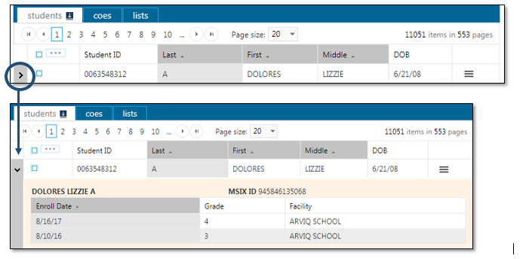

Searching Tips:
In addition to searching for names or partial name, the basic search bar has the capability to search for dates.
- To search for a specific date range type dates like: mm/dd/yyyy-mm/dd/yyyy.
- For a date range with no end date: mm/dd/yyyy-.
- Hover over the drop down arrow in order to see instructions for searching.
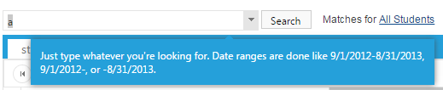
- The dropdown arrow will show a list of the user’s recent searches.
- Be sure the search is set for All Students, in order to see the most complete list of search results.

Advanced Search
To use the advanced search, click on the plus (+) symbol on the right hand side of the webpage.
Clicking on the advanced search symbol (+) will bring up the following dialogue box.
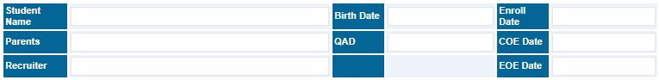
The advanced search option include the following fields:
- Student Name – the name, or partial name, of a migratory child as listed in the Child Data Section of an approved COE.
- Parents – the name, or partial name, of either parent listed in the Family Data Section of an approved COE.
- Recruiter – the name of the recruiter who completed the COE in the Alaska Migrant Web System.
- Birth Date – the birth date (mm/dd/yyyy) of a child listed in the Child Data Section of an approved COE.
- QAD – the Qualifying Arrival Date as listed in question 3 of the Qualifying Moves & Work Section of an approved COE.
- Enroll Date – the enroll date (mm/dd/yyyy) of a child listed in the Child Data Section of an approved COE.
- COE Date – the date that a COE was created in either the MIS2000 desktop or the Alaska Migrant Web System.
- EOE Date – the end of eligibility date for a child(ren) listed on a particular approved COE. The EOE date is exactly three years after the QAD listed in question 3 of the Qualifying Moves & Work Section.
The user can use one or more of these fields during the advanced search. To complete the advanced search enter information next to the desired field and hit the Search button.
To cancel the advanced search click on the symbol in the upper right hand corner of the webpage.

COE Subtab
The COE subtab can be used to search for students and COEs that are fully approved, newly created, or partially through the eligibility determination process. The COE subtab is primarily used to create new move COEs for eligible and potentially eligible migratory children and youth. The COE subtab is also utilized to complete the ARC for children who are currently migrant eligible, but have not made a new qualifying move.
The COE subtab has the same basic and advanced search options that are available in the Students subtab. Recruiters will only be able to view results for students and COEs who are migrant eligible in their district.
Search results are displayed based on the parental information included on the COE rather than the Child Data Section information. Displayed fields also include COE ID, QAD, COE Date, and Recruiter (if entered through the web system).
Using general search criteria (i.e., searching just for a letter or partial name), will result in a larger results list. The results will include every child and every parent who meets the search criteria.
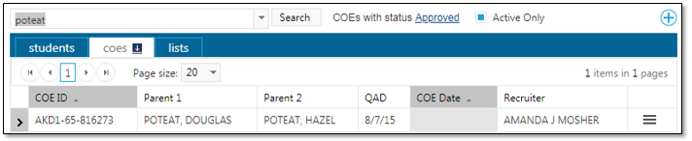
Search results can be expanded by clicking on the arrow on the left of each line. The expanded information lists each child on the COE.
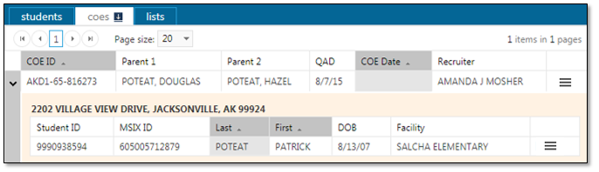
COEs are printed from the web system by hovering over the three line Hamburger (≡) menu to the far right, selecting view, and then using the print icon in PDF viewer.
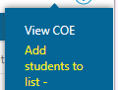

COE Status in the Web System
Recruiters and records managers must take into account the status of the COE when searching for a particular COE in the web system.
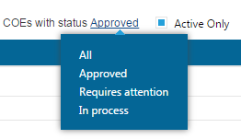
The web system categorizes COEs as:
- All – the All COE group will yield approved COEs in the search results. This COE status does not reliably return search results for unapproved COEs (COEs in In Process or Requires Attention status).
- Approved – COEs that have been fully approved by the MEO. These COEs cannot be edited in the web system or by district staff.
- Requires Attention – COEs the recruiter (creator) is able to edit. These COEs have not been approved by the MEO. If the recruiter switches the status of COEs from All to Requires Attention a list of the COEs the recruiter is currently able to edit will be displayed.
- In Process – COEs that the recruiter cannot edit. However, these COEs have not been approved by the MEO. COEs can show up in the In Process status for a variety of reasons, including:
  - the COE might be in Requires Attention status for another district recruiter,
  - the COE has been submitted through the web system to the records manager, and the records manager is currently processing the COE in COE Draft View in MIS2000, or
  - the COE is awaiting MEO approval.

Creating a COE in the Web System
- Navigate to the COE subtab of the Home tab in the Alaska Migrant Web System (ak.msedd.com).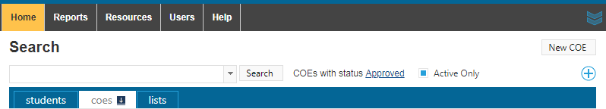
- Click on the New COE button, located in the upper right hand corner, to create a blank COE.
- Complete the COE. Please review the Certificate of Eligibility (COE) section starting on page 40 for detailed instructions on how to fill out a COE and any specific comments that may be required.
- Use the Save My Work button often throughout the COE data entry process.
- When changes are saved, a blue bar will appear at the top of the screen with the message Changes saved.
- Use the Check For Errors button to ensure the COE is as complete and correct as possible, prior to printing the COE and obtaining signatures. As part of the error check, the user’s work is automatically saved in the event that the Save My Work button was not utilized first.
- Any errors found are displayed at the top of the screen in red.
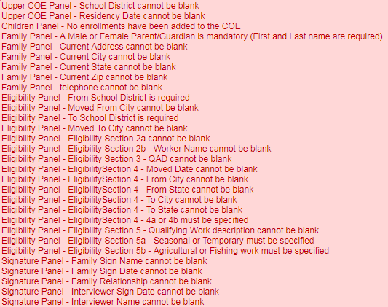
- Click on the View COE button found in the upper right hand side to view the PDF version of the COE.
- In the PDF window, click on the print icon located in the upper right hand corner to print the COE.
- Obtain interviewee signature on the printed COE.
- Sign the COE as the interviewer.
- Navigate to the COE subtab, and change the search status to Requires attention.
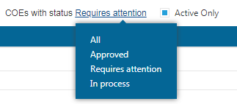
- Hover over the three line Hamburger (≡) menu on the desired COE and click Edit COE from the drop down list.
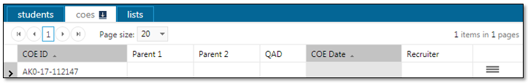
- Enter the Interviewee and Interviewer signature information into the fields at the bottom of the COE in the web system.
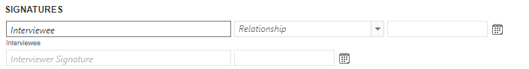
- Use the Save My Work button in order to save changes.
- Click on the Submit COE for Review button, located in the upper left hand corner, to send the electronic COE information to the district records manager in MIS2000. Any errors preventing COE submission will appear in red at the top of the screen.
- When the COE Log is displayed click the OK button.
- Users are not required to add information to the COE Log, unless the COE is being rejected.

Important Information Regarding COEs in the Web System

General
- A blank COE in the web system looks very similar to the paper/PDF versions of the COE. Sections of the COE are labeled and appear in the same order as the paper/PDF COE.
- Users can use all caps to type or standard capitalization conventions in the web system.
- Do not enter dashes (-) into the web system.
- Users can tab through fields in the web system, or they can click into each field in order to complete the COE.
- COE ID numbers are generated by the Alaska Migrant Web System when the New COE button is clicked. All of the COE ID numbers generated in the web system will begin AK0.
- COEs created in the web system will be marked Incomplete until they are successfully submitted to the MIS2000 desktop.
- The COE will be auto populated with the recruiter’s school district at the top of the COE. The recruiter will not be able to edit this.
- It is best practice to save the COE throughout the entry process using the Save My Work button at the top of the screen.
- The COE log facilitates communication between recruiter and reviewers. When submitting the COE, the recruiter does not need to enter information into the log. However, whenever a COE is Rejected back to the recruiter, the reviewer must enter comments. The COE log can be viewed by clicking on the View Log button.
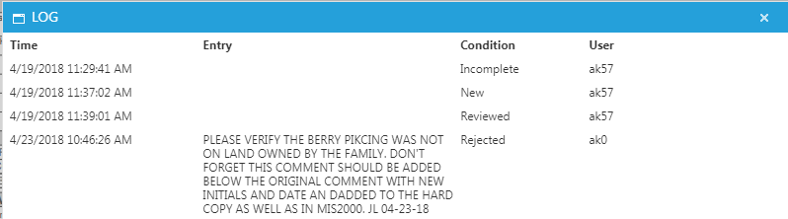

Date Fields
Throughout the web COE, there are several date fields. The calendar icon to the right of each field denotes each date field. The user can directly type desired dates into these fields, or they can click on the calendar icon, and choose the date from the calendar.
- The Residency Date is located in upper right hand corner of the COE.
- Date fields will automatically format to mm/dd/yyyy format, after the date has been typed in.
  - You can enter a date with or without dashes.
- Dates can be selected by clicking on the calendar icon next to any date field. Use the arrows shown below in order to change months. The double arrows jumps three months. The single arrow jumps one month.
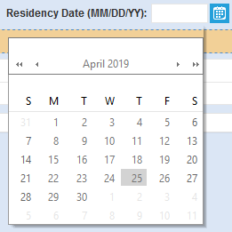

Drop Down Lists
Throughout the web COE, there are fields that consist of drop down lists. Users can tab or click into these fields and start typing to bring up predictive drop downs. User can also click on the down turned arrows in order to see the entire drop down list.
Fields that have Drop Down Lists:
- City and State
- From District and To District
- Country Code
- Gear and Catch
- Sex
- MB (multiple birth)
- EB (ethnic breakdown)
- VER (birth date verification code)
- Grade
- Facility (school name)
- Type (type of enrollment)

Tips by COE Section

Top of the COE
- The recruiter’s district is auto populated into the School District Name field at the Top of the COE. The recruiter cannot change the school district.

Child Data Section
- To add children to the COE, click on the blank line in the Child Data section. There is no limit to the number of children that can be added to the Child Data Section of the COE created in the web system.
  - If a COE contains more than five children, the COE will print on multiple pages. Signatures must be obtained on each page of the COE.
- The following child data entry panel will appear after clicking on the blank line in the Child Data Section. Enter data into the white fields in the orange area. The recruiter can tab through each field.
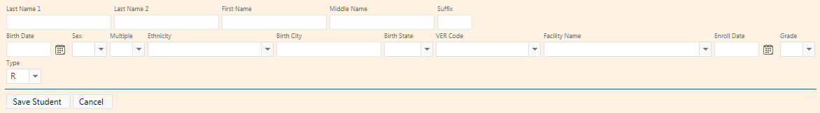
- After completing all the fields the recruiter must click the Save Student button shown above. Clicking the Save My Work button at the top of the page, will not save student data.
  - The recruiter must enter a VER Code and Grade before the recruiter can save the student.
  - Data will be populated into the first blank row in the Child Data Section. Note, the school name will be shown as a code rather than the school name entered in the previous screen.
    - Though the School Name is displayed as School ID. The School Name will be displayed when the COE is printed.
  - If a mistake has been made in the Child Data Section, click once on the corresponding line in the Child Data Section in order to edit the data populated into the fields.
- Many of the fields listed in the child panel are drop downs. Additionally these drop downs spell out the full words, rather than codes for the user’s convenience. Once the child data is saved, the data will be converted to the required codes on the COE.
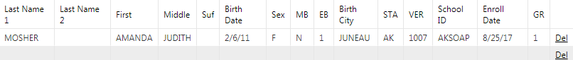
- To delete a child from the COE, click on the Del button, all the way to the right on the corresponding child data line, as show above.

Qualifying Moves & Work Section
- Check boxes can be changed if the wrong item is initially selected (i.e., the recruiter checks, spouse instead of parent/guardian).
- The Country Code “USA” is defaulted into question 1 and question 4 of the Qualifying Moves & Work Section. Additionally, the state abbreviation “AK” is defaulted into the State fields in questions 1 and 4.
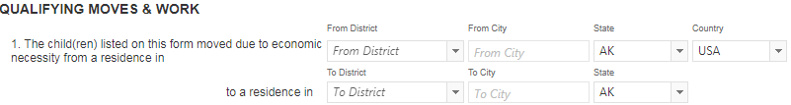
- When the recruiter selects to join or precede the worker in 2a, additional fields will be displayed that the user must complete, (including a separate comments field, not pictured, for the 2bi comment).
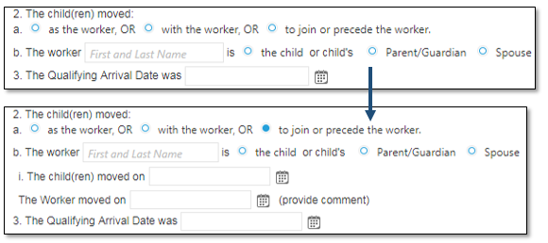
- If the move information in questions 1 and 4 are the same: Recruiters have the option to copy information regarding the child’s move (question 1) into the question regarding the worker’s move (question 4) by selecting the check box for The same as question 1. Once the user checks the box, the information regarding the school districts, cities, states, and country listed for the child’s move will be populated into the fields for the worker’s move. If the user determines the information in these questions should not be the same, they can unselect the checkbox and will then be able to edit the data regarding the worker’s qualifying move in question 4.
  - Question 1 in Qualifying Moves & Work Section – Child(ren)’s Move
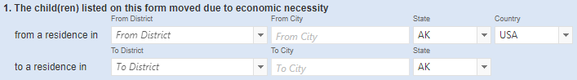
  - Question 4 in Qualifying Moves & Work Section – Worker’s Move
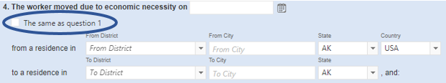
- The qualifying work listed under question 5 is separated into two fields. The first field is the gear, the second field is the catch.
  - Many gear and catch options are listed in the drop down menus twice, once as commercial and once as subsistence.
    - Commercial or subsistence should match both the gear and the catch. For example, both the gear and the catch are listed as commercial.
    - The recruiter should choose commercial or subsistence based on the activity that the worker engaged in for the majority of the move listed in question 4.
- The recruiter must check the personal subsistence box if the move listed in the Qualifying Moves & Work Section is, even in part, for subsistence.

Additional Qualifying Moves Box
- The Additional Qualifying Moves box will automatically calculate the number nights for each move.
  - The calculated nights will show up after the recruiter uses the Save my Work button.
  - The recruiter cannot manually enter the number of nights.
  - If the moves are typed out of order, the nights will reorder themselves from most recent to least.
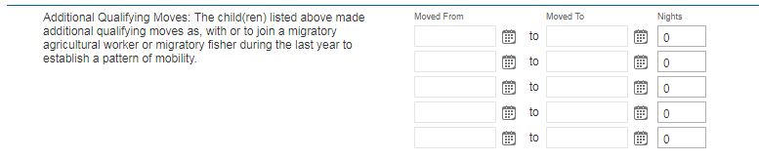

Comments Section
- The Comments box can be expanded for the recruiter’s convenience by clicking and dragging the shaded lower right hand corner.

Printing & Obtaining Signatures
- COEs must be printed from the web system and signatures obtained prior to COEs being submitted to the records manager through MIS2000.
  - The interviewee must sign the printed COE first.
  - The interviewer/recruiter must sign the printed COE after the interviewee.
  - By signing the COE, the interviewee and interviewer are verifying that the information on the COE is complete and correct, and that the moves documented on the COE were made due to economic necessity.
- In order to print the COE, the recruiter must utilize the View COE, button at the top of the page. In the PDF viewer displayed, the recruiter can choose to print by clicking on the print icon.
- After obtaining the required signatures on the hard copy printed COE, the recruiter will enter the signature information into the COE using the web system.
  - It is the records manager’s responsibility to obtain the SEA Reviewer signature when they have received the hard copy COE.

COE Errors and Submission Checks
The Alaska Migrant Web System contains the same pop-up messages and error checks as the MIS2000 desktop utilized by records managers. After the recruiter hits the Submit COE for Review or Check For Errors buttons, any errors will be listed in red at the top of the screen. Below is a complete list of errors and pop-up message in the web system.
Error and Warnings Messages | Description
Child Missing First or Last Name Error  “Field ‘Last Name’ must have a value”  “Field ‘First name’ must have a value.” | Each child listed on the COE must have both a first and last name. If one of these names are missing the COE cannot be submitted to the next level of approval and errors will be displayed.
Date of Birth is After the QAD Error  “This child was born after the QA Date.” | The Child has a date of birth that is after the QAD. A child must have been born prior to the QAD in order to be listed in the Child Data Section of the COE.
Missing Birthdate Verification Code Error  “Birth Verification must be specified.” | The VER (birth date verification) code must be listed for each child on the COE. This field cannot be blank.
Missing Sex (Gender) Error  “Field ‘Sex’ must have a value.” | The sex (gender) must be specified for each child listed on the COE.
Missing Birthdate Error  “Field ‘Birth Date’ must have a value.” | Each child listed on the COE must have a date of birth listed in mm/dd/yyyy format.
Missing Multiple Birth Error  “Field ‘Multiplebirth Code’ must have a value.” | Each child listed on the COE must have the MB (multiple birth) field completed. This is a Yes/No field.
Missing Ethnicity Error  “Field ‘Race’ must have a value.” | Each child listed on the COE must have their race/ethnicity specified in the EB (ethnic breakdown) field.
Missing Facility Error  “Field ‘Facility’ must have a value.” | Each child listed on the COE must have a school (facility) name.
Facility Name Incompatible with Grades 00 or OY Error  “Child must have a school district with grades 00 or OY.” | Children listed in grades 00 or OY must use the generic facility name for a particular school district. The School Name field must be completed with the School District Name. Any other facility name will cause the error to occur.
Missing Grade Error  “Field ‘Grade’ must have a value.” | When entering enrollment data for a child on the Child Data tab, the district must enter a grade in the Grade field. An error message will pop-up if a grade is not entered.
QAD and RES Date are the Same Warning  “QAD and RES dates are the same. Please indicate the length of move in comments.” | The QAD and Res Date can be the same on the COE. However, when this occurs a comment is required to describe the length of engagement in the migratory work as listed in questions 4 and 5 of the Qualifying Moves & Works Section. This pop-up will not prevent users from submitting the COE to the next level of approval. However, if this comment is not in the Comments Section, the MEO Eligibility Specialist will reject the COE back to the records manager.
Residency Date Reminder  “The RES date is more than 30 days after the QAD Date. Please make a note in the Comments box explaining the duration of the migratory move (start and end date) and why the RES date is much later than the QAD date.” | When entering data in the Qualifying Data Section of the COE, this pop-up message may appear if data was entered incorrectly or the data entered needs more clarification. The system does not allow for the Residency date to be more than 30 days after the QAD date. This warning does not prevent the COE from being submitted to the next level of approval. If the Residency date entered is correct and is 30 days or more after the QAD, a comment must be provided in the Comments Section.
Less than Seven Nights on COE Warning  “There are less than seven nights listed on the COE. Enter a comment detailing at least seven nights of engagement in qualifying work. Ensure that all additional qualifying moves accounted for. Number of nights is currently X.” | When there are less than seven nights listed on the COE (including Additional Qualifying Moves) a warning message will be displayed. When this occurs a comment is required to describe the length of engagement in the migratory work as listed in numbers 4 and 5 of the Qualifying Moves & Work Section. This pop-up will not prevent users from submitting the COE to the next level of approval. However, if this comment is not in the Comments Section, the MEO Eligibility Specialist will reject the COE back to the records manager.
Pole Comment Reminder  “Comment is needed verifying pole was not used for Sport or Recreation.” | When users select “pole” for the gear listed in the Qualifying Data tab, the user will see the following warning. This will not prevent the user from submitting the COE. The message serves as a reminder for a required comment regarding the use of the pole.
Enroll Date Must be Later than the QAD Error  “Enrollment date must be later than the Qualifying Arrival Date.” | The Enroll Date must be later than the Qualifying Arrival Date. The enroll date is the first day the child is physically in the classroom after the most recent qualifying move.
Enroll Date before QAD or Res Date Error  “The Enroll Date entered is before the QAD or Res Date. This is incorrect; please correct the dates.” | The Enroll Date cannot be before the QAD or the Residency Date. The enroll date is the first day of school that the child attends after the qualifying move.
Future Enroll Date Error  “Child must have a non-future enroll date with grades PS-12.” | Children cannot be certified on any enrollment (COE or ARC) with a future enrollment date. The Enrollment Date field requires a date to be on or after 8/1 of the given school year and on or after today’s date. Any dates submitted later than today’s date will result in an error.
Additional Qualifying Move Date Error  “Additional move dates must be before the QAD.” | When entering qualifying move data on the Qualifying Data tab, this pop-up message will appear if data was entered incorrectly. The system does not allow the Additional Move Dates to be after the QAD date. Most likely cause is an error inputting the dates.
Additional Qualifying Moves Date Restrictions Error  “Eligibility Panel – Additional Move From Date is more than 365 Days from QAD.” | Error checks have been implemented in both MIS2000 and the web system to ensure that the start date for additional qualifying moves must be within 1 year/365 days of the QAD.
City Name Restrictions Error  “Eligibility Section 1 – Moved From and To City cannot be the same”  “Eligibility Section 4 – Moved From and To City cannot be the same.” | Error checks have been implemented in both MIS2000 and the web system to ensure that if the district names listed in question 1 or 4 of the Qualifying Moves & Work Section are the same for both the to and from districts, the to and from cities must be unique.
Missing Signature and Date Errors  “Interviewee signed by name must be specified.”  “Interviewee relationship must be specified.”  “Interviewee signed date must be specified.”  “Interviewer signed by name must be specified.”  “Interviewer signed date must be specified.” | When entering information into the Signature tab, the district must enter the all signature information for the Interviewee and Interviewer. This data includes Interviewee Signed by Name, Interviewee Relationship, Interviewee Signed Date, Interviewer Signed by Name, Interviewer Signed by Date, Designated SEA Reviewer Name, and Designated SEA Reviewer Signed Date. An error message will appear if any part of it is not entered.
Missing Residency Date Error  “Upper COE Pane – Residency Date cannot be blank.” | Residency date is a required field on the COE. Enter the Residency date in the Qualifying Data tab, next to the QAD.
Missing Enroll Date Error  “Children Panel – [last name, first name]: Enroll Date cannot be blank.” | Children listed in grades PS-12 are required to have enrollment dates listed on the COE. Children marked as grade 00 or OY, will not receive this error.
Missing Current Address Errors  “Family Panel – Current Address cannot be blank.”  “Family Panel – Current City cannot be blank.”  “Family Panel – Current State cannot be blank.”  “Family Panel – Current Zip cannot be blank.” | The current address is required on all COEs. This information must be completed in the Family Data tab of the MIS2000 desktop. Street address, city, state, and zip are all required fields.
Missing Phone Number Error  “Family Panel – Phone Number cannot be blank.” | When entering data for the family on the Family Data tab, the district must enter a telephone number in the Phone Field. An error message will appear if a phone number is not entered.
Missing Move From or To Errors  “Eligibility Panel – From School District is required,” (for AK school districts only).  “Eligibility Panel – From City cannot be blank.”  “Eligibility Panel – From State cannot be blank.”  “Eligibility Panel – From Country cannot be blank.”  “Eligibility Panel – To School District is required.”  “Eligibility Panel – To City cannot be blank.”  “Eligibility Panel – To State cannot be blank.”  “Eligibility Section 4 – From District cannot be blank,” (for AK school districts only).  “Eligibility Section 4 – From City cannot be blank.”  “Eligibility Section 4 – From State cannot be blank.”  “Eligibility Section 4 – From Country cannot be blank.”  “Eligibility Section 4 – To District cannot be blank,” (for AK school districts only).  “Eligibility Section 4 – To City cannot be blank.”  “Eligibility Section 4 – To State cannot be blank.” | When entering qualifying move and worker move data in the Qualifying Data tab, the district must enter the Move From and the Move To locations. Required Data includes From School District (for all districts in Alaska), From City, From State, From County, To School District (for all districts in Alaska), To City, To State. This applies to the child’s move in number 1 and the worker’s move in number 4. All error messages will be displayed after the user hits the submit button if any of these data are omitted.
Missing Selection in 2a (As, With, or To Join) Error  “Eligibility Panel Section 2a cannot be blank.” | A selection must be made in 2a of the Qualifying Data tab, to determine whether the child made the qualifying move as the worker, with the worker, or to join or precede the worker. If no selection is made an error occur.
Missing Worker Name Error  “Eligibility Panel 2b – Worker name cannot be blank.” | A worker name must be specified in 2b. If a worker name is not specified the user will receive an error message.
Both To Join and Child Selected Error  “Eligibility Section 2 – ‘To join or precede the worker’ with a relationship of ‘Child’ are contradictory and not allowed.” | The child cannot have moved both “to join or precede” the worker in 2a and be the worker as marked in 2b of the Qualifying Moves & Work Section. If these options are chosen and error will occur.
Missing QAD Error  “Eligibility Section 3 – QAD cannot be blank.” | Every COE must have a QAD listed in section three of the Qualifying Data tab. If the QAD is not specified the user will receive an error.
QAD More than 36 Months Ago Error  “Eligibility Panel – QAD cannot be more than 36 months from today.” | The QAD listed in number 3 of the Qualifying Data tab, must be with 36 months of the current date. If the user clicks the submit button, and the QAD is more than 36 months from today, an error will occur.
No Longer Migratory Worker Error  “Eligibility Section 4 – Moved Date cannot be more than 36 months from today.” | The individual listed is not considered to be a migratory worker. The date of worker engagement as typed in 4a is more than 36 months from today’s date.
4a or 4b Not Specified Error  “Eligibility Section 4 – 4a or 4b must be specified.” | Users must select either 4a or 4b from Qualifying Data tab. This cannot be left blank. The worker must have either engaged in new qualifying work soon after the move (4a) or actively sought new qualifying work and have a recent history of moves for qualifying work. If no selection is made and error will occur.
Missing 4b Comment Error  “Eligibility Section 4 – 4b requires a comment.” | When 4b is selected in the Qualifying Data tab comments must be provided.
Missing Gear and/or Catch Error  “Eligibility Section 5 – Qualifying Work description cannot be blank.” | The qualifying work must be specified in question 5 of the Qualifying Data tab. Leaving the gear or the catch field blank will result in a submission error.
Missing Seasonal or Temporary Error  “Eligibility Section 5a – Seasonal or Temporary must be specified.” | After the work is listed in question 5, a selection must be made in 5a to determine whether the qualifying work was seasonal or temporary. If no selection is made, the user will receive a submission error.
Missing Agriculture or Fishing Error  “Eligibility Section 5b – Agriculture or Fishing work must be specified.” | After the work is listed in number 5, a selection must be made in 5b to determine whether the qualifying work was agriculture or fishing. If no selection is made, the user will receive a submission error.
Missing Temporary Documentation Error  “Eligibility Panel – Eligibility Section 6 must be completed.” | If “temporary” is selected in 5a, the user must also complete question 6 in the Qualifying Data tab. This information documents how the temporary employment was verified. If no selection in question 6 is made, when “temporary” is selected in 5b, the error will occur.
Missing 6a or 6b Comment Error  “Eligibility Section 6 – 6a or 6b requires a comment.” | When “temporary” is selected in 5a, and “worker’s statement” (6a) or “employer’s statement” (6b) is selected in 6, of the Qualifying Data tab, users must enter required the statements as required comments. If no comments are provided, an error will occur.
Missing 6C Employer Name Error  “Eligibility Section 6c – Employer Name cannot be blank.” | When “temporary” is selected in 5a, and “state documentation” is selected in 6, of the Qualifying Data tab, users must specify the Employer Name. If no employer is specified, an error will occur.
Interviewee Signature Date Error  “Signature Panel – Interviewer Sign Date cannot be prior to Interviewee Sign Date.” | The Interviewee Sign Date must be the same as or before the Interviewer Signature Date and SEA Reviewer Signature Date.
Interviewer Signature Date Error  “Signature Panel – SEA Reviewer Sign Date cannot be prior to Interviewee Sign Date.” | The Interviewer signature date must be the same as or before the SEA Reviewer signature date. If the user enters an SEA Reviewer Sign Date that predates the interviewer sign date, and error will occur.

Creating an ARC in the Web System
- Navigate to the COE subtab of the Home tab in the Alaska Migrant Web System (ak.msedd.com).
- Search for the child, family, or most recently approved COE.
  - Ensure that the search criteria is set to COEs with status Approved.
  - Ensure that the Active Only box is checked
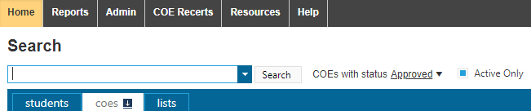
- Click on the three line Hamburger (≡) menu, located to the right of the data displayed.
- Click on View COE.
- Click on the Recertify button, located in the upper left hand corner.
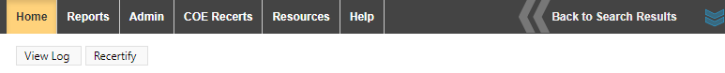
- Click on Edit for the first child who should be recertified on the ARC.
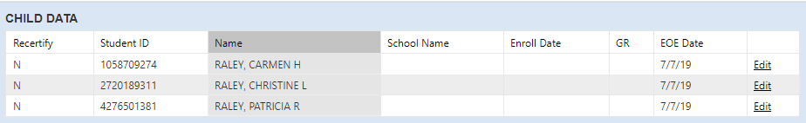
- In the Recertify field, change the N to a Y for Yes.
- Choose the school name the child is attending for the current school year from the drop down menu in the School Name field.
  - For more information refer to the School Names, Enroll Dates, and Grades section starting on page 45.
- Enter the first day of school the child attend for the current school year in the Enroll Date field, if applicable.
  - Children who are not attending any school will not have an Enroll Date.
- Enter the grade for the child in the GR (Grade) field.
  - For information on Grades, refer to page 44.
- Click on the Update button, located to the right of the EOE Date.
- Click on the Save Changes button located in the upper right hand corner of the screen, to save the changes that have been made.
- Repeat steps 6-12 for each child who should be recertified on the ARC.
  - Please note that it is likely that not all of the children listed on a particular COE should be recertified on an ARC. It is fine for children to be left with Recertify = N. Children who should not be recertified on ARC includes, but is not limited to: graduates, children who have aged out of the program, deceased, and children who have made a new qualifying move.
- Enter comments, if any, in the Comments field located underneath the Child Data Section.
- Click on the Save Changes button located in the upper right hand corner of the screen to save the changes that have been made.
- Click on the Print button.
  - A PDF of the ARC form will be created that the user will print.
- Complete the Interviewer Signature field on the hard copy ARC.
- Click on the Submit for Review button.
- Send the hard copy ARC to the records manager to get the Designated SEA Reviewer Signature.
  - It is important to note that records managers cannot review ARCs created in the web system until they have received the completely signed hard copy ARC from the recruiter.

Important Information Regarding ARCs in the Web System

Finding a Partially Completed or Rejected ARC to Update
To find a partially completed or rejected ARC, follow the procedure outlines below.
- Click on the COE Recerts tab in the ribbon located at the top of the webpage.
- Click on the desired Annual Rectification (ARC) of No New Moves from the list provided.
- Update the ARC as needed using the Edit and Update buttons and/or type directly in the Comments section.
- Click on the Save Changes button to save the ARC.
  - Click on the Update button, if the Child Data section is still open for editing prior to clicking on the Save Changes button.
- Print the ARC (if it has not been printed and signed yet).
  - If the ARC is already printed, make the changes on the hard copy that have been made in the web system. Be sure to initial and date any comments or cross outs.
  - Complete the Interviewer Signature field on the hard copy ARC, if not already filled out.
- Click on the Submit for Review button.
- Send the hard copy ARC to the records manager. It is the responsibility of the records manager to obtain the Designated SEA Reviewer Signature, if not already complete on the hard copy ARC.

Deleting an ARC
There are situations where an ARC should be deleted prior to the recruiter submitting it to the records manager for review. This occurs when the children listed on the form are not currently living in the recruiting district, attending school in the recruiting district, or otherwise being served by the recruiting district with migrant funds. It is also possible that though the children listed on an ARC were migrant eligible at the time the recruiter started to complete the ARC they have since EOEd before the ARC could be submitted and approved. If any of these situations occur, the ARC should be completely removed from the web system.
- Click on the COE Recerts tab.
- Click on the COE ID of the ARC that needs to be deleted.
- To delete ARCs created in the web system, the user will click on the Delete Recertification button located in the upper right hand corner of the webpage. This button is available any time the user is editing a particular ARC. Clicking this button will completely remove the ARC from the web system.
- Click on the OK button when the web system prompts “Are you sure you want to delete this?”
  - Note – Once deleted, the ARC can’t be recovered. The ARC would need to be completed again.
To remove only one child from an ARC, simply update the Recertify field for a particular child, so that it displays N instead of Y.

ARC Errors and Submission Checks
The MEO has implemented a series of pop-up messages throughout the web system in an attempt to avoid common errors with data entry and to ensure the fidelity of historical data. Various pop-up error, warning, and reminder messages are described on the following pages specifically in regards to creating ARCs in the web system. For additional questions regarding pop-up messages, please contact the MEO (page 136).
Error Messages | Description
Child has EOEd Error  “The QADate on this COE is older than three years.” | ARCs can only be submitted for children who have not reached their End of Eligibility Date (EOE), based on the approved COE that is being recertified. If the QAD is more than three years from today’s date, ARC cannot be completed and an error will occur.
Child has Graduated Error  “Child has a graduation date.” | If a child is marked in MIS2000 as having graduated in a previous school year, they cannot be recertified on an ARC. If a recruiter attempts to certify a child that has already graduated as is noted in MIS2000 an error will occur.
Child has Terminated Error  “Child has terminated.” | Only active and eligible children are eligible to be recertified using an ARC. If an ARC is created in the web system for a child who has permanently termed out of the migrant program (i.e. graduated, deceased, aged out) as is noted in MIS2000 an error will occur.
Child is Over 20 without an IEP Error  “Child is over 20 without an IEP.” | All children listed on an ARC must be under the age of 20 at the time the ARC is submitted, unless an active IEP is on file with the district and documented in MIS2000. If a child is 20 years or older at the time or recertification and there is no IEP on file based on the data in MIS2000 an error will occur.
Child is Over 22 Error  “Child is over 22.” | All children listed on an ARC must be under the age of 22 at the time the ARC is submitted. If a child is over the age of 22 at the time of ARC submission through the web system an error will occur.
COE not Approved Error  “The COE has not been approved.” | ARCs can only be submitted for children listed on an approved COE for the recruiter’s district. If a recruiter tries to create an ARC based on a COE created by another district an error will occur.
Facility Name Incompatible with Grades 00 or OY Error  “Child must have a school district with grades 00 or OY.” | Children listed in grades 00 or OY must use the generic facility name for a particular school district. The School Name field must be completed with the School District Name. Any other facility name will cause an error.
Facility Not Authorized Error  “Child is not in a school you are authorized for.” | ARCs can only be completed by recruitment staff using a specified list of facility names. School names must be chosen based on the list of approved facilities for each district. These lists are customized for each district. Unapproved facility names being used on enrollments will result in an error.
Future Enroll Date Error  “Child must have a non-future enroll date with grades PS-12.” | Children cannot be certified on any enrollment (COE or ARC) with a future enrollment date. The Enrollment Date field requires a date to be on or after 8/1 of the given school year and on or before today’s date. Any dates submitted later than today’s date will result in an error.
Grades 00 or OY cannot have an Enroll Date Error  “Child cannot have an enroll date in grades 00 or OY.” | Enrollment dates cannot be submitted on ARCs for children who are not attending any school – these are children listed in grades 00 or OY. These children will have no enrollment date, as they are not currently enrolled in any school. If an enrollment date is submitted for children listed in grades 00 or OY an error will occur.
Missing Enroll Date (Children Not in Grades 00 or OY) Error  “Enroll Date is required on this enrollment.” | Enroll Dates are required on all enrollments (COE or ARC) created in the web system, unless an enrollment is submitted for a child in grade 00 (too young to be in school) or OY (dropped out of school). Any other grade will require an enroll date. If no enroll date is submitted, when required, an error will occur.
Missing Facility Error  “Facility must be specified.” | All enrollments created in the web system (COE or ARC) require a facility to be chosen from the School Name drop down list. If a facility is not chosen for an enrollment an error will occur.
Missing Grade Error  “Grade must be specified.” | All enrollments created in the web system (COE or ARC) must include a grade as described on page 44. An error will occur if an enrollment is submitted without any grade specified.
No Student to Recertify Error  “No students have been selected to recertify.” | At least one child listed on the ARC in the web system, must have the Recertify field showing “Y” for yes. If all children listed on the recertification screen have the Recertify field set to “N” for no an error will occur.
Unacceptable Grade Error  “Child cannot have grade UG.” | Children cannot be submitted on any enrollment (COE or ARC) with grade UG. The only acceptable grades are those outlined on page 44. If grade UG is submitted an error will occur.

Glossary

Acronyms/Abbreviations
Acronym | Meaning
AKSID | Alaska Student ID
ARC | Annual Recertification of No New Moves
CFR | Code of Federal Regulations
CNA | Comprehensive Needs Assessment
COE | Certificate of Eligibility
COS | Continuation of Services
DEED | Alaska Department of Education & Early Development
EB | Ethnic Breakdown
ED | US Department of Education
EL | English Learner
EOE | End of Eligibility
ESEA | Elementary and Secondary Education Act
ESSA | Every Student Succeeds Act
FERPA | Family Education Rights and Privacy Act of 1974
FY | Fiscal Year
GED | General Education Diploma
GR | Grade
GPRA | Government Performance and Result Act
ID&R | Identification and Recruitment
IEP | Individualized Education Program
IM | Immunizations Records
LEA | Local Education Agency (School District)
MA | Medical Alert
MB | Multiple Birth
MDEs | Minimum Data Elements
MEO | Migrant Education Office at the State of Alaska, DEED
MEP | Migrant Education Program
MPO | Measureable Program Outcomes
MSIX | Migrant Student Information Exchange
NCLB | No Child Left Behind Act
NRG | Non-Regulatory Guidance
OME | U.S. Department of Education’s Office of Migrant Education
OSY or OY | Out of School Youth
PAC | State Parent Advisory Council
PFS | Priority for Service
QAD | Qualifying Arrival Date
RES | Residency Date
SDP | Service Delivery Plan
SEA | State Education Agency
SP | Supplemental Programs
TA | Technical Assistance
VER | Birth Date Verification Code

Definitions
Word | Definition | Reference, if applicable
Activities | Activities related to identification and recruitment activities, parental involvement, program evaluation, professional development, or administration of the program are examples of allowable activities that are not considered services.
Active/Accepted COE | A COE is active/accepted when the COE has been reviewed and all children on the COE are deemed eligible by the MEO.
Actively Sought | The individual takes positive actions to seek new qualifying work. The process of actively seeking new qualifying work should happen within 60 days of the move. | NRG, Chapter II, C10
Agricultural Production | Work done at facilities engaged in the growing and harvesting of crops or the keeping of livestock. | NRG, Chapter II, F1
Agricultural Work | The production or initial processing of crops, dairy products, poultry, or livestock, as well as the cultivation or harvesting of trees. It consists of work performed for wages or personal subsistence. | 34 C.F.R. §200.81(a)
Alaska Migrant Web System | The Alaska Migrant Web System is a secure website utilized in several ways to help streamline Alaska’s Migrant Education Program. Listed below are some of the applications of the Alaska Migrant Web System:  - A secure transmission portal of migratory children and youth data between recruiters, records managers and the MEO  - A recruiting tool for recruiters and records manager to use to complete a COE and submit to the district migrant database, MIS2000  - A generator of migratory children and youth reports
Allocation | Amount of MEP funds given by the Alaska Department of Education & Early Development to an eligible school district. The funds are based on a formula and the student count generated by that district.
Annual Recertification of No New Moves | The form used to recertify eligible migratory children in the recruiters district who have not made any additional qualifying moves since the last interview. An Annual Recertification of No New Moves recertifies a child’s eligibility in the recruiter’s district.
Annual Verification | The State of Alaska requires all migratory children to be contacted each year for verification of eligibility in the Migrant Education Program.
Canceled COE | The status of a COE which, for a variety of factors, the MEO has found the children to not be eligible for the Migrant Education Program. There are several reasons for cancelling a COE including: move was too short in length, the family did not travel far enough, no economic necessity indicated, etc. Canceled COEs will be deleted from MIS2000 soon after they have been deemed ineligible
Certificate of Eligibility | A form adopted by the U.S. Department of Education and the Alaska Migrant Education Program that is used to document a child’s eligibility. The COE contains the information needed to certify a child as eligible for the Migrant Education Program.
Child Data Tab | The Child Data tab in the COE View or COE Draft View of MIS2000 contains the information from the Child Data Section of the hardcopy COE. The Child Data tab in COE View, is the starting point for entering COEs through MIS2000.
COE View | The section of MIS2000 where COEs can be viewed. This is also the starting point for creating a COE and entering hard copy COE data in MIS2000. After COEs are fully approved information can be viewed in COE Draft View.
COE Draft View | The section of MIS2000 where COEs are editable by the records manager. COEs created in the web system or in MIS2000 all as part of the COE entry process are submitted to COE Draft View. At a minimum, records managers search for students in COE Draft View to ensure duplicate students are not created and that all of a child’s migrant records stay together.
Comments Tab | The Comments tab in MIS2000 (COE or COE Draft View) contains the information from the Comments Section of the hardcopy COE and any state comments from the MEO. Comments tab will only be available in COE Draft View until the final eligibility determination has been made.
Continuation of Services | School districts may choose to offer services to migratory children whose eligibility has ended under the following conditions:  - a child who ceases to be a migratory child during a school term shall be eligible for services until end of such term;  - a child who is no longer a migratory child may continue to receive services for one additional school year, but only if comparable services are not available through other programs; and  - students who are eligible for services in secondary school may continue to be served through credit accrual programs until graduation. | §1304(c) of ESEA, as amended
Course History | As part of the minimum data elements (MDEs) required by OME, districts report course history information on their migratory children in grades 9-12, twice a year. This information is uploaded to MIS2000.
Credit Accrual Tab | The Credit Accrual tab in MIS2000 Student View shows course history information for students in grades 9-12.
Crop | A plant that is harvested for use by people or by livestock. | NRG, Chapter II, F3
Cultivation of Trees | Work that promotes the growth of trees. | NRG, Chapter II, F9
Designated SEA Reviewer | The staff member at the district office that has agreed to be the district’s final reviewer on all COEs.
Emancipated Youth | Children who have not yet reached adult age who are no longer under the control of a parent/guardian and who are solely responsible for their own welfare. | NRG, Chapter II, A6
Economic Necessity | The child and the worker (if the child is not the worker) move because they could not afford to stay in the current location. | NRG, Chapter II, D3
Engaged In | To do or take part in new temporary or seasonal employment or personal subsistence in agricultural or fishing work.
Enroll Date | The first day the child attends school in the recruiter’s district after making a qualifying move for the current school year.
End of Eligibility Date | Also called the EOE, this date is three years (36 months) from a migratory child’s most recent Qualifying Arrival Date. After this date a child is no longer eligible for the MEP and MEP services, unless they make another qualifying move.
ESEA Consolidated Application | A single, consolidated application for all ESEA formula entitlements, including the following titles: Title I-A, Title I-C, Title I-D, Title II-A, Title III-A, and Title IV-A. The consolidated application is completed using an electronic web-based application, known as GMS.
Extended Move (30 days or more) | The comment required when the move listed in question 1 or question 4 of the Qualifying Moves and Work Section is more than 30 days long. When this occurs, the recruiter must verify the length of time the migratory worker was engaged in the qualifying work.
Fall Recruitment Report | This report is a list of the eligible migratory children in a district from the previous school year (and those who have EOEd since the previous school year). This report serves as a “to do” list for the district at the start of the school year. The district must contact all children and families on the list prior to the November 15th recruitment deadline.
Family Data Tab | The Family Data tab in MIS2000 COE View or COE Draft View contains the information from the Family Data Section of the hardcopy COE.
FERPA | The Family Education Rights and Privacy Act (FERPA) is a Federal law that protects the privacy of student education records. | 20 U.S.C §1231(g) & 34 C.F.R §99
Fishing Work | The catching or initial processing of fish or shellfish or the raising or harvesting of fish or shellfish at fish farms. It consists of work performed for wages or personal subsistence. | 34 C.F.R. §200.81(c)
Fish Farm | A tract of water, such as a pond, a floating net pen, a tank, or a raceway reserved for the raising or harvesting of fish or shellfish. Large fish farms sometimes cultivate fish in the sea, relatively close to shore. The fish are artificially cultivated, rather than caught, as they would be in fishing. | NRG, Chapter II, F17
Grants Management System | The electronic web-based grants management system used for the ESEA Consolidated Grant application and reimbursement requests. gms.education.alaska.gov
Guardian | Any person who stands in the place of the child’s parent, in loco parentis, whether by voluntarily accepting responsibility for the child’s welfare or by a court order. | NRG, Chapter II, B2
Guardian Move | Type of qualifying move where the migratory worker is not the children’s parent and/or legal guardian. The migratory worker is the guardian of the children during the move only. The guardian must be 14 years or older. The qualifying move must be an economic need for the child(ren)’s primary household. If applicable, the subsistence must go back to support the child(ren)’s primary household.
Harvesting of Trees | The act of gathering or taking of the trees. Some examples of harvesting are: topping, felling and skidding. This does not include harvesting for personal use. | NRG, Chapter II, F13-F14
Identification | Determining the location and presence of potentially eligible families of migratory children. | NRG, Chapter III, A1
ID&R Plan | A document that establishes an identification and recruitment process for a district- level Migrant Education Program that encompasses training of staff, identifying potential children, and effective recruitment.
Individualized Education Program | A written document required for each child who is eligible to receive special education services that is developed, reviewed and revised in a meeting. | 34 C.F.R. §300.22 & §300.320
Initial Processing | Work that is beyond the production stage of agricultural work and precedes the transformation of the raw product into something more refined. | NRG, Chapter II, F 20
Instructional Service | Services that provide evidence-based instruction to migratory children.
Literacy Grant | The Alaska Department of Education & Early Development’s Migrant Literacy Grant is a grant-based program for the purchase of literary materials for migratory children. Allocation size depends on the number of qualifying migratory children served by the district.
Literacy Grant Final Report | This report is for districts that choose to participate in the Migrant Literacy Grant. The report describes what a district did with its literacy grant funds.
Livestock | Any animal produced or kept primarily for breeding or slaughter purposes, including, but not limited to, beef cattle, hogs, sheep, goats, and horses. | NRG, Chapter II, F6
Local Education Agency | The local agency responsible for the implementation of program services to identified eligible migratory children. In Alaska, this is usually the school district.
Lunch List | A list of all eligible migratory children in the records manager’s district, including those that the district did not recertify during the current or previous school year. This list contains all children recruited by the district who are within their three years of migrant eligibility as of 7/1.
Mass Withdrawal Report | The end of school year report provided to district records managers. The records manager reports the supplemental program services received by migratory children during the school year on this report. This report also allows the MEO to withdrawal all migratory children from the program at the end of the school year.
Measureable Program Objectives | Measurable outcomes are the results the MEP hopes to achieve at the State and district levels through the provision of specific educational or educationally related services. Measurable outcomes help the MEP determine whether and to what degree it has met the special educational needs of migratory children that the SEA identified through the comprehensive needs assessment. The measurable outcomes at both the State and districts help migratory children achieve the State’s performance targets. | NRG, Chapter VIII, B1, 4  §1306(a)(1)
Migrant Education Office | The Migrant Education Office (MEO) is located at the Department of Education & Early Development (DEED) office in Juneau.
Migrant Coordinator | The district-level staff member responsible for ensuring local quality control of the migrant identification, recruitment and eligibility certification process. The coordinator also ensures that key tasks are completed by the deadline and may also develop a program plan or be involved with the federal grant application.
Migratory Agricultural Worker | An individual who made a qualifying move in the preceding 36 months and, after doing so, engaged in new temporary or seasonal employment or personal subsistence in agriculture, which may be dairy work or the initial processing of raw agricultural products. If an individual did not engage in such new employment soon after a qualifying move, such individual may be considered a migratory agricultural worker if the individual actively sought such new employment and has a recent history of moves for temporary or seasonal agricultural employment. | §1309(2) of ESEA, as amended
Migratory Child | A child or youth under the age of 20 (22 with an active IEP) who made a qualifying move in the preceding 36 months—  - as a migratory agricultural worker or a migratory fisher; or  - with, or to join, a parent or spouse who is a migratory agricultural worker or a migratory fisher. | §1309(3) of ESEA, as amended
Migratory Fisher | An individual who made a qualifying move in the preceding 36 months and, after doing so, engaged in new temporary or seasonal employment or personal subsistence in fishing. If the individual did not engage in such new employment soon after the move, the individual may be considered a migratory fisher if the individual actively sought such new employment and has a recent history of moves for temporary or seasonal fishing employment. | §1309(4) of ESEA, as amended
Minimum Data Elements | States are required to collect and report minimum data elements (MDEs) to the U.S. Department of Education – Office of Migrant Education (OME). MDEs are data elements that states must collect and maintain in their migratory children and youth databases (i.e. MIS2000) for each of their eligible migratory children in order to make those data available to other states via the national migrant student database, MSIX.
MIS2000 | The Alaska Migrant database. All migrant eligibility information, as well as all MDEs required for the program are entered, stored and reported through this database.
Missing Eligible Students Report | A report that lists the children in the district that still have migrant eligibility but were not recertified for the current school year. This report is useful to districts after fall recruitment is over. The MEO can run the missing eligible student list for the district upon request.
Monitoring | A review of fiscal and program records to determine if those activities are in compliance with federal and state regulations and in conjunction with the LEA application.
Move | A change from one residence to another that occurs due to an economic necessity. | 34 C.F.R. §200.81(j)
MSIX | The Migrant Student Information Exchange (MSIX) system is the technology that allows states to share educational and health information on migratory children who travel from state to state and who as a result, have student records in multiple states' information systems. MSIX works in concert with the existing migrant student information systems that states currently use (MIS2000 in Alaska) to manage their migrant data to fulfill its mission to ensure the appropriate enrollment, placement, and accrual of credits for migratory children nationwide.
Needs Assessment | A needs assessment is a systematic assessment and decision-making process that progresses through a defined series of phases to determine needs, examine their nature and causes, and set priorities for future action. | NRG, Chapter III, A2
New Move/New Student COE | A New Student COE indicates that the child(ren) listed on the COE are completely new to the recruiter’s district MEP. A new move COE indicates the child(ren) are established migratory children in the recruiter’s district who have made a new qualifying move since their last interview.
Not Yet in School | A child who is usually under the age of 5, and has not yet enrolled in any school. These students will have a grade listed on the COE as 00.
As the Worker Move | The child is at least 14 years of age, and made a qualifying move as a migratory fisher or migratory agricultural worker.
Out of School Youth | Children under the age of 20 who are entitled to free public education in the State and who meet the definition of migratory child, but who are not currently enrolled in a K-12 institution. This term could include students who have dropped out of school or youth who are working on a high school equivalency diploma (GED). This term would not include children in preschool. | NRG, Chapter II, A5
Parent Advisory Council | A council comprised of parents of migratory children representing all regions of the state to provide a means for community and parent input during the planning, operation and evaluation of a Migrant Education Program project.
Parent/Guardian | The legal guardian or other person standing in loco parentis (such as a grandparent, stepparent, aunt or uncle, older sibling with whom the child lives, or a person who is legally responsible for the welfare of the child). | NRG, Chapter II, B2
Permanent Move | A move into a new district, where the family intends to remain and live indefinitely. This move could be made by the child individually, in order to attend school in another school or district (i.e. Mt. Edgecumbe, Galena, etc.)
Personal Subsistence | The worker and the worker’s family, as a matter of economic necessity, consume, as a substantial portion of their food intake, the crops, dairy products or livestock they produce or the fish they catch. | 34 C.F.R. §200.81(m)
Priority for Service | A term used to identify students in greatest need of migrant education services.  In providing services with migrant funds, the district shall give priority to migratory children who have made a qualifying move within the previous 1-year period and who—  - are failing, or most at risk of failing, to meet the challenging State academic standards; or  - have dropped out of school. | §1304(d) of ESEA, as amended
Priority for Srvc Tab | The Priority for Srvc tab in MIS2000 Student View contains information regarding students’ Priority For Service status both current and historical.
Production (Agricultural) | Work on farm, ranches, dairies, orchards, nurseries, and greenhouses engaged in the growing and harvesting of crops, plants, or vines and the keeping, grazing or feeding of livestock or livestock products for sale. The term also includes, among other things, the production of bulbs, flower seeds, vegetable seeds, and specialty operations such as sod farms, mushroom cellars, and cranberry bogs. | NRG, Chapter II, F2
Qualifying Arrival Date | The date the child and the migratory agricultural worker or migratory fisher (if the child is not the worker) complete a qualifying move to be together. If the child and the worker move at the same time, the QAD is the date they both arrive. If the child’s move precedes the worker’s move, the QAD is the date that the worker arrived. If the child’s move follows the worker’s move, the QAD is the date the child arrived. | NRG, Chapter II, E1 & E3
Qualifying Data Tab | The Qualifying Data tab in MIS2000, COE View or COE Draft View, contains the information from the Qualifying Move and Work Section of the hardcopy COE.
Qualifying Move | A move due to economic necessity—  - from one residence to another residence; and  - from one school district to another school district, except—  - in the case of a State that is comprised of a single school district, wherein a qualifying move is from one administrative area to another within such district; or  - in the case of a school district of more than 15,000 square miles, wherein a qualifying move is a distance of 20 miles or more to a temporary residence. | §1309(5) of ESEA, as amended
Qualifying Work | The temporary or seasonal employment, or personal subsistence in agricultural work or fishing work. | 34 C.F.R. §200.81(n)
Migratory Worker | Shortened term for Migratory Agricultural Worker or Migratory Fisher.
Quality Control Plan | A document that establishes a quality control process for ensuring the integrity and accuracy of the identification and recruitment policies and procedures of a district-level Migrant Education Program.
Records Manager | The district-level staff member assigned the responsibility of collecting and reporting all pertinent migrant child data in a timely basis and transmitting such information to the MEO through MIS2000. The records manager is the primary user of the MIS2000 desktop database.
Recent History of Moves | At least 2 moves that resulted in temporary or seasonal agricultural or fishing employment or personal subsistence (i.e. qualifying work) within the preceding 36 months of the recruiter’s interview. | NRG, Chapter II, C13-C17
Recruiter | The district-level staff member assigned to identify and recruit families of migratory children. This person usually conducts the parent interviews and completes the COEs.  A recruiter's primary responsibilities are:  - to obtain information provided by parents, guardians, and others regarding the child’s eligibility for the MEP;  - to make initial determinations of eligibility; and  - to accurately and clearly record information that establishes that a child is eligible for the MEP on a COE or ARC form.
Recruitment | The process of making contact with families of migratory children, explaining the MEP, securing the necessary information to make a determination that the child is eligible for the MEP, and recording the basis of the child’s eligibility on a COE. | NRG, Chapter III, A1
Referred Service | Referred services are those provided to a migratory child by another agency through a referral by the migrant program (or migrant funded staff).
Rejected COE | A COE is marked Rejected if more information is needed, this could be due to missing or inaccurate information on the COE. Rejected COEs are editable by the records manager in COE Draft View.
Residence | A place where one lives and not just visits. In certain circumstances, boats, vehicles, tents, trailers, etc., may serve as a residence. | NRG, Chapter II, D2
Residency Date | The date the child establishes or reestablishes residency in the recruiter’s district after the most recent qualifying move.
Seasonal Employment | Employment that occurs only during a certain period of the year because of the cycles of nature and that, by its nature, may not be continuous or carried on throughout the year. | 34 C.F.R. §200.81(o)
Service Delivery Plan | Guiding document for the implementation of the Alaska Migrant Education Program. It identifies performance targets, measurable program outcomes, service delivery, and evaluation.
Snap 6 | Also called the Eligibility Status List. This MIS2000 generated report is a list by COE ID of the district’s COEs that the records manager has entered into MIS2000 for the year, but are not active (i.e. not approved by the MEO). This report tells the records manager the COEs current status: incomplete, new/rejected, reviewed/verified, or canceled. Statuses are reported as I, N, V, C respectively. Please note all canceled COEs will be deleted from MIS2000 soon after the eligibility determination has been made.
Snap 7 | This report lists the district’s active COEs and the migrant eligible children on each of them for the current school year. Children must be certified on a new move or new student COE for the current school year to be on this report. Children recertified through a school history line/ARC will not be included.
Snap 12 | A list of all migratory children who are currently eligible (recertified for the current school year) in the record manager’s school district.
Soon After the Move | Within 60 days after the qualifying move. | NRG, Chapter II, C5
Spouse | The husband or wife of the migratory child.
State Education Agency | The government agency responsible for statewide education program supervision and administration. The legal entity in each state recognized by the U.S. Department of Education as being the governing agency eligible to receive migrant funds and administer the MEP.
Student View | The section of MIS2000 where student information is viewable. This includes school enrollment, PFS, assessment data, course history, and supplemental services. The student view of MIS2000 is also where records managers enter information for students listed on the ARC form.
Summer Enrollment and Withdrawal | This report is provided to districts who run a migrant summer program and is very similar to the Mass Withdrawal Report. Supplemental Services received in a migrant funded summer program are recorded on this report and returned to the MEO by September 30th.
Supplement, not Supplant | "Supplement, not supplant" is the phrase used to describe the requirement that MEP funds may be used only to supplement the level of funds that would, in the absence of MEP funds, be made available from non-Federal sources for the education of children participating in MEP projects. SEAs and LEAs may not use MEP funds to supplant (i.e., replace) non-Federal funds. | NRG, Chapter X, A1
Supplemental Program Services | Services provided to eligible migratory children. The supplemental program services are those educational or educationally related activities that:  - directly benefit a migratory child;  - address a need of a migratory child consistent with the state’s comprehensive needs assessment and service delivery plan;  - are evidence-based or, in the case of support services, are a generally accepted practice; and  - are designed to enable the program to meet its measurable outcomes, and contribute to the achievement of the state’s performance targets.
Supplemental Tab | The Supplemental tab in the Student View of MIS2000 shows both the supplemental program service (SP) information for students and their corresponding school history information.
Support Service | Services to provide support and advocacy to migratory children.
Technical Assistance | Individual identification and recruitment process and procedure training for MEP staff at each school district as needed. Need is determined by the district and DEED. Technical assistance is provided by the assigned ID&R specialist or migrant program manager. This assistance can be provided on site or through virtual means.
Temporary Employment | Employment that is conducted for a limited time frame (usually only a few months, but no longer than 12 months). | 34 C.F.R. §200.81(p)
Temporary Residence | A place where one lives and not just visits. It is expected that an individual would only live in temporary housing for a limited period of time, usually a few months, but no longer than 12 months.
Test Tab | The Tests tab, the student view of MIS2000, shows the student’s state assessment data.
To Join/Precede Worker | When the child and the migratory worker make the qualifying move listed in question 1 of the Qualifying Moves & Works Section of the COE separately. The child’s move may either precede or follow the worker’s move. The date of the child’s move must be within 12 months of the date the migratory worker’s move. The QAD will be the date the child and the worker complete the move to be together.

Appendix

Eligibility Checklist
A child is migrant eligible if all four of the following conditions are met:
Use the checklist below to determine whether a child meets each of the four migrant eligibility criteria. Circle each sub criteria (a, b, c, i, ii, etc.) that a particular child meets. If a child meets the required sub criteria, check the “Yes” check box under “Meets Criteria”. In order for a child to be considered a migratory child, all four “Yes” boxes must be checked.

Meets Criteria
Yes No

Yes No

Yes No

Yes No

Eligibility Criteria
- The child is eligible for a free public education, and
- the child is under 20 years old (or under 22 with an active IEP), and
- (choose one of the following)
- the child has not graduated from high school with a diploma, or
- the child is too young to be enrolled in school (baby, toddler, etc.)
- made a qualifying move within the preceding 36 months
- the move was due to economic necessity, and
- the move was from one residence to another residence, and
- (choose one of the following), and
  - the move was from one school district to another school district, or
  - the move was 20 miles or more one way to a temporary residence in a district that is greater than 15,00 square miles
- the length of the qualifying move was at least 1 night/2 days with a total of 7 nights/8 days within a one year period.
- as, with or to join a parent/guardian or spouse
The child made the qualifying move (choose one of the following)
- as the worker, or
- with the worker,
  - a parent/guardian, or
  - a spouse
- to join the worker,
  - a parent/guardian, or
  - a spouse
- who is a migratory agricultural worker or migratory fisher
A migratory agricultural worker or migratory fisher
- made a qualifying move in the preceding 36 months, and
- soon after doing so (choose one of the following)
  - engaged in new temporary or seasonal employment or personal subsistence in agriculture or fishing or
  - did not engage in such new employment soon after the move, but
    - the individual actively sought such new employment, and
    - the individual has a recent history of moves (at least two moves) for temporary or seasonal agricultural or fishing employment

COE Review Checklist
Recruiters may use this checklist to help review the COE. Please note that this is not an all-inclusive list of requirements.
General Checklist Items | Met
A trained recruiter completed the COE.
COE is written in blue or black ink.
Every field on the COE is reviewed for spelling and consistency.
Dates are listed in the MM/DD/YY format.
A new COE is used for each child with a different QAD, different eligibility information, or different residence.
Qualifying Moves and Work Section: No corrections made. No cross-out, whiteout, or correction tape.
Other sections: Corrections are made by drawing a single line through the mistake and is initial and dated.

Top of COE Section Checklist Items | Met
COE is for the current school year.
Residency date is provided. (Date child establishes/reestablishes residency in the recruiter’s district.)

Child Data Section Checklist Items | Met
Children are listed youngest to oldest.
The full legal names for each child is provided. Names are spelled correctly.
The following fields are completed for each child: Birthdate, Sex, MB, EB, and VER
Each child has a school name, enroll date (if applicable), and grade. Enroll dates are required for all children, except children who are not yet enrolled in school (00), or out of school youth (OY).
Enroll dates are for the current school year and are on/after the QAD and residency date.

Family Data Section Checklist Items | Met
Parent/Guardians’ names are listed in the order of Last Name, First Name.
A current address is provided. Mailing address is provided if different than current address.
A telephone number that can be used to reach the family is provided. The number isn’t a district number.

Qualifying Moves & Work Section Checklist Items | Met
All moves are within the preceding 36 months.
All moves are due to economic necessity.
The worker’s name is listed First Name then Last Name.
The child’s relationship to the worker matches whether they moved with/as/to join or precede the worker.
The eligibility data is clear and appears reasonable (i.e., the child meets all MEP eligibility criteria, including that the worker meets the definition of a migratory worker).
The Qualifying Work activity (i.e., catch and gear) is provided.
“Temporary” or “Seasonal” is selected accordingly.
“Agricultural” or “Fishing” is selected accordingly.
Personal subsistence is selected, if applicable.
The QAD makes sense in accordance with the Residency Date and place of residence.

Additional Qualifying Moves Section Checklist Items | Met
Additional qualifying moves are older than the QAD.
Additional moves are listed in order of most recent (after QAD) to oldest.

Comments Section Checklist Items | Met
Required comments are provided for 2bi, 4a, 5*, 6a, and 6b, if applicable.
Comments provided allow for a 3rd party reviewer to understand eligibility determination.
Comments are initialed and dated.

Interviewee Section & Eligibility Data Certification Section Checklist Items | Met
The COE is signed and dated by the interviewee prior to any other signatures.
The COE is signed and dated by the interviewer after the interviewee.
The COE is signed and dated by the designated SEA reviewer after the interviewer.

Eligibility Flowchart
- Determine if there is a an individual in the household who meets the definition of child:
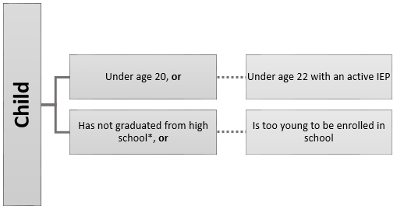

- Determine if the child made a qualifying move:
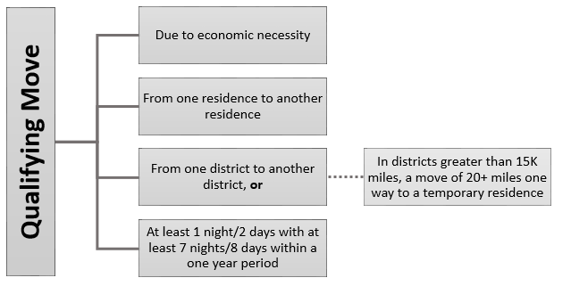

- Determine how the child made the qualifying move (either as, with , or to join a parent/guardian or spouse who is a migratory worker):
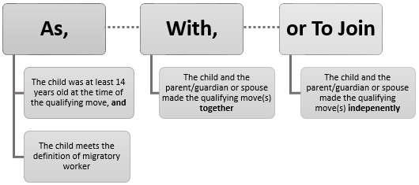
- Determine if the child, the child’s parent/guardian, or the child’s spouse meets the definition of migratory agricultural worker or migratory fisher:
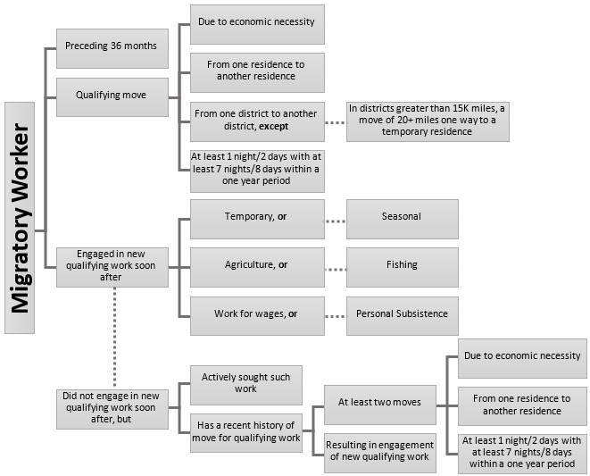

Interview Framework
Section 1: Lay the Groundwork for the Interview
Introduce Yourself Hello, my name is _____________. I work with the [DISTRICT NAME] Migrant Education Program. It is a program that is related with the local school that could help you or your children with their education. If I can speak to you for a few minutes about your family and your work, some members of your family might be eligible for services.
Build Rapport (Look for connections that you can make with the family. For example, did your children go to the same school that the children attend? Finding something positive to say about the parent or child may also help to put the family at ease.)
Credentials Here is my identification (or business card). It shows that I work for the Migrant Education Program.
Not in Sales I am not selling anything. Here is a brochure about the Migrant Education Program.
Privacy The information you share with me is private, and will be used for educational purposes only. I don’t share information with other agencies or government departments unless I have your permission to do so.
Better Time Is this a good time to talk? I can talk with you at another time if that would be more convenient.
Section 2: Transition to the Interview
Explain the Interview The Migrant Education Program helps families that have worked in agriculture or fishing. I need to ask some questions about you and your family to find out if this program can help you. For example, I’ll ask about your children’s ages, the work you’ve done, and where you have lived, and where the children have gone to school. We will talk about those things for a little while and then I will summarize what you have told me.
Repeat Questions Just to be sure that I understood what you told me, I might repeat questions, or ask for the same information in a different way.
Probes If you don't remember something, I will try to help you by asking other questions.
Documents If you have documents that have information about your family, you can use them to help you answer my questions.
Time to Recall If you don't know the answers to some of my questions, I can always call you or come by later to finish up our conversation.
Personal Information I apologize if some of the questions I’ll ask seem very personal. I don’t mean to offend you, but I need this information to see if this program can help you.

Section 3: Gather Information on Child Eligibility
Eligibility Requirements 1. The child, is eligible for free public education, and
- made a qualifying move(s) due to economic necessity across school district boundaries
- as, with or to join a parent/guardian or spouse
- who is a migratory agricultural worker or migratory fisher.
Section 4: Complete COE
Complete COE Now I want to fill out the remaining information on the Certificate of Eligibility (COE) Form for the Migrant Education Program.
Section 5: Transition to the Confirmation Process
Wrap Up You’ve been very helpful. I’m going to follow up with my office so they can decide if you and your family are eligible for the program. After all this discussion, do you have anything else to add, or any questions for me?
Introduce Summary Now I am going to summarize some of the information you told me. Please listen carefully and see if I understood the information that you provided. If I didn’t understand something you said, PLEASE let me know and I will change it.
Section 6: Confirm Responses
Confirm Data Go through each section of the COE with the parent and confirm that the information on the form is accurate. Verify all sections of the COE. Be sure to verify move dates and locations, economic necessity, and the four eligibility requirements.
Make Corrections If necessary, make corrections or clarifications to the COE based off of the information garnered while confirming COE data with the interviewee.
Section 7: Close the Interview
Remind About Privacy The information you share with me is private, and will be used for educational purposes only. I don’t share information with other agencies or government departments unless I have your permission to do so. [Additional information may be explained regarding Family Educational Rights and Privacy Act (FERPA).]
Sign COE Form If the information that I have confirmed with you is correct, the interview is now over. Would you please sign the Certificate of Eligibility (COE) form here to confirm that the information that you have provided is correct? Your signature simply means that you confirm that I’ve written what you told me.
Give Copy of COE Here is a copy of the form that I went over with you that you can keep so you have a record of the questions that I asked you. If your child/you is/are determined to be eligible, I will mail a completed copy of this form to you.

Sample Interview Script

(blank) = fill in response
= mark
[ ] = fill in prompt without asking

Interviewee’s First/Last Name:
Date of Interview:

Eligible Children in Household
- Do you have children under 20 years of age that have not graduated from high school including children who are too young to be enrolled in school?
No (Re-word the question to confirm whether all children in the household have graduated high school. If no eligible children, exit interview.)
Yes (Continue to question 2)
- Have you or anyone in your household moved or traveled from your home or another location to do fishing, logging, or agricultural activities (including berry picking) within the past 3 years?
No (Re-word the question to confirm and if none, exit interview.)
Yes (Continue to question 3)
Qualifying Move for the Migratory Agricultural Worker or Migratory Fisher
- Who was engaged in the work?

- Did anyone else outside of the household go on the move?
No
Yes (If the child was the worker, ask if the child traveled with a worker from another household. Refer to page 64 in the Recruiter Handbook for recording moves made with a guardian from another household.)

- What work specifically was the [WORKER NAME from #3] engaged in?

(Verify type of gear/activity and type of catch. Refer the Recruiter Handbook starting on page 129 for term lists. Ask about the nature of job duties if unclear.)
- When was the last time [WORKER NAME from #3] engaged in the [SPECIFIC WORK LISTED from #4]?

- Where did [WORKER NAME from #3] travel from/to for the [SPECIFIC WORK LISTED from #4]?
(City might not be an actual city. Ask names of fish camps or river, if applicable.)
  - From (Record school district, city, state):

  - To (Record school district, city, state):

  - Miles (If move was within the same district):

(The distance of 20 miles or more one way to a temporary residence does not have to be in a straight line. For example, they could be river miles.)
- How long was [WORKER NAME in #3] engaged in the [SPECIFIC WORK LISTED from #4]?

(It might be necessary to ask additional questions to determine the number of nights and length of eligible moves. “How many nights were you gone?” If less than 7 night/8 days of worker engagement, ask if there were any other additional qualifying moves where the worker engaged in qualifying fishing, agriculture, or logging activity. “Did you just go on one trip this year or did you travel more than once?”)
- Did your children travel with [WORKER NAME from #3] on the move for the [SPECIFIC WORK LISTED from #4]?
No (Continue on to question 10)
Yes (Skip to question 13)
Qualifying Move for the Child(ren)
- If no, did the children travel separately to join [WORKER NAME from #3] there?
No (Continue on to question 11)
Yes (Answer a, b, and c then skip to question 13)
- What was the date the children moved?
- What was the date the [WORKER NAME from #3] moved?
- Why did they travel on separate dates?

- If no, was one or more of the children at least 14 years old at the time of the move, and traveled to engage in the [SPECIFIC WORK LISTED from #4] themselves?
No (Continue on to question 12)
Yes (Skip to question 13)
- If no, did the children make a different move with or to join [WORKER NAME from #3]?
No (Re-word the question to confirm and if none, exit interview)
Yes (Answer a, b, and c then continue to question 12)
- If yes, what was the date of this move? (insert QAD)
- On this date, where did children and [WORKER NAME from #3] travel from? (Record school district, city, state)

- Where did the children and [WORKER NAME from #3] move to? (Record school district, city, state)

Economic Necessity of Move(s)
- Please explain how the move/trip helps your family.
(Verify that the move(s) were an economic necessity for the family. What hardships would your family encounter if not for the move?” “Why is this move a need for your family?” “What would change if you didn’t have the food/money from this move?” “Could you afford to stay in your current location without this move?” DO NOT ASK about the amount of money derived from the activity.)

Child Data
- Please list the information for the children who went on the qualifying move(s) in the table below:
First/Middle/Last Names | Birth Date | Ethnicity | School Name | Grade | Enroll Date

When to Fill Out a COE
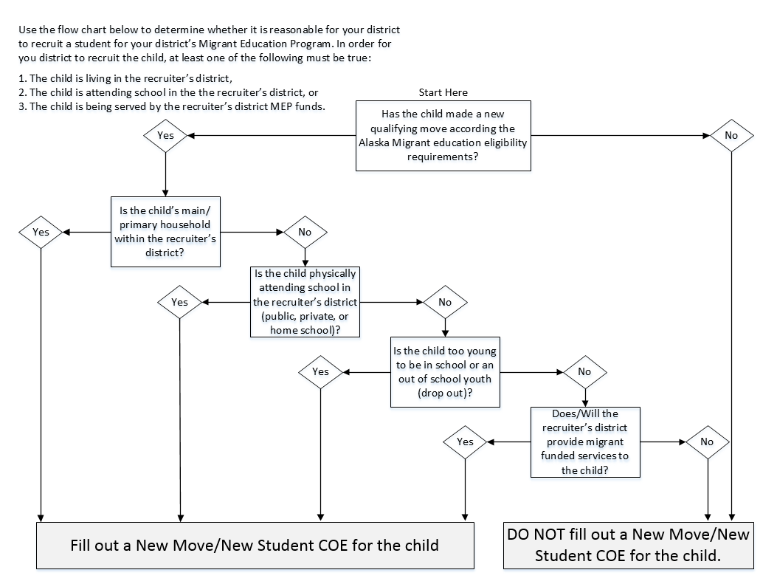

When to Fill Out an ARC
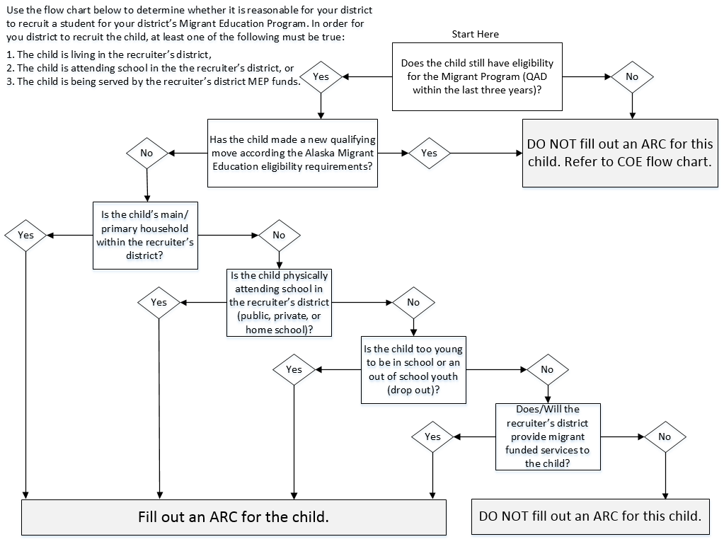

Guide to Economic Necessity and Personal Subsistence
Economic Necessity is the backbone of the Migrant Education Program. It is crucial that the recruiter verify that the moves recorded on the COE were due to economic necessity.
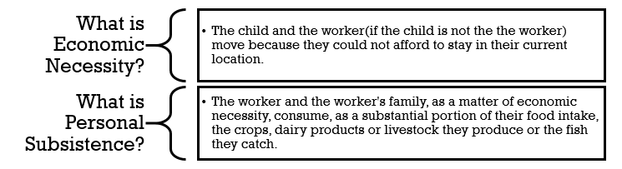
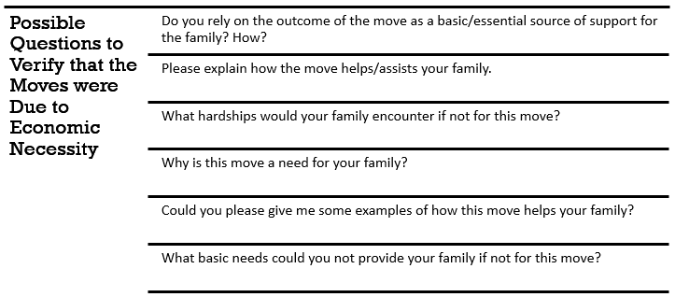
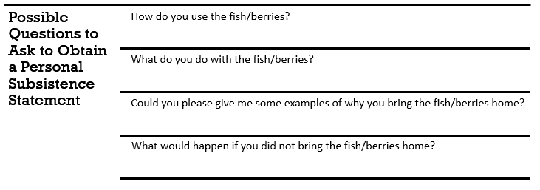

Key Charts

Gender (Sex)
Code | Definition
M | Male
F | Female
Multiple Birth (MB)
Code | Definition
Y | Yes (Twin, Triplet, or other Multiple Birth)
N | No (Single Birth)
Birth Date Verification Code (VER)
Code | Definition
1003 | Baptismal or Church Certificate
1004 | Birth Certificate
1005 | Entry in Family Bible
1006 | Hospital Certificate
1007 | Parent’s Affidavit
1008 | Passport
1009 | Physician’s Certificate
1010 | Previously Verified School Records
1011 | State Issued ID
1012 | Driver’s License
1013 | Immigration Document
1082 | Life Insurance Policy
1099 | Other
Ethnic Breakdown (EB)
Code | Definition
1 | White (Caucasian)
2 | Black or African American
3 | Hispanic/Latino
4 | Asian
5 | American Indian
6 | Alaska Native
7 | Two or More Races
8 | Native Hawaiian or Pacific Islander
Immunizations Records Flag (IM)
Code | Definition
Y | Yes (Immunizations Records on File at District)
No | No (Immunizations Records not on File at District)
Grade (GR)
Code | Definition
00 | Not Yet in School
PS | Preschool
K | Kindergarten
1 | First Grade
2 | Second Grade
3 | Third Grade
4 | Fourth Grade
5 | Fifth Grade
6 | Sixth Grade
7 | Seventh Grade
8 | Eighth Grade
9 | Ninth Grade
10 | Tenth Grade
11 | Eleventh Grade
12 | Twelfth Grade
OY | Out of School Youth
Permanent Termination Codes (Term)
Code | Definition
D | Deceased
G | Graduated
Y | Aged Out
Temporary Termination Codes (Term)
Code | Definition
M | Moved
N | Parental Refusal
O | Dropped Out
U | Unreachable
Type of Enrollment (Type)
Code | Definition
R | Regular School Year
S | Summer Program
Medical Alert Indicator (MA)
Code | Definition
C | Chronic
A | Acute
N | None

State Abbreviations Key
State | Abbreviation
Alabama | AL
Alaska | AK
Arizona | AZ
Arkansas | AR
California | CA
Colorado | CO
Connecticut | CT
Delaware | DE
Florida | FL
Georgia | GA
Hawaii | HI
Idaho | ID
Illinois | IL
Indiana | IN
Iowa | IA
Kansas | KS
Kentucky | KY
Louisiana | LA
Maine | ME
Maryland | MD
Massachusetts | MA
Michigan | MI
Minnesota | MN
Mississippi | MS
Missouri | MO
Montana | MT
Nebraska | NE
Nevada | NV
New Hampshire | NH
New Jersey | NJ
New Mexico | NM
New York | NY
North Carolina | NC
North Dakota | ND
Ohio | OH
Oklahoma | OK
Oregon | OR
Pennsylvania | PA
Rhode Island | RI
South Carolina | SC
South Dakota | SD
Tennessee | TN
Texas | TX
Utah | UT
Vermont | VT
Virginia | VA
Washington | WA
West Virginia | WV
Wisconsin | WI
Wyoming | WY

US Districts & Territories Key
District or Territory | Abbr.
American Samoa | AS
District of Columbia (Washington DC) | DC
Federated States of Micronesia | FM
Guam | GU
Marshall Islands | MH
Northern Mariana Islands | MP
Palau | PW
Puerto Rico | PR
Virgin Islands | VI

School District Boundaries
Districts with an Area Less than 15,000 Square Miles
In all school districts which have an area less than 15,000 square miles, qualifying moves must cross school district boundaries.

Anchorage School District
Annette Island School District
Bristol Bay School District
Cordova School District
Craig School District
Delta/Greely School District
Denali School District
Dillingham School District
Fairbanks School District
Galena School District
Haines School District
Hoonah School District
Hydaburg School District
Juneau School District
Kake School District
Kashunamiut School District
Ketchikan School District
Klawock School District
Kuspuk School District
Mt. Edgecumbe School District
Nenana School District
Nome School District
Pelican School District
Petersburg School District
Pribilof School District
Saint Mary’s School District
Sitka School District
Skagway School District
Tanana School District
Unalaska School District
Valdez School District
Wrangell School District
Yupiit School District

Districts with an Area More than 15,000 Square Miles
In all school districts which have an area more than 15,000 square miles, qualifying moves must cross school district boundaries or be a distance of 20 miles or more, one way to a temporary residence.

Alaska Gateway School District
Aleutian Region School District
Aleutians East School District
Bering Strait School District
Chatham School District
Chugach School District
Copper River School District
Iditarod School District
Kenai School District
Kodiak School District
Lake & Peninsula School District
Lower Kuskokwim School District
Lower Yukon School District
Mat-Su School District
North Slope School District
Northwest Arctic School District
Southeast Island School District
Southwest Region School District
Yakutat School District
Yukon Flats School District
Yukon-Koyukuk School District

Further documentation for qualifying moves in districts with an area more than 15,000 square miles must be done during the interview process. A map is required to document moves of 20 miles or more. The map must have a legend/scale for determining distance and must be attached to the original COE and be kept on file at the district office.
Districts must adopt necessary procedures to ensure the validity of the qualifying move. On the COE, the specific geographic location of the most recent qualifying move must be listed to determine eligibility.

Commercial Fishing Terms
A – Commercial Fishing Gear or Processing Activity

Beach Seining
Boxing Line Worker
Canning
Cold Storage Worker
Digging
Dinglebar
Dip Netting
Diving
Dragging
Dredging
Glazing
Drift Net
Farming
Fish Wheel
Freezing
Gillnetting
Halibut Cheeking
Hand Picking
Hand Trolling
Jigging
Laying Skates
Line Worker
Loading Dock Worker
Longlining
Packing Eggs (Roe)
Pots
Pound
Power Trolling
Preparation for Shipping
Purse Seining
Set Net
Scow
Shoveling
Smoking
Spotting
Sunken Net
Tendering
Trawling
Unload and Sort

AND
B – Type of Commercial Catch

Abalone
Arctic Cisco
Atka Mackerel
Clams
Crab
Flounder
Geoduck
Halibut
Herring
Herring Eggs
Hooligan - Smelt
Lingcod
Mussels
Octopus
Oysters
Pacific Cod
Pollock
Rockfish (Redfish)
Sablefish
Salmon
Scallops
Sea Cucumber
Sea Urchins
Shrimp
Sole
Squid
Turbot

Subsistence Fishing Terms
A – Subsistence Fishing Gear or Processing Activity

Beach Seining
Canning
Curing
Cutting
Digging
Dip Netting
Diving
Dragging
Drift Net
Drying
Fish Trapping
Fish Wheel
Freezing
Gillnetting
Hand Picking
Hand Trolling
Jigging
Laying Skates
Longlining
Pots
Pole
Purse Seining
Rendering
Set Line
Set Net
Spear
Smoking
Storing
Tendering
Power Trolling

AND
B – Type of Subsistence Catch

Abalone
Atka Mackerel
Arctic Char
Arctic Cisco
Arctic Grayling
Arctic Lampreys
Bering Cisco
Black Fish
Burbot
Clams
Crab
Dolly Varden
Flounder
Geoduck
Gumboot Chilton
Halibut
Herring
Herring Eggs
Hooligan
Lingcod
Longnose Sucker
Mussels
Oysters
Pacific Cod
Pike
Pollock
Rockfish (Redfish)
Salmon
Sablefish
Scallops
Sheefish
Shrimp
Smelt
Stickleback
Trout
Whitefish

Agriculture/Logging Terms
Logging Activities

Boom Boat Operator
Boom Manning
Booming
Bucking
Bull Bucking
Bushing
Choke Setting
Creek Clearing
Cutting
Falling
Front End Loader
Grapple Yarder Operator
Hook Tending
Log Banding
Log Chasing
Log Loader Operating
Log Scaling
Log Towing
Planting Seedlings
Rigging Slinger
Side Rodding
Skidder Operating
Soil Preparing
Tending Seedlings
Tree Thinning
Marking
Shifting
Shovel Operator

Agriculture/Crop Terms
A – Crop Work or Processing Activity

Applying Herbicides
Applying Insecticides
Breaking/Tilling Soil
Canning and Labeling
Cooking and Preserving
Cultivating/Plowing
Cutting
Digging
Fertilizing
Freezing
Growing
Harvesting
Hoeing
Irrigating
Loading
Packaging
Picking
Planting
Preparing Land
Pruning
Thinning
Washing and Sorting
Watering
Weeding

AND
B – Type of Crop

Apples
Barley
Berries
Cherries
Corn
Hay
Mushrooms
Oranges
Pine Cone Seeds
Potatoes
Tobacco
Vegetables
Wheat

Agriculture/Livestock Terms
A – Livestock Work or Processing Activity

Branding/Tagging
Cleaning Animals, Stalls, Barns, etc.
Cleaning, Maintaining Area & Equipment
Feeding, Watering and Tending
Fencing/Building & Repairing Fences
Labeling
Loading and Unloading Livestock
Packaging
Slaughtering
Weighing
Preparing for Transport to Processor

AND
B – Type of Livestock

Cattle
Horses
Reindeer

COE Comments Menu
Below are a list of the required comments needed for various scenarios, a COE could have multiple required comments. For a more detailed explanation on comments required and recommended comments refer to the Comments Section starting on page 64.
Additional Qualifying Moves
List any differences that the moves listed in the Additional Qualifying Moves Section have compared to the moves listed in the Qualifying Moves and Work Section such as different locations, qualifying work, or migratory worker (if applicable).
Provide any other clarifying information (if applicable).
Agricultural Move
Document if the immediate or extended family own the land where the migratory worker was engaged in the qualifying work.
Provide any other clarifying information (if applicable).
Child As the Worker Move
Economic necessity statement that verifies that the fish and/or income went back to support child’s main household.
Provide any other clarifying information (if applicable).
Children Not on Move / Siblings on Another COE
List any children living in the same household who did not go on the move (if applicable).
Document whether these children are listed on an ARC (if applicable).
List siblings that are on another COE due to different move dates, etc. (if applicable).
Provide any other clarifying information (if applicable).
Did Not Engage in New Qualifying Work (#4b)
Document how the migratory worker actively sought new qualifying work.
Document the migratory worker’s recent history of moves (at least 2 moves) for qualifying work.
Provide any other clarifying information (if applicable).
Extended Move (30+ days)
Verify dates of engagement in qualifying work.
Provide any other clarifying information (if applicable).
Migratory Worker Engaged in Work More than 60 Days After the Move (#4a)
Explain why worker is determined to be a migratory worker based on his or her engagement in new qualifying work more than 60 days after the qualifying move described in question 4 of the Qualifying Moves and Work Section.
Provide any other clarifying information (if applicable).
Migratory Worker (Guardian)/Different Household
Guardian’s physical address, phone number and relationship to child (P.O. Box addresses are not considered physical addresses).
Verify that the fish and/or income went back to support child’s main household and the worker’s household if qualifying work was for personal subsistence.
Guardian must be 14 years of age or older at the time of the qualifying move.
Provide any other clarifying information (if applicable).
Migratory Worker Residency Date
Document migratory worker residency date if the move listed in question 1 is different than the move listed in questions 4 of the Qualifying Moves and Work Section to show at least 7 nights/8 days of engagement in qualifying work.
Provide any other clarifying information (if applicable).
Moves Within a 15K+ District
Map with a scale is attached which verifies that the moves were at least 20 miles or more one way to a temporary residence when the moves are within a 15K+ district.
If the guardian lives in a different location then the child, a separate map with a scale for both the child and the guardian must be attached to original COE and a map comment for both the child and guardian must be provided.
Provide any other clarifying information (if applicable).
Multiple Middle Names
List child’s full name if it does not fit in the Child Data Section (if applicable).
Provide any other clarifying information (if applicable).
Multiple Migratory Workers
Verify that each migratory worker has engaged in migratory work for 7 days/8 nights within a one-year period.
Provide any other clarifying information (if applicable).
Not Attending School in Recruiting District
Document school name.
Document district name (if public school in state of Alaska).
Provide any other clarifying information (if applicable).
Permanent Move
Document the actual dates of engagement in qualifying work.
Provide any other clarifying information (if applicable).
Personal Subsistence (#5*)
Document if the worker and the worker’s family, as a matter of economic necessity, consume, as a substantial portion of their food intake, the crops, dairy products, or livestock they produce or the fish they catch.
Provide any other clarifying information (if applicable).
Pole Fishing
Verify that the pole was not used for either sport or recreation. Pole must only be used for subsistence purposes.
Provide any other clarifying information (if applicable).
Temporary Employment (#6a or 6b)
Verify the method of determining that the work was temporary
Worker’s Statement
Employer’s Statement
Provide any other clarifying information (if applicable).
To Join/Precede Worker (#2bi)
Verify the reason for child to either join/precede worker.
Provide any other clarifying information (if applicable).

School Name/Enroll Date/Grade Flowchart
Below is a flow chart showing different scenarios on how to fill out the School Name, Enroll Date and Grade on the COE/ARC. Further information is available showing School Name/Enroll Date/Grade Scenarios starting on page 45.
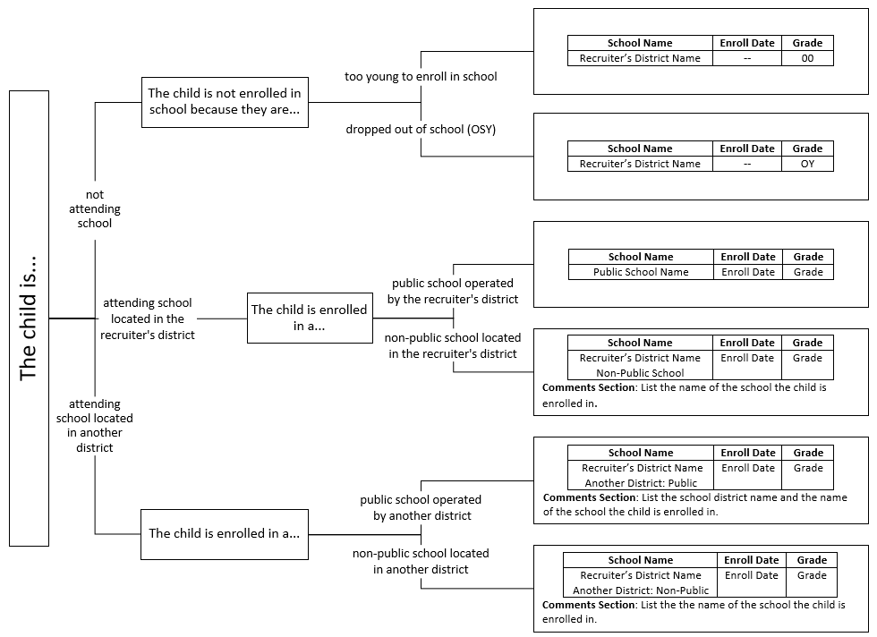

Alaska School District Map
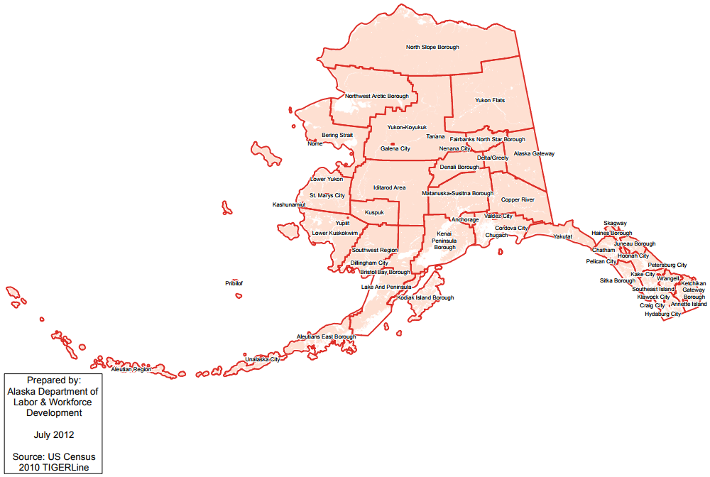

Calendars

Migrant Education Office (MEO) Contact Information
Mailing: P.O. Box 110500 Juneau, Alaska 99811-0500 | Physical: 801 West 10th St. Suite 200, Juneau, AK 99801
Website: education.alaska.gov/esea/titlei-c

Migrant Education Staff | Contact Information
Sarah Emmal, Migrant Program Manager
sarah.emmal@alaska.gov
907-465-3826
Program Guidance and Questions
Funding – Awards and Budget Approvals
Grants Management System (GMS)
Schoolwide Consolidation
State Parent Advisory Council (PAC)
ESEA Monitoring
ESEA Federal Programs Weekly Newsletter

Amanda Mosher Schmitz, Data Specialist
amanda.mosher.schmitz@alaska.gov
907-465-2885
MIS2000 - Connection Issues, Technical Assistance, Reports
Reports - Mass Withdrawal, Summer Withdrawal, Course History, Fall Recruitment, Priority for Service
Participation Rate, Summer OASIS, Fall OASIS
MSIX
Fall Training
Technical Assistance Visits

Chris Mariano, Identification & Recruitment Specialist
chris.mariano@alaska.gov
907-465-5531
Re-interviewing - Statewide and Technical Assistance Calls
Literacy Grant – Applications and Final Reports
Fall Training
Technical Assistance Visits
COE Quality Control Review
Newsletter, Website, and Email Contact List

Jannessa Luerra, Eligibility Specialist
jannessa.luerra@alaska.gov
907-465-8231
COEs - MIS2000 Entries, Eligibility Determinations, COE Submissions
Eligibility Questions
Fall Training Registration and Reimbursement
MIS2000 Technical Assistance
Migrant Forms: Remote Access, SEA Reviewer, and Web System Access
Web System User Account

ESEA §1301.
Non-Regulatory Guidance, Chapter II, #E1.
To be eligible for migrant recruitment, a child must be eligible for a free public education. In Alaska, this means that the child must be younger than 20 and must not have a high school diploma. A child who has a Certificate of Achievement or GED, but not a high school diploma, is eligible for a free public education. A child who is eligible for special education (active IEP on file) is entitled to a free public education until the age of 22.
In all school districts that have an areas less than 15,000 square miles, qualifying moves must cross school district boundaries. In school districts that have an area greater than 15,000 square miles, qualifying moves must cross school district boundaries or be a distance of 20 miles or more one way to a temporary residence.
AS §14.03.070 and AS §14.03.080
Non-Regulatory Guidance, Chapter II, #D3.
Non-Regulatory Guidance, Chapter II, #D2.
Non-Regulatory Guidance, Chapter II, #D5.
Non-Regulatory Guidance, Chapter II, #D15.
Non-Regulatory Guidance, Chapter II, #E2.
Non-Regulatory Guidance, Chapter II, #E2.
Non-Regulatory Guidance, Chapter II, #E2.
Non-Regulatory Guidance, Chapter II, #B2.
Non-Regulatory Guidance, Chapter II, #B3.
Non-Regulatory Guidance, Chapter II, #E4.
Non-Regulatory Guidance, Chapter II, #E2.
ESEA §1309(2)
ESEA §1309(4)
Non-Regulatory Guidance, Chapter II, #C5.
Non-Regulatory Guidance, Chapter II, #C7.
Non-Regulatory Guidance, Chapter II, #C10.
Non-Regulatory Guidance, Chapter II, #C11.
Non-Regulatory Guidance, Chapter II, #C16.
Non-Regulatory Guidance, Chapter II, #C15.
Non-Regulatory Guidance, Chapter II, #C17.
Non-Regulatory Guidance, Chapter II, #C18.
34 C.F.R 200.81(n)
34 C.F.R 200.81(p)
34 C.F.R 200.81(o)
34 C.F.R 200.81(m)
34 C.F.R 200.81(a)
Non-Regulatory Guidance, Chapter II, #F2.
Non-Regulatory Guidance, Chapter II, #F3.
MEP Policy Q&As, April 2018.
Non-Regulatory Guidance, Chapter II, #F4.
Non-Regulatory Guidance, Chapter II, #F6.
Non-Regulatory Guidance, Chapter II, #F7.
Non-Regulatory Guidance, Chapter II, #F20.
Non-Regulatory Guidance, Chapter II, #F21.
Non-Regulatory Guidance, Chapter II, #F22.
Non-Regulatory Guidance, Chapter II, #F24.
Non-Regulatory Guidance, Chapter II, #F9.
Non-Regulatory Guidance, Chapter II, #F10.
Non-Regulatory Guidance, Chapter II, #F11.
Non-Regulatory Guidance, Chapter II, #F12.
Non-Regulatory Guidance, Chapter II, #F13.
Non-Regulatory Guidance, Chapter II, #F4.
Non-Regulatory Guidance, Chapter II, #F15.
34 C.F.R 200.81(c)
Non-Regulatory Guidance, Chapter II, #F19.
Non-Regulatory Guidance, Chapter II, #F17.
Non-Regulatory Guidance, Chapter II, #F18.
Non-Regulatory Guidance, Chapter II, #F20.
Non-Regulatory Guidance, Chapter II, #F23.
Non-Regulatory Guidance, Chapter II, #F24.
If the worker did not engage in new qualifying work soon after the move, the worker must have: - actively sought new qualifying work, and - a recent history of moves for qualifying work.
Pole fishing is acceptable subsistence migratory work. However, a statement is required in the Comments Section verifying that the pole was not used for either sport or recreation.
Berries – Subsistence berry picking is different from agricultural berry picking. Agricultural berry picking is usually performed for wages.
*GED and certificate of achievement are not considered the same as graduating with a high school diploma.
To be eligible for migrant recruitment, a child must be eligible for a free public education. In Alaska, this means that the child must be younger than 20 and must not have a high school diploma. A child who has a Certificate of Achievement or GED, but not a high school diploma, is eligible for a free public education. A child who is eligible for special education (active IEP on file) is entitled to a free public education until the age of 22.
In all school districts that have an areas less than 15,000 square miles, qualifying moves must cross school district boundaries. In school districts that have an area greater than 15,000 square miles, qualifying moves must cross school district boundaries or be a distance of 20 miles or more one way to a temporary residence.
A child who has an active IEP on file is entitled to a free public education until the age of 22.
A child who has a Certificate of Achievement or GED, but not a high school diploma, is eligible for a free public education.
In all school districts that have an areas less than 15,000 square miles, qualifying moves must cross school district boundaries. In school districts that have an area greater than 15,000 square miles, qualifying moves must cross school district boundaries or be a distance of 20 miles or more one way to a temporary residence.
The length of the qualifying move(s) must be at least one night/two days, with a total of at least seven nights/eight days within a one-year period.
Reminder: the move that the child makes with the worker does not have to be the move that was made to engage in the work.
Economic necessity means that the child and the worker move because they could not afford to stay in their current location.
Pole fishing is acceptable subsistence migratory work. However, a statement is required in the Comments Section verifying that the pole was not used for either sport or recreation.
Berries – Subsistence berry picking is different from agricultural berry picking. Agricultural berry picking is usually performed for wages.

