Migrant Eligibility Survey
- Has anyone in your family been involved in any of the following activities during the past three years (check all that apply)?
Subsistence fishing
Commercial fishing
Cannery work
Subsistence berry picking
Logging
Other agricultural or farm work
- Have your children (birth to not yet graduated) made an overnight trip or moved within the past 3 years with you, someone at least 14 years old, or by themselves?
Yes
No
- If yes, when was the most recent trip or move?

If you answered yes to the questions above, a migrant recruiter may contact you to find out if your child is eligible for the Migrant Education Program. Final eligibility determination is made by the Alaska Migrant Education Office. Only one survey per family needed.
Family Information
Parent/Guardian:
Phone Number:
Best Time to Call:
Names & Grades of Children:

Return this survey to your school secretary
Address Information
Recipient Name
Street Address
City, State, ZIP Code
Company Name
Street Address
City, State, ZIP Code

Alaska Migrant Education Program
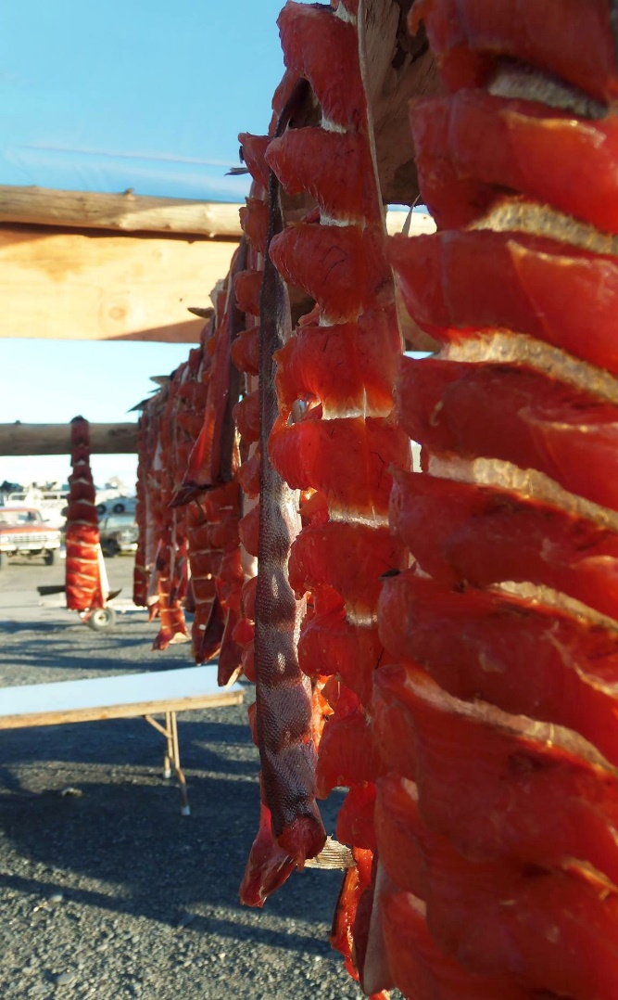
Cut fish hanging for drying at the dock of the Unalakleet River
Photo credits to Francine Johnson
PROVIDED BY:
State of Alaska Migrant Parent Advisory Council
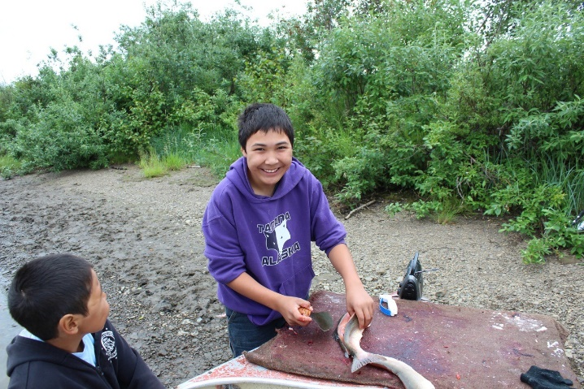
Subsisting on the Unalakleet River
Duncan Ivanoff cutting the fish and little brother Mason ivanoff looking on. Photo Creds to mother Dorothy Ivanoff of Unalkleet
Migrant Education

Overview
The primary goal of the Migrant Education Program is to ensure that all migrant students reach challenging academic standards AND graduate with a high school diploma that prepares them for responsible citizenship, further learning, and productive employment.
Parent Advisory Council
If you are interested in contacting your local parent representative or attending a statewide Migrant Parent Advisory Council meeting, please access our website
(education.alaska.gov/ESEA/TitleI-C/pac.html).

Quick Facts

In Alaska
- About 13,000 children are currently eligible for the Migrant Education Program in Alaska
- 41 school districts across the state of Alaska participate in the Migrant Education Program
- The most common type of gear used by Alaska migrant families is a Set Net
- Salmon is the number one catch for Alaska migrant families
- Whitefish is the number two catch for Alaska migrant families
Program Services

Possible Services
- Eligibility for free school meals
- Migrant Education Literacy Grant
- Academic enrichment activities
- Tutoring
Each district offers different services to migrant children. Please contact your local school or district office for more details.
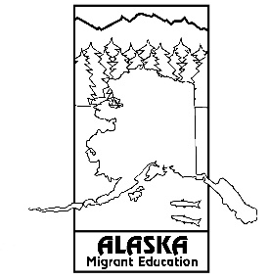
Summer Calendar

June 2019
Su | M | Tu | W | Th | Fri | Sat
 |  |  |  |  |  | 1
2 | 3 | 4 | 5 | 6 | 7 | 8
9 | 10 | 11 | 12 | 13 | 14 | 15
16 | 17 | 18 | 19 | 20 | 21 | 22
23 | 24 | 25 | 26 | 27 | 28 | 29
30

July 2019
Su | M | Tu | W | Th | Fri | Sat
 | 1 | 2 | 3 | 4 | 5 | 6
7 | 8 | 9 | 10 | 11 | 12 | 13
14 | 15 | 16 | 17 | 18 | 19 | 20
21 | 22 | 23 | 24 | 25 | 26 | 27
28 | 29 | 30 | 31

August 2019
Su | M | Tu | W | Th | Fri | Sat
 |  |  |  | 1 | 2 | 3
4 | 5 | 6 | 7 | 8 | 9 | 10
11 | 12 | 13 | 14 | 15 | 16 | 17
18 | 19 | 20 | 21 | 22 | 23 | 24
25 | 26 | 27 | 28 | 29 | 30 | 31

September 2019
Su | M | Tu | W | Th | Fri | Sat
1 | 2 | 3 | 4 | 5 | 6 | 7
8 | 9 | 10 | 11 | 12 | 13 | 14
15 | 16 | 17 | 18 | 19 | 20 | 21
22 | 23 | 24 | 25 | 26 | 27 | 28
29 | 30

