Alaska Statewide Assessments
Monitoring Guide

Updated for Spring 2024

Table of Contents
Purpose 3
Statewide Assessment Monitoring 4
Monitoring Schedule 4
Monitoring Process 4
Indicator 1: Test Administration 5
Indicator 2: Test Security 6
Indicator 3: Test Administration for Special Populations – Students with Disabilities and English Learners 6
Indicator 4: Assessment Participation 7
Indicator 5: Assessment Reports 7
Appendix A: Notification Letter 8
Appendix B: Documentation Submission Process 9
Appendix C: How to Drop-Off Files Securely Using ZendTo 10
Appendix D: Laws and Regulations Related to this Monitoring Guidance 14

Purpose
The United States Department of Education mandates that states have a plan and process in place to monitor assessment administration. In order to comply with federal requirements, DEED has been working on creating and planning what assessment monitoring will look like in our state. Beginning in fall of 2019, districts in Alaska will begin the monitoring process for the first time.
During the monitoring process, districts will be asked to provide various pieces of evidence that prove the district is following the requirements, regulations, and procedures regarding assessment. After receiving district evidence, DEED will provide districts with feedback and suggestions for improvement. The purpose is not to seek out what districts are doing wrong; the purpose of monitoring is to validate areas of excellence and support areas in need of improvement.
DEED feels very strongly that the indicators within the monitoring document should be a reflection of what is already happening in schools. Monitoring is a procedural method of looking at a district’s practices as a whole. More than a requirement, monitoring is an opportunity for DEED and school districts to work together to ensure standardized assessment administration and test security of the very highest caliber.

Statewide Assessment Monitoring

Monitoring Schedule
The monitoring schedule will be posted to the DEED Assessments Monitoring webpage. The schedule is subject to change. In the spring of each year, DEED will notify districts that will be monitored in the coming year. Notification will be in the form of a letter to the superintendent and District Test Coordinator. In addition to the deadline of submission, the letter will also contain the list of schools within the district selected for monitoring. Reminders will be sent each fall.
Five to seven districts will be monitored each year. Of the districts to be monitored within a particular year, a number of school sites within the district will be included in the monitoring process. In addition to districts scheduled to be monitored, DEED reserves the right to select districts and/or schools based on the following criteria from the prior testing year:
- Observed statistical irregularities or discrepancies with student assessment data (e.g., high growth in percent of students scoring proficient, questionable erasure analysis, change in student demographics)
- An established pattern of testing violations as reported to DEED (e.g., vendor reports, invalidations, improper test administration, failure to attend or conduct yearly training)
- Documented concerns (e.g., parent and community, noncompliance issues from prior years, other technical assistance requests) and/or;
- Testing irregularities discovered through previous monitoring.

Monitoring Process
DEED will conduct monitoring utilizing data and evidence submitted to DEED by the district. DEED also reserves the right to conduct on-site monitoring for any assessment at any time.
The test administration year being monitored will be the most recent administration. For example, in school year 2020-2021, the test administrations being monitored will be spring 2020.
One webinar will be hosted for each district, if requested, after monitoring notification to review the monitoring process and timeline for submission, and one webinar, if requested, will be hosted to follow-up after the process is complete to discuss the status of the district’s submission.
All documentation must be received by DEED by the date indicated in the notification letter. Documentation may only be submitted in electronic format. See Appendix B for the Documentation Submission Process.
DEED may use the following steps to review evidence received:
- Review all submitted documentation required by the District Monitoring Form.
- Collaborate with various DEED teams to cross check data (e.g., Special Education, ESEA Federal Programs, Data Management)
- Work with testing vendors to reference data files.
DEED will provide monitoring results to the superintendent and District Test Coordinator. A letter sent to the district will inform the district of the monitoring status. The status of “compliance” will be given if all requirements have been met and the evidence is complete and valid. If any indicator is found deficient with additional monitoring or documentation being required, a “noncompliant’ status will be indicated.
Districts that provide complete and valid evidence and receive a status of ‘compliant’ during the monitoring process will return to the scheduled 10-year cycle. Districts that do not provide complete and valid evidence of successful accountability will have some form of monitoring until sufficient evidence is obtained. Repeated noncompliance with state and federal regulations may result in: on-site visitations, repeated monitoring and/or other consequences as determined by DEED.
Download the current year’s Statewide Assessments Monitoring District Response Form from the DEED Forms page under the Assessments section or the DEED Assessments Monitoring webpage. This form is also attached to the official monitoring notification letter.
Review all the monitoring indicators on the District Response Form.
Enter brief comments or explanations in the “District Response” row of the form that will further explain the supporting documentation and district procedures. This document must be submitted as a Microsoft Word document.
Collect the appropriate information to document the district’s compliance with that indicator. Documentation should be from the most recent spring administration. Evidence should be specific enough to provide the reader with an accurate description of what procedures are in place. Providing only a copy of the DEED’s policy and that it will be in effect is incomplete. Complete and valid evidence would include a written description indicating how the site implements the policy. If appropriate, steps can be bulleted or numbered instead of written in a paragraph.
A brief description of each indicator is provided below.

Indicator 1: Test Administration
Standardized administration of statewide assessments is crucial to maintaining the quality of data that is collected by each assessment. Certainty that all students are tested under the same conditions ensures that valid and reliable inferences can be made from the data collected by each assessment.
Indicator 1 asks districts to provide evidence related to test administration and standardized procedures. The regulation that covers this indicator (4 AAC 06.761) requires districts to administer all required assessments and to follow specific procedures related to test centers, training of district employees for test administration, building test coordinators, and test security agreements for employees involved with assessment.
Evidence that fulfills the requirements of Indicator 1 must include lists of assessments administered in the district and where the assessments occurred (i.e. schools, alternate test centers), school and district test calendars, proof of training, signed Test Security Agreements (TSAs), and documentation of how trainings and TSAs were tracked. Examples of proof of training might include PowerPoint slides used for training and sign in sheets with attendee signatures. Examples of how training and TSAs were tracked might include a spreadsheet with names of employees that were checked off when requirements were met. Please do not provide written procedures without accompanying documentation that communicates to DEED how these procedures were carried out.

Indicator 2: Test Security
Test security is another important consideration of standardized administration and maintaining data quality. Test security – avoiding cheating or exposure of assessment items at multiple levels of administration – is essential to guaranteeing the integrity of assessment data.
Indicator 2 asks districts to provide evidence related to test security and the consequences of a test security breach, an event that results in the inappropriate exposure of test items or that could potentially impact the accuracy of test results. The regulation that covers this indicator (4 AAC 06.765) requires districts to keep all test materials (paper- and computer-based) secure; to train Test Administrators on test security-related topics; to create and disseminate an electronic devices policy; to immediately report and document any irregularities; and to maintain confidentiality of student information, test materials, and assessment results.
Evidence that fulfills the requirements of Indicator 2 must include documentation of how secure materials were received as well as inventoried, stored, and tracked for chain-of-custody during administration – from district receipt, distribution to schools and students, collection, and return. Evidence that fulfills the requirements of this indicator also includes proof of training that includes test administration procedures and test security, assessment logs and irregularity reports (or similar), assessment observation forms, and description of how confidentiality of results is maintained.
Some elements of the District Monitoring Form require specific pieces of evidence, such as an electronic devices policy. Other requirements allow for some variation between districts and schools, such as “Daily Check-in/Check-out Worksheet (or similar documentation)” or “Assessment Log and Irregularity Reports or similar method of tracking assessment irregularities.” Some criteria may be satisfied by written description. Please provide actual documentation and evidence when possible, and use the District Response form field for clarifications or to provide written description where appropriate.

Indicator 3: Test Administration for Special Populations – Students with Disabilities and English Learners
Indicator 3 asks districts to provide evidence related to assessment of students with disabilities and English Learners. The regulation that covers this indicator (4 AAC 06.775) requires districts to follow all guidance outlined in the department’s Participation Guidelines for Inclusion of Alaska Students in State Assessments. The regulation also requires districts to provide students with appropriate accommodations – as determined by an IEP or 504 plan team – when testing students, and to document all provided accommodations. An additional regulation (4 AAC 06.776) for this indicator requires schools to appoint a team to determine what accommodations should be provided for students who are English learners for the content area assessment.
Evidence that fulfills the criteria for Indicator 3 must include examples or a written description of how student accommodations are provided for students with disabilities and English Learners, proof that all test administrators received training on administering accommodations, an example or written description of how IEP teams determine whether or not a student should take the alternate assessment, how test administrators know which students need which accommodations, and documentation of accommodations provided during assessment.
Examples of acceptable evidence might include, but are not limited to, district established forms or checklists that are completed for each student indicating what accommodations are to be provided for each assessment throughout the school year, completed Alternate Assessment Participation Criteria checklists for students, and training presentation slides showing requirements for providing students accommodations during testing.

Indicator 4: Assessment Participation
Indicator 4 asks districts to submit evidence related to participation in assessments. This indicator reflects requirements for districts to administer assessments to all eligible students. All districts must administer the statewide standards based assessments (currently AK STAR and Alaska Science Assessments) or alternate assessment (currently DLM), the ELP assessment (currently WIDA ACCESS for ELLs) for students who are English learners, and the early literacy screener (currently mCLASS DIBELS 8) to all students in grades K-3. Schools or districts may not systematically exclude students from assessment. See Alaska Statute Sec. 14.03.016. A parent’s right to direct the education of the parent’s child.
Evidence that fulfills the criteria for Indicator 4 must include documentation of how special circumstances (Do Not Score Codes) are tracked and documented, school and district testing schedules, and description of how students needing to be assessed are tracked. Evidence must also include participation rates and district/school plans to address low participation in any schools, as applicable.
Examples of acceptable evidence might include, but are not limited to, spreadsheets or written lists of students who didn’t test and which special circumstance, or Do Not Score codes need to be entered, family outreach about the importance of assessment, and the district’s process for parents to indicate refusal for student to participate in each assessment.

Indicator 5: Assessment Reports
Indicator 5 asks districts to submit evidence related to providing assessment results to schools, families, and educators.
Evidence that fulfills the criteria for Indicator 5 must include a description of how reports are disseminated to parents, families, schools, and educators and maintaining confidentiality of assessments results.
Examples of acceptable evidence might include, but are not limited to, sample letter sent home to parents accompanying the individual student reports or an email sent to parents notifying results have been posted in PowerSchool.

Appendix A: Notification Letter
Dear (Name of Superintendent),

The United States Department of Education requires all states to monitor and ensure fidelity in assessment administration and security practices. To meet these requirements, the Alaska Department of Education and Early Development (DEED) will be conducting monitoring of the Alaska System of Academic Readiness (AK STAR), the Alaska Science Assessment, Dynamic Learning Maps (DLM), ACCESS for ELLs, and Alternate ACCESS.
Your school district has been selected for review of the spring 20XX administration.
The monitoring process will include document review at the district, and the following schools:
- [List of schools]

Please use the attached monitoring form when gathering district and school documentation. Additional information about the monitoring process can be found in the Alaska Statewide Assessment Monitoring Guide located on the DEED Assessment Monitoring webpage.
To assist you in the monitoring process, DEED will work with your district to schedule a webinar to review requirements, the submission process, and discuss any questions you may have. It is expected that, at the time of the webinar, those in attendance will have read through, and be familiar with the guidance provided with this letter. Someone from the Assessments team will work with your District Test Coordinator in the coming days to schedule the webinar.
DEED is looking forward to working with you throughout the monitoring process. Please do not hesitate to contact Elizabeth Greninger, Assessments Administrator at elizabeth.greninger@alaska.gov or 465-8728 if you have any questions or concerns prior to the aforementioned webinar.
Sincerely,

Elizabeth Greninger, Assessments Administrator

Appendix B: Documentation Submission Process
Electronic submission of documentation is required. Documents may be scanned or saved as PDF files, Word, or Excel as applicable. Label/title each document with the corresponding indicator name. Organize the documents in folders by indicator.
Your file structure should look like this:
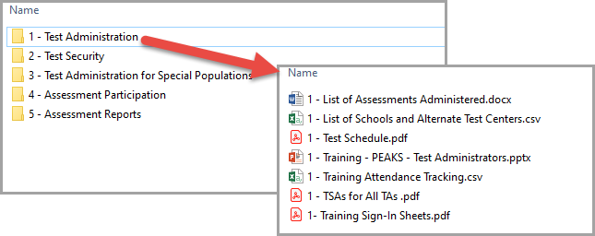
For documents that will be used to address more than one indicator, include the document only once in your submission. A document may be used as evidence for more than one indicator by referencing the document by name in the District Response Form. Links to sources of evidence found online may also be provided on the District Response Form.
• ZendTo: Districts must send documentation via the State’s secure drop box ZendTo at drop.state.ak.us. Instructions for sending files to DEED using ZendTo are included in Appendix C of this document.
• Google Docs: This method is available for districts to submit their evidence to DEED. Folder must be created by the district or by DEED. File structure should still follow the above.
- Direct email of documentation is not allowed. Some documentation is likely to include sensitive information and therefore, should not be sent via unsecured email.

Appendix C: How to Drop-Off Files Securely Using ZendTo
- Go to ZendTo (drop.state.ak.us/drop)
- Click on “Drop-off”

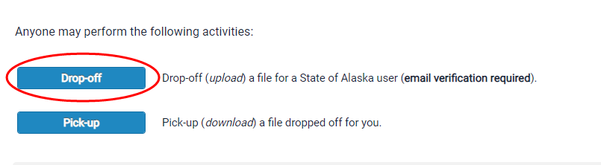

- On the next page, enter in your name, your school district, and your email address.

- At the bottom of the screen, you will be asked to confirm that you are a real person by clicking the Captcha box “I’m not a robot”.

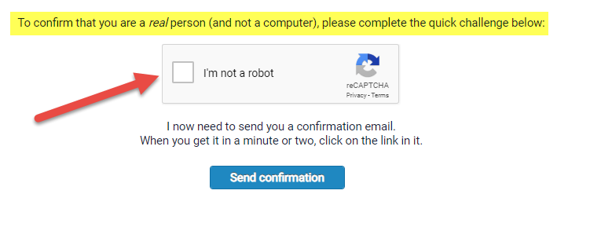

- Click “Send Confirmation”.
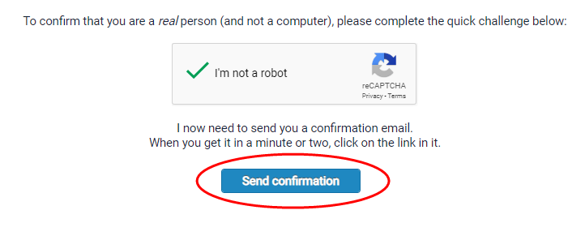
- The next page confirms that an email has been sent to the email you entered from ZendTo. This email should arrive just moments after this screen. 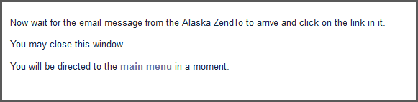
- This is an example of what this email referenced above looks like. Click on link to be re-directed to the ZendTo site.
- In the pop up window type Rachel Schweissing and the email rachel.schweissing@alaska.gov then click “Add & Close”.
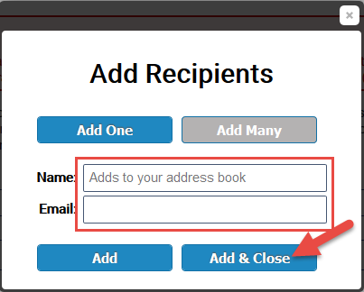
The recipient will appear in the ‘To’ field.
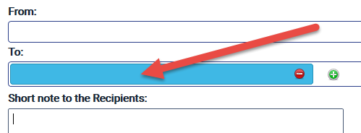
- Attach the file you wish to send by dragging the file onto the screen or clicking “Click to Add Files or Drag Them Here.”
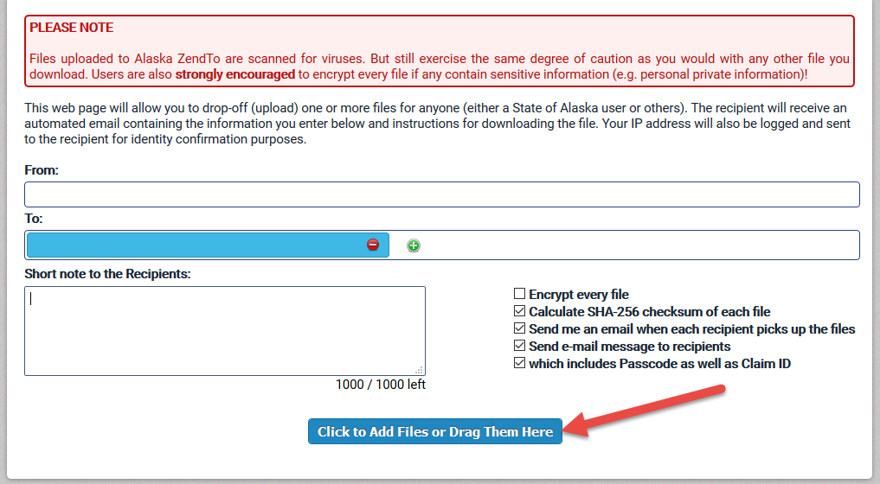

- If you choose the Click to Add Files button, then select the file you wish to send.
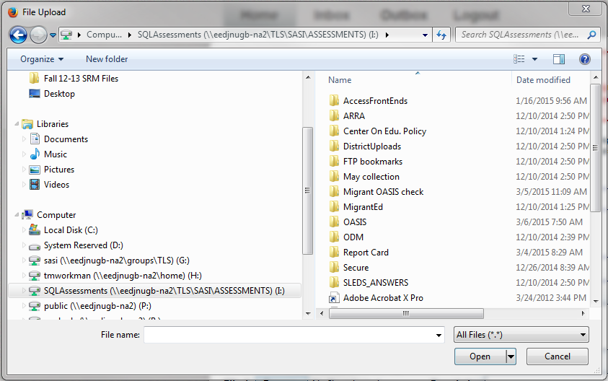

- After you select a file, it will appear under Filename. Follow steps 9 and 10 for each file you wish to send.
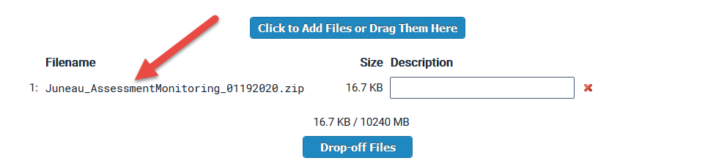

- After you are finished uploading files, you may choose to write a short note to the recipient(s) in the box. When you are finished, click ‘Drop off Files’.
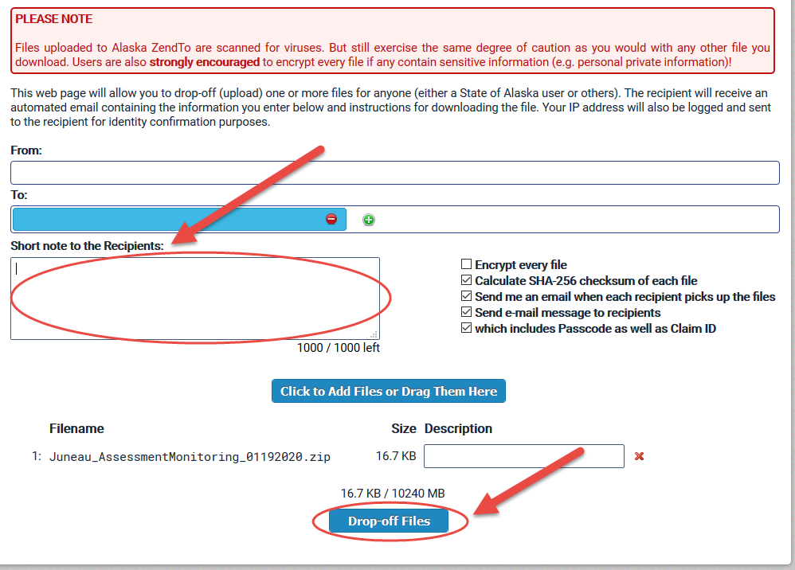

Appendix D: Laws and Regulations Related to this Monitoring Guidance
4 AAC 06.710. Statewide student assessment system
The commissioner will develop a statewide student assessment system composed of multiple indicators that include
(1) a standards-based test to measure student attainment of the state's standards as described in 4 AAC 06.737(a);
(2) an alternate assessment under 4 AAC 06.775(b);
(3) biennial participation in the national assessment of educational progress in mathematics and reading in grades four and eight; and
(4) the assessments included in 4 AAC 34.055 to identify English language proficiency; and
(5) a statewide screening tool as described in AS 14.30.760 and 4 AAC 06.400.
4 AAC 06.737. Standards-based test
(1) The commissioner will select a standards-based test to estimate the degree to which students have mastered the state's standards for English language arts, mathematics, and science. For school years after school year 2013 - 2014, the standards-based test must test for mastery of the English language arts, mathematics, and science standards adopted by reference in 4 AAC 04.140(a). Except for students eligible for an alternate assessment under 4 AAC 06.775(b), each district shall administer the standards-based test in English language arts, and mathematics annually to every student in grades three through eight and in one or more years, as determined by the commissioner, in grades nine through 12, and each district shall administer the standards-based test in science annually to every student in grades five, eight, and ten. A school that does not assign students to grade levels shall assess students using the grade-level assessment that would apply if the school had standard grade levels based upon the number of years a student has been enrolled in school.
4 AAC 06.738. Assessment results.
(a) Except as provided by this section, all student assessment results as described in 4 AAC 06.710 are confidential and may not be disclosed by a district except as provided by 34 C.F.R. Part 99, dealing with family educational rights and privacy.
(b) The commissioner shall compile the results of the standards-based test, alternate assessment, and English language proficiency assessments by school district, school, classroom, and individual, and shall annually provide school results to the board and the legislature.
(c) The commissioner shall provide to a school district the district, school, classroom, and individual student results for the district.
(d) After receiving test results from the commissioner or test publisher, a school district shall distribute
(1) class and individual student results to each teacher, for the teacher's classes and students not later than the date decided by the commissioner and announced by the department; and
(2) individual student results to each student's parents not later than the date decided by the commissioner and announced by the department.
4 AAC 06.761. Test administration
(a) Unless an assessment is specifically exempted, or the department has approved in writing a different process, a district shall administer the statewide assessments described in 4 AAC 06.710 in conformance with the requirements of this section.
(b) A district shall administer an assessment under this section only in a school test center designated by each district. Each school test center must be secure, free of disruptions, have an established seating arrangement, and be well lighted. Only designated district test coordinators, associate test coordinators, proctors, or test administrators may be in the test center rooms at the time of testing students.
(c) Each district shall designate an employee of the district as the district test coordinator. In districts with two or more school test centers, the district shall designate an on-site associate test coordinator for each center. The district test coordinator or associate test coordinator shall assign as many test administrators or proctors to each school test center as necessary to ensure adequate supervision or monitoring of students taking the assessment. Each test coordinator, associate test coordinator, proctor, and test administrator must execute an agreement, on a form provided by the department, affirming that the test procedures of the department and test publisher will be followed.
4 AAC 06.765. Test security; consequences of breach
(a) All test questions on norm-referenced tests, standards-based tests, and the high school graduation qualifying examinations, which are provided for in 4 AAC 06.700 - 4 AAC 06.790, the college and work preparedness assessment provided for in 4 AAC 06.717, and on the English language proficiency assessment provided for in 4 AAC 34.055, are confidential, and may be disclosed only as provided in this section.
(b) Test questions may be disclosed to
(1) a student on the date and at the time specified by the commissioner, to the extent necessary to administer the test;
(2) testing personnel in the course of fulfilling their duties;
(3) a department official as required for the performance of that official's duties; and
(4) a test administrator if necessary to fulfill duties under 4 AAC 06.775 regarding the delivery of accommodations.
(c) School and district personnel responsible for test administration shall
(1) inventory and track test materials from the time the materials arrive at the school or district office until the time the materials are returned to the test publisher;
(2) securely store tests before distribution to school test centers and after their return;
(3) control distribution of tests to and from school test centers;
(4) control the storage, distribution, administration, and collection of tests;
(5) ensure that no test or test question is copied in any manner, whether on paper or by electronic means.
(d) School personnel at a school test center shall
(1) code the tests according to test administration directions before testing;
(2) inventory and track test materials from the time the materials arrive at the school until the time the materials are returned to the district;
(3) securely store tests before and after each testing session;
(4) control distribution of tests within the school test center;
(5) ensure that no test or test question is copied, reproduced, or paraphrased in any manner by an examinee or anyone else;
(6) ensure that examinees use only those reference materials allowed by the test publisher's testing procedures;
(7) ensure that no individual receives a copy of the test, or learns of a specific test question or item, before the test date and time set by the commissioner, unless knowledge of the question or item is necessary for delivery of accommodations under 4 AAC 06.775;
(8) ensure that examinees do not exchange information during a test, except when the test procedure so specifies;
(9) ensure that an examinee's answer is not altered after testing is completed;
(10) ensure that no examinee is assisted in responding to or review of specific test questions or items before, during, or after a test session.
(e) A teacher holding a certificate issued under 4 AAC 12 who breaches security as described in this section is subject to investigation and adjudication by the Professional Teaching Practices Commission.
(f) School and district personnel responsible for test administration shall
(1) annually execute an agreement, on a form provided by the department, affirming that they will follow the test procedures required under this section;
(2) provide training in test procedures to all district staff involved in testing as directed by the department, and ensure that staff complete the training;
(3) ensure that all district staff involved in testing read and follow all testing procedures and manuals published by the test publisher, unless instructed otherwise by the department.
(g) All school and district personnel shall maintain the security and confidentiality of electronic test data files, individual student reports, and other testing reports designated as secure.
(h) District personnel in charge of testing shall immediately report any breach of test security to the department. If a student's IEP requires a modification that violates test security under this section, the modification will be provided only if it does not affect test security for any students other than the student who requires the modification. A modification that violates test security under this section results in an invalid assessment and the assessment will not be scored.
4 AAC 06.775. Statewide assessment program for students with disabilities
(a) When administering to students with disabilities the statewide assessments under 4 AAC 06.710, a district shall follow the requirements of this section and the department's Participation Guidelines for Inclusion of Alaska Students in State Assessments, adopted by reference.

(b) The commissioner shall select an alternate assessment for use in this state, to be known as the Alaska Alternate Assessment, for assessment of students with significant cognitive disabilities who are not able to complete either regular curricular offerings or substitute courses under 4 AAC 06.078 that would lead to a diploma. A student's eligibility for the Alaska Alternate Assessment shall be established in the student's IEP in accordance with the criteria in the Participation Guidelines for Inclusion of Alaska Students in State Assessments, adopted by reference in (a) of this section. Each district shall administer the Alaska Alternate Assessment to eligible students whenever it administers the state assessments described in 4 AAC 06.710.

4 AAC 06.776. Assessment of a student that is an English learner
(a) A student identified as an English learner under 4 AAC 34.090(2) shall participate, either with or without an accommodation, in a test included in the statewide student assessment system under 4 AAC 06.700 - 4 AAC 06.790. (b) A district shall appoint a team that includes, if practicable, a teacher with experience in teaching students who are English learners to determine the necessary accommodations for English learners under the department's Participation Guidelines for Inclusion of Alaska Students in State Assessments, adopted by reference in 4 AAC 06.775(a). The team shall document the accommodation decision and may not provide a modification.
4 AAC 06.820. Participation
- The participation rate on the state standards-based assessments described in 4 AAC 06.737 is computed by dividing the number of students that took an assessment in each subject by the number of students enrolled in tested grades on the first day of testing. Each school and district in the state shall ensure that all students enrolled in tested grades are given the opportunity to and are expected to participate in the state assessments, and shall have a target of 95 percent participation in assessments.
For purposes of this section, a student participates in a state assessment if the student receives a valid test score on the assessment. (b) A school or district may not systematically exclude students from assessment.

