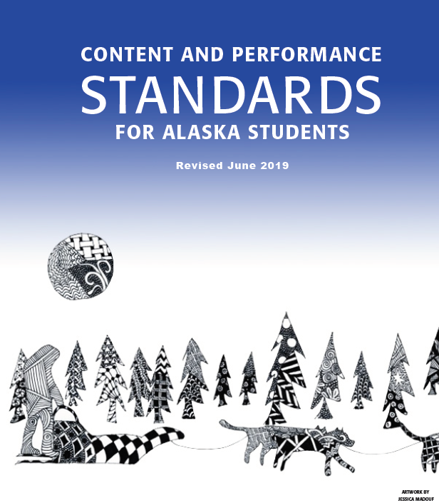

ALASKA CONTENT STANDARDS

TABLE OF CONTENTS
- CONTENT STANDARDS
Geography.......................................................................................2
Government and Citizenship .........................................................5
History ..........................................................................................10
Skills for a Healthy Life ...............................................................13
Arts 15
World Languages 16
Employability 17
Library/Information Literacy 18
- CULTURAL STANDARDS
Cultural Standards 20
- PERFORMANCE STANDARDS/ GRADE LEVEL EXPECTATIONS
History 24

ALASKA CONTENT STANDARDS

GEOGRAPHY

A

A student should be able to make and use maps, globes, and graphs to gather, analyze, and report spatial (geographic) information
.
A student who meets the content standard should:
- use maps and globes to locate places and regions;
- make maps, globes, and graphs;
- understand how and why maps are changing documents;
- use graphic tools and technologies to depict and interpret the world’s human and physical systems;
- evaluate the importance of the locations of human and physical features in interpreting geographic patterns; and
- use spatial (geographic) tools and technologies to analyze and develop explanations and solutions to geographic problems

B

A student should be able to utilize, analyze, and explain information about the human and physical features of places and regions.
A student who meets the content standard should:
- know that places have distinctive geographic characteristics;
- analyze how places are formed, identified, named, and characterized;
- relate how people create similarities and differences among places;
- discuss how and why groups and individuals identify with places;
- describe and demonstrate how places and regions serve as cultural symbols, such as the Statue of Liberty;
- make informed decisions about where to live, work, travel, and seek opportunities;
- understand that a region is a distinct area defined by one or more cultural or physical features; and
- compare, contrast, and predict how places and regions change with time.

C

A student should understand the dynamic and interactive natural forces that shape the Earth’s environments.
A student who meets the content standard should:
- analyze the operation of the Earth’s physical systems, including ecosystems, climate systems, erosion systems, the water cycle, and tectonics;
- distinguish the functions, forces, and dynamics of the physical processes that cause variations in natural regions; and
- recognize the concepts used in studying environments and recognize the diversity and productivity of different regional environments.
D

A student should understand and be able to interpret spatial (geographic) characteristics of human systems, including migration, movement, interactions of cultures, economic activities, settlement patterns, and political units in the state, nation, and world.
A student who meets the content standard should:
- know that the need for people to exchange goods, services, and ideas creates population centers, cultural interaction, and transportation and communication links;
- explain how and why human networks, including networks for communications and for transportation of people and goods, are linked globally;
- interpret population characteristics and distributions;
- analyze how changes in technology, transportation, and communication impact social, cultural, economic, and political activity; and
- analyze how conflict and cooperation shape social, economic, and political use of space.
E

A student should understand and be able to evaluate how humans and physical environments interact.
.
A student who meets the content standard should:
- understand how resources have been developed and used;
- recognize and assess local, regional, and global patterns of resource use;
- understand the varying capacities of physical systems, such as watersheds, to support human activity;
- determine the influence of human perceptions on resource utilization and the environment;
- analyze the consequences of human modification of the environment and evaluate the changing landscape; and
- evaluate the impact of physical hazards on human systems.
F

A student should be able to use geography to understand the world by interpreting the past, knowing the present, and preparing for the future.
A student who meets the content standard should:
- analyze and evaluate the impact of physical and human geographical factors on major historical events;
- compare, contrast, and predict how places and regions change with time;
- analyze resource management practices to assess their impact on future environmental quality;
- interpret demographic trends to project future changes and impacts on human environmental systems;
- examine the impacts of global changes on human activity; and
- utilize geographic knowledge and skills to support interdisciplinary learning and build competencies required of citizens.

GOVERNMENT
AND CITIZENSHIP

A
A student should know and understand how societies define authority, rights, and responsibilities through a governmental process.
A student who meets the content standard should:
  - understand the necessity and purpose of government;
  - understand the meaning of fundamental ideas, including equality, authority, power, freedom, justice, privacy, property, responsibility, and sovereignty;
  - understand how nations organize their governments; and
  - compare and contrast how different societies have governed themselves over time and in different places.

B

A student should understand the constitutional foundations of the American political system and the democratic ideals of this nation.

A student who meets the content standard should:
- understand the ideals of this nation as expressed in the Declaration of Independence, the United States Constitution, and the Bill of Rights;
- recognize American heritage and culture, including the republican form of government, capitalism, free enterprise system, patriotism, strong family units, and freedom of religion;
- understand the United States Constitution, including separation of powers, the executive, legislative, and judicial branches of government, majority rule, and minority rights;
- know how power is shared in the United States’ constitutional government at the federal, state, and local levels;
- understand the importance of individuals, public opinion, media, political parties, associations, and groups in forming and carrying out public policy
- recognize the significance of diversity in the American political system;
- distinguish between constitution-based ideals and the reality of American political and social life;
B ^{(continued)}

- understand the place of law in the American political system; and
- recognize the role of dissent in the American political system.

C
A student should understand the character of government of the state.
A student who meets the content standard should:
- understand the various forms of the state’s local governments and the agencies and commissions that influence students’ lives and property;
- accept responsibility for protecting and enhancing the quality of life in the state through the political and governmental processes;
- understand the Constitution of Alaska and Sec. 4 of the Alaska Statehood Act, which is known as the Statehood Compact;
- understand the importance of the historical and current roles of Alaska Native communities;
- understand the Alaska Native Claims Settlement Act and its impact on the state;
- understand the importance of the multicultural nature of the state;
- understand the obligations that land and resource ownership place on the residents and government of the state; and
- identify the roles of and relationships among the federal, tribal, and state governments and understand the responsibilities and limits of the roles and relationships

D

A student should understand the role of the United States in international affairs.
A student who meets the content standard should:
- analyze how domestic politics, the principles of the United States Constitution, foreign policy, and economics affect relations with other countries
D ^{(continued)}

- evaluate circumstances in which the United States has politically influenced other nations and how other nations have influenced the politics and society of the United States;
- understand how national politics and international affairs are interrelated with the politics and interests of the state;
- understand the purpose and function of international government and non- governmental organizations in the world today; and
- analyze the causes, consequences, and possible solutions to current international issues.

E

A student should have the knowledge and skills necessary to participate effectively as an informed and responsible citizen.

A student who meets the content standard should:
- know the important characteristics of citizenship;
- recognize that it is important for citizens to fulfill their public responsibilities;
- exercise political participation by discussing public issues, building consensus, becoming involved in political parties and political campaigns, and voting;
- establish, explain, and apply criteria useful in evaluating rules and laws;
- establish, explain, and apply criteria useful in selecting political leaders;
- recognize the value of community service; and
- implement ways of solving problems and resolving conflict.

F

A student should understand the economies of the United States and the state and their relationships to the global economy.

A student who meets the content standard should:
- understand how the government and the economy interrelate through regulations, incentives, and taxation;
- be aware that economic systems determine how resources are used to produce and distribute goods and services;
- compare alternative economic systems;
- understand the role of price in resource allocation;
- understand the basic concepts of supply and demand, the market system, and profit;
- understand the role of economic institutions in the United States, including the Federal Reserve Board, trade unions, banks, investors, and the stock market;
- understand the role of self-interest, incentives, property rights, competition, and corporate responsibility in the market economy;
- understand the indicators of an economy’s performance, including gross domestic product, inflation, and the unemployment rate;
- understand those features of the economy of the state that make it unique, including the importance of natural resources, government ownership and management of resources, Alaska Native regional corporations, the Alaska Permanent Fund Corporation, the Alaska Housing Finance Corporation, and the Alaska Industrial Development and Export Authority; and
- understand how international trade works.

G

A student should understand the impact of economic choices and participate effectively in the local, state, national, and global economies.

A student who meets the content standard should:
- apply economic principles to actual world situations;
- understand that choices are made because resources are scarce;
- identify and compare the costs and benefits when making choices;
G ^{(continued)}

- make informed choices on economic issues;
- understand how jobs are created and their role in the economy;
- understand that wages and productivity depend on investment in physical and human capital; and
- understand that economic choices influence public and private institutional decisions.
ALASKA CONTENT STANDARDS

HISTORY

A

A student should understand that history is a record of human experiences that links the past to the present and the future.

A student who meets the content standard should:
- understand chronological frameworks for organizing historical thought and place significant ideas, institutions, people, and events within time sequences;
- know that the interpretation of history may change as new evidence is discovered;
- recognize different theories of history, detect the weakness of broad generalization, and evaluate the debates of historians;
- understand that history relies on the interpretation of evidence;
- understand that history is a narrative told in many voices and expresses various perspectives of historical experience;
- know that cultural elements, including language, literature, the arts, customs, and belief systems, reflect the ideas and attitudes of a specific time and know how the cultural elements influence human interaction;
- understand that history is dynamic and composed of key turning points;
- know that history is a bridge to understanding groups of people and an individual’s relationship to society; and
- understand that history is a fundamental connection that unifies all fields of human understanding and endeavor.

B

A student should understand historical themes through factual knowledge of time, places, ideas, institutions, cultures, people, and events.

A student who meets the content standard should:
- comprehend the forces of change and continuity that shape human history through the following persistent organizing themes:
  - the development of culture, the emergence of civilizations, and the accomplishments and mistakes of social organizations;
B^{(continued)}

  - human communities and their relationships with climate, subsistence base, resources, geography, and technology;
  - the origin and impact of ideologies, religions, and institutions upon human societies;
  - the consequences of peace and violent conflict to societies and their cultures; and
  - major developments in societies as well as changing patterns related to class, ethnicity, race, and gender;
- understand the people and the political, geographic, economic, cultural, social, and environmental events that have shaped the history of the state, the United States, and the world;
- recognize that historical understanding is relevant and valuable in the student’s life and for participating in local, state, national, and global communities;
- recognize the importance of time, ideas, institutions, people, places, cultures, and events in understanding large historical patterns; and
- evaluate the influence of context upon historical understanding

C

A student should develop the skills and processes of historical inquiry
.
A student who meets the content standard should:
- use appropriate technology to access, retrieve, organize, and present historical information;
- use historical data from a variety of primary resources, including letters, diaries, oral accounts, archeological sites and artifacts, art, maps, photos, historical sites, documents, and secondary research materials, including almanacs, books, indices, and newspapers;
- apply thinking skills, including classifying, interpreting, analyzing, summarizing, synthesizing, and evaluating, to understand the historical record; and
- use historical perspective to solve problems, make decisions, and understand other traditions.

D

A student should be able to integrate historical knowledge with historical skill to effectively participate as a citizen and as a lifelong learner.
A student who meets the content standard should:
- understand that the student is important in history;
- solve problems by using history to identify issues and problems, generate potential solutions, assess the merits of options, act, and evaluate the effectiveness of actions;
- define a personal position on issues while understanding the historical aspects of the positions and roles assumed by others;
- recognize and demonstrate that various issues may require an understanding of different positions, jobs, and personal roles depending on place, time, and context;
- base personal citizenship action on reasoned historical judgment with recognition of responsibility for self and others; and
- create new approaches to issues by incorporating history with other disciplines, including economics, geography, literature, the arts, science, and technology.

ALASKA CONTENT STANDARDS

SKILLS FOR A

HEALTHY LIFE

A
A student should be able to acquire a core knowledge related to well-being.
A student who meets the content standard should:
- understand that a person’s well-being is the integration of health knowledge, attitudes, and behaviors;
- understand how the human body is affected by behaviors related to eating habits, physical fitness, personal hygiene, harmful substances, safety, and environmental conditions;
- understand and identify the causes, preventions, and treatments for diseases, disorders, injuries, and addictions;
- recognize patterns of abuse directed at self or others and understand how to break these patterns;
- use knowledge and skills to promote the well-being of the family;
- use knowledge and skills related to physical fitness, consumer health, independent living, and career choices to contribute to well-being;
- understand the physical and behavioral characteristics of human sexual development and maturity; and
- understand the ongoing life changes throughout the life span and healthful responses to these changes.

B

A student should be able to demonstrate responsibility for the student’s well-being.
A student who meets the content standard should:
- demonstrate an ability to make responsible decisions by
- discriminating among risks and by identifying consequences;
- demonstrate a variety of communication skills that contribute to well-being;

B^{(continued)}
- assess the effects of culture, heritage, and traditions on personal well-being;
- develop an awareness of how personal life roles are affected by and contribute to the well-being of families, communities, and cultures;
- evaluate what is viewed, read, and heard for its effect on personal well-being; and
- understand how personal relationships, including those with family, friends, and co-workers, impact personal well-being.

C
A student should understand how
well-being is affected by relationships with others
A student who meets the content standard should:
  - resolve conflicts responsibly;
  - communicate effectively within relationships;
  - evaluate how similarities and differences among individuals contribute to relationships;
  - understand how respect for the rights of self and others contributes to relationships;
  - understand how attitude and behavior affect the well-being of self and others; and
  - assess the effects of culture, heritage, and traditions on well-being.

D
A student should be able to contribute to the well-being of families and communities.
A student who meets the content standard should:
- make responsible decisions as a member of a family or community;
- take responsible actions to create safe and healthy environments;
- describe how public policy affects the well-being of families and communities;
- identify and evaluate the roles and influences of public and private organizations that contribute to the well-being of communities;
- describe how volunteer service at all ages can enhance community well- being; and
- use various methods of communication to promote community well-being.

ALASKA CONTENT STANDARDS

ARTS

A

CREATE (CR)
A student should be able to imagine and develop artistic ideas and work.
A student who meets the content standard should:
- generalize and conceptualize artistic ideas and work;
- organize and develop artistic ideas and work; and
- refine and complete artistic work.

B
PRESENT (PR)
A student should be able to interpret and share artistic work.
A student who meets the content standard should:
- select, analyze and interpret artistic works, including those from diverse cultural traditions, for performance, presentation and/or production;
- develop and refine artistic work for performances, presentations and/or productions; and
- perform, present and/or produce artistic work.

C

RESPOND (RE)
A student should be able to understand and evaluate how the arts convey meaning.
A student who meets the content standard should:
- recognize and analyze artistic works, including those from diverse cultural traditions;
- interpret intent and meaning in artistic works; and
- apply criteria to evaluate artistic work.

D
CONNECT (CO)
A student should be able to relate artistic ideas and work with personal meaning and external context.
A student who meets the content standard should:
- relate, synthesize, and express both knowledge and personal experiences as a way to participate in the arts; and
- relate artistic ideas and works with societal, cultural, and historical contexts to deepen understanding.

ALASKA CONTENT STANDARDS

WORLD LANGUAGES

A

A student should be able to communicate in two or more languages, one of which is English.
A student who meets the content standard should:
- understand written and oral communication in two or more languages;
- write and speak understandably in two or more languages;
- use two or more languages effectively in real life situations; and
- use two or more languages to learn new information in academic subjects.

B

A student should expand the student’s knowledge of peoples and cultures through language study.
A student who meets the content standard should:
- understand the relationship between language and culture;
- learn about and experience surface characteristics of the culture, including art, cuisine, dance, dress, geography, history, music, and literature;
- learn about and experience deep characteristics of the culture, including folkways, mores, laws, traditions, customs, and patterns of behavior;
- improve the student’s understanding of the student’s language and culture through experiences with other languages and cultures;
- apply knowledge of the functions and structure of one language to the study of another language; and
- recognize through language study that all cultures contribute to the global society.

C

A student should possess the language skills and cultural knowledge necessary to participate successfully in multilingual communities and the international marketplace
A student who meets the content standard should:
- interact appropriately in multilingual communities through various means, including printed and electronic media, audio and visual sources, face-to-face conversations, penpals, and travel;
- use experiences with language and culture to explore the student’s personal interests and career options;
- learn how language skills and cultural knowledge enhance a person’s competitiveness in the international marketplace; and
- apply language skills and cultural knowledge to enhance the student’s intellectual and social growth and to promote lifelong learning.

ALASKA CONTENT STANDARDS

EMPLOYABILITY

A

A student should be able to develop and be able to use employability skills
in order to effectively make the transition from school to work and lifelong learning
.
A student who meets the content standard should:
- develop and maintain a work ethic necessary for success in the workplace that includes honesty, integrity, dependability, punctuality, self-discipline, initiative, reliability, accuracy, productivity, respect, and perseverance;
- understand how to apply skills and academic knowledge in a variety of work settings;
- understand the process for seeking employment including résumé development, application completion, interview skills, and appropriate dress for work settings;
- understand the process for developing self-employment opportunities including marketing studies, business plan development, and managing business finances;
- understand how an individual job fits into the overall organization and how the organization fits into the overall economy;
- understand the need for safe practices in workplaces; and
- understand employer and employee rights and responsibilities.

B

A student should be able to identify career interests and plan for career options.
A student who meets the content standard should:
- identify and appreciate personal interests, aptitudes, abilities, and priorities;
- identify possible career options, considering both employment and self employment, and understand how changes in the workplace affect career choice;
- use labor market information to identify occupational and economic trends and opportunities, and evaluate possible career options;
- identify education and/or training needed for career options and advancement, and develop a career plan; and
- identify resources available to support education and training related to career possibilities.

ALASKA CONTENT STANDARDS

LIBRARY/INFORMATION

LITERACY

A

A student should understand how information and resources are organized.
A student who meets the content standard should:
- recognize that libraries use classification systems to organize, store, and provide access to information and resources;
- understand how library classification and subject heading systems work;
- understand how information in print, non-print, and electronic formats is organized and accessed;
- search for information and resources by author, title, subject, or keyword, as appropriate; and
- identify and use search strategies and terms that will produce successful results.

B

A student should understand and use research processes necessary to
locate, evaluate, and communicate
information and ideas.
A student who meets the content standard should:
- state a problem, question, or information need;
- consider the variety of available resources and determine which are most likely to be useful;
- access information;
- evaluate the validity, relevancy, currency, and accuracy of information;
- organize and use information to create a product; and
- evaluate the effectiveness of the product to communicate the intended message.

C

A student should recognize that being an independent reader, listener, and viewer of material in print, non-print, and electronic formats will contribute to personal enjoyment and lifelong
A student who meets the content standard should:
- read for pleasure and information;
- read, listen, and view a wide variety of literature and other creative expressions; and
- recognize and select materials appropriate to personal abilities and interests.

D

A student should be aware of the freedom to seek information and possess the confidence to pursue information needs beyond immediately available sources
.
A student who meets the content standard should:
- know how to access information through local, national, and international sources in printed and electronic formats;
- recognize the importance of access to information and ideas in a democratic society;
- access information on local, state, national, and world cultures and issues;
- evaluate information representing diverse views in order to make informed decisions; and
- assimilate and understand how newly acquired information relates to oneself and others.

E

A student should understand ethical, legal, and social behavior with respect to information resources.
A student who meets the content standard should:
- use library materials and information resources responsibly;
- understand and respect the principles of intellectual freedom;
- understand and respect intellectual property rights and copyright laws; and
- develop and use citations and bibliographies.

ALASKA CONTENT STANDARDS
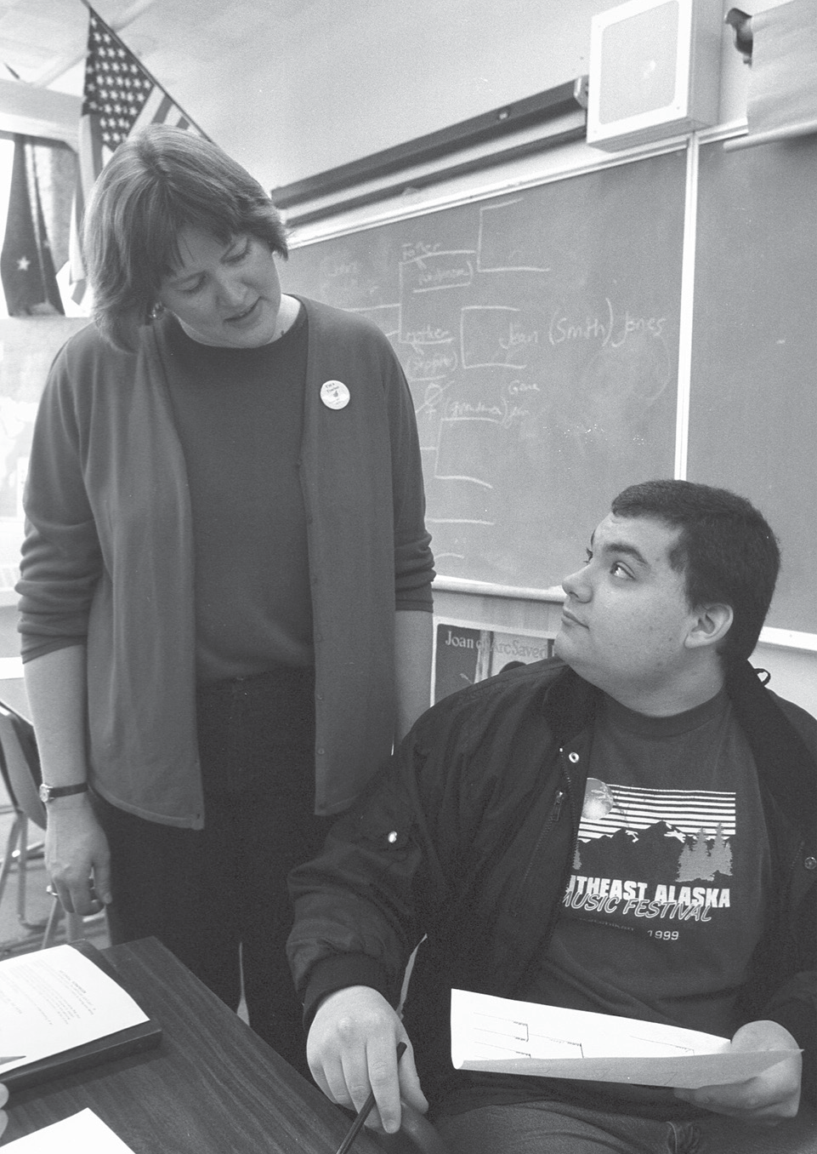

CULTURAL STANDARDS FOR ALASKA STUDENTS
The Alaska Cultural Standards for Students were developed by the Alaska Native Knowledge Network in 1998. They also were adopted by the State Board of Education & Early Development in the same year. The Cultural Standards are

meant to enrich the Content Standards and provide guidelines for nurturing and building in students the rich and varied cultural traditions that continue to be practiced in communities throughout Alaska.
The standards are broad statements of what students should know and be able to do as a result of their experience in a school that is aware of and sensitive to the surrounding physical and cultural environment.

ALASKA CONTENT STANDARDS

CULTURAL STANDARDS

A

Culturally- knowledgeable students are well grounded in the cultural heritage and traditions of their community.
Students who meet this cultural standard are able to:
- assume responsibilities for their role in relation to the well-being of the cultural community and their lifelong obligations as a community member;
- recount their own genealogy and family history;
- acquire and pass on the traditions of their community through oral and written history;
- practice their traditional responsibilities to the surrounding environment;
- reflect through their own actions the critical role that the local heritage language plays in fostering a sense of who they are and how they understand the world around them;
- live a life in accordance with the cultural values and traditions of the local community and integrate them into their everyday behavior; and
- determine the place of their cultural community in the regional, state, national, and international political and economic systems.

B

Culturally- knowledgeable students are able to build on the
knowledge and skills of the local cultural community as a foundation from which to achieve personal and academic success throughout life.
Students who meet this cultural standard are able to:
- acquire insights from other cultures without diminishing the integrity of their own;
- make effective use of the knowledge, skills, and ways of knowing from their own cultural traditions to learn about the larger world in which they live;
- make appropriate choices regarding the long-term consequences of their actions; and
- identify appropriate forms of technology and anticipate the consequences of their use for improving the quality of life in the community.

C

Culturally- knowledgeable students are able to actively participate in various cultural environments.
Students who meet this cultural standard are able to:
- perform subsistence activities in ways that are appropriate to local cultural traditions;
- make constructive contributions to the governance of their community and the well-being of their family;

C^{(continued)}

- attain a healthy lifestyle through which they are able to maintain their social, emotional, physical, intellectual, and spiritual well-being; and
- enter into and function effectively in a variety of cultural settings.

D

Culturally- knowledgeable students are able to engage effectively in learning activities that are based on traditional ways of
knowing and learning.
Students who meet this cultural standard are able to:
- acquire in-depth cultural knowledge through active participation and meaningful interaction with Elders;
- participate in and make constructive contributions to the learning activities associated with a traditional camp environment;
- interact with Elders in a loving and respectful way that demonstrates an appreciation of their role as culture-bearers and educators in the community;
- gather oral and written history information from the local community and provide an appropriate interpretation of its cultural meaning and significance;
- identify and utilize appropriate sources of cultural knowledge to find solutions to everyday problems; and
- engage in a realistic self-assessment to identify strengths and needs and make appropriate decisions to enhance life skills.

E

Culturally- knowledgeable students demonstrate an awareness and appreciation of the relationships and processes of interaction of all elements in the world around them.
Students who meet this cultural standard are able to:
- recognize and build upon the interrelationships that exist among the spiritual, natural, and human realms in the world around them, as reflected in their own cultural traditions and beliefs as well as those of others;
- understand the ecology and geography of the bioregion they inhabit;
- demonstrate an understanding of the relationship between world view and the way knowledge is formed and used;
- determine how ideas and concepts from one knowledge system relate to those derived from other knowledge systems;
- recognize how and why cultures change over time;
- anticipate the changes that occur when different cultural systems come in contact with one another;
E ^{(continued)}

- determine how cultural values and beliefs influence the interaction of people from different cultural backgrounds; and
- identify and appreciate who they are and their place in the world.

Introduction to Alaska History Standards
Unlike the Performance Standards/Grade Level Expectations developed for each grade in reading, writing, mathematics, and science, the Alaska History Standards reflect the cumulative knowledge a student must demonstrate in order to fulfill the Alaska history graduation requirement detailed in regulation 4 AAC 06.075 (g) High school graduation requirements.
The teaching of history should introduce students to the process of historical inquiry. This process requires critical examination of evidence and careful weighing of facts and hypotheses. It provides experience in the kind of reasoned and informed decision-making that should characterize each student’s knowledge of and participation in state events and issues. For this reason, the standard for historical inquiry stands alone; the intent is to integrate this standard, where appropriate, into the standards that follow. The objective of the historical inquiry standard is to apply conceptual knowledge and skills as designated in all strands of Alaska History by problem solving, communicating, reasoning, and making connections.
This framework uses the scholarly approach of the historian to define the content of the standards. This approach presents the people, ideas, events, themes, and sources to be included in order for a student to demonstrate competency in Alaska History. While recognizing that knowledge of specifics is important, the framework design emphasizes that knowledge of context is crucial to meaning and understanding.
The framework organizes Alaska history into four central themes that give perspective and meaning to the people, ideas, and events that shaped the state. The framework also divides Alaska history into five chronological periods that structure the sequence of events.
From the statewide perspective, these are the essential learnings. The state encourages districts to add to and enrich the scope of their local Alaska history curriculum.
PERFORMANCE STANDARDS (Grade Level Expectations)

HISTORY PERFORMANCE STANDARDS (Grade Level Expectations)
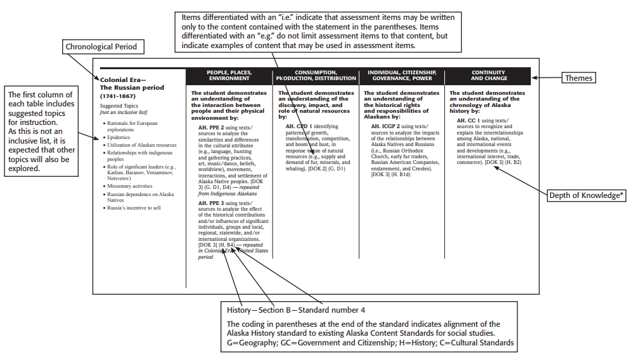
* Depth of Knowledge (DOK) is the cognitive demand associated with each item. Briefly, DOK levels reflect the following: DOK 1: Recall of Information; DOK 2: Basic Reasoning; DOK 3: Complex Reasoning; DOK 4: Extended Reasoning. For additional information, please see the accompanying document, Depth-of-Knowledge (DOK) Levels for Social Studies.
Because the Alaska History standards are intended to provide the content to which a student demonstrates knowledge of Alaska History, the DOK assigned to each standard should be used as the ceiling to which assessment items are written. When considering the highest DOK Level as the ceiling not the target, the standard has the potential to be assessed at Depth of Knowledge Levels at the ceiling, and up to the ceiling, depending upon the demand of the standard.

Depth-of-Knowledge (DOK) Levels for Social Studies
Descriptors of DOK Levels for Social Studies (based on Webb, Technical Issues in Large-Scale Assessment,
report published by CCSSO, December 2002)

Level 1 Recall of Information
Level 1 asks students to recall facts, terms, concepts, trends, generalizations and theories or to recognize or identify specific information contained in graphics. This level generally requires students to identify, list, or define. The items at this level usually ask the student to recall who, what, when and where. Items that require students to “describe” and “explain” could be classified at Level 1 or 2 depending on what is to be described and explained. A Level 1 “describe or explain” would recall, recite or reproduce information. Items that require students to recognize or identify specific information contained in maps, charts, tables, graphs or drawings are generally level 1.
Level 2 Basic Reasoning
Level 2 includes the engagement of some mental processing beyond recalling or reproducing a response. This level generally requires students to contrast or compare people, places, events and concepts; convert information from one form to another; give an example; classify or sort items into meaningful categories; describe, interpret or explain issues and problems, patterns, reasons, cause and effect, significance or impact, relationships, points of view or processes. A Level 2 “describe or explain” would require students to go beyond a description or explanation of recalled information to describe or explain a result or “how” or “why.”
Level 3 Complex Reasoning
Level 3 requires reasoning, using evidence, and a higher level of thinking than the previous two levels. Students would go beyond explaining or describing “how and why” to justifying the “how and why” through application and evidence. The cognitive demands at Level 3 are more complex and more abstract than Levels 1 or 2. Items at Level 3 include drawing conclusions; citing evidence; applying concepts to new situations; using concepts to solve problems; analyzing similarities and differences in issues and problems; proposing and evaluating solutions to problems; recognizing and explaining misconceptions or making connections across time and place to explain a concept or big idea.
Level 4 Extended Reasoning
Level 4 requires the complex reasoning of Level 3 with the addition of planning, investigating, or developing that will most likely require an extended period of time. The extended time period is not a distinguishing factor if the required work is only repetitive and does not require applying significant conceptual understanding and higher-order thinking. At this level the cognitive demands should be high and the work should be very complex. Students should be required to connect and relate ideas and concepts within the content area or among content areas in order to be at this highest level. The distinguishing factor for Level 4 would be evidence through a task or product that the cognitive demands have been met. A Level 4 performance will require students to analyze and synthesize information from multiple sources, examine and explain alternative perspectives across a variety of sources, and/or describe and illustrate how common themes and concepts are found across time and place. In some Level 4 performance students will make predictions with evidence as support, develop a logical argument, or plan and develop solutions to problems.
Many on-demand assessment instruments will not include assessment activities that could be classified as Level 4. However, standards, goals, and objectives can be stated so as to expect students to perform thinking at this level. On-demand assessments that do include tasks, products, or extended responses would be classified as Level 4 when the task or response requires evidence that the cognitive requirements have been met.

History

Historical Inquiry
The student demonstrates an understanding of the methods of documenting history by:
AH. HI 1 planning and developing history projects, utilizing research tools such as: interviewing protocols, oral history, historical context, pre-interview research, primary sources, secondary sources, proper citation, corroboration, and cause and effect of historical events. [DOK 4] (H. C1-4)

Indigenous Alaskans before western contact (time immemorial—contact)

Suggested Topics
[not an inclusive list]
- Locations
- Social organizations
- Cultures
- Political traditions
- Natural resources
- Cultural changes
- Archeology
- Native oral traditions

PEOPLE, PLACES, ENVIRONMENT | CONSUMPTION, PRODUCTION, DISTTRIBUTION | INDIVIDUAL, CITIZENSHIP, GOVERNANCE, POWER | CONTINUITY AND CHANGE
The student demonstrates an understanding of  the interaction between people and their physical environment by:  AH. PPE 1 comparing and contrasting geographic regions of Alaska. [DOK 2] (G. B4, B8)  AH. PPE 2 using texts/ sources to analyze the similarities and differences in the cultural attributes (e.g., language, hunting and gathering practices, art, music/ dance, beliefs, worldview), movement, interactions, and settlement of Alaska Native peoples. [DOK 3] (G. D1, D4)  AH. PPE 3 using texts/ sources to analyze the effect of the historical contributions  and/or influences of significant individuals, groups and local, regional, statewide, international organizations. [DOK 3] (H. B4) |  | The student demonstrates an understanding of  the historical rights and responsibilities of Alaskans by:  AH. ICGP 1 identifying and summarizing the structures, functions, and transformation of various attributes (e.g., leadership, decision-making, social and political organization) of traditional Alaska Native governance. [DOK 2] (GC. A4)
Colonial Era—
The Russian period
(1741-1867)
Suggested Topics
[not an inclusive list]
- Rationale for European explorations
- Epidemics
- Utilization of Alaskan resources
- Relationships with indigenous peoples
- Role of significant leaders (e.g., Katlian, Baranov, Veniaminov, Netsvetov)
- Missionary activities
- Russian dependence on Alaska Natives
- Russia’s incentive to sell

PEOPLE, PLACES, ENVIRONMENT | CONSUMPTION, PRODUCTION, DISTTRIBUTION | INDIVIDUAL, CITIZENSHIP, GOVERNANCE, POWER | CONTINUITY AND CHANGE
The student demonstrates an understanding of  the interaction between people and their physical environment by:  AH. PPE 2 using texts/sources to analyze the similarities and differences in the cultural attributes (e.g., language, hunting and gathering practices, art, music/dance, beliefs, worldview), movement, interactions, and settlement of Alaska Native peoples. [DOK 3] (G. D1, D4)  AH. PPE 3 using texts/ sources to analyze the effect of the historical contributions and/or influences of significant individuals, groups and local, regional, statewide, and/or international organizations. [DOK 3] (H. B4) | The student demonstrates an understanding of the discovery, impact, and role of natural resources by:  AH. CPD 1 identifying patterns of growth, transformation, competition, and boom and bust, in response to use of natural resources (e.g., supply and demand of fur, minerals, and whaling). [DOK 2] (G. D1) | The student demonstrates an understanding of  the historical rights and responsibilities of Alaskans by:  AH. ICGP 2 using texts/ sources to analyze the impacts of the relationships between Alaska Natives and Russians (i.e., Russian Orthodox Church, early fur traders, Russian American Companies, enslavement, and Creoles). [DOK 3] (H. B1d) | The student demonstrates an understanding of the chronology of Alaska history by:  AH. CC 1 using texts/ sources to recognize and explain the interrelationships among Alaska, national,  and international events and developments (e.g., international interest, trade,  commerce). [DOK 3] (H. B2)

Colonial Era
The United States Period (1867-1912)
Suggested Topics
[Not an inclusive list]
- United States’ motives for purchasing Russia’s interest in Alaska
- Treaty of Cession
- Legal status of Alaska Natives under the Commerce Clause and the Marshall Trilogy
- Mining Law of 1872
- Organic Act of 1884
- Role of Sheldon Jackson
- Resources (e.g., whaling, fur trading, mining, commercial fisheries)
- Gold Rush
- Nelson Act of 1905 and the dual school system
- Creation of National Forests.

PEOPLE, PLACES, ENVIRONMENT | CONSUMPTION, PRODUCTION, DISTTRIBUTION | INDIVIDUAL, CITIZENSHIP, GOVERNANCE, POWER | CONTINUITY AND CHANGE
The student demonstrates an understanding of  the interaction between people and their physical environment by:  AH. PPE 3 using texts/ sources to analyze the effect of the historical contributions and/or influences of significant individuals or groups and local, regional, statewide, and/or international organizations. [DOK 3] (H. B4) | The student demonstrates an understanding of the discovery, impact, and role of natural resources by:  AH. CPD 2 using texts/ source to draw conclusions about the role of the federal government in natural resource development and land management (e.g., jurisdiction, authority, agencies, programs, policies). [DOK 3] (GC. F1) | The student demonstrates an understanding of  the historical rights and responsibilities of Alaskans by:  AH. ICGP 3 explaining and analyzing tribal and western concepts of land ownership and how acting upon those concepts contributes to changes in land use, control, and ownership. [DOK 4] (H. C7, C8)  AH. ICGP 4 explaining Alaskans’ quest for self- determination (i.e., full rights as U.S. citizens) through the statehood movement. [DOK 1] (GC. C3)  AH.ICGP 5 explaining the impacts of military actions (e.g., Naval bombardment of Angoon, Aleut internment, military expeditions) relative to Native communities. [DOK 2] (H. B1)  (continued) | The student demonstrates an understanding of the chronology of Alaska history by:  AH. CC 2 describing how policies and practices of non- natives (e.g., missionaries, miners, Alaska Commercial Company merchants) influenced Alaska Natives. [DOK 2] (H. B4, B5)

Colonial Era
The United States Period (1867-1912)
(continued)

PEOPLE, PLACES, ENVIRONMENT | CONSUMPTION, PRODUCTION, DISTTRIBUTION | INDIVIDUAL, CITIZENSHIP, GOVERNANCE, POWER | CONTINUITY AND CHANGE
ICGP 6 using texts/sources to analyze how the military population and its activities, including administrative policing, defense, mapping, communication, and construction, have impacted communities. [DOK 3] (H. B2)
AH. ICGP 7 describing the historical basis of federal recognition of tribes, their inherent and delegated powers, the ongoing nature and diversity of tribal governance, and the plenary power of Congress. [DOK 1] (GC. C8)

Alaska as a Territory (1912-1959)
Suggested Topics
[Not an inclusive list]
- Territorial Organic Act of 1912
- Native efforts toward civil and land rights (e.g., founding of Alaska Native Brotherhood (ANB), Alaska Native Sisterhood (ANS), and Tanana Chiefs)
- Role of significant individuals (e.g., Judge Wickersham, William Paul, Elizabeth Peratrovich, Ernest Gruening)
- Infrastructure (e.g., railroad, aviation, roads, ships)
- Indian Reorganization Act
- World War II and internment of Aleuts and Japanese Americans
- Cold War
- National Parks and National Forests, resources (e.g., oil, timber, coal)
- Constitutional Convention, constitution, and statehood

PEOPLE, PLACES, ENVIRONMENT | CONSUMPTION, PRODUCTION, DISTTRIBUTION | INDIVIDUAL, CITIZENSHIP, GOVERNANCE, POWER | CONTINUITY AND CHANGE
The student demonstrates an understanding of  the interaction between people and their physical environment by:  AH. PPE 4 describing how Alaska’s strategic location played an important role in military buildup and explaining the interrelated social and economic impacts. [DOK 2] (G. A5) | The student demonstrates an understanding of the discovery, impact, and role of natural resources by:  AH. CPD 3 using texts/ sources to draw conclusions about the significance of natural resources (e.g., fisheries, timber, Swanson River oil discovery, “sustained yield” in the Alaska Constitution) in Alaska’s development and in the statehood movement. [DOK 3] (G. F1, F4) | The student demonstrates an understanding of the historical rights and responsibilities of Alaskans by:  AH. ICGP 4 explaining Alaskans’ quest for self- determination (i.e., full rights as U.S. citizens) through the statehood movement. [DOK 1] (GC. C3)  AH.ICGP 5 explaining the impacts of military actions relative to Native communities (e.g., Naval bombardment of Angoon, Aleut internment, military expeditions). [DOK 2] (H. B1)  AH. ICGP 8 describing how Alaskans, particularly the Native people, challenge  the status quo to gain recognition of their civil rights (e.g., appeals to the Russian  (continued) | The student demonstrates an understanding of the chronology of Alaska history by:  AH. CC 3 describing how the roles and responsibilities in Alaska Native societies have been continuously influenced by changes in technology, economic practices, and social interactions. [DOK 2] (G. D4, H. B1b)

Alaska as a Territory (1912-1959)
Suggested Topics
[Not an inclusive list]

(continued)

PEOPLE, PLACES, ENVIRONMENT | CONSUMPTION, PRODUCTION, DISTTRIBUTION | INDIVIDUAL, CITIZENSHIP, GOVERNANCE, POWER | CONTINUITY AND CHANGE
government, Ward Cove Packing Co. Case, Molly Hootch, anti-discrimination acts, women’s suffrage). [DOK 2] (H. B2, GC. B5)
AH. ICGP 9 exploring the federal government’s influence on settlements in Alaska (e.g., Matanuska Colony, Anchorage, Adak, Tok, Hydaburg) by establishment of post offices, military facilities, schools, courts, and railroads. [DOK 1] (G. G2, H. B1)
AH. ICGP 10 identifying the role of Alaska Native individuals and groups in actively proposing and promoting federal legislation and policies (e.g., William Paul, Tanana Chiefs, ANB, ANS) [DOK 1] (H. A1, B2)
AH. ICGP 11 exploring federal policies and legislation (e.g., Alaska Citizenship Act, Tlingit- Haida Jurisdictional Act, Indian Citizenship Act of 1924, Alaska Reorganization Act, ANCSA) that recognized Native rights. [DOK 1] (H. B2)

Alaska as a State (1959-present)
Suggested Topics [Not an inclusive list]
- Role of significant individuals (e.g., Eben Hopson, Howard Rock, Ted Stevens, Katie John)
- Controversies of Statehood Act land selections
- Disasters (e.g., 1964 Earthquake, 1967 Interior flood, Exxon Valdez oil spill)
- Formation of Inuit Circumpolar Conference
- Formation of AFN
- Development of public education (e.g., Molly Hootch case)
- Prudhoe Bay and oil pipeline construction
- Permanent Fund
- Alaska Native Claims Settlement Act (ANCSA)
- Marine Mammal Protection Act 1972 (MMPA)
- Alaska National Interest Lands Conservation Act (ANILCA)
- Indian Self-Determination Act 1975

PEOPLE, PLACES, ENVIRONMENT | CONSUMPTION, PRODUCTION, DISTTRIBUTION | INDIVIDUAL, CITIZENSHIP, GOVERNANCE, POWER | CONTINUITY AND CHANGE
The student demonstrates an understanding of  the interaction between people and their physical environment by:  AH. PPE 4 describing how Alaska’s strategic location played an important role in military buildup and explaining the interrelated social and economic impacts. [DOK 2] (G. A5)  AH. PPE 5 comparing and contrasting the differing perspectives between rural and urban areas. [DOK 2] (H. B1b, C. E4)  AH. PPE 6 analyzing patterns of movement and settlement. [DOK 2] (H. B4, G. D3) (continued) | The student demonstrates an understanding of the discovery, impact, and role of natural resources by:  AH. CPD 4 describing the federal government’s construction and maintenance of Alaska’s infrastructure (e.g., transportation, communication, public health system, education). [DOK 1] (G. D4)  AH. CPD 5 using texts/ sources to analyze the multiple perspectives in the continuing debate between conservation and development of resources. [DOK 3] (G. E4, F3)  AH. CPD 6 describing the formation of Alaska Native Corporations and their impact on Alaska’s economy. [DOK 2] (GC. F9) (continued) | The student demonstrates an understanding of  the historical rights and responsibilities of Alaskans by:  AH. ICGP 3 explaining and analyzing tribal and western concepts of land ownership and how acting upon those concepts contributes to changes in land use, control, and ownership (e.g., ANCSA, ANILCA). [DOK 4] (H. C7, C8)  AH. ICGP 8 describing how Alaskans, particularly the Native people, challenge the status quo to gain recognition of their civil rights (e.g., appeals to the Russian government, Ward Cove Packing Co. Case, Molly Hootch, anti-discrimination acts, women’s suffrage). [DOK 2] (H. B2, GC. B5) (continued) | The student demonstrates an understanding of the chronology of Alaska history by:  AH. CC 4 giving correct and incorrect examples to explain subsistence as a way of life. [DOK 2] (H. B1b)  AH. CC 5 defining, describing, and illustrating the economic, political, and social characteristic of the major periods, their key turning points (e.g., implementation of Prudhoe Bay pipeline, Molly Hootch case, ANCSA, ANILCA, ANWR, natural and manmade disasters, establishment of Alaska Native Corporations) and how they interrelate. [DOK 4] (H. B2) (continued)

Alaska as a State (1959-present)
Suggested Topics [Not an inclusive list]

(continued)

- Indian Child Welfare Act 1978
- Arctic National Wildlife Refuge (ANWR)
- Tourism
- Fiscal issues
(continued)

PEOPLE, PLACES, ENVIRONMENT | CONSUMPTION, PRODUCTION, DISTTRIBUTION | INDIVIDUAL, CITIZENSHIP, GOVERNANCE, POWER | CONTINUITY AND CHANGE
AH. PPE 7 using texts/ sources to explain the political, social, cultural, economic, geographic, and historic characteristics of the student’s community or region. [DOK 3] (H. B1b, C. E2, E8) | AH. CPD 7 explaining the creation and implementation of the Permanent Fund and how it has impacted the state. [DOK 2] (GC. F9) | AH. ICGP 10 identifying the role of Alaska Native individuals and groups in actively proposing and promoting federal legislation and policies (e.g., William Paul, Tanana Chiefs, ANB, ANS) [DOK 1] (H. A1, B2)  AH. ICGP 12 using texts/ sources to analyze the evolution of self-government through an examination of organic documents (i.e., Treaty of Cession, Organic Act, Territorial Act, Alaska State Constitution, Statehood Act). [DOK 3] (H. B2, B4) | AH. CC 6 explaining the historical context and the legal foundations (e.g., Alaska Constitution, ANCSA, MMPA, ANILCA, Katie John case) pertinent to subsistence. [DOK 1 (GC. A2, C. A4)  AH. CC 7 comparing and contrasting the perspectives of sport, commercial, and subsistence users on policies regarding fish and game management. [DOK 2] (G. E4, F5)

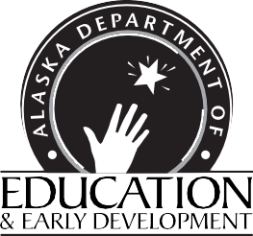

Department of Education & Early Development
P.O. Box 110500
801 W. 10th Street Juneau, AK 99811-0500

