

**Alaska Social Studies Standards**

***Crosswalk:***Civics in the 2024 Social Studies Standards

**Purpose and Audience:**

This document was drafted to:

* Unpack the Civics standards in the 2024 Alaska Social Studies Standards[1]
* Define and clarify the changes regarding Civics standards and content from the 1998 standards to the 2024 standards

This document is intended to support the following audiences:

* Teachers in Alaska who teach Civics or Social Studies
* Pre-service teachers preparing to teach Civics, Social Studies, or primary grades in Alaska
* Alaska School Districts
* Interested Community Partners

**Key Vocabulary**

***Civics*** may refer to:

1. Standards related to Civics which occur in all grades, K-12, in the 2024 Alaska Social Studies Standards.
2. A grade 8 course in “U.S. History and Civics” as articulated in the 2024 Alaska Social Studies Standards.
3. A course, often in high school, on Civics offered in Alaska School Districts.

**Courses with Civics Focus**

In the 2024 Standards, one course at Grade 8 features a Civics focus.

|  |  |
| --- | --- |
| **Grade** | **Course Name** |
| *Grade 8* | **U.S. History and Civics** |

Figure 1: Course with Civics focus in the 2024 Alaska Social Studies Standards

**Context**

On December 9, 2024, the Alaska Board of Education adopted the revised Alaska Social Studies Standards. This revision followed a process begun by DEED in February of 2021[2]. The previous (and initial) Alaska Social Studies Standards were adopted in 1998.[3]

**Alignment**

The College, Career, and Civic Life Framework for Social Studies State Standards (C3 Framework[4]) and the National Standards for Civics and Government (NSGC [5]) served as foundational documents in the design and drafting process. The 2024 standards align closely with both frameworks, throughout K-12.

**Comparison of Structure**

The 2024 standards feature significant changes in the structure, quantity, and frequency of Civics content and standards as compared to the 1998 standards.

|  |  |
| --- | --- |
| **1998 Social Studies Standards** | **2024 Social Studies Standards** |
| * Published in short, separate documents | * Published in a unified, 129-page document |
| * Three content areas:   + History   + Geography   + Government and Citizenship | * Skills and content standards are organized under four disciplinary strands:   + History   + Civics   + Economics   + Geography |
| * No grade levels included * No guidance for differentiation of content standards based on grade levels | * Grade banded: K-2, 3-5, 6-8, 9-12 * Content anchor standards embedded in every grade level   + Organized by theme   + Leveled content standards explicitly differentiate each content anchor standard |
| * No Inquiry standards included | * Inquiry standards embedded in each grade band   + Differentiated for each grade level |
| *\*\*Key takeaway: The same content standards for History, Geography, and Government and Citizenship could be used by lower and upper grades, K-12.* | *\*\*Key takeaway: Students will encounter differentiated content for Alaska Studies anchor standards recursively throughout their Alaska classroom experience, K-12.* |

Figure 2: Comparison of 1998 standards to 2024 standards

**Comparison of Civics Standards and Content Across Grades**

The 2024 Standards feature Civic Content Anchor Standards which are embedded in every grade level, K-12. This means that students will encounter the Civics anchor standards and Civics content recursively throughout their Alaska classroom experience, K-12.

In the 1998 standards there are no grade levels, and there is no guidance for differentiation of content standards based on grade levels. Prior to the 2024 standards adoption, the same content standards for Government and citizenship were being used by lower grades and upper grades, K-12.

**Content Anchor Standards**

|  |  |  |  |
| --- | --- | --- | --- |
| **Civics** | **Economics** | **Geography** | **History** |
| **Anchor Standard 6** Civic and Political Institutions and Systems | **Anchor Standard 11** Economic Systems, Models, and Markets | **Anchor Standard 16** Human Environment Interaction: Place, Regions, and Culture | **Anchor Standard 21** Perspectives |
| **Anchor Standard 7**  Participation and Deliberation | **Anchor Standard 12** Decision-Making and Personal Finance | **Anchor Standard 17** Global Interconnections: Changing Spatial Patterns | **Anchor Standard 22**  Historical Sources and Evidence |
| **Anchor Standard 8**  Processes, Rules, and Laws | **Anchor Standard 13** The National Economy | **Anchor Standard 18**  Geographic Representations and Reasoning | **Anchor Standard 23**  Change, Continuity, and Context |
| **Anchor Standard 9**  Alaska’s Governments | **Anchor Standard 14**  The Global Economy | **Anchor Standard 19**  Human Populations: Spatial Patterns and Movement | **Anchor Standard 24**  Historical Thinking |
| **Anchor Standard 10**  Rights, Rules, and Responsibilities of Citizens | **Anchor Standard 15**  Alaska Economies: State, Local, and Tribal | **Anchor Standard 20**  Geography of Alaska | **Anchor Standard 25**  Alaskan History |

Figure 3: Content standards from the 2024 Alaska Social Studies Standards featuring Alaska

**Inquiry Anchor Standards**

The 2024 Standards also feature Inquiry Anchor Standards embedded in every grade level. Civics is specifically featured in Inquiry Anchor Standard 5.

|  |  |
| --- | --- |
| **Anchor Standard 1** | Develop Questions and Plan Inquiries |
| **Anchor Standard 2** | Evaluate Sources and Evidence |
| **Anchor Standard 3** | Develop Claims |
| **Anchor Standard 4** | Communicate and Critique Conclusions |
| **Anchor Standard 5** | Informed Civic Discourse and Engagement |

Figure 4: Anchor Standards featuring Civics

**Depth of Detail**

The 2024 standards include definitions for each set of content anchor standards (see Figure 5).

Civics anchor standards in primary grade bands (K-2 and grades 3-5) include grade band standards and leveled content standards. Leveled content standards give teachers clear descriptions of performance benchmarks students should meet by the end of a given grade level (see Figures 6 and 7). This depth of detail extends the depth of coverage of Civics standards at all grade levels, K-12, compared to the 1998 standards.

In grades 6-8, Civics anchor standards are embedded in themes which include grade-leveled content standards (see Figure 8). At grade 8, the course “U.S. History and Civics” features a Civics focus in Theme 5.

In grades 9-12, Civics anchor standards are listed with 9-12 content standards. Related content standards are embedded in course themes for each course included in the document: U.S. History, World History, and Alaska History (see Figure 9).

|  |  |
| --- | --- |
| **Civics Anchor Standard:** | **Definition** |
| **Civic and Political Institutions and Systems** | Knowledge of law, politics, and government is essential to understanding the important institutions of society and the principles these institutions are intended to reflect. |
| **Participation and Deliberation** | Civics teaches the principles—such as adherence to the social contract, consent of the governed, limited government, legitimate authority, federalism, and separation of powers—that are meant to guide official institutions such as legislatures, courts, and government agencies. It also teaches the virtues—such as honesty, mutual respect, cooperation, and attentiveness to multiple perspectives—that citizens should use when they interact with each other on public matters. Principles such as equality, freedom, liberty, respect for individual rights, and deliberation apply to both official institutions and informal interactions among citizens. Learning these virtues and principles requires obtaining factual knowledge of written provisions found in important texts such as the founding documents of the United States. It also means coming to understand the diverse arguments that have been made about these documents and their meanings. Finally, students understand virtues and principles by applying and reflecting on them through actual civic engagement— their own and that of other people from the past and present. |
| **Processes, Rules, and Laws** | Determining how groups of people make decisions, govern themselves, and address public problems is a key component of functioning in a democratic republic. People address problems at all scales, from a classroom to the agreements among nations. Public policies are among the tools that governments use to address public problems. |
| **Alaska’s Governments** | Alaska’s government influenced the history and culture of the citizens of Alaska. These standards promote understanding of the functions of local government, where applicable. |
| **Rights, Roles, and Responsibilities of Citizens** | Exemplifying the characteristics of productive citizenship includes adherence to and understanding of the social contract, consent of the governed, limited government, legitimate authority, federalism, and separation of powers. It also includes civic dispositions, such as honesty, mutual respect, cooperation, and attentiveness to multiple perspectives, which citizens should use when they interact with each other on public matters. It means understanding the diverse arguments made about the underlying principles and founding documents and their meanings. |

Figure 5: Civics Content Anchor Standards with Definitions

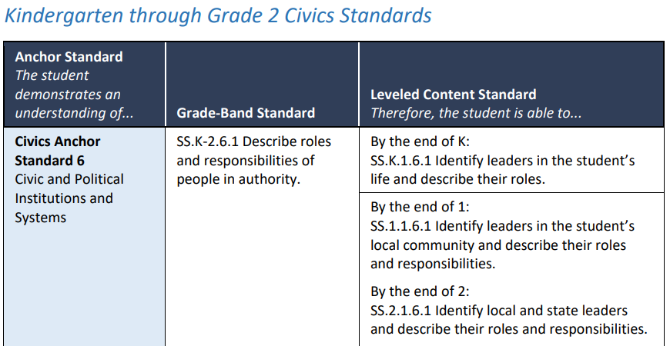

Figure 6: Civic anchor standard with related grade-band and leveled content standards in K-2 grade band.

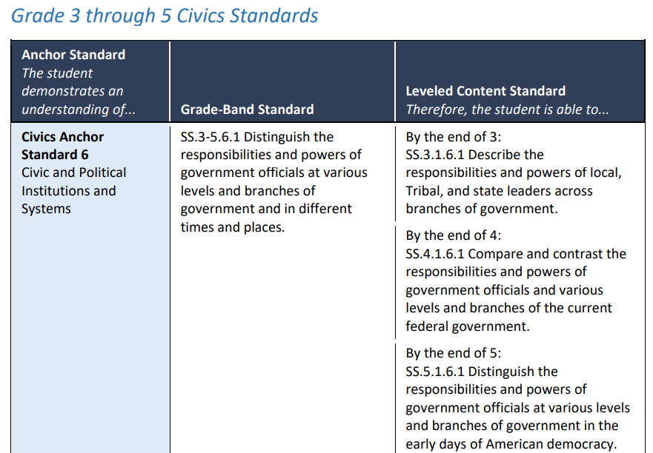

Figure 7: Civic anchor standard with related grade-band and leveled content standards in 3-5 grade band.

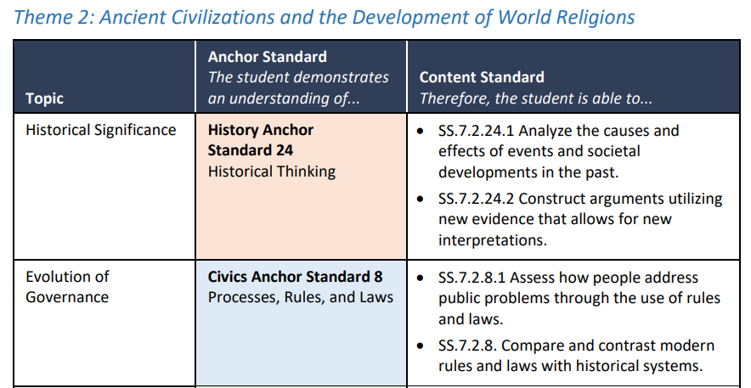

Figure 8: Civic anchor standard with related leveled content standards from Grade 7, Theme 2.

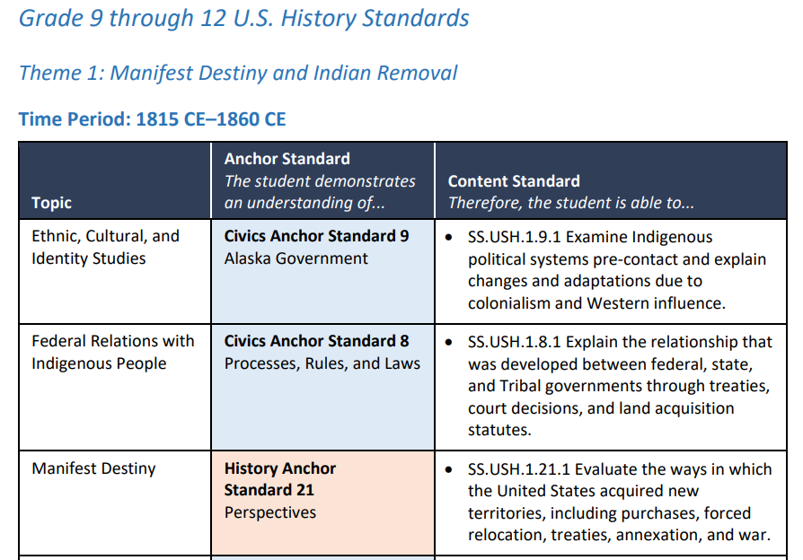Figure 9: Civic anchor standard with leveled content standards in Grade 9 “U.S. History” course.

**Summary and Key Takeaways**

*Definition:*

* “Civics” refers to standards and content in the 2024 standards related to Civics, as well as the grade 8 “U.S. History and Civics” course, and high school courses in Civics.

*Key changes for Civics in 2024 standards:*

* The 2024 standards include guidance and differentiation for each grade level
* One Civics-featured course articulated in the 2024 standards:
  + Grade 8: U.S. History and Civics
* Civics-related standards appear throughout the grade levels and content standards; as a result, students will encounter Alaska content and standards throughout K-12
* Anchor standards definitions and grade-leveled content standards give the 2024 standards a much greater level of clarity and detail than the 1998 standards

1. <https://education.alaska.gov/akstandards/Adopted-AK-SS-Standards-2024.pdf>
2. [AK DEED 2023-24 Social Studies Standards Revision Process Guide](https://education.alaska.gov/akstandards/social/AK%20SS%20Standards%20Process%20Guide_1.2.25%20Final%20508.docx)
3. The original, 1998 Alaska Social Studies Standards are no longer available to the public.
4. The National Council for the Social Studies. “College, Carrer, and Civic Life (C3) Framework for Social Studies State Standards” 2013. Retrieved from <https://www.socialstudies.org/system/files/2022/c3-framework-for-social-studies-rev0617.2.pdf>.
5. Center for Civic Education. (2014). National Standards for Civics and Government. Retrieved from <http://www.civiced.org/standards>