Review the plan in the AK STEPP tool or print out a Comprehensive Report
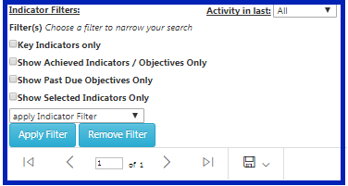
To view a school improvement plan in its entirety, log into Alaska STEPP, and on the “Home” page, hover over the 4th icon to the right, “Our Progress”, and click the “View Reports”. Next, click on the “Comprehensive Report” button which is the last button to the upper right of the page. This will display the entire improvement plan. To download or export, click the dropdown menu of the small disc icon. If more targeted information is wanted, there are several helpful filtering options that one can apply to this report. (Figure 1)
Disc
Figure 1 |  | 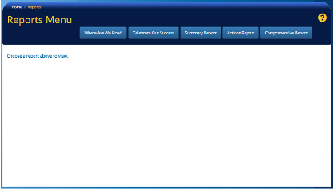  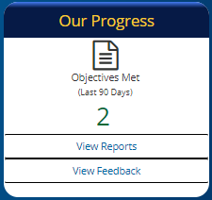
Check Dates and Outdated Information
Check all target due dates for up-to-date objectives and actions. If they are part of the plan for this year, make sure they have target dates that are in the future. Also, make sure their text description is current.
Objectives: To edit the dates and descriptions of objectives, go to the 3rd icon to the right, the “Success Cycle” and click on the “Assess, Create, Monitor” text. Select the desired indicator and scroll down to “Create & Monitor.” Best practice is to type the current date into the field when editing descriptions of objectives and the text box will continue to expand with historical information. To do so, type the current date and description in the text box titled “Describe how it will look when this objective is being fully met.”
Action: To edit “Action” target due dates related to the objective that was edited, scroll down, and then click on individual action row (the row will highlight yellow when you mouse over it for selection). Follow the prompts in the window that pops up and delete or save the “Action.” (Figure 2)
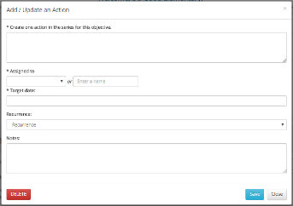
Pop up window.
Figure 2
Upload copies of the Needs Assessment and Assurance(s)
To upload a completed Needs Assessment, the signed School Improvement Plan Assurances, and (if applicable) the signed Title I Schoolwide Plan Assurances, go to the “Home” page, find the blue banner below the four main icons and click on the tab “Complete Forms”. Click on the template you want to download and once downloaded, enter information. To upload the completed documents go to the “Home” page, click on the document folder in the upper right hand corner. Then click on the blue “Upload a New File” button, next click on the white “Choose File” button (retrieve file from your computer), and fill in the fields. Don’t forget to choose a destination folder in the “Add in Folder” drop down menu and lastly click on the blue “Upload” button at the bottom of the page. (Figure 3)
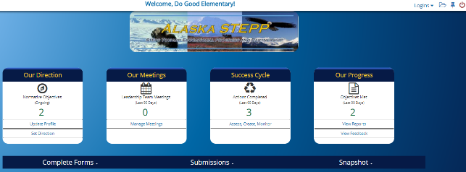  Forms  Figure 3 | To Upload  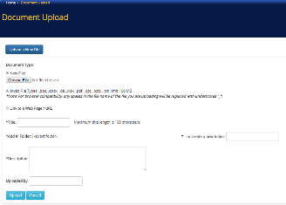  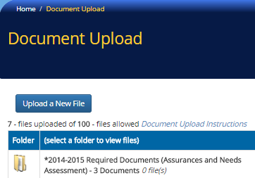  Upload
Submit the plan and uploaded Needs Assessment and Assurance(s)
Even if assessing, creating, and monitoring all indicators using Alaska STEPP is done and all documents have been uploaded, there is still one more step: Submitting. Because DEED encourages continuous improvement, it’s not assumed the plan is ready to be reviewed until submission is official. To do so, go to the “Home” page and click on the “Submissions” tab on the blue banner below the four main icons. To submit the “Alaska STEPP – Comprehensive Plan Report,” click the blue submit button on the right-hand side. This will take a snapshot of the current plan at that time. To submit any uploaded documents, click their blue “Submit” button and a calendar will appear. Click the date the form was uploaded into STEPP. (Figure 4)

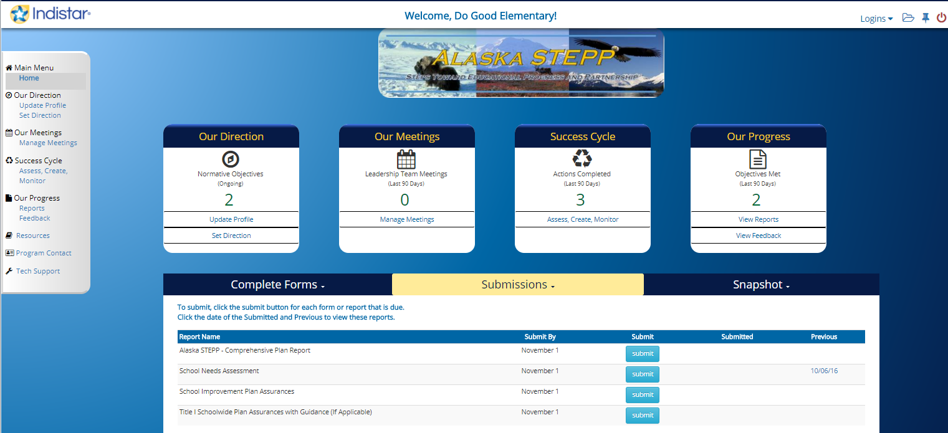
Submit Buttons
Figure 4

