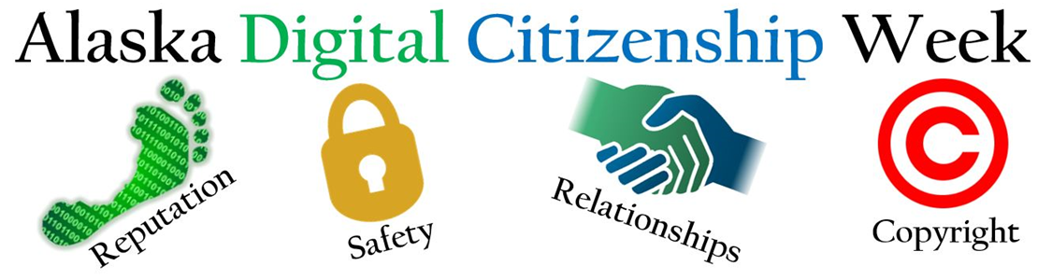
We appreciate that you are supporting your students by taking part in Alaska Digital Citizenship Week! We have put together THREE ways to participate in the daily themes which begin on Tuesday. By completing the Curriculum Tutorial on Monday and teaching lessons, you are well on your way to being Common Sense Certified! Whether you pursue certification or not, you are making an impact on our students’ success as members of a digital society.

Choose the activity or combination that best suits you and your students’ needs:
- Teach a 45-minute lesson. Each lesson has three delivery options: low/non tech, iBooks, and Nearpod. If time is tight, teach one suggested specific activity from the aligned lesson (linked in the chart below under Lesson).
- Show and discuss the highlighted video. This is the way to go if you only have 5-10 minutes to introduce the theme of the day.
- Share the corresponding Family Tips Sheets (linked in chart).

9-12 | Monday  Educate Yourself | Tuesday  Media Balance and Well Being | Wednesday  Privacy and Security | Thursday  Digital Footprint and Identity | Friday  Relationships and Cyberbullying
Lessons  45 minutes | Use today to create your account of Common Sense Media and begin exploring the digital citizenship curriculum and training | Social Media and How You Feel | Big Data Dilemma | Who's Looking At Your Digital Footprint? | Relationships: Rewarding Relationships  Cyberbullying: Countering Hate Speech Online
Videos: |  | Is Social Media Making you Sick? (KQED) | The Power of Likes (2015)  3.5 minutes  Still valid points | Harvard withdraws acceptances over social media messages (ABC)  (4 minutes) | Relationships: Frientimacy: The 3 Requirements of All Healthy Friendships | Shasta Nelson (0:00-8:30)  Cyberbullying:  Teen Voices: Hate Speech Online (6 minutes)
Family Tip Sheets | We encourage school leaders to send this letter home digitally or with students. | Help Kids Balance Their Media Lives | Help Boost Kids' Safety, Privacy, and Security | Help Kids Post, Comment, and Upload Responsibly | Help Kids Fight Cyberbullying and Other Mean Online Behavior

Bonus! – Consider having your students work through Filter Bubble Trouble from News and Media Literacy over the weekend and compare impressions on the following Monday. Digital Citizenship is a year round thing, right?

