Instructions to Complete the Program Demand
Cost Model
for
Alaskan Schools

Consultant HMS Inc.
4103 Minnesota Drive
Anchorage, Alaska

Editor Division of Finance & Support Services, Facilities Section
Alaska Department of Education & Early Development
Juneau, Alaska

Acknowledgements
Thanks to the individuals at HMS Inc. for their flexibility and professional advice on the 25th Edition revised through the early 2026 construction season. Thanks also to the Bond Reimbursement and Grant Review Committee members who may have participated in the publication in its final form and to users of previous editions for their suggestions for improvement.

Also, thanks to previous DEED employees who have worked on developing and editing this document in past years.

This publication may not be reproduced for sale by individuals or entities other than the:

State of Alaska
Department of Education & Early Development
Juneau, Alaska

The Alaska Department of Education and Early Development complies with Title II of the 1990 Americans with Disabilities Act. This publication is available in alternative communication formats upon request. To make necessary arrangements, contact the Employee Planning and Information Center of the Division of Personnel and Labor Relations at (907) 465-4434 or the TDD for the hearing impaired at (800) 770-8973.

The 25th Edition of the Program Demand Cost Model, developed by HMS Inc., is a complete demand cost model for both new construction (or major additions) and renovation.

Prices and unit rates are based on early 2026 costs for materials, equipment, freight, and April 2026 Title 36 labor rates. It should be noted that this is a method to develop a budget only and actual costs will vary. The Program Demand Cost Model will not be applicable for specific projects with developed design beyond concept level.

Opinions or estimates of probable construction costs used in developing the Program Demand Cost Model and escalation rate are prepared on the basis of HMS Inc.’s experience and qualifications and represent HMS Inc.’s judgment as a professional generally familiar with the industry. However, since HMS Inc. has no control over the cost of labor, materials, equipment or services furnished by others, over contractor’s methods of determining prices, or over competitive bidding or market conditions, HMS Inc. cannot and does not guarantee that proposals, bids, or actual construction cost will not vary from HMS Inc.’s opinions or estimates of probable construction cost contained in this cost model study.

Escalation has been estimated and included based on a current understanding of the local construction industry and national effect on the price of commodities, such as oil, oil-based products, steel, copper, and other basic materials.

Material and equipment prices have been gathered from a number of sources that include Spenard Builders Supply, Central Plumbing and Heating, Inc., Anchorage Sand and Gravel Company, Inc., Alaska Architectural Lighting, Inc., and Alaska Steel. The Guide, Means Cost Data, and other information was obtained through the practice of construction cost estimating.

Program Demand Cost Models: 1st Edition – May 1981; 2nd Edition – November 1983 (computerized in December 1984); 3rd Edition – August 1986; 4th Edition – August 1988; 5th Edition – June 1991; 6th Edition – July 1997; 7th Edition – November 1997; 8th Edition (7th Revised) - March 2000; 9th Edition – April 2001; 10th Edition – March 2005; 11th Edition – March 2007; 11th Edition Update – March 2008; and 11th Edition Revised – April 2009; 12th Edition – April 2010; 12th Edition Update – April 2011; 12th Edition Update Revised – April 2012; 13th Edition – April 2012; 14th Edition – April 2015; 15th Edition – May 2016; 16th Edition – April 2017; 17th Edition – April 2018; 18th Edition – April 2019; 19th Edition – April 2020; 20th Edition – April 2021: 21st Edition – April 2022; 22nd Edition – April 2023; 23rd Edition – April 2024; 24th Edition – April 2025.

Table of Contents
How to Use the Program Demand Cost Model 1
Getting Started 3
Worksheet – Instructions 3
Worksheet – Project Summary 3
New School or Addition Projects 4
Worksheet - 1.00 - Instructional/Resource and Support Teaching Areas 4
Worksheet - 2.00 - General Support/Supplementary Areas 4
Worksheet - 3.00 - Special Requirements 4
Worksheet - 4.00 - Site Work 6
Worksheet - 5.00 - Construction General Requirements 9
Worksheet - 6.00 - Geographic Area Cost Factor 9
Worksheet - 7.00 - Size Factor 9
Worksheet - 8.00 - Contingencies 10
Worksheet - 9.00 - Project Overhead and Other Costs 10
Renovations Projects 13
Worksheet - 11.00 - Renovation 13
Worksheet - 12.00 - Additional Costs for Hazardous Material Removal 24
Worksheet - 13.00 - Construction General Requirements 26
Worksheet - 14.00 - Geographic Area Cost Factor 26
Worksheet - 15.00 - Adjustment Factor 26
Worksheet - 16.00 - Contingencies 27
Worksheet - 17.00 - Project Overhead and Other Costs 27
Completion of the Cost Model Estimate 30
Worksheet - General Summary 30
Worksheet - Notes – Notes and Assumptions 30
Saving & Printing 30
Sample Estimate 30
Tables 40
Table No. 1 – Geographic Area Cost Factor (July 2023) 41
Table No. 2a – Size Adjustment Factor 44
Table No. 2b – Dollar Adjustment Factor 45
Table No. 3 – Alaskan Construction Index May 2022 46
Table No. 4 – Appendix E – Type Of Space Added Or Improved 49
Table No. 5 – Abbreviations 50
Table No. 6 – Statement Of Specifications 51
Bibliography 53

How to Use the Program Demand Cost Model
The Program Demand Cost Model for Alaskan Schools (Cost Model) was originally developed for the State of Alaska, Department of Education in 1981; and has been used over the years with much success. Through the 6th Edition, it was revised periodically to keep unit costs current. The 6th and 7th Editions underwent significant modification of the Renovation module by shifting to a building systems based model to provide users a more versatile estimating tool. The 8th Edition provided detailed renovation cost data. The 10th Edition further developed building systems and advanced low voltage electrical systems that better reflect those used in a modern school. The 11th Edition reflected major cost changes experienced in the 2005/2006 period. The 11th Edition Update continued to reflect major cost changes and added specific classroom technology. The 12th Edition was developed spring 2010 to provide an updated escalation analysis and reconsidered new and reconditioned space cost factors. The 12th Edition Updates reflected cost adjustments for 2011 and 2012, as did the 13th, 14th, and 15th Editions, which also updated escalation rates. The 16th and 17th Editions updated changes in material cost and labor rates. The, 18th Edition represented a significant expansion to the previous models and included additional cost programming line items that expanded site work, site improvements, power generation, interior finishes, furnishings, mechanical, and electrical work. The 19th Edition updated changes in material cost and labor rates and moved to light-gauge metal framing for exterior walls. A unique market risk was also included in this edition to address the global health pandemic. The 20th Edition updated material costs and labor rates, and removed the market risk. The 21st Edition updated material cost and labor rates, and included a unique market risk to address global market shortages. The 22nd Edition, 23rd Edition, and 24th Edition address changes in material costs and labor rates. The current 25th Edition updates material costs and labor rates, and includes a unique market risk to address challenges related to tariff and fuel pricing volatility.

The Cost Model is designed to address two types of construction projects: New Schools or Additions and Renovations. The renovation costs are itemized by building systems to allow the user to generate project-specific renovation costs. This provides the renovation module the ability to address a wide variety of project scopes, from window replacements to complete interior tear out and remodel.

The renovation module can generate good quality cost estimates but require that the user has an understanding of the building systems affected by the project and a rough idea of the quantity of work required to each building system. It is not as quick as summing the square footage of space to be renovated and applying a light, medium, or high renovation cost. However, properly applied it will generate a good quality, project-specific cost estimate.

The Cost Model is to be used to establish a complete budget for a specific school construction project. The project construction budget can be utilized as a basis for legislative funding requests, local bond issues, or other forms of appropriation. It can be used to generate a conceptual estimate without going to the expense of producing architectural drawings or engineering reports, or as a means of assessing a consultant’s estimate for its reasonableness.

It should be noted that the Cost Model is a tool to develop a construction project budget for projects with limited information or in the early stages of definition. It is not intended for projects beyond the conceptual design level or for projects where detailed estimates or contractor quotes are available.

Getting Started
The Cost Model is available from the Department of Education & Early Development’s website for Capital Improvement Project Application & Support (education.alaska.gov/Facilities/FacilitiesCIP.html)

To use the model, open the Excel link, and save the file on your hard drive. The Cost Model workbook is composed of a series of worksheets that address different project costs. Worksheets 1.00 through 9.00 are for New Construction or Addition work and Worksheets 11.00 through 17.00 are for Renovation work.

All rates are based on prices derived from the costs associated with school construction in Anchorage. Lump sum costs may require further technical assistance to determine, and should be based on Anchorage pricing. The final sum of all costs will be regionally adjusted by using the geographic cost factors listed in Table No. 1.

Worksheet – Instructions
The workbook should open to the Instructions worksheet. This worksheet provides a brief explanation of the functionality of the workbook. The cells with red text are to be used for entry of project specific information. The red text cells should be the only editable cells in the workbook. The tab key will move the cursor from editable cell to editable cell while skipping the locked cells. The cells containing estimated project costs are linked to other worksheets and no edits to these cells are required.

Worksheet – Project Summary
This worksheet provides a single page summary of the project identification and the estimated project costs. Please refer to the Samples section for an example of the Project Summary worksheet. Complete the project summary information (school district, project name, location, and date of estimate), save the file, and proceed to the next worksheet. It is recommended that the file be saved at the completion of each worksheet.

New School or Addition Projects

Worksheet - 1.00 - Instructional/Resource and Support Teaching Areas
This worksheet contains square foot of floor area unit costs for various types of instructional resource and support teaching areas. These space categories are similar to those in Appendix E of the CIP Application Instructions. Enter the square feet of floor area that is required in each of the space types. Categories 1.09 and 1.10 are available for other required instructional spaces that are not specifically listed. Enter a descriptive title for the other space on the worksheet by overwriting the red text cell entitled Other. Please provide additional information regarding the physical characteristics of the space and the basis for the estimated cost on the Notes and Assumptions worksheet.

Worksheet - 2.00 - General Support/Supplementary Areas
This worksheet contains square foot of floor area unit costs for various types of general support and supplementary areas. These space categories are similar to those in Appendix E of the CIP Application Instructions. Enter the square feet of floor area that is required in each of the space types. Categories 2.11 and 2.12 are available for other required general support spaces that are not listed. Enter a descriptive title for the other space on the worksheet by overwriting the red text cell entitled “Other”. Please provide additional information regarding the physical characteristics of the space and the basis for the estimated cost on the Notes and Assumptions worksheet.

Worksheet - 3.00 - Special Requirements
This worksheet contains unit costs for special requirements that are often included in the construction of a new school or addition. Please note that the unit costs are no longer based entirely on square feet of floor area so the units entered in the red text cells must coincide with units used in pricing a particular item. Below is a brief summary of the work items included on worksheet 3.00:

3.011 Emergency Generator Within the Building – enter the number of kilowatts (KW) required based on the emergency circuits needed to maintain critical functions. In lieu of this information, 25% of the total building load may be used.

3.012 Emergency Standby Generator (Pre-Packaged) – this item assumes the use of a generator in a pre-packaged arctic enclosure. Enter number of kilowatts (KW) required based on the emergency circuits needed to maintain critical functions. In lieu of this information, 25% of the total building load may be used.

3.013 Generator Primary Power – this item assumes primary power for the school being provided by designated power generation using oil fired generators. Enter the number of kilowatts (KW) required for the entire facility.

3.02 Fuel Oil Storage for Generator – enter the gallon capacity of fuel of the generator’s storage tank (this tank is in addition to the day tank) if supplementary gallons are required in additional to the storage for heating fuel.

3.031 Fire Protection Diesel Pump – enter the number of pumps that are assumed to utilize diesel as the fuel source.

3.032 Fire Protection Electric Pump – enter the number of pumps that are assumed to utilize electrical power as the fuel source.

3.033 Fire Protection - Mist System – enter the square feet (SF) of the area to receive the mist fire protection system. Bear in mind that a mist fire protection system is not typically appropriate as a whole school system.

3.04 Fire Protection - Water Storage – enter the gallon capacity of water storage tanks required to provide sufficient water to supply the fire sprinkler system. Technical assistance may be required to accurately calculate the water storage tank size requirements.

3.05 Add for Crawlspace – enter the square foot area of the crawlspace. Costs include excavation, structural floor, sprinklers and lighting.

3.06 Pile Foundation with Subfloor System – enter the square foot area of the ground floor. Costs include piles, structural floor, soffit with interstitial space, sprinklers and lighting.

3.07 Thermopile Foundation with Subfloor System – enter the square foot area of the ground floor. Costs include thermopiles, structural floor, soffit with interstitial space, sprinklers and lighting.

3.08 Demolition of Existing Building – enter complete square foot area of the facility to be demolished. Costs include demolition and landfill costs, but exclude hazardous material abatement. Note, this item is for removal of the entire building.

3.09 Abatement of Existing Building – enter complete square foot area of the facility to be abated. Costs exclude demolition included in 3.08 Demolition of Existing Building.

3.10 Sewage Lagoon Closeout – This item represents the cost to close out, fill, revegetate, and monitor sewage lagoons at the end of their useful life. Enter the approximate square footage (SF) of the lagoon.

3.11 Other Special Requirements – enter a lump sum amount for other special requirement costs. The lump sum cost should be calculated as if the work were to be performed in Anchorage. The geographic factor applied on worksheet 6.00 will convert the lump sum cost to an appropriate regional cost. Provide additional information regarding the other work on the Notes and Assumptions worksheet. Technical assistance may be required to accurately calculate these costs.

Worksheet - 4.00 - Site Work
This worksheet contains unit costs for site work. There is an increase in categories on this worksheet that are lump sum (LS) entries. This requires the input of a dollar amount rather than a quantity and will probably require technical assistance to complete accurately. Please note that all lump sum costs should be calculated as if the work were to be performed in Anchorage. The geographic factor applied on worksheet 6.00 will convert the lump sum costs to an appropriate regional cost. Below is a brief summary of the work items included on worksheet 4.00:

4.01 Site Preparation (Estimate) – enter the lump sum dollar amount required to prepare the site. Includes work such as soil remediation, building relocation, shoring, dewatering, and environmental protection. Use this line item to enter an established budget for site preparation, if available.

4.011 Soil Remediation (Estimate) – enter the cubic yards (CY) of soil that require remediation. Unit cost includes soil testing, excavation of contaminated soils, treatment of contaminated soils, and replacement of excavated soils with non-frost susceptible fill. Note this item also occurs in Section 12.13. This should only be entered in one location.

4.02 Site Earthwork (Estimate) – enter the lump sum dollar amount required for site earthwork. Includes work such as clearing, excavation, grading, leveling, dewatering, and import/export of fill.

4.03 Site Improvements (Estimate) – enter the lump sum dollar amount required for site improvements. Includes work such as site paving, walks, sports courts and fields, stairs, ramps, walls, decks, fences, landscaping and play equipment, etc., and installation of other site accessories. Use this line item to enter an established budget for site improvements, if available.

4.031 Construct Paved Parking Area – enter the number of parking stalls anticipated. This item includes fills in place, paving (including drive lanes), pavement marking, curbs, and handicapped accessible stalls and signage.

4.032 Construct Unpaved Parking Area – enter the anticipated area of parking. This item includes fills and signage at handicapped areas.

4.033 On Grade Boardwalk – enter anticipated area of boardwalk constructed at grade. This item anticipates raised boardwalk at areas of utility crossings.

4.034 Elevated Boardwalk – enter anticipated square feet (SF) of boardwalk constructed on piles.

4.035-A Large Play Equipment with Fall Protection – enter number of anticipated large play structures.

4.035-B Medium Play Equipment with Fall Protection – enter number of anticipated medium play structures.

4.035-C Small Play Equipment with Fall Protection – enter number of anticipated small play structures.

4.035-D 4-Bay Swing Set – enter number of 4-bay swing sets anticipated.

4.035-E Playground Safety Surfacing – enter the anticipated square feet (SF) of playground safety surfacing over and above that provided for in the safety zones of playground equipment entered above.

4.036-A Play Deck on Grade – enter the anticipated square feet (SF) of play deck built on grade.

4.036-B Play Deck on Helical Piles – enter the anticipated square feet (SF) of play deck built on piles.

4.037-A Landscaping with Truck Access – enter the anticipated square feet (SF) of landscaping for sites that are on the road system.

4.037-B Landscaping with Barge Access – enter the anticipated square feet (SF) of landscaping for sites that are only barge accessible.

4.038 Sports Field/Track – this line item anticipates the construction of an asphalt running track with grass covered infield. Enter the square feet (SF) for the entire area, including track and infield.

4.04 Site Structures (Estimate) – enter the lump sum dollar amount required for site structures such as covered walkways, covered play areas and support buildings if an established budget is available. Otherwise use the line items for the individual site structures included.

4.041 Covered Play Area – enter the anticipated square feet (SF) of a covered play structure.

4.042 Utility Building Built in Place – enter the anticipated square feet (SF) of a utility building separate from the primary structure.

4.043 Pile Supported Deck Structure – enter the anticipated square feet (SF) of pile supported deck structure outside of the primary facility, including stair area.

4.05 Site Utilities (Estimate) – enter the lump sum dollar amount required for the installation of gas service, utilidors, and storm drainage.

4.051 Water Main – enter the linear foot (LF) length of the proposed sewer pipe.

4.052 Sewer Main – enter the linear foot (LF) length of the proposed sewer main.

4.053 Underground Storm Water System – enter the square feet (SF) of the site to be drained via an underground storm sewer system, excluding the building footprint area.

4.054 Pumped Sanitary Sewer System – enter the linear foot (LF) of the proposed pumped sanitary sewer system.

4.055 Well – enter the proposed number of water wells.

4.056 Pre-Packaged Water Treatment – enter one (1) if a pre-packaged water treatment plant is anticipated for use with the project. The plant indicated will serve from 50 to 250 students.

4.057 Utilidor – enter the linear foot (LF) length of the above-grade utilidor, excluding piping.

4.06 Bulk Fuel Storage – enter the gallon capacity of the new bulk fuel storage facility. This cost is for construction of a complete new above ground fuel storage and distribution system with a storage capacity exceeding 1,000 gallons. The Cost Model unit cost for this category varies automatically based on the storage capacity. Projects that require replacement of an existing above ground bulk fuel storage system should use category 12.10 Replace Bulk Fuel System (Above Ground) in lieu of category 4.06. Projects that require replacement of an existing below ground bulk fuel storage system should use category 12.09 Replace Small Fuel Oil Tank (Below Ground) in lieu of category 4.06. Category 12.13 Soil Remediation should be used in conjunction with categories 12.09 and 12.10 if contaminated soil exists at existing fuel storage areas.

4.07 Site Electrical (Estimate) – enter the lump sum dollar amount required for electrical site work. This includes headbolt heaters and connections to equipment, including the cost for running conduit and wire to the building. Costs associated with electrical supply and communications to the building, such as electrical service and transformer, should also be entered in this category.

4.08 Site Lighting (Cost Per Fixture) – enter number of fixtures required for site lighting. Costs associated with electrical supply to the building, such as electrical service and transformer, should be entered in category 4.07 Site Electrical. Generally, category 4.08 Site Lighting is to include the cost of running conduit and wire from the facility’s panels to various electrical fixtures on the site, and the cost of furnishing and installing those fixtures.

4.09 Septic Tank/Leach Field – enter the number of complete systems needed. Basis of system is a 5,000 gallons tank storage, 300 linear feet of drain line and 2,100 cubic yards of select backfill. System is sufficient for approximately 90 fixture units.

4.091 Sewage Lagoon – enter the anticipated number of users, including students, staff, and community members.

4.092 Pre-Packaged Waste Water Treatment - enter one (1) if a pre-packaged sewer treatment plant is anticipated for use with the project. The plant indicated will serve from 50 to 250 students.

4.10 Other – enter here estimates of additional cost for site work, both on and off site. Provide additional information describing the required work and the basis for the estimated cost on the Notes and Assumptions worksheet.

Worksheet - 5.00 - Construction General Requirements
This worksheet calculates the overhead and profit charges for a general contractor’s services, insurances, and bond. This cost is set at a percentage of the direct construction cost. No entries are required on this worksheet.

Worksheet - 6.00 - Geographic Area Cost Factor
This worksheet calculates the additional cost for construction based on the project location. The unit costs in the Cost Model are all based on the cost of material and labor in Anchorage. Therefore, to accurately reflect construction costs in other regions of the state, a geographic factor is applied to the construction costs to adjust them to reflect the actual cost of construction in the project’s locale. The geographic area cost factor includes costs related to logistics (shipping, subsistence, travel, etc.), and regional design criteria as applied to different locations.

The regional geographic factors can be found in Table No. 1 Geographic Area Cost Factor. Table No. 1 lists school districts alphabetically, with some districts having multiple factors. There are two values to the right of the district name: the Index and the Percentage. The listed percentage for the school district will automatically populate according to the location listed on the Project Summary page. The spreadsheet will automatically calculate the reduced or additional construction cost due to the geographic location of the project.

Worksheet - 7.00 - Size Factor
This worksheet calculates the premium that a project will cost based on the size of the project. It can be anticipated that projects smaller than 25,000 square feet will cost more per square foot because a portion of a contractor’s general requirement costs are fixed. The additional cost required due to the size of the project is calculated automatically on this worksheet. If the Size Adjustment Factor does not apply to this project, select “Yes” on whether to override, and the amount calculated for this factor will be disregarded by the model.

Worksheet - 8.00 - Contingencies
This worksheet calculates the necessary contingencies for the project. Three contingencies are addressed: a general design contingency, a unique market risk, and an escalation contingency.

The general design contingency is to accommodate unknowns due to the conceptual level of the design. The general design contingency is fixed at 10% of the subtotal of costs calculated on worksheets 1.00 through 7.00. No entries are required to determine the general design contingency.

The unique market risk addresses material prices that have remained highly volatile over the past year, driven by production constraints, extended lead times, sustained demand, and continued strain in the construction labor market. The ongoing volatility related to tariffs in their implementation, scope, and magnitude has increased perceived risk and have now materially affected the construction industry. This contingency is set at a fixed rate of 5% and no entries are required.

The escalation contingency is to account for the increase in current construction costs to the year in which the project is anticipated to be constructed. The escalation rate is automatically calculated based on the anticipated construction year entry that is to be entered in the red text cell for category 8.04.

Worksheet - 9.00 - Project Overhead and Other Costs
This worksheet calculates project overhead and other costs that are associated with the construction of a new school or addition. This worksheet also provides the total project cost. Below is a brief summary of the costs included on worksheet 9.00:

9.01 Construction Management (By Consultant) – enter the percent of construction cost required for construction management. The Department of Education & Early Development’s suggested range for construction management is 2%, 3%, or 4% of the construction cost. If costs are expected to exceed the department’s recommended percentages, please provide a detailed justification of the overage. Also note that AS 14.11.020(c) places limits on the cost of construction management furnished by a private contractor:

AS 14.11.020
(c) The construction management costs of a project assumed under this section may not exceed four percent of the amount of appropriations for the facility if the amount of appropriations is $500,000 or less. The construction management costs of a project assumed under this section may not exceed three percent of the amount of appropriations for the facility if the amount of appropriations is over $500,000 but less than $5,000,000. The construction management costs of a project assumed under this section may not exceed two percent of the amount of appropriations for the facility if the amount of appropriations is $5,000,000 or more. For purposes of this subsection “construction management” means management of the project’s schedule, quality, and budget during any phase of the planning, design, and construction of the facility by a private contractor engaged by the municipality or regional educational attendance area.

9.02 Land Purchase Costs – enter the lump sum amount for land purchase costs. Even if the site has already been purchased it is wise to include the acquisition cost, especially if state reimbursement or funding is to be sought. Please note that 4 AAC 31.025 defines the requirements for reimbursement of site acquisition costs. Information regarding school site selection is available in the Department of Education & Early Development publication, Site Selection Criteria and Evaluation Handbook, current edition.

9.03 Site Investigation – enter the lump sum amount for site investigation. Site investigation costs include costs associated with selecting a site, site surveys, and geotechnical investigation services.

9.04 Seismic Hazard – enter a cost provided by an Alaska seismic safety design professional to perform seismic surveys of existing facilities, make recommendations, and provide a plan or specification to implement seismic improvements.

9.05 Design Services Costs – enter the percent of construction cost required for design services costs. Design costs include the costs associated with project planning (from educational specifications through design development), preparation of construction/bid documents, and overseeing the completion of the work. Typically, large projects require smaller design cost percentages. The Department of Education & Early Development’s suggested range for the cost of project design is 6 – 10% of the construction cost. If costs are expected to exceed the department’s recommended percentages, please provide a detailed justification of the overage.

9.06 Other Construction – enter construction cost if provided by a third party for items not otherwise included in the program demand cost model. This amount should include all costs required for completion of work not estimated using the Cost Demand Model. Provide detailed information describing lump sum source and basis for the costs or construction work on the Notes and Assumptions worksheet; can supplement with attachment, if needed.

9.07 Equipment & Technology Costs – enter the percent of construction cost required for equipment costs. Please refer to the Department of Education & Early Development publication, Guidelines for School Equipment Purchases, current edition, for information regarding the definition of equipment. Budget parameters for equipment costs on a per student basis are also established in the publication. The Department of Education & Early Development’s suggested range for the cost of furnishings and equipment is 0 – 4% of the construction cost. Technology is included with equipment. If costs are expected to exceed the department’s recommended percentages, please provide a detailed justification of the overage.

9.08 District Administrative Overhead – enter the percent of construction cost required for district administrative overhead costs. Indirect costs include the school district’s cost of facilitating the entire project, accounting costs, and in-house construction management costs. Typically, large projects require smaller indirect cost percentages. The Department of Education & Early Development’s suggested range for the cost of project administration is 2 - 9% of the construction cost. If costs are expected to exceed the department’s recommended percentages, please provide a detailed justification of the overage.

9.09 Art– enter the percent of construction cost required for art. The department applies the provisions of AS 35.27.020 to establish the required percent for art in school projects. This requirement is being applied by the department to all School Construction projects and some Major Maintenance projects based on the scope of the project. The minimum requirement for rural school facilities is 0.5% of construction cost. The minimum requirement for all other school facilities is 1% of construction cost. The department’s suggested range for art procurement correlates to the appropriate minimum percentage required.

9.10 Project Contingency – calculates the project contingency for the entire project. The project contingency is fixed at 5% of the subtotal shown in category 8.04, so no entries are required to generate the cost. This contingency is to cover the possibility of above average design, management, or administration costs, as well as construction cost overruns. The project contingency is in addition to the 10% general design contingency that was applied in worksheet 8.00.

9.11 Project Total Cost – provides the estimated project total cost for new construction or addition work. This line also provides a total of the additional percent costs associated with the project. If these costs exceed 30% of the project construction cost, then a detailed justification of the additional costs will be required.

Worksheets 1.00 – 9.00 comprise the New School or Addition module of the Program Demand Cost Model for Alaskan Schools – 25th Edition. Please refer to the Samples section for examples of the Project Summary, General Summary, and Notes and Assumptions worksheets.

Renovations Projects

Worksheet - 11.00 - Renovation
This worksheet is the heart of the Renovation Cost Model. Unit costs are provided by work assembly. A work assembly can be thought of as a summary of a group of tasks required to complete that item. A building system is composed of a series of work assemblies. An example of a building system would be 11.30 Exterior Closure. An example of a work assembly is the replacement of an exterior door. Below are the tasks that contribute to the unit cost to replace an exterior door:

- Remove interior and exterior door trim;
- Remove door and door frame;
- Dispose of demolition debris;
- Install new door frame and hang door;
- Install new door hardware;
- Install new interior and exterior door trim;
- Install new caulking at door opening;
- Paint door, door frame, door trim.

The use of work assemblies provides users with the flexibility to customize a renovation estimate to the repairs required at a specific facility. Not every conceivable building system replacement is covered here, just the most common building systems found in existing Alaskan schools. If the proposed project incorporates a special building system that is not included in worksheet 11.00, a consultant knowledgeable in the special system will be required to prepare an accurate cost estimate. Note that hazardous material abatement is not included in worksheet 11.00 unit costs. Costs for removal of hazardous materials are covered on worksheet 12.00 and should be selected as necessary. Below is a brief summary of the unit costs included on worksheet 11.00:

11.01 Site Work
11.02 Paving Replacement – enter the number of stalls to be replaced. This item includes demolition, new base course, paving, pavement markings, and drive lanes.

11.03 Fencing Replacement – enter the linear feet (LF) of fence to be replaced.

11.04 Replace Septic System – enter the anticipated gallons of the septic tank to be replaced. This item includes complete replacement of the system, including piping, tank, and drain field.

11.10 Foundation and Substructure
11.11 Repairs (Estimate) – enter the lump sum amount required for foundation and substructure repairs. If the facility requires foundation or substructure repairs, technical assistance from a consultant with foundation repair experience will be required to accurately estimate the extent of repairs required and their cost. Please provide additional information describing the required repairs and the basis for the estimated cost on the Notes and Assumptions worksheet.

11.12 Recharge Thermopiles – enter the number of thermopiles that require recharging.

11.13 Site Grading/Drainage – enter the acreage of the failed storm drainage system to be replaced.

11.20 Superstructure
11.21 Repairs (Estimate) – enter the lump sum amount required for superstructure repairs. If the facility requires superstructure repairs, technical assistance from a consultant with structural repair experience will be required to accurately estimate the extent of repairs required and their cost. Please provide additional information describing the required repairs and the basis for the estimated cost on the Notes and Assumptions worksheet.

11.22 Seismic Repairs (Estimate) – enter the lump sum amount required for seismic repairs. This item will require technical assistance from a seismic safety design professional who has experience to accurately estimate the extent of repair, upgrades and improvements, and the associated cost. Provide additional information describing the required repairs and the basis for the estimated cost on the Notes and Assumptions worksheet.

For all 11.3X, 11.4X and some other individual items, enter the square footage of the amount of the system to be replaced. Do NOT use the total square footage of the building.

11.30 Exterior Closure
11.31 Exterior Upgrades (Replace Exterior Beveled Siding) – enter the square feet of beveled siding to be replaced. This unit cost includes: removal and disposal of existing siding, installation of new Tyvek and beveled cedar siding, installation of new exterior trim and flashing, new caulking at openings, new paint to siding and trim.

11.32 Exterior Upgrades (Repaint Existing) – enter the square feet of exterior siding to be repainted. This unit cost includes: removal of old caulking, installation of new caulking, preparation of surfaces, new paint to doors, trim and exterior siding.

11.33 Exterior Insulation Finish System to Existing – enter the square feet of EIFS to be installed over the existing siding. This unit cost includes: surface preparation of existing siding, installation of 1” EIFS, new sealant and flashing. Please note that the cost to remove existing siding is excluded from the 11.33 unit cost. If your project requires removal and disposal of existing siding, enter the lump sum cost in category 11.42 for the demolition work. Provide a description of extra work on the Notes and Assumptions worksheet and remember that all lump sum costs should be calculated as if the work were to be performed in Anchorage. The geographic factor applied on worksheet 14.00 will convert the lump sum costs to an appropriate regional cost.

11.34 Exterior Upgrades (Painted Cement Board) – enter the square feet of painted cement board to be installed over the existing siding. This unit cost includes: surface preparation of existing siding, installation of cement board, new exterior trim, painting of exterior, new sealant, new Tyvek, and new flashing. Please note that cost to remove existing siding is excluded from the 11.34 unit cost. If your project requires removal and disposal of existing siding, enter the lump sum cost in category 11.42 for the demolition work. Provide a description of extra work on the Notes and Assumptions worksheet and remember that all lump sum costs should be calculated as if the work were to be performed in Anchorage. The geographic factor applied on worksheet 14.00 will convert the lump sum costs to an appropriate regional cost.

11.35 Exterior Skin (Metal Siding) – enter the square feet of metal siding to be installed over the existing siding. This unit cost includes: furring and ½” CDX plywood, installation of Kynar finish metal siding system, new sealant, new Tyvek, and new flashing. Please note that cost to remove existing siding is excluded from the 11.35 unit cost. If the project requires removal and disposal of existing siding, enter the lump sum cost in category 11.42 for the demolition work. Provide a description of extra work on the Notes and Assumptions worksheet and remember that all lump sum costs should be calculated as if the work were to be performed in Anchorage. The geographic factor applied on worksheet 14.00 will convert the lump sum costs to an appropriate regional cost.

11.36 Exterior Skin (New Metal Siding Installed Over Existing) – enter the square feet (SF) of new metal siding to be installed over existing metal siding.

11.37 Insulation (Replace Insulation and Gypboard) – enter the square feet (SF) of insulation to be replaced in existing exterior wall. This unit cost includes: removal of GWB and insulation on exterior wall, disposal of debris, installation of new R-19 insulation, installation of new 10 mil vapor barrier, and installation of new GWB.

11.38 Exterior Closure (Replace Doors and Frames) – enter the number of door leafs to be replaced. This unit cost includes: removal of interior and exterior door trim, removal of door and frame, disposal of debris, installation of new door and frame, installation of new door hardware, new caulking, and painting of all new work.

11.39 Exterior Closure (Replace Overhead Doors) – enter the square feet (SF) area of the doors to be replaced.

11.40 Exterior Closure (Replace Windows) – enter the square feet of glazing to be replaced. This unit cost includes: removal of windows and blinds, disposal of windows and blinds, installation of new metal clad windows, installation of new interior and exterior trim, painting of trim, installation of new horizontal blinds.

11.41 Exterior Closure (Replace Curtain Wall) – enter square feet (SF) area of curtain wall assembly to be replaced.

11.42 Other Repairs (Estimate) – enter a lump sum amount for exterior repairs or alterations not accounted for elsewhere. Provide details regarding the additional cost on the Notes and Assumptions worksheet. All lump sum costs should be calculated as if the work were to be performed in Anchorage. The geographic factor applied on worksheet 14.00 will convert the lump sum costs to an appropriate regional cost.

11.50 Roofing (Area of Roof)
11.51 Replace Metal Roofing – enter the square feet (SF) of metal panel roofing to be replaced. This unit cost includes: removal and disposal of existing roofing (excluding hazardous material abatement), minor repair of approximately 20% of roof deck, installation of new metal panel roofing, and allowance for mechanical and electrical work associated with roof replacements.

11.52 Replace Insulated Metal Panel Roofing – enter the square feet (SF) of metal roofing to be replaced. This unit cost includes: removal and disposal of existing roofing (excluding hazardous material abatement), minor repair of approximately 20% of roof deck, replacement of approximately 20% of insulation and vapor barrier, installation of new metal roofing, and allowance for mechanical and electrical work associated with roof replacements.

11.53 Replace Membrane Roofing – enter the square feet (SF) of flat roof membrane to be replaced. This unit cost includes: removal and disposal of existing roofing, minor repair of approximately 20% of roof deck, installation of new vapor barrier, installation of new 6” rigid insulation, installation of new flashing, installation of new EPDM roofing, and allowance for mechanical and electrical work associated with roof replacements.

11.54 Replace Asphalt Shingle Roofing – enter the square feet (SF) of roof surfaces to be replaced—properly accounting for roof slopes as needed. This unit cost includes: removal and disposal of existing roofing, minor repair of approximately 20% of roof deck, installation of new roofing felt and roof shingles, installation of new flashing, and allowance for mechanical and electrical work associated with roof replacements.

11.55 Increase Roof Insulation by R-10 During Roof Replacement – enter the square feet (SF) of roof surface to receive additional R-10 (2”) rigid insulation. Note this item is for the additional insulation to be installed during a re-roof project. It does not include cost for re-roofing and associated work.

11.56 Replace Roof Drain/Rain Leader – enter the number of roof drains to be replaced. This item includes roof drains, rain leader piping, insulation, and heat trace.

11.60 Interior Construction
11.61 Replace Partitions (Includes Finishes) – enter the square feet of new interior partitions. The quantity of new partitions is the sum of the square feet of framed wall, not the square feet of GWB. This unit cost includes: removal and disposal of existing partitions, framing of new 2x4 and 2x6 partitions, installation of new sound batt insulation, installation of new GWB, installation of new base, installation of new wall finishes, and painting. Please note that this cost, while including a variety of common wall finishes, does not include ceramic tile. Use category 11.69 for installation of ceramic wall tile.

11.62 Replace Wall Finishes – this item assumes replacement of all wall finishes in a school or related. Enter the square feet (SF) area of the building.

11.63 Replace Door Leaf and Frames – enter the number of door leaves to be replaced (note, count 2 for double doors). This unit cost includes: removal of door and frame, disposal of debris, installation of new door and frame, installation of new door hardware, and painting of all new work.

11.64 Interior Painting (Walls and Ceilings) – enter the square feet (SF) of the building interior to be painted. This unit cost includes: removal and reinstallation of electrical device covers, painting of walls, painting of ceiling, and painting of doors.

11.65 Replace Carpet Tile – enter the square feet (SF) of new carpeting. This unit cost includes: removal and disposal of existing floor finish, installation of new carpet, and installation of new base.

11.66 Replace Resilient Flooring – enter the square feet (SF) of new resilient flooring (sheet vinyl and VCT). This unit cost includes: removal and disposal of existing floor finish, installation of new resilient flooring, and installation of new base.

11.67 Replace Wood Gym Flooring – Enter the square feet (SF) of the new gym flooring. The unit cost includes removal and disposal of existing floor finish, installation of new floor and base, and court markings.

11.68 Replace Resilient Gym Flooring – enter the square feet (SF) of new gym flooring. This unit cost includes: removal and disposal of existing floor finish, installation of new sports flooring, and installation of new base.

11.69 Replace Ceramic Tile – enter the square feet (SF) of new ceramic tile. This unit cost includes: removal and disposal of existing tile surfaces, installation of new mosaic floor tile, and installation of new wall tile with cementitious backer.

11.70 Replace Acoustical Tile Ceiling – enter the square feet (SF) of suspended acoustic ceiling tile to be replaced. This unit cost includes: removal and reinstallation of light fixtures, removal of existing suspended acoustical ceiling system, and installation of new suspended acoustical ceiling system.

11.71 Replace Gypboard Ceiling – enter the square feet (SF) of new gypsum board ceiling. This unit cost includes removal and reinstallation of light fixtures, removal of existing gypsum board ceiling, installation of new gypsum board ceiling, and painting of new ceiling.

11.80 Specialties / Furnishings and Equipment
11.81 Replace Toilet Partitions – enter the number of toilet partitions to be replaced. This unit cost includes: removal and disposal of existing toilet partitions, installation of new toilet partitions, and installation of new associated toilet accessories.

11.82 Replace Toilet Accessories – enter the number of toilet accessories (soap dispensers, waste receptacles, paper towel dispensers, etc.) to be replaced. This cost includes: removal and disposal of existing toilet accessories and installation of new toilet accessories.

11.83 Smart Boards – this assumes one smart board per classroom and the work associated with its installation.

11.84 Replace Sports Equipment and Lockers (Small Gym) – enter the number of lots of sports equipment and lockers to be replaced. Each lot includes the following work: removal and disposal of existing equipment, installation of 50 new lockers, installation of two new wall mount basketball goals, installation of four new floor inserts, installation of two new chinning bars, and installation of two new climbing peg boards. This is only useable for a small gym installation (for a full size gym, increase cost by x4).

11.85 Replace Bleachers – enter the seating capacity of bleacher seats to be replaced.

11.86 Replace Tack/Chalk/Marker Boards – enter the square feet (SF) of new marker, chalk, and tack board. This unit cost includes: removal and disposal of existing boards, and installation of new boards.

11.87 Replace Base Cabinet Units – enter the linear feet (LF) of new base cabinets. This unit cost includes: removal and disposal of existing cabinets, installation of new base cabinets, and installation of new plastic laminate countertops.

11.88 Replace Wall Hung Units – enter the linear feet (LF) of new wall hung cabinets. This unit cost includes: removal and disposal of existing cabinets, and installation of new wall cabinets.

11.89 Replace Window Coverings – enter the square feet (SF) of blinds to be replaced.

11.90 Other Repairs (Estimate) – enter a lump sum amount for furnishings and equipment repairs or alterations not accounted for elsewhere. Provide details regarding the additional cost on the Notes and Assumptions worksheet. All lump sum costs should be calculated as if the work were to be performed in Anchorage. The geographic factor applied on worksheet 14.00 will convert the lump sum costs to an appropriate regional cost.

11.100 Conveying (Elevators, Etc.)
11.101 New Two Stop Elevator – enter number of elevators. This is installation of a two-stop hydraulic elevator for access in a two-story school, which would save space over the traditional ramp approach. Cost includes electrical connections, new walls and cutting and patching.

11.102 Replace Wheelchair Lift – enter number of wheelchair lifts to be replaced.

11.103 Repairs/Replacement (Estimate) – enter a lump sum amount for repair, replacement, or addition of a conveying system. In most cases this category will address the cost of work related to elevators or lifts. Technical assistance from a consultant will be required to accurately estimate the cost of this work.

11.110 Mechanical
11.111 Replace Plumbing - Fixtures Only – enter the number of plumbing fixtures to be replaced. This unit cost includes: removal and disposal of existing plumbing fixture, replacement of some associated piping, repair of adjacent finishes, and installation of new plumbing fixture. This category is for replacement of plumbing fixtures only. If the entire plumbing system is to be replaced, use category 11.112.

11.112 Replace Plumbing - Entire System – enter the square feet (SF) of building area that is to receive a new plumbing system. Typically, the entire building square footage should be inserted unless portions of the building have plumbing systems that will not be replaced. The unit cost for this category assumes that this work will occur in conjunction with a major renovation of the space and includes: removal and disposal of existing plumbing system, installation of new sanitary waste and vent piping system, installation of new domestic water piping, installation of new plumbing fixtures, and installation of a new water heater. If this work is not to occur in conjunction with a major renovation project, additional costs to protect and repair existing finishes should be added. Enter the additional lump sum cost for this work in category 11.131. Provide details regarding the additional cost on the Notes and Assumptions worksheet.

11.113 Replace Plumbing - Domestic Water Piping – enter the square feet (SF) of the building that the piping will be replaced in. This item includes architectural demolition and restoration as required to access the piping work.

11.114 Replace Plumbing - Waste Piping – enter the square feet (SF) of the building that the piping will be replaced in. This item includes architectural demolition and restoration as required to access the piping work.

11.115 Replace Heating Systems – enter the square feet (SF) of building area that is to receive a new heating system. Typically, the entire building square footage should be inserted unless portions of the building have heating systems that will not be replaced. The unit cost for this category assumes that this work will occur in conjunction with a major renovation of the space and includes: removal and disposal of existing heating system, installation of new oil fired boiler and accessories, installation of new distribution piping, installation of new radiators, and installation of a new electrical connections. If this work is not to occur in conjunction with a major renovation project, additional costs to protect and repair existing finishes should be added. Enter the additional lump sum cost for this work in category 11.131. Please provide details regarding the additional cost on the Notes and Assumptions worksheet.

11.116 Replace Boiler(s) Including Partial Boiler Room Re-Piping – enter the MBH of the boilers to be replaced.

11.117 Replace Cabinet Unit Heaters – enter the number of cabinet unit heaters to be replaced.

11.118 Replace Hot Water Generator Including Disposal – enter the GPH flow rate for the hot water generator to be replaced.

11.119 Replace Ventilation Systems – enter the square feet (SF) of building area that is to receive a new ventilation system. Typically, the entire building square footage should be inserted unless portions of the building have ventilation systems that will not be replaced. The unit cost for this category assumes that this work will occur in conjunction with a major renovation of the space and includes: removal and disposal of existing ventilation system, installation of new air handling units and exhaust fans, installation of new ductwork, and installation of a new electrical connections. If this work is not to occur in conjunction with a major renovation project, additional costs to protect and repair existing finishes should be added. Enter the additional lump sum cost for this work in category 11.131. Please provide details regarding the additional cost on the Notes and Assumptions worksheet.

11.120 Replace Air Handling Unit – enter the CFM rating of the air handler to be replaced.

11.121 New Exhaust Fan – enter the number of new exhaust fans. This unit cost includes: demolition and disposal of finishes to provide access for new system, installation of new up to 1,500 CFM exhaust fan, installation of new ductwork, installation of new exterior venting, repair of existing finishes, and installation of a new electrical connections. Alternative pricing by CFM.

11.122 New Cooling Systems – enter the square feet (SF) of building area that is to receive a new cooling system. Typically, the entire building square footage should be inserted unless portions of the building will not be served by the cooling system. This unit cost includes: removal and disposal of existing cooling system, installation of new air handling units and exhaust fans, installation of new ductwork, and installation of a new electrical connections. This unit cost assumes that an adequate ventilation system is available for the distribution of cool air throughout the building. If a ventilation system is not available, refer to category 11.119 Replace Ventilation Systems. Alternative pricing by the ton.

11.123 New DDC Controls – enter the square feet (SF) of building area that is to receive new controls. This unit cost includes: removal and disposal of existing controls, installation of new thermostats, and installation of new DDC control system.

11.124 Replace DDC Headend Equipment – enter the number of DDC headend equipment packages to be replaced (typically no more than one per building).

11.125 New Electric Controls – enter the square feet (SF) of the building to receive the replacement of electronic control points. This item provides for replacement of obsolete electric control points and thermostats in lieu of upgrading the entire control system to DDC (see Item 11.123).

11.126 New Sprinkler System (Excludes Replace Ceiling) – enter the square feet of building area that is to be fire sprinkled. Please note that some building types may require sprinklers in attic spaces and large exterior canopy areas, so it is not uncommon for the square feet of sprinkled area to exceed the actual square feet of building area. This unit cost includes: installation of a new fire water service, demolition and replacement of ceiling finishes, and installation of a new wet pipe fire sprinkler system. Place additional lump sum costs associated with a dry pipe sprinkler system in category 11.131. A consultant may be required to determine the additive cost of a dry pipe over a wet pipe sprinkler system.

11.127 New Mist Sprinkler System – enter the square feet (SF) of the area to receive the mist fire protection system. Bear in mind that a mist fire protection system is not typically appropriate as a whole school system.

11.128 Fire Protection Diesel Pump Replacement – enter the number of diesel fire pumps to be replaced.

11.129 Fire Protection Electric Pump Replacement – enter the number of electric fire pumps to be replaced.

11.130 Replace Bulk Water Storage Tank – enter the capacity in gallons of the tank to be replaced.

11.131 Other Repair/Replacement (Estimate) – enter a lump sum amount for other mechanical repair or replacement costs. The lump sum cost should be calculated as if the work were to be performed in Anchorage. The geographic factor applied on worksheet 14.00 will convert the lump sum cost to an appropriate regional cost. Provide additional information regarding the other work on the Notes and Assumptions worksheet.

11.140 Electrical
11.141 Replace Main Service and Distribution – enter the number of lots of main electrical supply and distribution to be replaced. Each lot includes the following work: removal and disposal of seven existing electrical panels, installation of a new 1,600 amp main distribution panel (MDP), installation of a new 1,600 amp disconnect switch, installation of two 225 amp subpanels, installation of four new 100 amp subpanels, and installation new wiring between panels. Please note that categories 11.142 and 11.143 are subsets of category 11.141. Therefore, an entry in category 11.141 will typically preclude entries into the other categories.

11.142 Replace Main Distribution Panel – enter the number of main distribution panels (MDP) to be replaced. This unit cost includes: removal and disposal of existing MDPs, installation of a new 1,600 amp MDP, installation of a new 1,600 amp disconnect switch.

11.143 New Power Panel – enter the number of new power panels to be installed. This unit cost includes: installation of a new 225-amp power panel and connection to existing power supply.

11.144 Replace Lighting - Fixtures & Wiring – enter the square feet (SF) of building area to receive new lighting. This unit cost includes: removal and disposal of existing lighting and wiring, installation of new wiring, installation of new devices, and installation of energy-saving light fixtures.

11.145 Replace Lighting - Fixtures Only – enter the square feet (SF) of building area to receive new lighting. This unit cost includes: removal and disposal of existing lighting and installation of energy-saving light fixtures.

11.146 Re-Lamp Fixtures – enter the square feet (SF) of building area to receive re-lamping. This unit cost includes: removal and disposal of existing lamps (bulbs) and installation of new lamps in troffers, can lights, and high-bay fixtures.

11.147 Replace Power Devices – enter the square feet (SF) of building area to receive new power wiring. This unit cost includes: removal and disposal of existing power devices (outlets, etc.) and wiring, installation of new wiring, and installation of new power devices.

11.148 New Standby Power and Fuel Oil – enter the number of kilowatts (KW) for new standby power required. This unit cost is based on new above ground fuel storage tank, new tank foundation, new fuel piping to the generator, a new 150 KW generator and day tank, and a new 600 amp automatic transfer switch.

11.149 New Pre-Packaged Standby Power and Fuel Oil – enter the number of kilowatts (KW) for required based on the emergency circuits needed to maintain critical functions. In lieu of this information, 25% of the total building load may be used.

11.150 Generator Primary Power – This item is primary power for the school being provided by dedicated fuel oil driven generators. Enter the number of total kilowatts (KW) required to power the entire facility.

11.160 Fire Alarm/Communications/Security
11.161 New Addressable Fire Alarm System – enter the square feet of building area to receive a new fire alarm system. Typically, the entire building square footage should be inserted unless portions of the building already have a functional fire alarm system. This unit cost includes: all work required for a complete fire alarm system.

11.162 Replace Fire Alarm Panel – enter the number of fire alarm master panels to be replaced (typically one).

11.163 New Computer Outlets (Rough In) – enter the square feet of building area to receive new computer outlets. Typically, the entire building square footage should be inserted unless portions of the building already have functional computer outlets and will not be receiving new outlets. This cost is included in the cost for additions and new construction and should not be duplicated here. This unit cost includes: installation of new conduit, installation of new computer wire, an allowance for cutting and patching, and installation of new data outlets.

11.164 New Data/Telecommunication/Address/Clock Systems – enter the square feet of building area to receive a new telephone/intercom/public address system (a synchronized clock system is included with the public address system). Typically, the entire building square footage should be inserted unless portions of the building already have a functional telephone/intercom/ public address system and will not be receiving any new work. This unit cost includes: all work required for a complete data/telecommunication/public address system.

11.165 New Public Address (Gym and Stage) – enter the number of new gym and stage public address systems required. This unit cost includes: all work required for a complete gym and stage public address system.

11.166 New Hearing Impaired Audio System – enter the number of hearing-impaired audio systems required. This unit cost includes: all work required for a complete hearing-impaired audio system for eight listeners only.

11.167 New Security System/CCTV – enter the square feet of building area to receive a simple new security system. Typically, the entire building square footage should be inserted unless portions of the building already have a functional security system and will not be receiving any new work. This unit cost includes: all work required for a complete security system.

11.168 Key Card Entry System – enter the number of openings to receive card key access in the facility.

11.169 Enhanced Reception Security – enter one (1) for enhanced reception security, including panic button, CCTV coverage, and office door electrification for access.

11.180 Other Repairs/Replacement/Demolition
11.181 Other Repairs/Replacement/Demolition (Estimate) – enter a lump sum amount for other repairs, replacement, and demolition costs. The lump sum cost should be calculated as if the work were to be performed in Anchorage. The geographic factor applied on worksheet 14.00 will convert the lump sum cost to an appropriate regional cost. Provide additional information regarding the other work on the Notes and Assumptions worksheet.

Worksheet - 12.00 - Additional Costs for Hazardous Material Removal (Options)
This worksheet supplements worksheet 11.00 Renovation and addresses the costs associated with the removal of hazardous materials. The unit costs for categories 12.01 through 12.08 are only to be used in conjunction with the work assembly costs in category 11.00 when the demolition will require removal of hazardous materials. Categories 12.09 through 12.12 provide stand-alone unit costs for a complete work assembly. Below is a brief summary of the unit costs included on worksheet 12.00:

12.01 Complete Renovation (Interior) (Removal Only) – enter the square feet of building area to be completely gutted of hazardous material. This unit cost includes: removal of asbestos-containing wall board, roofing, vinyl flooring, ceiling tiles, pipe insulation, and wall covering adhesives; removal of doors with lead paint; removal of PCBs from light fixture ballasts. Note that categories 12.04 through 12.08 are subsets of category 12.01. If a major renovation is planned and asbestos-containing materials are anticipated to be encountered during demolition, use category 12.01 and disregard categories 12.02 through 12.08.

12.02 Roof Replacement (Roof Area) (Removal Only) – enter the square feet of asbestos-containing roofing to be removed. This unit cost includes: removal of asbestos-containing roofing.

12.03 Exterior Upgrade (Number of Doors) (Removal Only) – enter the number of exterior doors with lead paint to be removed. This unit cost includes: removal of exterior doors with lead paint.

12.04 Replace Interiors (Removal Only) – enter the square feet of building area that is to receive new finishes. This unit cost includes: removal of asbestos-containing vinyl flooring, ceiling tiles, and wall covering adhesives.

12.05 Replace Plumbing Fixtures (Removal Only) – enter the number of plumbing fixtures to be replaced. This unit cost includes: removal of asbestos-containing pipe insulation from domestic water piping. Note that it may be possible to replace plumbing fixtures without significantly disturbing existing piping.

12.06 Replace Heating and Ventilation Systems (Removal Only) – enter the square feet of building area that is to receive heating and ventilation system upgrades. This unit cost includes: removal of asbestos-containing ceiling tiles and pipe insulation from radiant heat piping.

12.07 New Sprinkler System (Removal Only) – enter the square feet of building area that is to receive a new fire sprinkler system. This unit cost includes: removal of asbestos-containing ceiling tiles.

12.08 Work in Connection with New Electrical Installation (Removal Only) – enter the square feet of building area that is to receive new electrical work. Typically, the entire building square footage should be inserted unless distinct portions of the building (for example, a detached wing) will not be receiving any new work. This unit cost includes: removal of asbestos-containing wallboard and ceiling tiles.

12.09 Replace Small Fuel Oil Tank (Below Ground) – enter the gallon capacity of the new underground fuel tank that is to replace an existing underground fuel tank. This unit cost includes: draining of existing tank, excavation of existing tank, removal of existing piping, soils testing for contamination, disposal of existing tank, installation of new underground fuel tank and leak detection system in existing pit, installation of new piping, and backfill of existing pit. Note that remediation of contaminated soil is excluded from this cost. Use category 12.13 for costs associated with the remediation of contaminated soil.

12.10 Replace Bulk Fuel Oil Tank (Above Ground) – enter the gallon capacity of the new aboveground fuel tank that is to replace an existing aboveground fuel tank. This unit cost includes: draining of existing tank, removal of existing piping, disposal of existing tank, installation of new aboveground fuel tank and containment system, and installation of new piping. Note that remediation of contaminated soil is excluded from this cost. Use category 12.13 for costs associated with the remediation of contaminated soil.

12.11 Remove Below Ground Tank & Install New Above Ground Tank – enter the gallon capacity of the new above ground fuel tank that is to replace an existing below ground fuel tank. This unit cost includes: draining of existing tank, excavation of existing tank, removal of existing piping, soils testing for contamination, disposal of existing tank, installation of new aboveground fuel tank and containment system, installation of new piping, and backfill of existing pit. Note that remediation of contaminated soil is excluded from this cost. Use category 12.13 for costs associated with the remediation of contaminated soil.

12.12 Remove Above Ground Tank & Install New Below Ground Tank – enter the gallon capacity of the new below ground fuel tank that is to replace an existing above ground fuel tank. This unit cost includes: draining of existing tank, removal of existing piping, disposal of existing tank, soil excavation for new tank pit, installation of new underground fuel tank and leak detection system, installation of new piping, and backfill of new pit. Note that remediation of contaminated soil is excluded from this cost. Use category 12.13 for costs associated with the remediation of contaminated soil.

12.13 Soil Remediation – enter the cubic yards of soil that requires remediation. This unit cost includes: soil testing, excavation of contaminated soils, treatment of contaminated soils, disposal of contaminated soils, and replacement of excavated soil with non-frost susceptible fill. Note this item also occurs in Section 4.011. This should only be entered in one of these locations.

12.14 Other Specific Abatement – enter a lump sum for other abatement-related activities. The lump sum cost should be calculated as if the work were to be performed in Anchorage. The geographic factor applied on worksheet 14.00 will convert the lump sum cost to an appropriate regional cost. Provide details regarding the additional costs in the Notes and Assumptions worksheet.

Worksheet - 13.00 - Construction General Requirements
This worksheet calculates the overhead and profit charges for a general contractor’s services, insurances, and bonds. This cost is set at a percentage of the direct construction cost. The extra percentage over new construction is to allow for additional coordination efforts typical of renovation projects. No entries are required on this worksheet.

Worksheet - 14.00 - Geographic Area Cost Factor
This worksheet calculates the additional cost for construction based on the project location. The unit costs in the Cost Model are all based on the cost of material and labor in Anchorage. Therefore, to accurately reflect construction costs in other regions of the state, a geographic factor is applied to the construction costs to adjust them to reflect the actual cost of construction in the project’s locale. The geographic area cost factor includes costs related to logistics (shipping, subsistence, travel, etc.), and regional design criteria as applied to different locations.

The regional geographic factors can be found in Table No. 1 Geographic Area Cost Factor. Table No. 1 lists school districts alphabetically, with some districts having multiple factors. There are two values to the right of the district name: the Index and the Percentage. The listed percentage for the school district will automatically populate according to the location listed on the Project Summary page. The spreadsheet will automatically calculate the reduced or additional construction cost due to the geographic location of the project.

Worksheet - 15.00 - Dollar Adjustment Factor
This worksheet calculates the premium that a project will cost based on the dollar amount of the project. Projects smaller than $4,000,000 can anticipate paying more per square foot because a portion of a contractor’s general requirement costs are fixed. The additional cost required due to the dollar amount of the project is calculated automatically on this worksheet. The dollar factor calculation should only be used on construction projects that incorporate a diverse scope of work. It serves to modify overall costs based on the concept that a large project will make more efficient use of labor and material resources than a small project. It does not attempt to incorporate bidding strategy, nor is it intended to be used on specialty type projects that have a specific or narrow scope such as a roof replacement or boiler replacement. If the Dollar Adjustment Factor does not apply to this project, select “Yes” on whether to override, and the amount calculated for this factor will be disregarded by the model.

Worksheet - 16.00 - Contingencies
This worksheet calculates the contingencies for the project. Three contingencies are addressed: a general design contingency, a unique market risk, and an escalation contingency.

The general design contingency is to provide design flexibility and to account for construction unknowns. The general design contingency is fixed at 15% of the subtotal of costs calculated on worksheets 11.00 through 15.00. This is 5% more than the similar contingency on a new construction project. The extra 5% is to allow for additional unknowns typical of renovation projects. No entries are required to determine the general design contingency.

The unique market risk addresses material prices that have remained highly volatile over the past year, driven by production constraints, extended lead times, sustained demand, and continued strain in the construction labor market. The ongoing volatility related to tariffs in their implementation, scope, and magnitude has increased perceived risk and have now materially affected the construction industry. This contingency is set at a fixed rate of 5% and no entries are required.

The escalation contingency is to account for the increase in construction costs for the year that the project is anticipated to start construction. The escalation rate is automatically calculated based on the anticipated construction date that is to be entered in the red text cell for category 16.04.

Worksheet - 17.00 - Project Overhead and Other Costs
This worksheet calculates Project Overhead and Other Costs that are associated with the construction of a new school or addition. This worksheet also provides the total project cost. Below is a brief summary of the costs included on worksheet 17.00:

17.01 Construction Management (By Consultant) – enter the percent of construction cost required for construction management by non-district personnel. The Department of Education & Early Development’s suggested range for construction management is 2%, 3%, or 4% of the construction cost. If costs are expected to exceed the department’s recommended percentages, please provide a detailed justification of the overage. Also note that AS 14.11.020(c) places limits on the cost of construction management furnished by a private contractor:

AS 14.11.020
(c) The construction management costs of a project assumed under this section may not exceed four percent of the amount of appropriations for the facility if the amount of appropriations is $500,000 or less. The construction management costs of a project assumed under this section may not exceed three percent of the amount of appropriations for the facility if the amount of appropriations is over $500,000 but less than $5,000,000. The construction management costs of a project assumed under this section may not exceed two percent of the amount of appropriations for the facility if the amount of appropriations is $5,000,000 or more. For purposes of this subsection “construction management” means management of the project’s schedule, quality, and budget during any phase of the planning, design, and construction of the facility by a private contractor engaged by the municipality or regional educational attendance area.

17.02 Land Purchase Costs – enter the lump sum amount for land purchase costs. Even if the site has already been purchased it is wise to include the acquisition cost, especially if state reimbursement or funding is to be sought. Please note that 4 AAC 31.025 defines the requirements for reimbursement of site acquisition costs. Information regarding school site selection is available in the Department of Education & Early Development publication, Site Selection Criteria and Evaluation Handbook, current edition.

17.03 Site Investigation – enter the lump sum amount estimated for site investigation activities. Site investigation include costs associated with selecting a site, site surveys, and geotechnical investigation services.

17.04 Seismic Hazard – enter a cost provided by an Alaska seismic safety design professional to perform seismic surveys of existing facilities, make recommendation and provide a plan or specification to implement seismic improvements.

17.05 Design Services Costs – enter the percent of construction cost required for design services costs. Design costs include the costs associated with project planning (from educational specifications through design development), preparation of construction/bid documents, and overseeing the completion of the work. Typically, large projects require smaller design cost percentages. The Department of Education & Early Development’s suggested range for the cost of project design is 6 – 10% of the construction cost. If costs are expected to exceed the department’s recommended percentages, please provide a detailed justification of the overage.

17.06 Other Construction – enter a construction cost if provided by a third party for items not otherwise included in the program demand cost model. This amount should include all costs required for completion of work not estimated using the Cost Demand Model. Provide detailed information describing lump sum source and basis for the costs or construction work on the Notes and Assumptions worksheet; can supplement with attachment, if needed.

17.07 Equipment & Technology Costs – enter the percent of construction cost required for equipment and technology costs. Please refer to the Department of Education & Early Development publication, Guidelines for School Equipment Purchases, current edition, for information regarding the definition of equipment. Budget parameters for equipment costs on a per student basis are also established in the publication. The Department of Education & Early Development’s suggested range for the cost of furnishings and equipment is up to 4% of the construction cost. Technology is included with equipment. If costs are expected to exceed the department’s recommended percentages, please provide a detailed justification of the overage.

17.08 District Administrative Overhead – enter the percent of construction cost required for district’s administrative overhead costs. Indirect costs include: the school district’s cost of facilitating the entire project, accounting costs, and in-house construction management costs. Typically, large projects require smaller indirect cost percentages. The Department of Education & Early Development’s suggested range for the cost of project administration is up to 9% of the construction cost. If costs are expected to exceed the department’s recommended percentages, provide a detailed justification of the overage.

17.09 Art – enter the percent of construction cost required for purchasing and installing art. The Department of Education & Early Development applies the provisions of AS 35.27.020 to establish the required percent for art in school projects. This requirement is being applied by the department to all School Construction projects and some Major Maintenance projects based on whether the scope of the project requires an educational specification. The minimum requirement for rural school facilities is 0.5% of construction cost. The minimum requirement for all other school facilities is 1% of construction cost. The department’s suggested range for art procurement correlates to the appropriate minimum percentage required.

17.10 Project Contingency – calculates the project contingency for the entire project. The project contingency is fixed at 5% of the subtotal shown in category 16.04, so no entries are required to generate the cost. This contingency is to cover the possibility of above average design, management, or administration costs as well as construction cost overruns. The project contingency is in addition to the 15% general design contingency that was applied in worksheet 16.00.

17.11 Project Total Cost – provides the estimated project total cost for new construction or addition work. This line also provides a total of the additional percent costs associated with the project. If these costs exceed 30% of the project construction cost, then a detailed justification of the additional costs will be required.

Worksheets 11.00 – 17.00 comprise the Renovation module of the Program Demand Cost Model for Alaskan Schools –25th Edition. Please refer to the Samples section for examples of the Project Summary, General Summary, and Notes and Assumptions worksheets.

Completion of the Cost Model Estimate

Worksheet - General Summary
The General Summary worksheet provides a consolidated summary of all the identified project costs. No entries are required on this worksheet because all the cost information is pulled from the previous worksheets. This worksheet serves as the project estimate while the other worksheets serve as project estimate back up. This worksheet provides an estimate structure and unit costs that enables the manual creation of a project estimate should a computer be unavailable. Refer to the Samples section for an example of the General Summary worksheet.

Worksheet - Notes and Assumptions
The Notes and Assumptions worksheet provides a location for detailed information regarding assumptions made while preparing the cost estimate. Each entry on the worksheet should include the line item (category number) and estimate summary page number defining the location in the estimate where the cost assumption has been placed. Each entry should also include a detailed description of the cost assumption including the dollar value associated with the assumption. Please refer to the Samples section for an example of the Notes and Assumptions worksheet.

Saving & Printing
As mentioned earlier, the file should be saved as an Excel Workbook with a descriptive title for easy reference. It is recommended that the file be saved periodically throughout the creation of the estimate. When the estimate is complete, all worksheets should be printed. The Project Summary and General Summary worksheets serve as broad and detailed estimate summaries, respectively. The Notes and Assumptions worksheet serves as a description of assumptions that were made during the creation of the estimate. The remainder of the worksheets serve as estimate back up.

Sample Estimate
The following pages from the Cost Model Workbook, contain samples of the Project Summary, the General Summary, and the Notes and Assumptions worksheets. Estimates prepared for the Department of Education & Early Development that utilize the Program Demand Cost Model for Alaskan Schools shall provide the Project Summary, the General Summary, and the Notes and Assumptions worksheets.

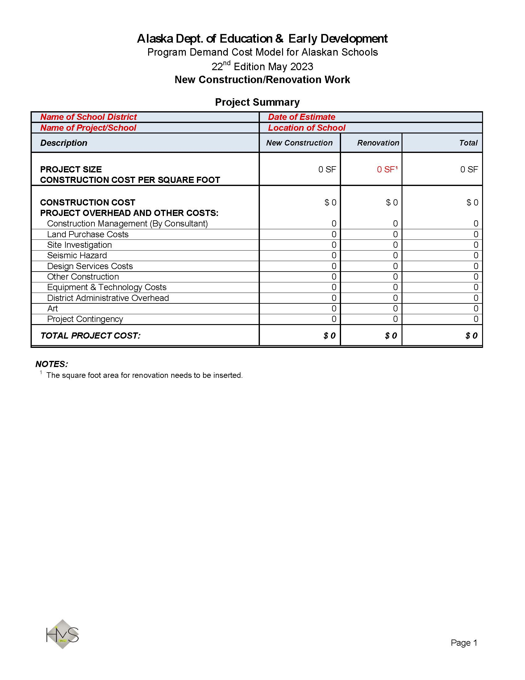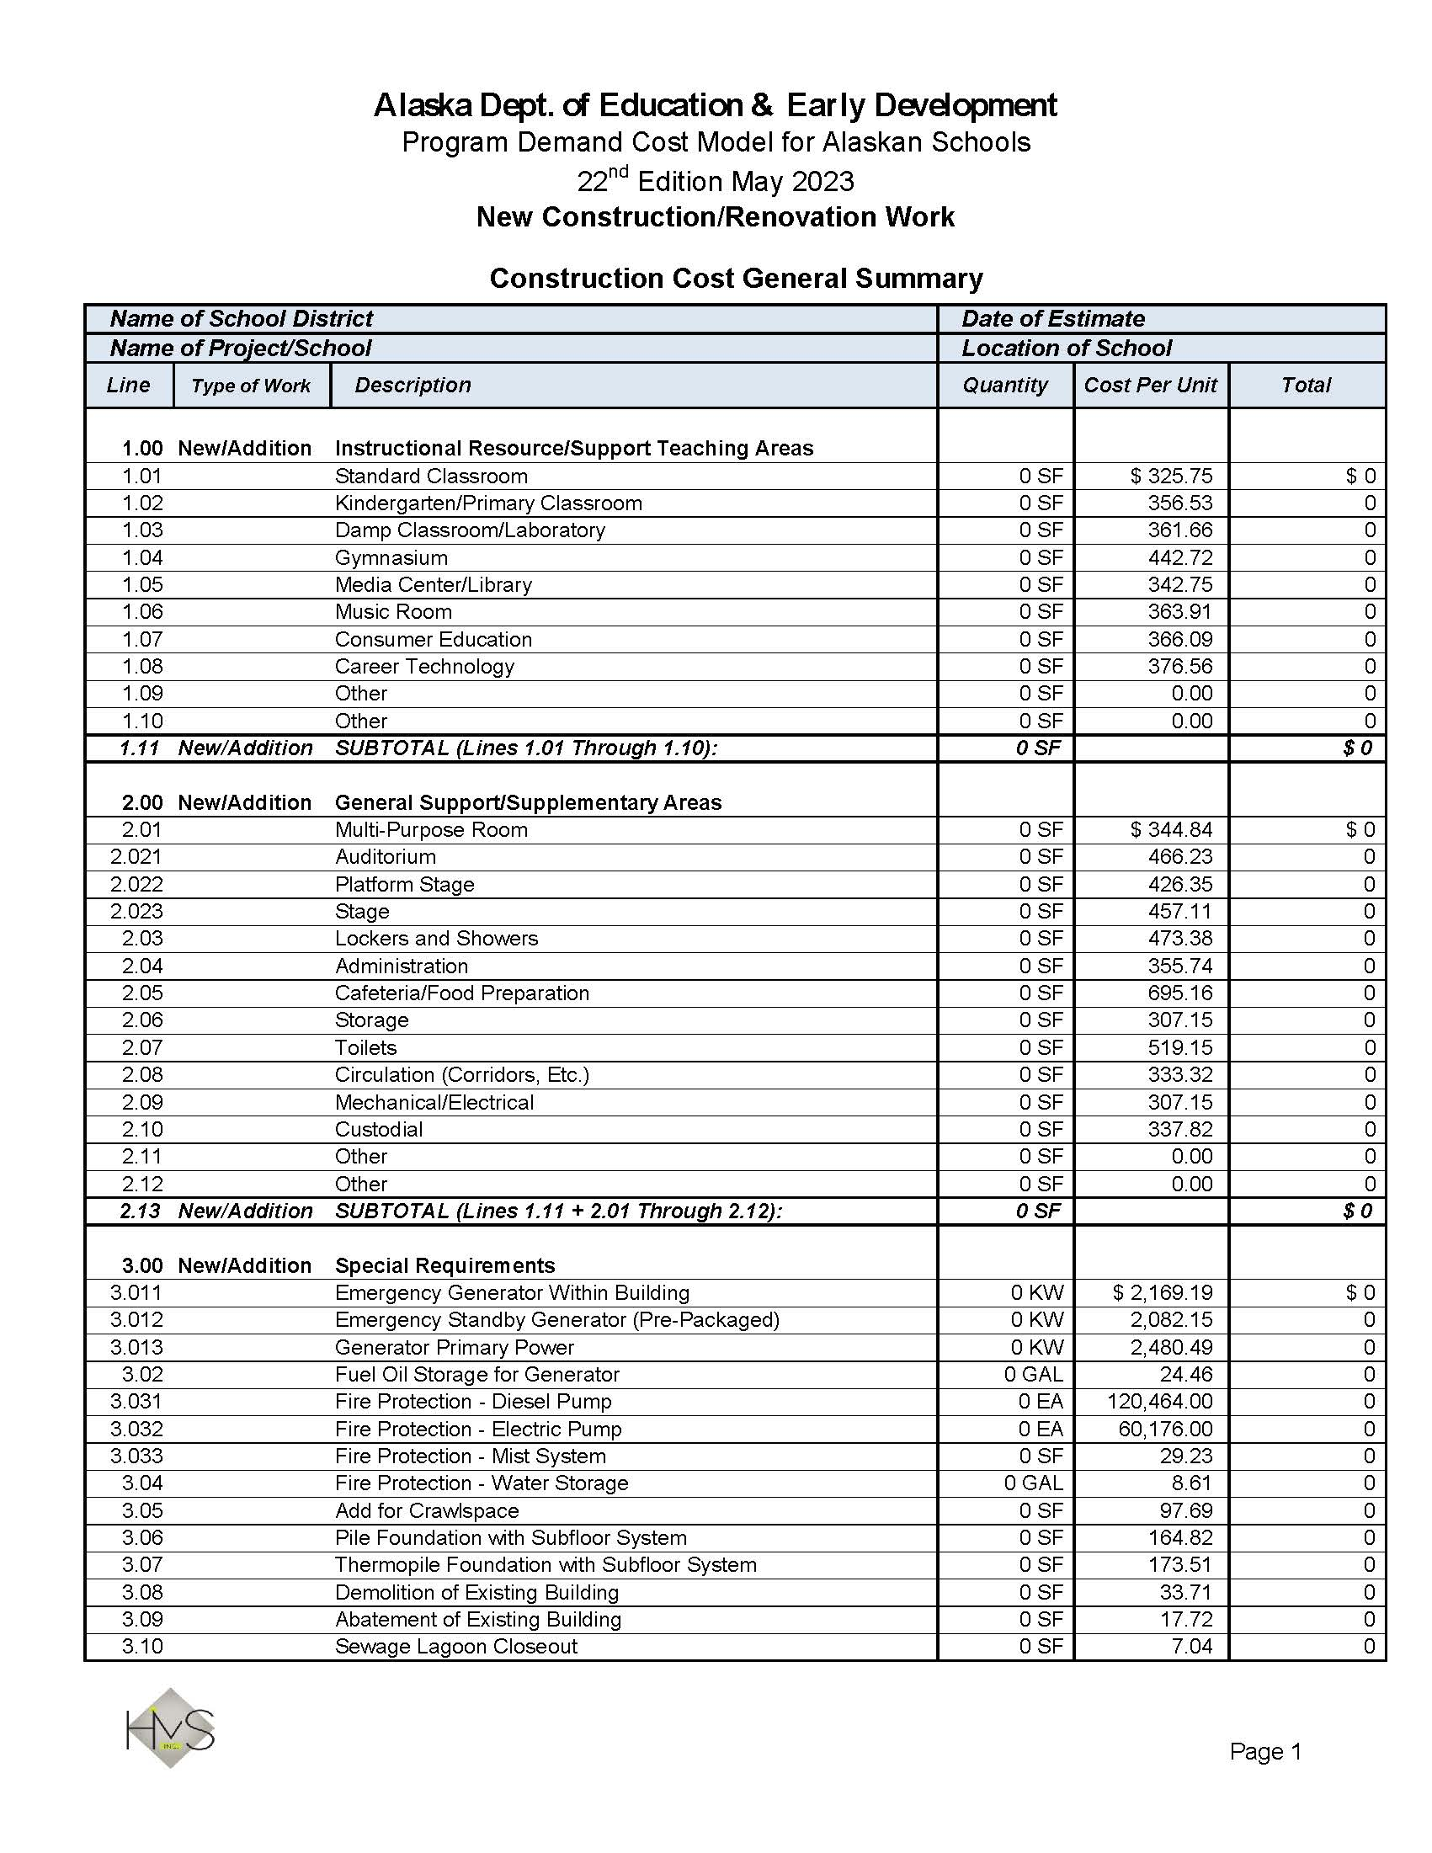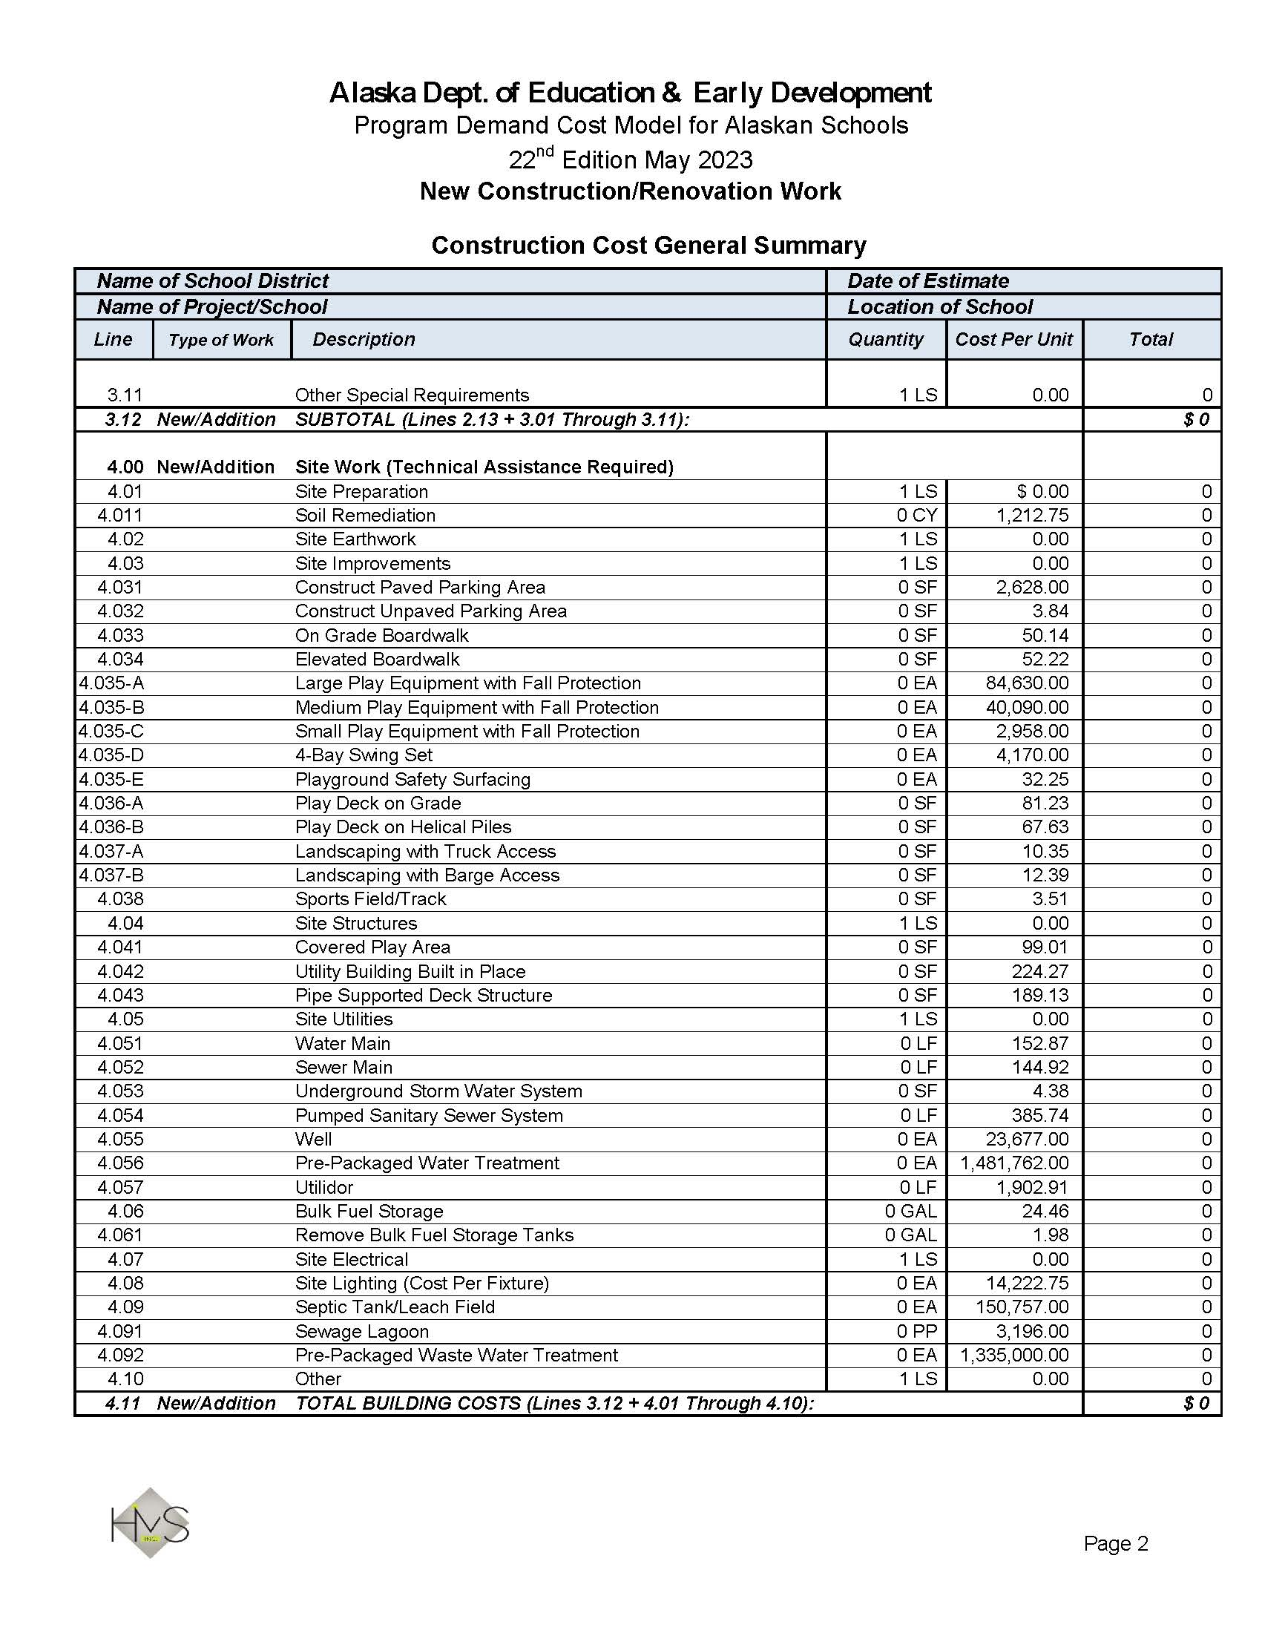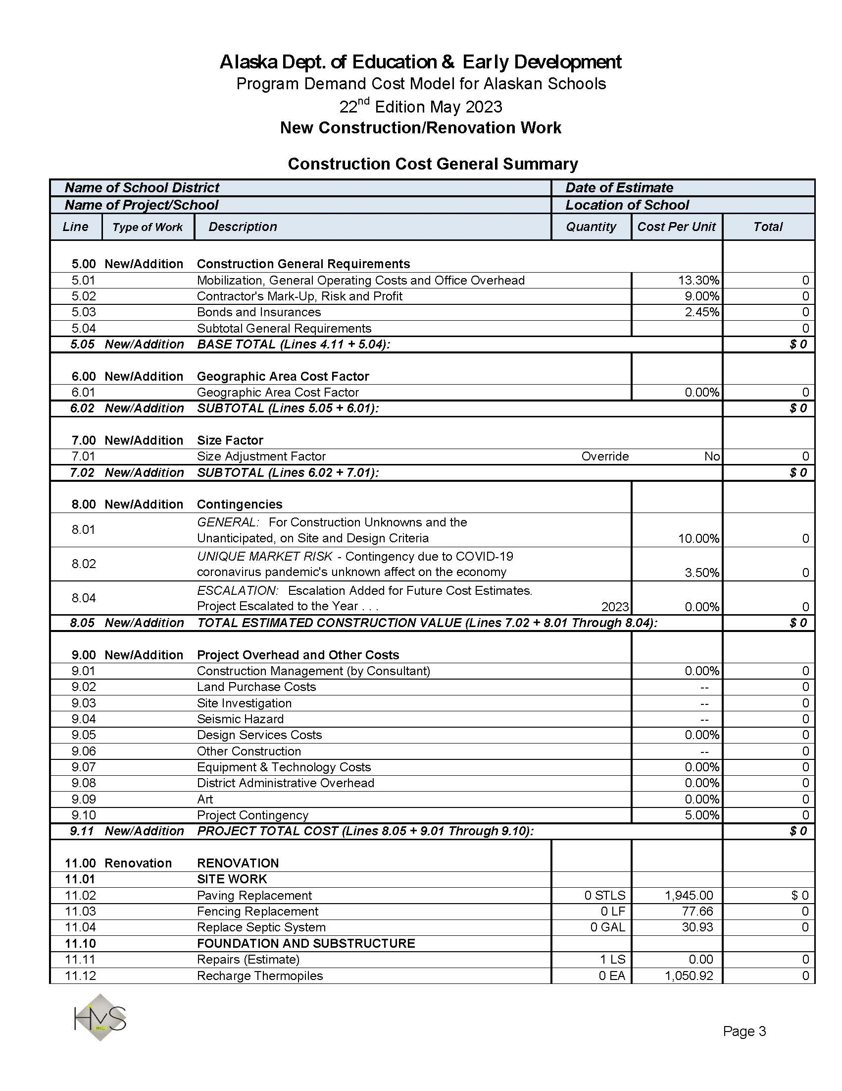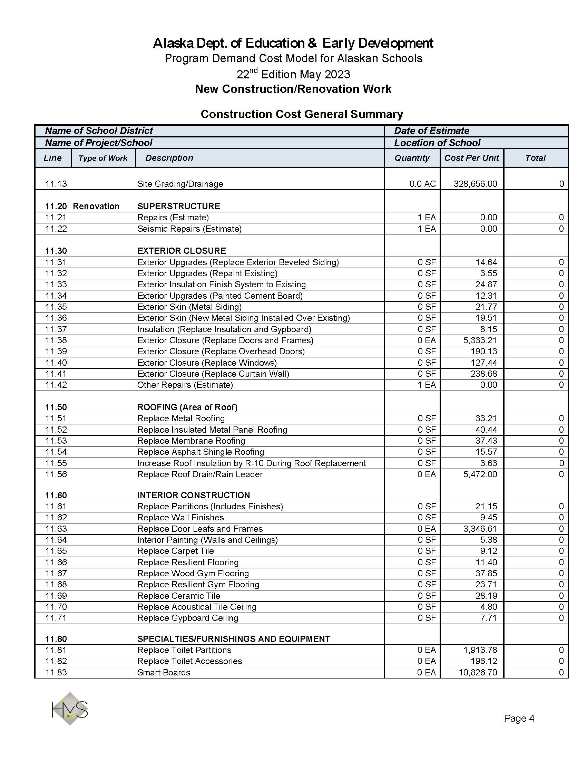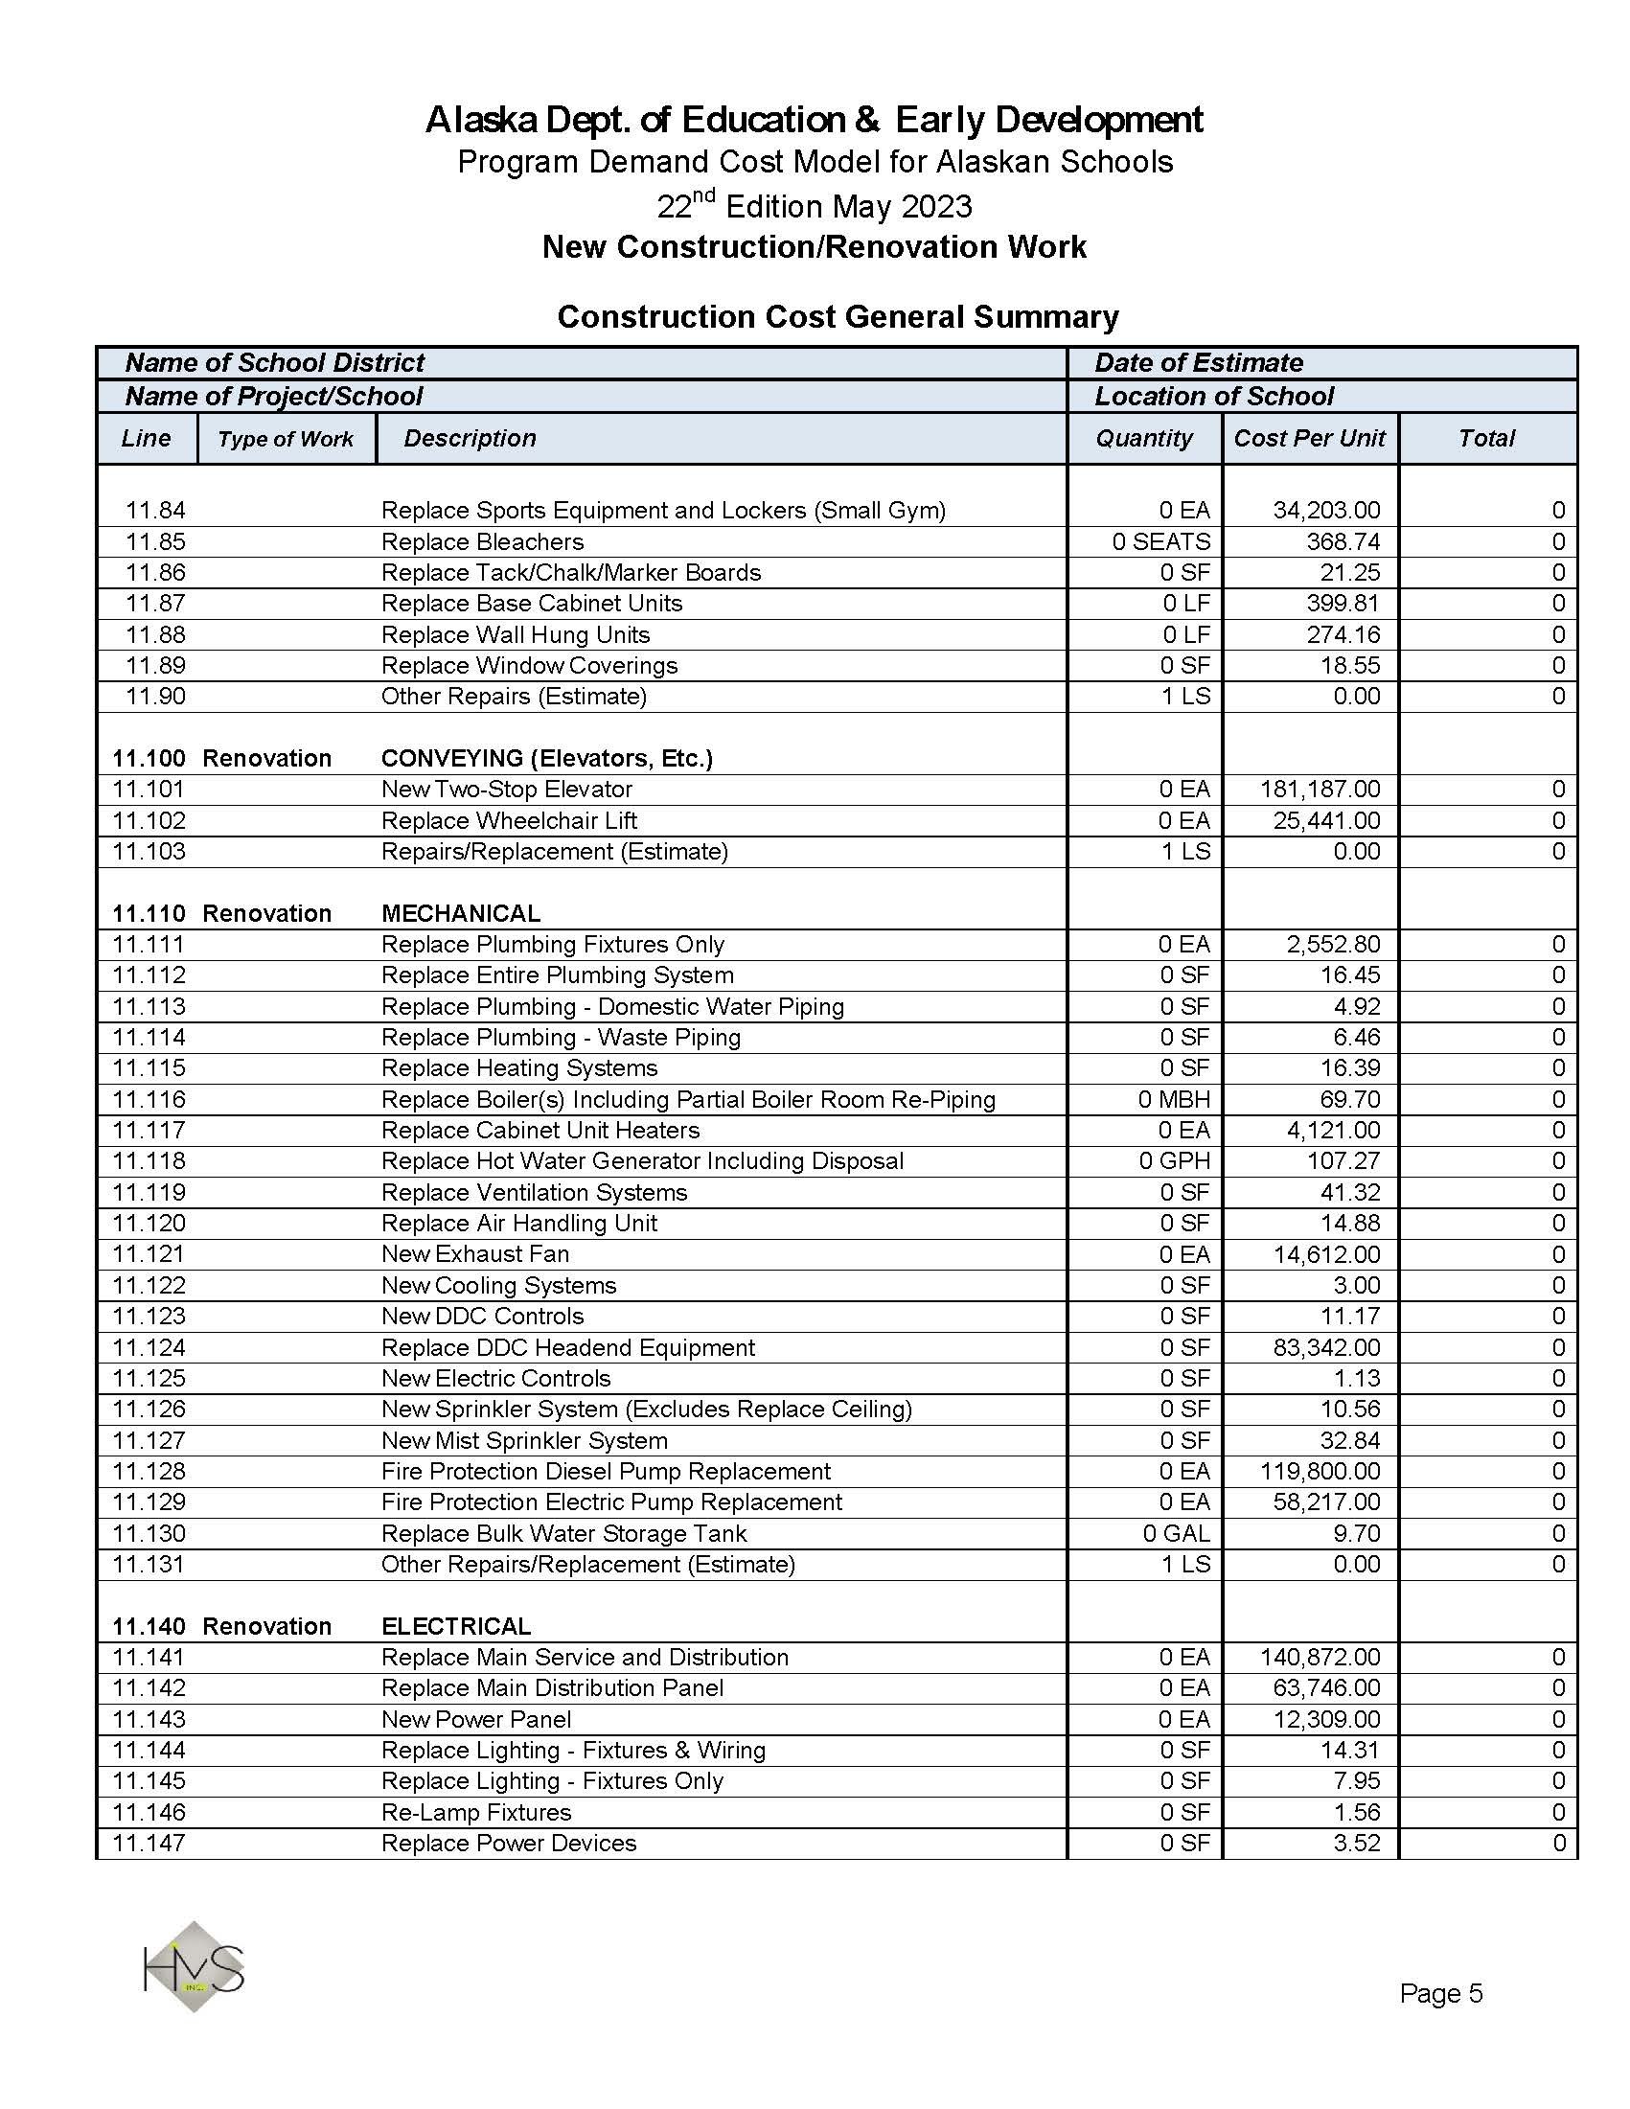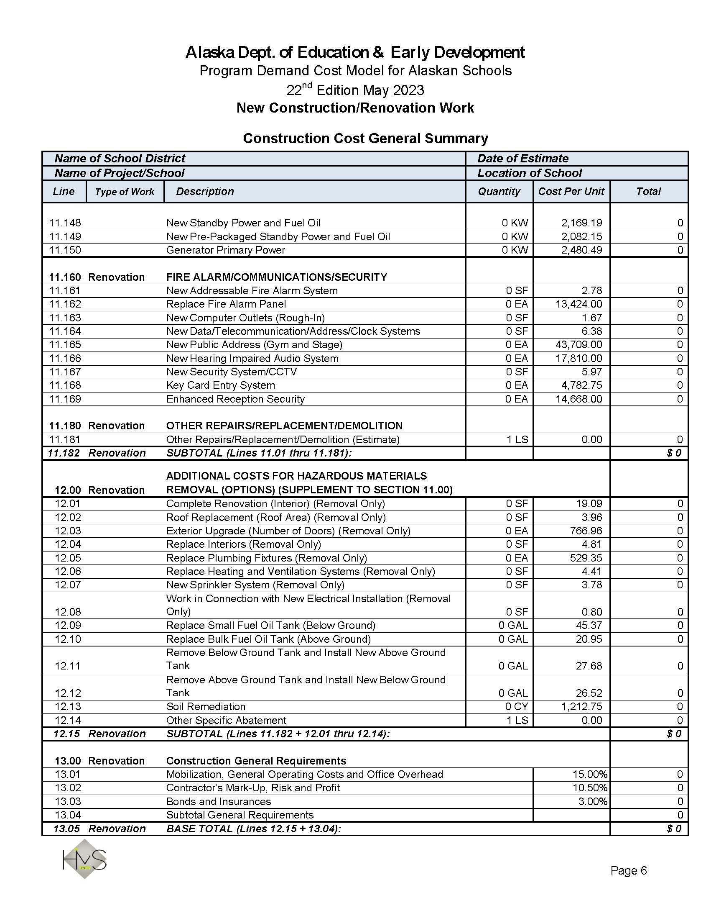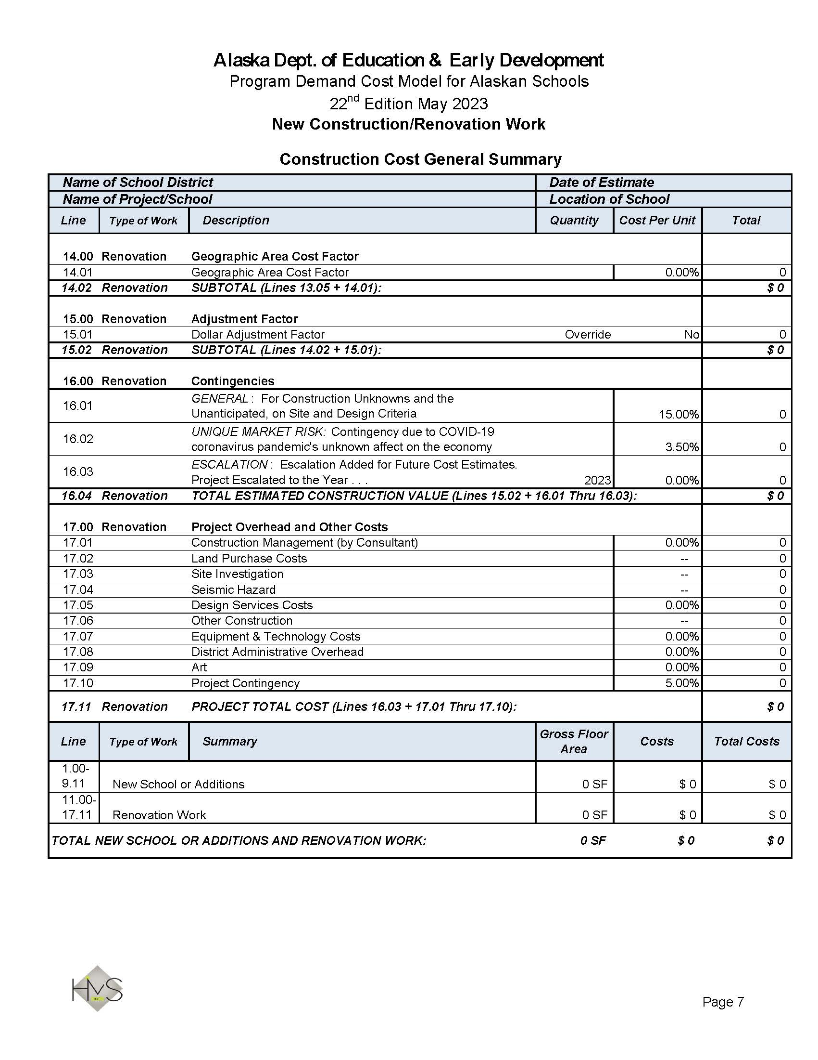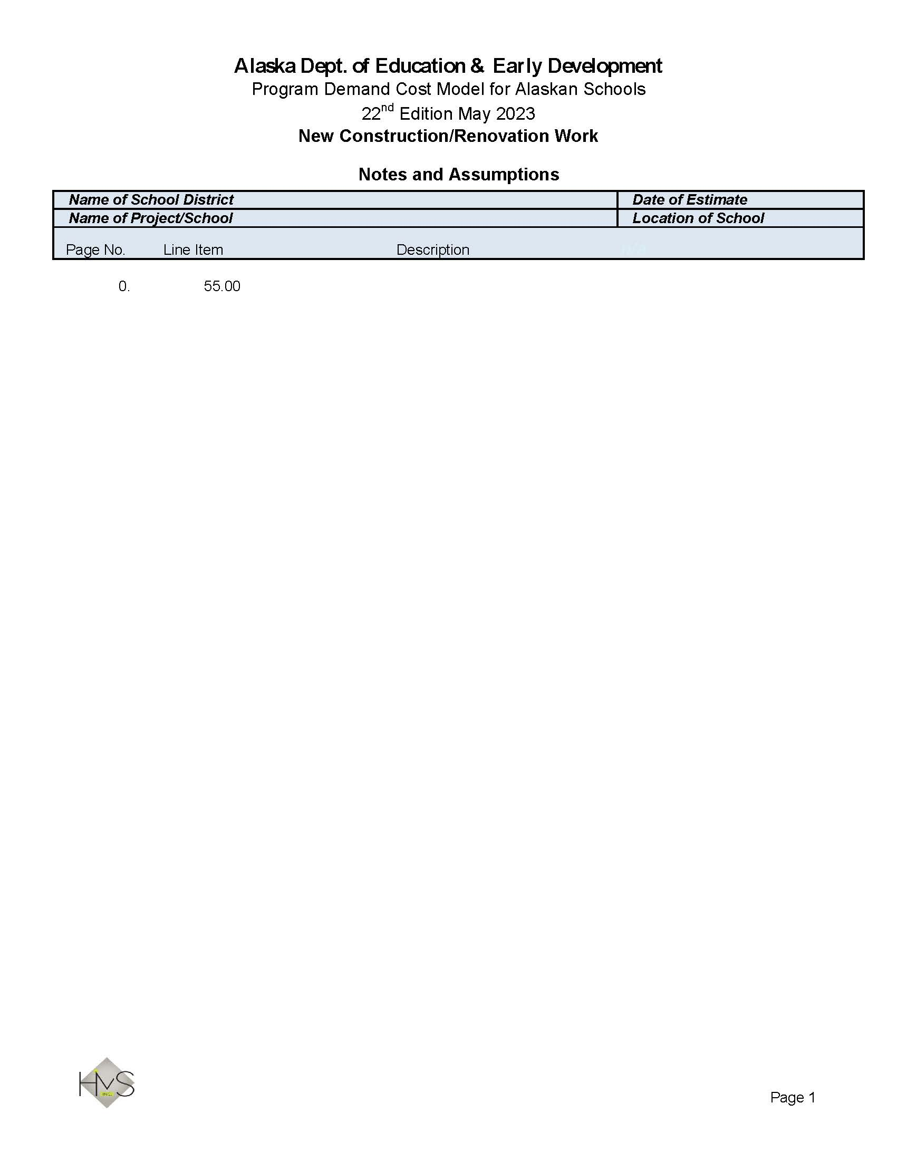

Tables



The following Tables were provided by HMS Inc. to accompany the Program Demand Cost Model.

Table No. 1 – Geographic Area Cost Factor
This is an estimate of geographic area cost factors based on averages for materials, freight, equipment costs, and current Title 36 labor rates. The cost factors are based on an institutional building in Alaska using a standard AIA contract or similar contract. This is merely a guide. Actual costs will vary.
This is only a guide and not necessarily correct for any specific need. It represents only a collection of costs normally found on some construction projects, rather than the custom requirements of a particular project.
This is not an index. This is a geographic area cost factor which includes not merely cost changes and logistical consideration, but also design criteria and how it is applied in different locations. Such design considerations would normally include standard concrete footings used mostly in Southcentral and Southeastern Alaska, to piling requirements in arctic and sub-arctic, however, as this is a line item in the cost model, it has not been included in these calculations.
The calculation used in developing these cost factors are based on reasonable assumptions. For example, barge freight, where appropriate, is mostly included rather than air freight for all materials and equipment. It is also assumed that local labor can be used to the fullest general availability, rather than all imported workers.
Village-to-village costs will vary plus or minus 5%. When using this geographic cost factor, consider how the location for which the estimate is being prepared is different from other surrounding places.
Regional cost factors are based on general and approximate calculations for anticipated conditions generally found in the area and logistic considerations. The more specific area factors are more subjective and based on opinion rather than any detailed analysis.
Cost factors are based on the methodology described in the document entitled Department of Education and Early Development Geographic Area Cost Factors Study as prepared by HMS Inc., dated May 30, 2023.
1Geographic Area Cost Factor May 2023
LOCATION | INDEX | PERCENTAGE
Alaska Gateway | 110.92 | 10.92%
Aleutian Region | 147.33 | 47.33%
Aleutians East Borough | 128.80 | 28.80%
Anchorage (Base) | 100.00 | 0.00%
Annette Island | 120.02 | 20.02%
Bering Strait (North of Nome/Offshore Villages) | 143.79 | 43.79%
Bristol Bay Borough | 122.87 | 22.87%
Chatham | 118.60 | 18.60%
Chugach | 126.51 | 26.51%
Copper River | 109.89 | 9.89%
Cordova City | 130.10 | 30.10%
Craig City | 119.97 | 19.97%
Delta/Greely | 114.82 | 14.82%
Denali Borough | 116.78 | 16.78%
Dillingham City | 123.19 | 23.19%
Fairbanks North Star Borough | 106.62 | 6.62%
Galena City | 132.99 | 32.99%
Haines Borough | 109.63 | 9.63%
Hoonah City | 119.32 | 19.32%
Hydaburg City | 122.03 | 22.03%
Iditarod Area - Yukon River Village | 134.45 | 34.45%
Iditarod Area - Kuskokwim River Village | 137.42 | 37.42%
Iditarod Area - Landlocked Village | 141.33 | 41.33%
Juneau City/Borough | 111.12 | 11.12%
Kake City | 123.42 | 23.42%
Kashunamiut | 141.76 | 41.76%
Kenai Peninsula Borough - Kenai/Soldotna | 103.87 | 3.87%
Kenai Peninsula Borough - Homer Area | 106.24 | 6.24%
Kenai Peninsula Borough - Eastern Area | 116.79 | 16.79%
Kenai Peninsula Borough - Western Area | 119.00 | 19.00%
Ketchikan Gateway Borough | 115.83 | 15.83%
Klawock City | 120.16 | 20.16%
Kodiak Island Borough - Kodiak | 119.50 | 19.50%
Kodiak Island Borough - Village | 128.10 | 28.10%
Kuspuk | 139.47 | 39.47%
Lake & Peninsula Borough - Gulf of Alaska Village | 141.14 | 41.14%
Lake & Peninsula Borough - Bristol Bay Village | 139.91 | 39.91%
Lake & Peninsula Borough - Landlocked Village | 138.44 | 38.44%
Lower Kuskokwim - Bethel | 118.37 | 18.37%
Lower Kuskokwim - Villages | 140.24 | 40.24%
Lower Yukon | 147.89 | 47.89%
Lower Yukon - Inland River/Villages | 147.96 | 47.96%
Mat-Su Borough – Palmer/Wasilla | 98.85 | -1.15%
Mat-Su Borough - Other Areas | 105.69 | 5.69%
Nenana City | 110.41 | 10.41%
Nome City | 126.44 | 26.44%
North Slope Borough - Utqiagvik (Barrow) | 139.60 | 39.60%
North Slope Borough - Villages | 160.17 | 60.17%
North Slope Borough - Atqasuk/Point Lay | 163.44 | 63.44%
Northwest Arctic - Kotzebue | 131.35 | 31.35%
Northwest Arctic – Villages With Barge Service | 154.02 | 54.02%
Northwest Arctic – Villages Without Barge Service | 161.06 | 61.06%
Pelican City | 127.91 | 27.91%
Petersburg Borough | 120.90 | 20.90%
Pribilof Island | 132.19 | 32.19%
Sitka City/Borough | 114.04 | 14.04%
Skagway Borough | 109.37 | 9.37%
Southeast Island | 119.30 | 19.30%
Southwest Region | 140.83 | 40.83%
St. Mary's City | 134.98 | 34.98%
Tanana City | 125.79 | 25.79%
Unalaska City | 118.15 | 18.15%
Valdez City | 121.61 | 21.61%
Wrangell City/Borough | 119.38 | 19.38%
Yakutat City/Borough | 137.38 | 37.38%
Yukon Flats - Village on Road System | 112.12 | 12.12%
Yukon Flats - Village on River | 140.74 | 40.74%
Yukon Flats - Landlocked Village | 142.99 | 42.99%
Yukon-Koyukuk - Village on Road System | 115.33 | 15.33%
Yukon-Koyukuk - Village on Yukon River | 142.18 | 42.18%
Yukon-Koyukuk - Village on Koyukuk River | 153.87 | 53.87%
Yupiit | 132.10 | 32.10%

Table No. 2a – Size Adjustment Factor

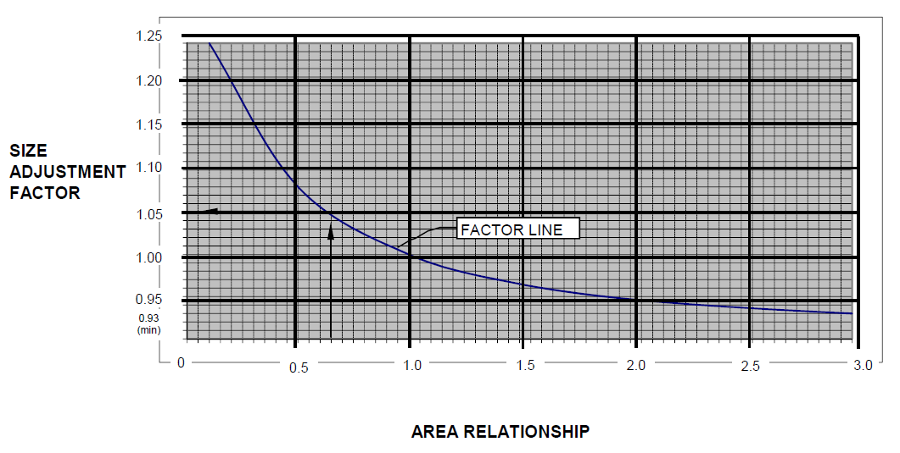This is a line graph representing area relationship. It visually represents a factor line. If one took 0.64 and raised it to the power of -0.074, the result would be the output or the adjustment factor.
For example, the Size Adjustment Factor is desired for a 16,000 SF Academic Facility. The Area Relationship is the desired facility size of 16,000 SF divided by the Typical Facility Size of 25,000 SF (16,000 ÷ 25,000 = 0.64). Find .64 on the horizontal axis. Trace a vertical line to the factor curve and then trace a horizontal line to the vertical axis ‘Size Adjustment Factor’, which in this example is 1.05.

Table No. 2b – Dollar Adjustment Factor

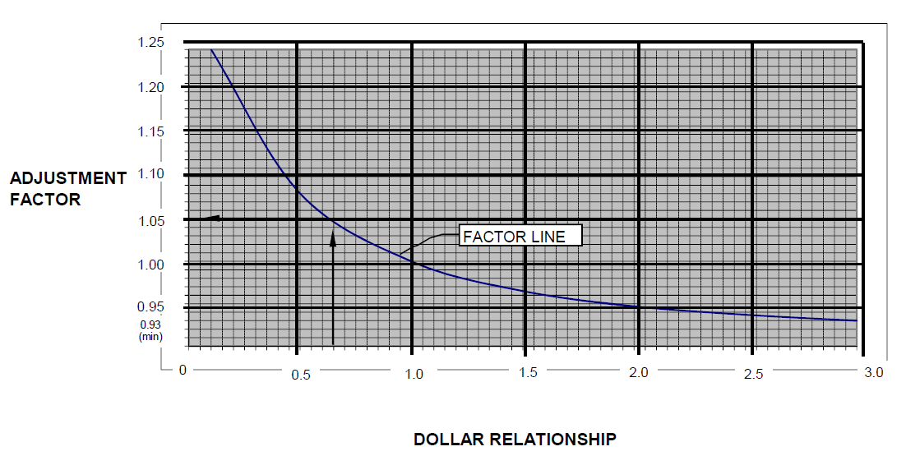
This is a line graph representing dollar relationship. It visually represents a factor line. If one took 0.64 and raised it to the power of -0.074, the result would be the output or the adjustment factor.
For example, the Dollar Adjustment Factor is desired for a $2,500,000 renovation project. The Dollar Relationship is the proposed facility cost of $2,500,000 divided by the Typical Facility Cost of $4,000,000 ($2,500,000 ÷ $4,000,000 = 0.625). Find 0.625 on the horizontal axis. Trace a vertical line to the factor curve and then trace a horizontal line to the vertical axis 'Dollar Adjustment Factor’, which in this example is 1.05.

Table No. 3 – Alaskan Construction Index April 2026
(Anchorage, Alaska)
These cost estimates are an index based on average costs for materials, freight and equipment, and also estimated Title 36 labor rates. The index is based on an institutional building in Anchorage using a standard AIA or similar contract.
Always remember that an index is only a useful guide and not necessarily correct for any specific need. It represents only a collection of costs normally found on some construction projects, rather than the custom requirements of a particular project.
Material prices have remained highly volatile over the past year, driven by tariffs, production constraints, extended lead times, and sustained demand. Increases have been observed across most sectors, with the most significant impact in metals. Steel, aluminum, and copper have risen approximately 20-40%, influenced in part by tariffs reaching up to 50%, with these costs ultimately carried through contractor pricing. Steel procurement and delivery challenges continue to compound these pressures. Mechanical and electrical components have also experienced notable increases, with pricing often quote dependent and, in some cases, only guaranteed for short durations. Finish materials have risen more moderately, averaging approximately 3.5%. Equipment costs have increased significantly due to the observation that commercial grade systems capable of supporting a student and staff population are required.

Over the past year, labor cost growth continues to rise but at a moderated rate, increasing approximately 3.4% over the past year. Union and skilled labor rates have outpaced non-union labor, largely driven by negotiated agreements and sustained demand for specialized trades. Additional upward pressure on labor costs is being driven by a reduced bidder pool, as contractors have ample work availability, along with ongoing shortages of skilled labor across multiple disciplines. Accelerated project delivery methods are further contributing to increased costs by driving premium time and reduced schedule flexibility.

Recent industry data from the Associated General Contractors (AGC) indicates continued strain in the construction labor market and a dampened future outlook. The declining overall confidence in labor coupled with 39% of firms reporting larger backlogs year-over-year, signals a sustained demand in work with a labor force that cannot keep up. Labor availability is believed to remain a significant challenge for contractors, with over 80% of firms reporting difficulty finding qualified hourly craft and salaried workers. These hiring challenges are further compounded by factors such as increased immigration enforcement, funding uncertainty, and extended construction timelines.

Labor factors such as these are becoming more difficult for contractors to manage. The volatility of tariffs and their potential impact on material costs are also likely to lead contractors to including percentages in their pricing to offset the perceived risks. With these factors in mind, HMS Inc. will continue to use an annual escalation rate of 4.00% for this 25th Edition.

Back-up data for this analysis is held at HMS Inc., 4103 Minnesota Drive, Anchorage, Alaska.

2 Alaskan Construction Index April 2026
BASE YEAR 1980 | INDEX (100.00) | INCREASE
1980 | 100.00 | N/A
1981 | 104.40 | 4.40%
1982 | 107.70 | 3.30%
1983 | 115.60 | 7.90%
1984 | 118.60 | 3.00%
1985 | 117.70 | -0.90%
1986 | 121.40 | 3.70%
1987 | 123.00 | 1.60%
1988 | 124.80 | 1.80%
1989 | 126.40 | 1.60%
1990 | 131.80 | 5.40%
1991 | 134.30 | 2.50%
1992 | 138.80 | 4.50%
1993 | 143.30 | 4.50%
1994 | 144.40 | 1.10%
1995 | 143.40 | -1.00%
1996 | 146.20 | 2.80%
1997 | 146.70 | 0.50%
1998 | 149.12 | 2.42%
1999 | 150.96 | 1.84%
2000 | 152.60 | 1.64%
2001 | 154.53 | 1.93%
2002 | 162.54 | 8.01%
2003 | 166.34 | 3.80%
2004 | 176.57 | 10.23%
2005 | 188.55 | 11.98%
2006 | 198.41 | 9.86%
2007 | 205.73 | 7.32%
2008 | 208.59 | 2.86%
2009 | 209.55 | 0.96%
2010 | 212.37 | 2.82%
2011 | 216.26 | 3.89%
2012 | 218.67 | 2.41%
2013 | 222.87 | 4.20%
2014 | 223.78 | 0.91%
2015 | 228.32 | 4.54%
2016 | 227.96 | -0.36%
2017 | 229.91 | 1.95%
2018 | 236.16 | 6.25%
2019 | 237.58 | 1.42%
2020 | 239.49 | 1.91%
2021 | 246.92 | 7.43%
2022 | 262.23 | 15.31%
2023 | 266.60 | 4.37%
2024  2025 | 275.00  280.39 | 8.40%  5.39%
2026 | 289.21 | 8.82%

Table No. 4 – Appendix E – Type Of Space Added Or Improved

Category A - Instructional or Resource
General Use Classrooms
Pre-K and Kindergarten
Elementary
Secondary
Special Education
Art
Science
Bi-Cultural/Bilingual
Consumer Education
Computer/Technology Lab
Music/Drama
Career and Technical Education
Library/Media Center
Gymnasium
Category B - Support Teaching
Teacher Workroom/Office
Teacher Breakroom
Counseling/Testing
Educational Resource Storage
Quiet Room
Category C - General Support
Administration
Conference Room
Parent/Community Schools
Nurse/Clinic
Cafeteria
Kitchen/Food Service
Student Store
Fitness Room
Locker Room/Showers
Student Commons
Multipurpose
Auditorium/Stage
Pool
Category D - Supplementary
Corridors/Vestibules/Entries
Stairs/Elevators
Restrooms/Toilets
Custodial
Supply/Food Storage
Refer/Freezer
Maintenance/Receiving
Mechanical/Electrical
Telecom/Server Room

Table No. 5 – Abbreviations

$ = Dollars
AC = Acre
BTU = British Thermal Units
CCTV = Closed-Circuit Television
CFM = Cubic Feet per Minute
CUH = Cabinet Unit Heater
CR = Classroom
CY = Cubic Yard
DDC = Direct Digital Controls
EA = Each
GAL = Gallon
GPH = Gallons per Hour
GPM = Gallons per Minute
GWB = Gypsum Wall Board
KW = Kilowatt
LF = Linear Foot
LS = Lump Sum
MBH = 1,000 BTU per Hour
PP = Per Person
SF = Square Foot
STL = Stall
VCT = Vinyl Composite Tile

Table No. 6 – Statement Of Specifications
Consideration for pricing of unit costs in the Program Demand Cost Model for Alaskan Schools is based on superior level of specifications generally applied to new construction throughout the state. The reason being is that these schools are subject to hard usage, by day for educational use housing a significant number of students, faculty, and support staff, and at other times schools are also used by the communities for a variety of functions.
To place the standard of specifications used on Alaskan schools in every day words, it will be reasonable to say that the quality of materials, workmanship, and equipment specified is well above residential facilities, above a standard office building, likely similar to an airport and a little lower than a medical center.
Since the early 1970s, Alaska has tried to consider future operations and maintenance cost impacts in the funding of new school programs in the hope that a better funded project would allow for a more economic facility in terms of Life Cycle Cost. For this reason, schools have been designed to a superior level of specification.
In recent years some significance has been placed on ecological concerns that are both earth friendly and include long-term cost savings.
Concrete:
Strength of concrete often is specified to a minimum of 4,000 psi.
Masonry:
Many areas in Alaska are Seismic Zone 4. Design of masonry work calls for significant reinforcing and support.
Metals:
Many areas in Alaska are Seismic Zone 4. Design of structural elements have enhanced strength connections and cross bracings.
Woods and Plastics:
Rough carpentry lumber at a minimum No. 2 grade, plywood (structural I) and finish work to a good quality with plastic laminate finish.
Wood framed buildings designed for Seismic Zone 4.
Thermal and Moisture Protection:
Thermal insulation in the building envelope complies with the requirements of ASHRAE 90.1 for commercial buildings. Roofing material is EPDM or Klip-Rib metal, the building sealed with air barrier and joint sealants.
Openings:
Superior quality doors, frames, and hardware. Windows Low E and insulated.
Finishes:
Standard school finishes. Gypboard walls, including impact protection where appropriate, acoustical tile ceilings, carpet and vinyl flooring with ceramic tile in bathroom toilets. Rigid vinyl wall coverings at janitor closets and kitchens.
Specialties:
Higher quality toilet partitions and toilet accessories, painted metal lockers, and comprehensive signage.
Equipment:
Superior quality kitchen equipment, stainless steel worktops, good quality sports equipment.
Furnishings:
Plastic laminate finish to casework. Solid surface countertops. Window coverings and entry mats. Smart boards.
Mechanical:
Copper water piping, insulated cast iron waste, American Standard fixtures.
Weil McLane high efficiency boilers, hydronic heating, air handling with computer room only cooling and exhaust system with digital controls.
Fully sprinklered fire suppression system throughout the school.
Electrical:
Good quality switchgear, panels and transformers, copper wiring all in conduit backed up with a standby generator. Lighting with energy saving lamps (LED) and good quality devices. Fire alarm system and all low voltage system currently used in modern Alaskan schools.
An allowance has been provided to include a school lockdown system.

Bibliography
The Council of Education Facility Planners, International (May 1994). Guide for School Facility Appraisal - Alaska Edition (Adapted for the State of Alaska Department of Education).

HMS Inc. (1981 - 2025). Program Demand Cost Model for State of Alaska Department of Education & Early Development:
- 1st Edition May 1981
- 2nd Edition November 1983
- Note - Computerized in December 1984
- 3rd Edition August 1986
- 4th Edition August 1988
- 5th Edition June 1991
- 6th Edition July 1997
- 7th Edition November 1997
- 8th Edition March 2000 (7th Edition Revised)
- 9th Edition April 2001
- 10th Edition March 2005
- 11th Edition April 2007
- 11th Edition Update March 2008
- 11th Edition Revised April 2008
- 12th Edition April 2010
- 12th Edition Update April 2011
- 12th Edition Revised April 2012
- 13th Edition April 2013
- 14th Edition April 2015
- 15th Edition April 2016
- 16th Edition April 2017
- 17th Edition April 2018
- 18th Edition May 2019
- 19th Edition April 2020
- 20th Edition April 2021
- 21st Edition May 2022
- 22nd Edition April 2023
- 23rd Edition April 2024
- 24th Edition April 2025

HMS Inc. (1980 - Early 2026). Cost Data Files and Records.

HMS Inc. (ND). U.S. Department of Defense Size Adjustment Factor.

State of Alaska Department of Education & Early Development (April 20, 2022). Appendix E: Type of Space Added or Improved Adopted by the Bond Reimbursement & Grant Review Committee.

Bibliography
Title 36, Public Contracts, State of Alaska Department of Labor & Workforce Development (Effective April 1, 2026). Laborers' and Mechanics' Minimum Rates of Pay, Issue 52.

State of Alaska Department of Education & Early Development (1st Edition, April 2022). Alaska School Design and Construction Standards.

