2022-2023 Educator Evaluation and Support System Data Submission Form

September 15, 2023
Table of Contents
General Information 3
Instructions 4
DEED Contacts 4
Data Elements 5
Frequently Asked Questions 7
How to Drop-Off Files Securely Using ZendTo 8

General Information
Purpose
The Department of Education & Early Development is collecting this information in order to monitor district compliance with AS 14.20.149 and 4 AAC 19. The collection will also be used to gather data required by the Every Student Succeeds Act (ESSA).
Statutory and regulatory references
The Educator Evaluation and Support System Data Submission authorized by AS 14.07.020, duties of the department; AS 14.07.060, AS 14.20.149 employee evaluations, and 4 AAC 19.055 reporting of evaluation results.

Term | Definitions
Teacher | An individual who holds an Initial, Professional, Master, or Limited teaching certificate and provides instruction to students or supports other teachers who are providing instruction to students.
Special Service Provider | An individual who holds a Type C certificate and is employed to provide the related service in which the individual is endorsed.
Administrator | An individual who holds a Type B administrative certificate and is employed to provide one or more of the administrative functions, described in 4 AAC 12.325, which include the following:  - Selection, appointment, oversight, review, or control of district employees required to hold certification; or  - Oversight of planning and development of one or more educational programs of the district.
Tenured | Indicates a teacher or service provider has met the requirements of AS 14.20.150 and has the right to employment with a district during continuous service as described in AS 14.20.155.
Non-tenured | Indicates that a teacher or special service provider has not met the requirements of AS 14.20.150 and does not have the rights to employment as described in AS 14.20.155.

Instructions
In the submission form workbook, there are three total tabs to be completed. The first is a tab for administrators, second teachers, and lastly special service providers. There are two tables on each tab, one for tenured personnel and one for non-tenured personnel.
For each of the six tabs complete the following steps:

- Fill in the school year, district Id, district name and the school year.
- List in numerical order all the school numbers and school names in columns D and E. The school numbers can be found at http://education.alaska.gov/Alaskan_Schools/Public/DistrictandSchoolIDs.pdf
- In Column F, complete the total number of employees for each school.
- Provide the evaluation results for each school and district office, if appropriate. The tenured employees will be reported in columns G – M. The definitions of the evaluation results can be found in the data elements.
- Repeat steps 2-4 on each tab for the tenured and non-tenured employees.

When all tabs have been completed, then submit the workbook via ZendTo (see page 8) to eed.edqual@alaska.gov.

DEED Contacts
Questions relating to the content of this collection should go to:
Sondra Meredith,
Education Administrator II
(907) 465-8663
sondra.meredith@alaska.gov

Adrianne Schwartz
Title II-A Program Manager
State Homeless Coordinator
(907) 465-8721
adrianne.schwartz@alaska.gov

Questions relating to the submission of this collection should go to:
Jeanny Smith
Education Associate II
(907) 465-2884
eed.edqual@alaska.gov

Data Elements
Status | Field | Description
Required | 1 | School Year  The school year for which the evaluation results were collected.
Required | 2 | District ID  Unique district id assigned by DEED.
Required | 3 | District Name  The district name that corresponds to the listed district id.
Required | 4 | School Number  Unique school code as assigned by DEED. A comprehensive list of school numbers for the 2020-2021 school year can be located at http://education.alaska.gov/Alaskan_Schools/Public/DistrictandSchoolIDs.pdf.
Required | 5 | School Name  The school’s name that corresponds to the listed school number.
Required | 6 | Total Number Employed  The total number of educators (teachers, special service providers, or administrators) who were employed in the school district at any time during the school year.
Required | 7 | Exceeds the Standards  The number of educators whose evaluation has documented evidence of the individual’s performance surpassing what the district has established as proficient on the performance standards establish through 4 AAC 04.205. Tenured teachers and special service providers who have exceeded the district's performance standards are eligible to receive one evaluation every two years per AS 14.20.149(b)(4). Continue to report them in this category.
Required | 8 | Meet the Standards  Indicate the number of educators who meet the district's performance standards under AS 14.20.149(b)(4).  Minimally, districts must ensure educators did not receive a performance rating of basic on more than one content standard. The district may have a higher standard.
Required | 9 | District Support  The number of educators that received no ratings of unsatisfactory and ratings of basic on two or more of the district performance standards establish through 4 AAC 04.205.  The district is required to provide support if a school district gives an educator a performance evaluation rating of basic on two or more of the content standards or other criteria as a result of the evaluation.
Required | 10 | Plan of Improvement (POI)  The number of employees that received a rating of unsatisfactory on at least one of the district performance standards establish through 4 AAC 04.205.  A district is required to prepare and implement a plan of improvement for an educator whose performance did not meet the district performance standards, except if the performance warrants immediate dismissal under AS 14.20.170(a).
Required | 11 | Resigned (POI)  The number of educators who were notified that their continued employment in the district was contingent on the implementation of a plan of improvement under AS 14.20.149 (b)(6) but resigned.  Educators who resign at another level than POI should be reported under that category.
Required | 12 | Dismissed  The number of educators who were dismissed under AS 14.20.170. An educator who has acquired tenure rights, may be dismissed at any time only for incompetency, immorality, or substantial noncompliance with the school laws of the state, the regulations or bylaws of the department, the bylaws of the district, or the written rules of the superintendent.
Required | 13 | Non-Retained  The number of educators who were non-retained under AS 14.20.175. An educator who has acquired tenure rights is subject to non-retention for the following school year only for causes noted in AS 14.20.175(b). An educator who has not acquired tenure rights is subject to non-retention for the school year following the expiration of the teacher's contract for any cause that the employer determines to be adequate.
Optional | 14 | Not Reported  The number of educators who were not reported in any of the above level of support categories. Any educators reported here should include an explanation in the comment field.
Optional | 15 | Notes

Frequently Asked Questions
Why are these data needed?
These data are needed to monitor the implementation of districts educator evaluation systems and the resulting level of support provided to teachers, special service providers and administrators. These data are also needed to address reporting requirements under the Every Student Succeeds Act (ESSA).

Does EED want the overall performance ratings as well?
No, the overall performance rating was removed from regulations in June of 2016.

Our district is not allowing any educators to use the alternate year option (i.e., every other year) until the system has been in place for a number of years – will this indicate there are no excellent educators in our district?
No, regardless of whether or not a district’s evaluation system allows for an alternate year option for tenured teachers who exceeded district standards, districts should report the number of educators who exceeded the standards in the reporting year.

What if an educator was on a plan of improvement and then moved to a plan of professional growth during the school year – do they get listed twice?
No, list the educator only under a plan of improvement.

If an educator satisfies a plan of improvement, should they still be counted? Likewise, a plan of professional growth?
Yes, list an educator on a plan of improvement or professional growth in those categories regardless of whether they satisfactorily completed the plan.

When should you count an educator as resigned based on evaluation results?
List an educator if they resigned while either on a plan of improvement or one had been determined necessary. Also count an educator that would not have been offered continued employment at the time of the resignation for any reason.

Should a district provide the employee counts regardless of FTE status?
Yes, districts should provide information per certified employee regardless of the employee’s FTE status. Part-time employees should be included in counts.

Does a zero need to be entered into a cell, if applicable, or can it be left blank?
Yes, please enter a zero when applicable. Do not leave a cell blank.

How do I submit my completed file to EED?
Please submit your completed file to EED through the secure ZendTo site to eed.edqual@alaska.gov. Refer to the ZendTo direction below for step-by-step instruction. Please do not send your file to EED through an unsecure email.

How to Drop-Off Files Securely Using ZendTo
A Quick Guide from the Alaska Department of Education & Early Development
- Go to the Alaska ZendTo website (drop.state.ak.us/drop/).
- Click on “Drop-off”.
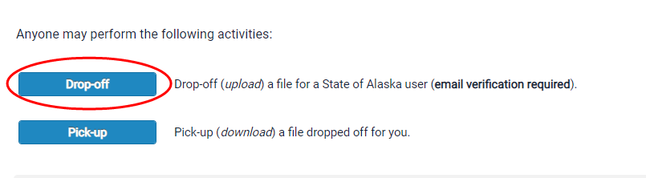
- On the next page, you will be prompted to enter in some information about yourself (the sender). Please enter in your name, your organization, and your email address.
- At the bottom of the screen, you will be asked to confirm that you are a real person by checking the indicated box.
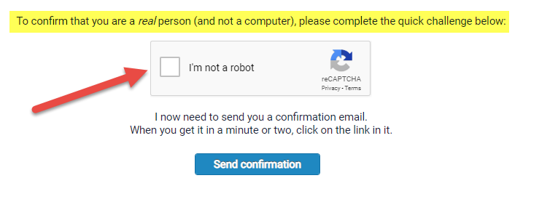
- Then click “Send Confirmation”.
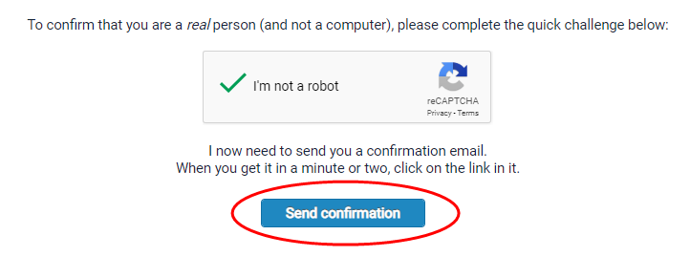
- The next page confirms that an email has been sent to the email you entered from ZendTo. This email should arrive just moments after this screen.
- This is an example of what this email referenced above looks like. Click on link to be re-directed to the ZendTo site.
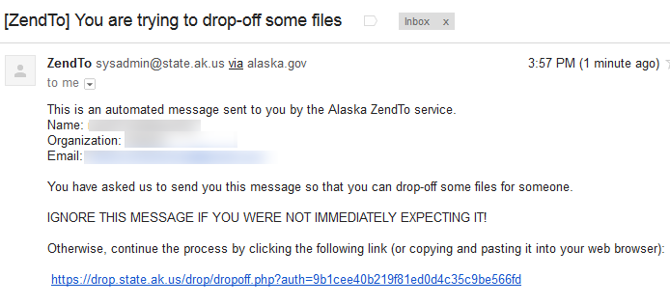
- The link in the email will take you to a page that looks like the screen below. Your name and email will already be in the ‘From’ field. You will need to fill in the ‘To’ field by clicking the green plus sign.
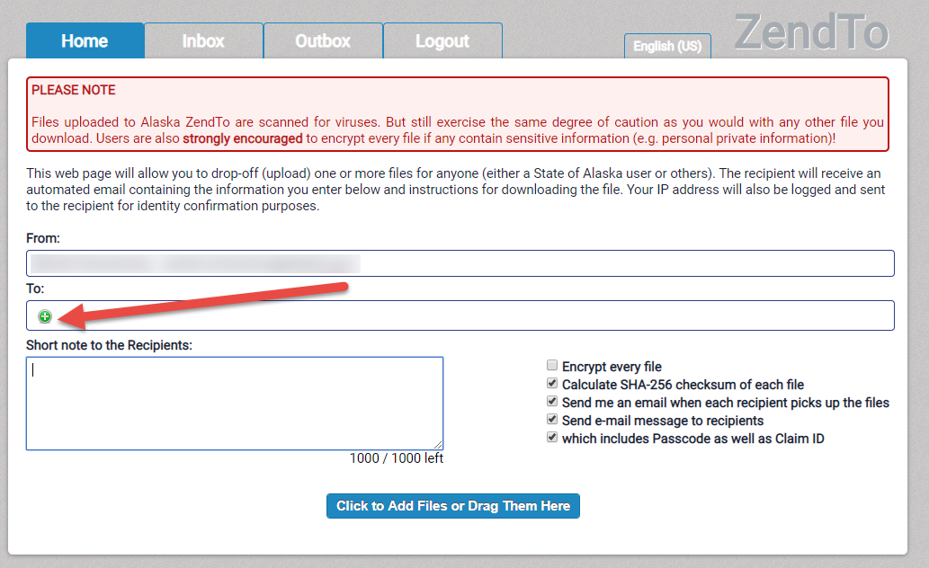
- A window will appear. This is where you enter the name and email of the person you wish to send the files to. Select ‘Add’ to add another recipient. Select ‘Add & Close’ when you are finished entering recipients. Once you select ‘Add’ or ‘Add & Close’, the recipient will appear in the ‘To’ field.
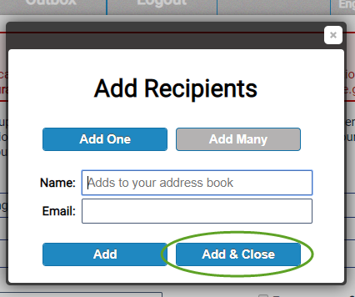
- Attach the file you wish to send by dragging files into the ZendTo window or by selecting ‘Click to Add Files or Drag Them Here’.
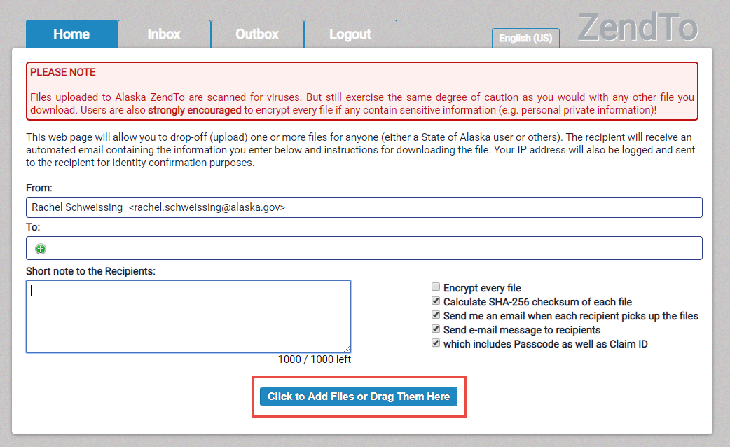
- If you choose to add the file from your computer, select the file you wish to send.
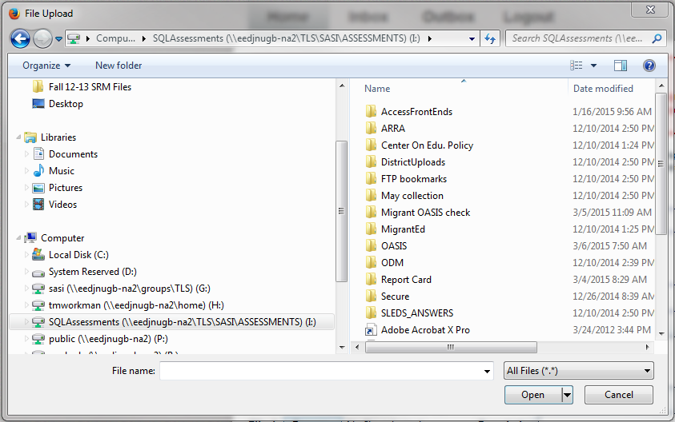
- After you select a file, it will appear under the heading ‘Filename’ and next to the number 1. You may choose to enter a description in the box next to your file. You also may select the red ‘x’ next to the description box to delete your file. Follow steps 10 and 11 for each file you wish to send.
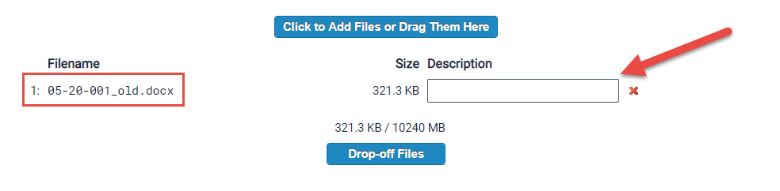
- After you are finished uploading files, you may choose to write a short note to the recipient(s) in the box.
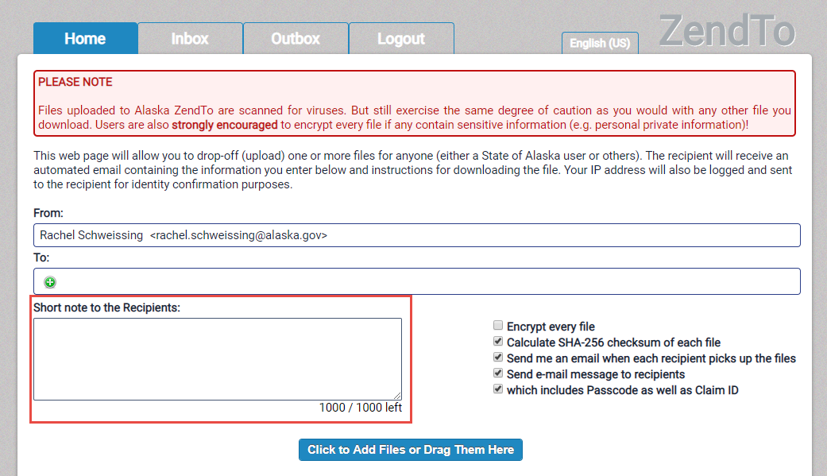
- Remember to select the “Encrypt every file” checkbox before submitting. A window will appear, and you will need to enter an Encryption Passphrase. Then select ‘OK’.
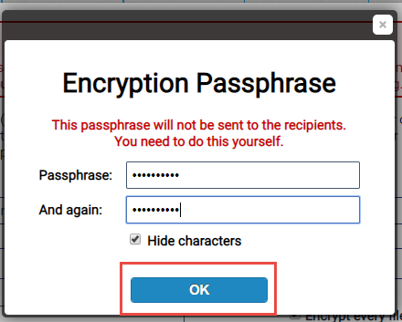
- Once an Encryption Passphrase has been chosen, please email the passphrase to eed.edqual@alaska.gov. Without this passphrase, DEED will not be able to access the files you send.
- Once you have sent DEED your passphrase, select ‘Drop-off Files’.

