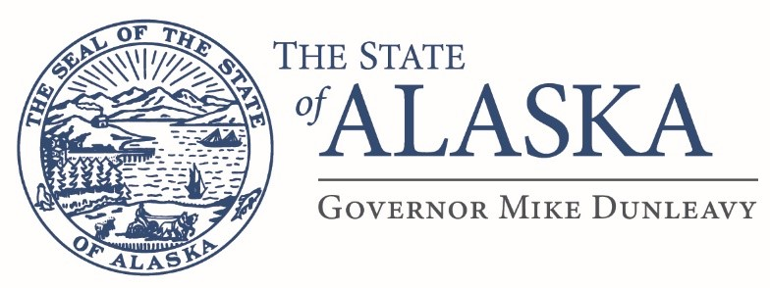
Department of Education
& Early Development

DIVISION OF STUDENT LEARNING
US Senate Youth Program

801 West 10th Street, Suite 200
P.O. Box 110500
Juneau, Alaska 99811-0500
Main: 907.465.2830
Fax: 907.465.6760

Dear parents, teachers, principals, and superintendents:
The United States Senate Youth Program (USSYP) has begun its statewide selection process. In March, two Alaskan students will join 104 other delegates for the program’s 58th annual Washington Week—an intensive week-long educational program about the workings of the Senate and the federal government overall. USSYP is sponsored by the US Senate and privately funded by The Hearst Foundation.
State delegates will have outstanding leadership abilities and a strong commitment to public service. They generally rank in the top one percent of their states academically. After Washington Week, delegates continue to excel and develop impressive qualities that are often directed toward public service. Each state delegate will receive a $10,000 undergraduate college scholarship, in addition to the all-expenses paid trip to the nation’s capital. The student delegates will visit Capitol Hill, the White House, the Pentagon, the State Department, the Supreme Court, and other historic sites in Washington. The agenda routinely includes meetings with Senators, the President, Cabinet Secretaries, a Justice of the Supreme Court, senior members of the national media, and other policy makers.
The 58^{h} Senate Youth Program Week will take place in Washington, D.C., on March 7th thru 14th and state designees will be required to attend all days. The entire week will be planned and coordinated by the Hearst Foundation. It will include many specific functions and events at national landmarks; however, personal free time will be extremely limited. Applicants should take this under consideration when applying.
The delegate selection is administered by each state’s chief school officer in cooperation with high school principals. Eligible delegates must be:
- Current high school juniors or seniors
- An elected student officer for the entire 2019-2020 academic year (Please reference the 2020 brochure for a complete list of eligible positions.)
- Residents of Alaska

Eligibility considerations may also be made for student representatives elected or selected (by a panel, commission or board) to district, regional or state-level civic or educational organizations.
Each student must be a resident of the United States and currently enrolled in a public or private secondary school located in the state (including for these purposes the District of Columbia) in which either one of his or her parents or guardians legally resides. Exceptions to the residency rule are made for the Department of Defense Education Activity and for states with schools operating under interstate education compacts.
Following this announcement are the 2020 brochure, student application, and an essay on the experience by one of last year’s delegates. Page 1 of the application includes a detailed checklist of required submission items. Please use this checklist to ensure your application is complete. Incomplete applications will not be considered.
The Alaska application deadline is November 1st, 2019 at 4pm.
The candidate selection process is three part:
- Students who submit complete applications will be initially ranked based on a rubric provided by the Hearst Foundation.
- The top ten applicants will be invited to take the 2020 United State Senate Youth Program Public Affairs and History Exam. This is a proctored exam that will affect an applicant’s total score and potential selection as a USSYP candidate.
- After performance on the USSYP exam is factored in, the top five applicants may also be asked to sit for a Skype interview with the selection committee. Performance during this interview will affect the applicant’s total score and potential selection as a USSYP candidate.

The names of students selected will be formally announced mid-December. For more information, interested students in Alaska should contact either their high school principal or myself via the contact information below. They may also access information via the DEED Scholarships & Recognition webpage.
Sincerely,

Bjørn Wolter, Ph.D.
Alaska Department of Education & Early Development
P.O. Box 110500
Juneau, Alaska, 99811-0500
907.465.6542 (p)
907.465.6760
(f)
bjorn.wolter@alaska.gov

