Alaska Developmental Profile (ADP) Website User’s Guide

Logging in

- To login, go to Teacher Login Page
  - Follow the posted login directions
  - Your login name is your first initial and full last name in lower case letters. For instance, “John Doe” would be jdoe
  - An Alaska teaching certificate is required to log in. Type in your first initial and last name exactly as it appears on your teaching certificate. This includes any hyphens, dots, spaces or other punctuation.
    - To confirm your teaching certificate information, please go to Teacher Certification Status Page.
      - Your password is your ATI. This number is located on the back of your teaching certificate or Link to look up ATI
- Once logged in, you will choose your school district and school

Picking Students

- On the school page, scroll down to see the list of Available Students.
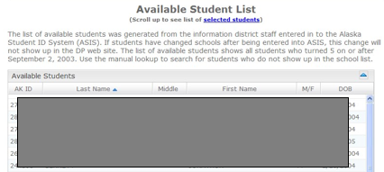

  - Starting in 2019, District Test Coordinators (DTC) are responsible for uploading ADP student lists. If no students are available, please contact your DTC.

  - Double click on the name of your student in the Available Student List. This will move the student’s name to Selected Students List at the top. 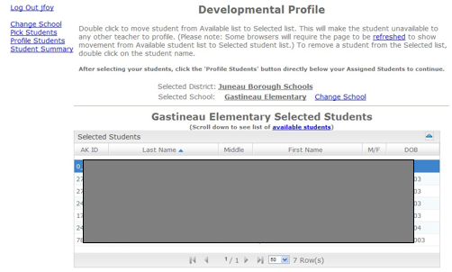

Profiling Students
- Select Profile Students
  - If you accidentally click on a student that is NOT in your class, double click their name to take them off a list.
- To record ratings on a specific student, click once on the student name.
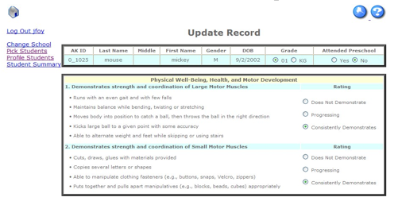
- After entering all ratings, select Save Record.
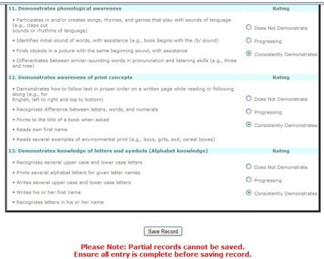

- The Profile Students page shows which students have been profiled.

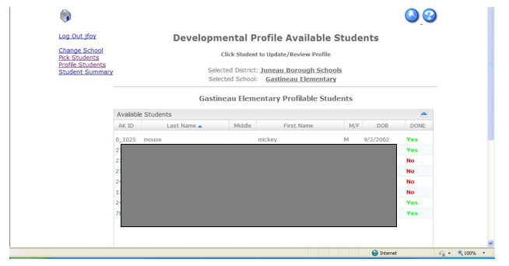

Manually Adding
  - If a student is not on the class list, you can do a search on the Pick Students page and manually add students. 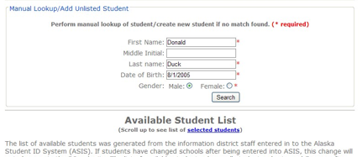
  - If the search does not find a student, you can automatically add the student to the list of selected students.
Please Note: Starting in 2019, you will need to know the student’s AKSID in order to use the Manual Add feature.

Contacts
For questions or help, please email
- Kristen Spencer kristen.spencer@alaska.gov
- Rachel Schweissing Rachel.schweissing@alaska.gov

