Order Instructions: Please indicate your order by writing the quantity of each item desired. You can email, or fax your completed order form to The Child Nutrition Programs at the above email or fax.
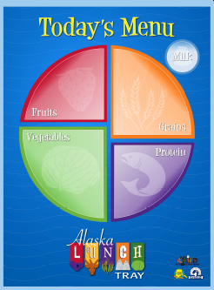 | Today’s Menu – Alaska Lunch My Tray  Dry-Erase (laminated) poster 18” x 22” Displays all 5 Food Groups Including Milk; used to indicate daily menu options to students. | 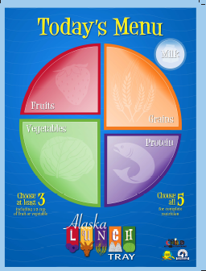 | Today’s Menu – Offer Vs. Serve Option  Comes in 18” x 24” and 8.5” x 11” sizes. Displays 5 Food Groups including milk. Dry Erase. Explains Offer Vs. Serve – Choose at least 3, or choose all 5 options.  Indicate quantity of each size desired.
Quantity ___________ |  | 18 x 24 Quantity________ | 8.5 x 11 Quantity________
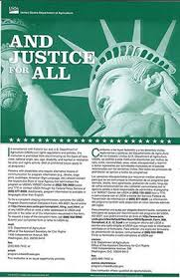 | “And Justice For All’ –Civil Rights Poster  Current version of the Civil Rights Poster. Required to be prominently displayed in all school cafeterias or eating areas. | 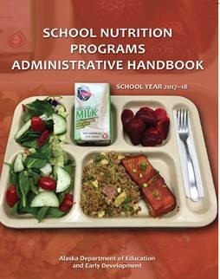 | School Nutrition Programs Administrative Handbook School Year 2017-18  This handbook provides an in depth look at the requirements the National School Lunch Program and School Breakfast Program and an overview of all the nutrition programs Alaska Child Nutrition Programs administer.
Quantity ___________ |  | Quantity ___________
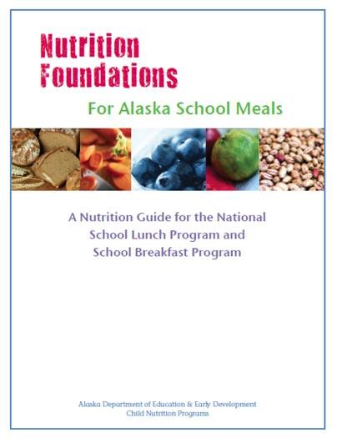 | Nutrition Foundations for Alaska School Meals This guidebook was developed to give schools the information needed to understand the new USDA meal patterns requirements for fruit, vegetables, and nutrient standards. | 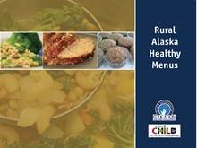 | Rural Alaska Healthy Menus This is the handbook for the rural menus which included a 2-week cycle menu for breakfast, and a 4-week cycle menu for lunch. This book has everything you need from production records to menu analysis to help those rural districts meet the USDA meal pattern.
Quantity ___________ |  | Quantity ___________
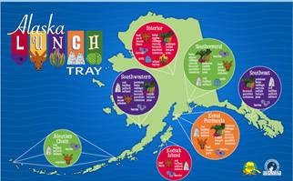 | Alaska Lunch Tray – State Map Local Foods  This fun and colorful map show students where in Alaska different types of local foods are grown and what kinds of locally grown foods we have in our state. | 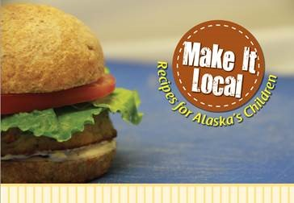 | Make It Local;  Recipes for Alaska’s Children  A comprehensive collection of recipes created for cooking with locally grown and harvested food items; from scratch. Recipes have ingredient list and step-by-step directions that have been standardized for 25 to 75 servings and meet NSLP  portion requirements.
Quantity ___________ |  | Quantity ___________

