 | Summer Food Service Program  CNP Web Tutorial  FY 2013 | Teaching and Learning Support  Child Nutrition Programs  801 West 10th Street, Suite 200  P.O. Box 110500  Juneau, Alaska 99811-0500  (907) 465-4788  (907) 465-8910

Please note our database is frequently modified by our contractor so the screen prints that you see in this tutorial may not match exactly what you see on your screen. If you have questions you may contact CNS for guidance.

Bookmark the following URL address for EED Child Nutrition Services webpage: https://cnsonline.alaska.gov/cnpweb/

Use this to access the CNP Web Login

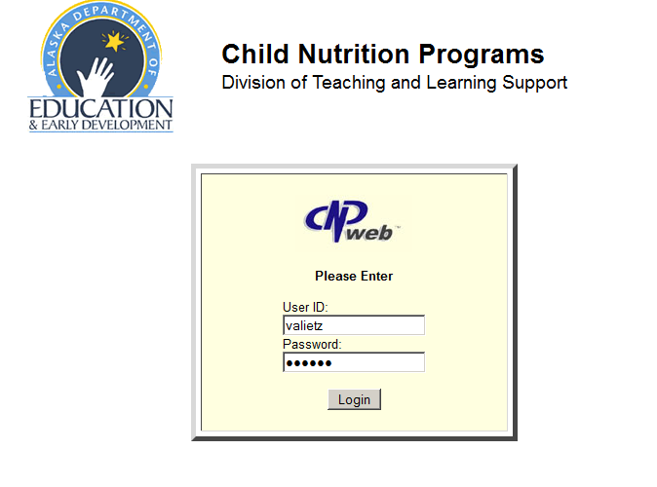 | Type in your User ID and Password. CNP will provide you with these via email once you have filled out the CNP Web User Authorization Request.  ONLY New Sponsors or Returning Sponsors who have forgot their username and password need to complete a CNP Web User Authorization Request.  Returning Sponsors/users will use the same username and password from FY12.
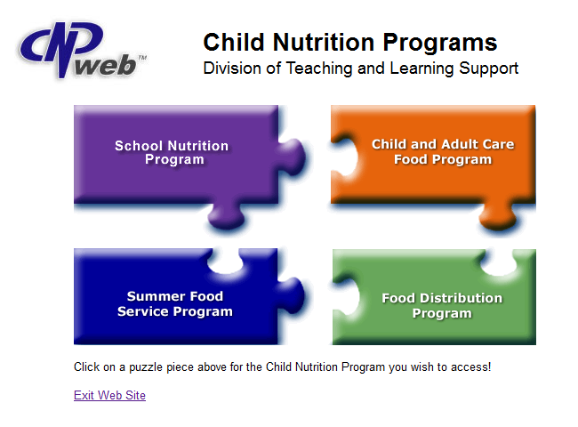 | Click on the BLUE puzzle piece to enter the SFSP Database
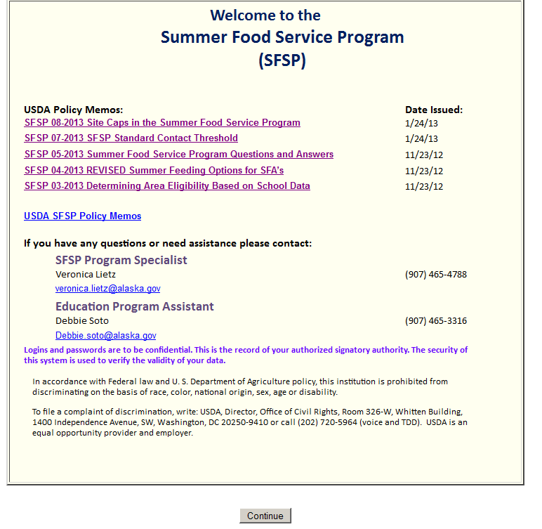 | Please read the Welcome Page each time you access the database as it will contain important program updates.  Click on continue to enter the database.
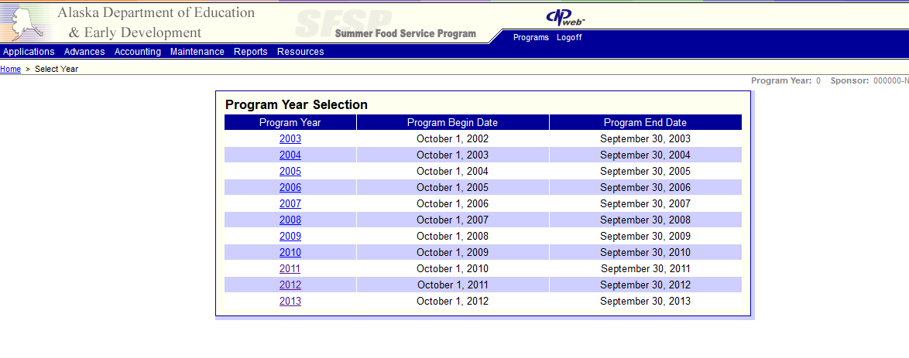 | Select the program year you wish to add/update (2013). *Note* you can view prior year’s program information and claims but DO NOT edit any prior year information.
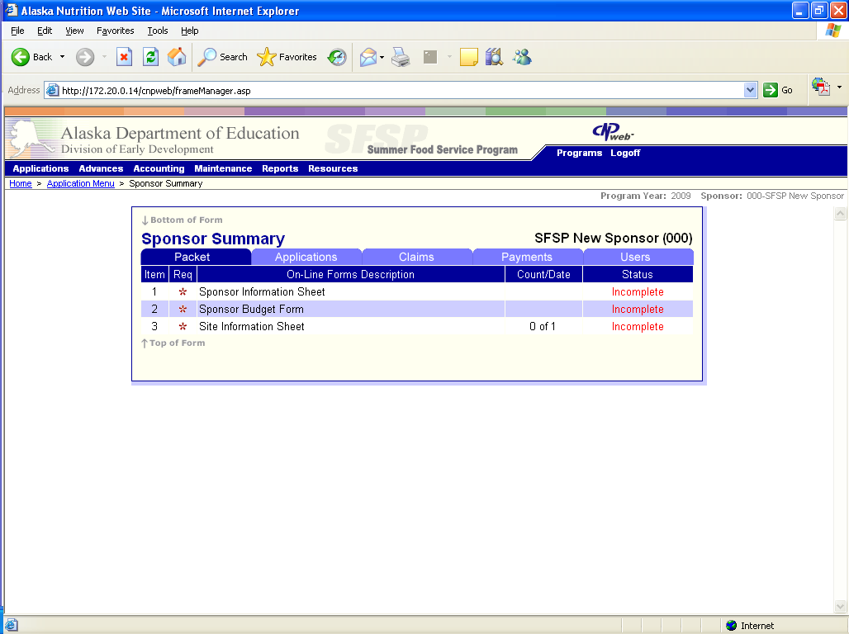 | This is the next screen you will see. Notice the tabs packet, applications, claims, payments and users. Click on the one you want and it will darken as the other stay light.
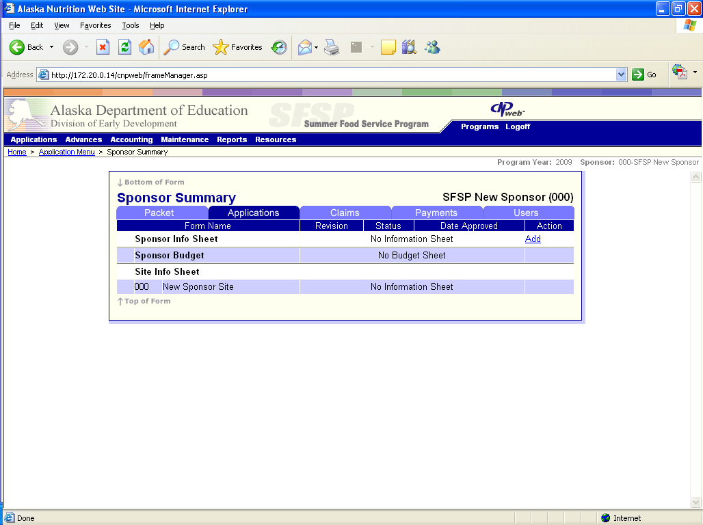 | Click on the applications tab to add/update your sponsor info, sponsor budget, and site info sheets. The sponsor sheet and sites from prior year will come forward into new year. You will need to click the “Add” toggle to update your sponsor information sheet.
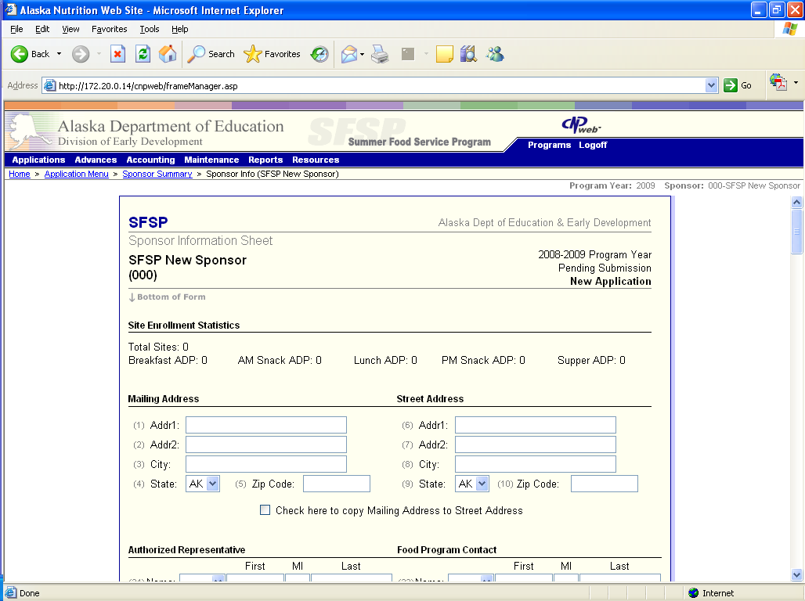 | Review all information in the body of the Sponsor Information Sheet and change as necessary. If changes happen after the initial data entry please make these changes as soon as possible.
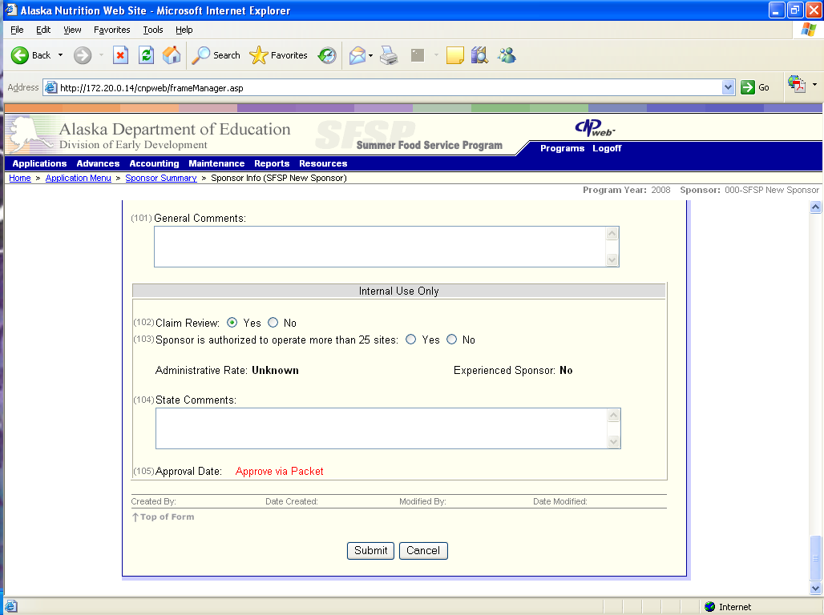 | Click on the Submit button when you are ready to save the data that you have entered. If you do not submit you will loose your information.
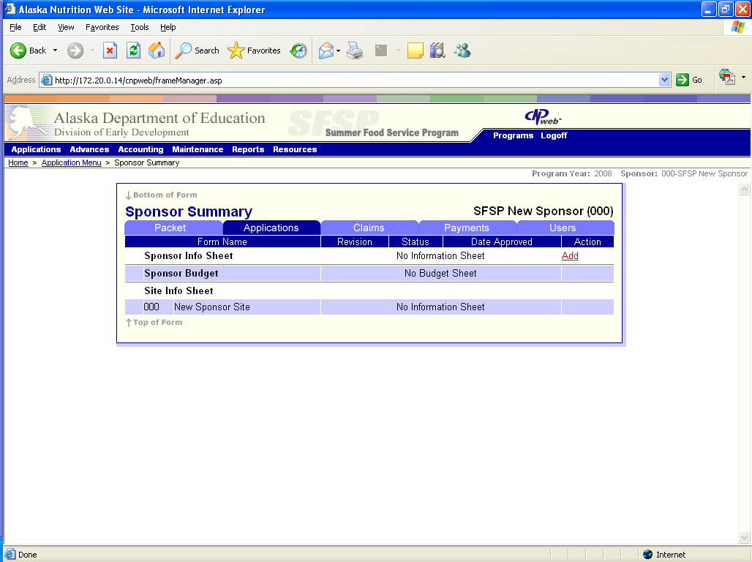 | Once you have added the Sponsor Info Sheet it will allow you to add the Sponsor Budget and Site Info Sheet. The Sponsor Budget sheet is waived for School Sponsors only, all other sponsors need to complete a sponsor budget.
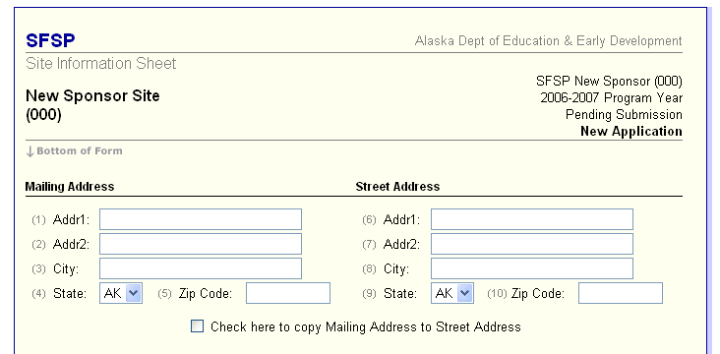 | Review all information in the body of the Site Information Sheet and change as necessary. If changes happen after the initial data entry please make these changes as soon as possible.
 | Don’t forget to click Submit when you are ready to save your work.
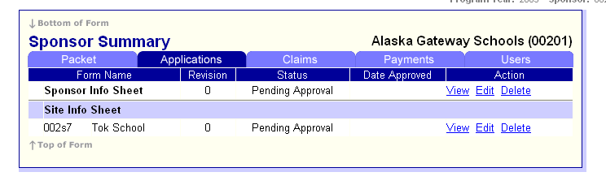  Pending Submission  Pending Submission | Once you clicked on submit at the bottom of each pages for Sponsor Info Sheet, Budget, and Site Info Sheet you will notice the status of Pending Submission on the Application tab.
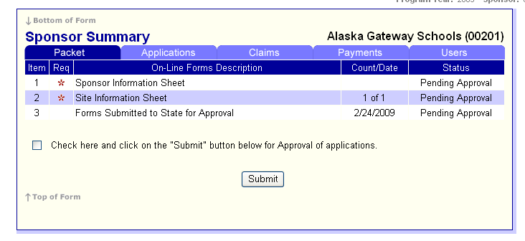  to submit to the State for approval  Pending Submission  Pending Submission | Go to the Packet Tab to see the status of your online application. Check the box and click on the Submit button when you are ready to “submit” to the State for approval.
Once you have completed the previous step you will see that the status changed from Pending Submission to Pending Approval.

You are not finished with the application process until you send in the required paper documents; see the Application General Information Packet for details.
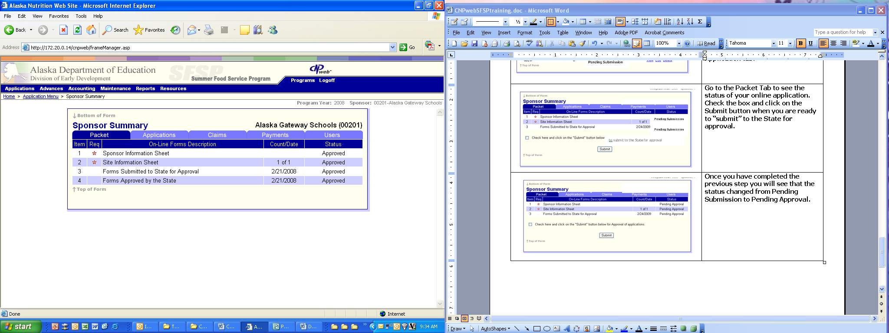 | Once the State has approved the online portion of the application process you will see the status on the Packet Tab reads “approved”.
If you should have any problems or questions during the new online application process contact Beth for assistance.

Beth Seitz
(907) 465-3316
elizabeth.seitz@alaska.gov

