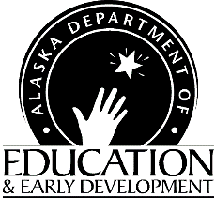 | CNP Web  User Deactivation Request | Finance & Support Services  Child Nutrition Programs  801 West 10th Street, Suite 200  PO Box 110500  Juneau, Alaska 99811-0500  907- 465-8708  Fax 907-465-8910

Instructions: Fill out this form and e-mail or fax it to Child Nutrition Programs (us). Retain a copy for your files.

Representing Sponsor/Agency Name(s): _________________________________________________________
Fiscally Responsible Authority Requesting Deactivation: ____________________________________________

Contact number for Fiscally Responsible Authority: ________________________________________________

Please terminate access for:
Name:
Title:
No longer an employee Security compromised
Change in job task Other:

________________________________________________________________________________________
Fiscally Responsible Authority Signature Date

NOTE: Please update your User Authorization Request forms as often as changes occur to reflect only those currently approved to view or enter data and/or approve claims.

State Official Use Only:

Deactivation request completed by: _____________________________________________________________
Date: ______________________

